The Whitby Secondary Partnership Federation
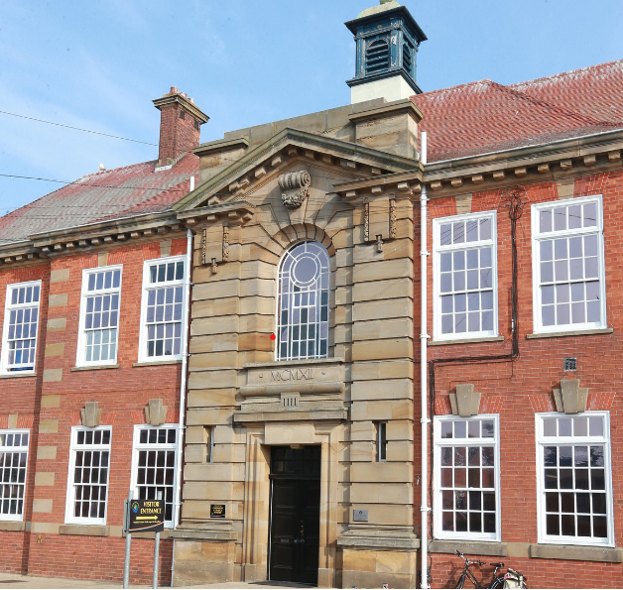

School Receptionist/Administration Assistant
Required ASAP
Recruitment Information Pack
Caedmon College Whitby,
Prospect Hill,
Whitby
YO21 1LA

Contents

Welcome from the Principal 3
Our staff 4
Application process and how to apply 5
Job Description 9-10
Person Specification 11

Dear applicant,

A warm welcome from all the staff, students and governors at Whitby Secondary Partnership Federation comprising Caedmon College Whitby, Whitby Sixth Form and Eskdale School.

Thank you for expressing interest in coming to join our staff team. While every headteacher will say their school is special – I truly believe that Caedmon College Whitby is.

We are hugely proud of our students and privileged to serve them and this community. We see it as our professional and moral duty to prepare them for adult life by not only fulfilling their potential and gaining the best possible qualifications but also to develop them into active, well-rounded citizens prepared to contribute to the local, national and global communities they will live in. This commitment is manifested in the lessons we deliver, the extra-curricular opportunities we offer and in the wider opportunities we promote.

In recent years enormous strides have been made to further increase learning standards. This hard work has seen results improve consistently and led to Ofsted rating our school as ‘Good’ in 2013 and in 2017. We are a school with highly effective teachers producing good, if not outstanding outcomes for our students.

I hope you can see that this is an excellent career opportunity. If successful you will be joining a highly professional team of teaching and support staff who are ambitious for our students. We take pride in ensuring colleagues receive opportunities to develop their skills and experiences – and we have an enviable reputation for delivering high quality professional development.

Before submitting your application form you would be most welcome to come for a visit and look around the school or, if this is not convenient, to arrange to speak to me personally.

Good luck with your application.

J Norden
Principal
October 2021

Our staff
Jo Cassell-Osowski is our Assistant Director of Science. She moved to the area in September 2020 from Barnsley.
What do you enjoy most about your job?

I love my job because everyone shares the same vision and I work amongst a super-supportive team. The students are enthusiastic to learn and I find it very rewarding to inspire them.

What’s the best thing about the community you work in?

It is a close-knit community and the school has a reputation for supporting students. It is growing because of that. In my interview, I asked the student panel what they liked most about living in and around Whitby and many said the fish and chips! Food aside, the sense of community within the school and around it is strong and I appreciate being part of it.

What’s the best thing about living and / or working on the Yorkshire Coast?
The Yorkshire Coast is a beautiful place to work and could make even a bad day better. On my morning commute I admire the view from above the town of the Abbey and historic harbour. It feels as though this setting generates positivity in the students and staff. I’m very proud to work in Whitby and at Caedmon College.

Finally, being able to walk to the beach whenever you please has to be a huge positive about living on the coast.

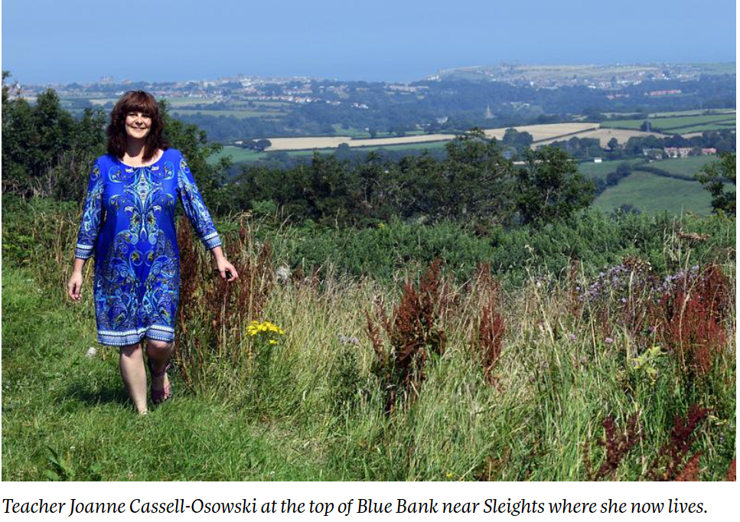

Application Process

The closing date for all applications is Thursday 4th November 2021

Interviews will be held as soon as possible after the closing date.

Completed applications must be returned to Garry Morrison at garry.morrison@northyorks.gov.uk

If you do not receive confirmation of receipt of your application within one working day please call Garry on 07814935700.

If you think you’re the person for the job, please complete the enclosed application form with a covering letter, no more than two sides of A4, and send to the email address above by the closing date.

An email will be sent to shortlisted candidates with details of the interview process. If you have not heard from us within a week of the closing date please assume your application has been unsuccessful.

Queries

Visits are warmly welcome. Please contact Garry to arrange.

We actively welcome you to contact Garry at North Yorkshire County Council to chat through the role and talk informally about the school/post and how working here will make a real difference to the children and young people on the coast.

Job Description

Post Title: Receptionist/Administrative Assistant
Job Purpose: To support the work of the Normanby Site College Office and Reception desk by greeting visitors and following office safeguarding protocols, franking mail and assisting with a range of office tasks, as part of a team, under the direction of the Senior Administrator responsible for the Normanby Site’s Office and Reception. The postholder may be expected to this role on a different site of the Whitby Secondary Partnership if required – this could be on the Sixth Form Site (Airy Hill, Whitby) or at Eskdale School (Stainsacre, Whitby) should the need arise.
RECEPTIONIST/ADMINISTRATIVE ASSISTANT
Administrative Assistants/Receptionists are collectively, as well as individually, responsible for a variety of tasks within the College Office. It is the responsibility of all office support staff to ensure a consistently high standard of work, and in particular to approach all activities with sensitivity, co-operation and friendliness. It is also important to liaise and communicate professionally with all your colleagues in the office; seeking assistance and advice when and where necessary. The Senior College Administrator should be informed of all potentially difficult or awkward situations, and of all emergencies in respect of students who may be in need of medical attention. Confidentiality and discretion are also essential. The College office wishes to maintain a high standard of output and professionalism and the office team adhere to a ‘House Style’ of office protocol.
Main duties and responsibilities
- To answer incoming telephone calls, taking messages and transfer calls, as appropriate.
- To assist visitors, students and staff as required, prioritising visitors and being polite and patient with all customers – internal and external.
- To undertake word-processing or other jobs from the central ‘office jobs’ system.
- To assist with franking out-going mail as well as sorting and distributing incoming mail as required.
- To maintain an up-to-date Free Schools Meals register if required.
- To assist with students who are ill, contacting home if necessary, or arranging for the student to be seen by a qualified first aider.
- To assist with the provision of hospitality for visitors and hospitality trays as required by staff for meetings and to liaise with the caretakers in this regard.
- To assist with general tidiness of reception area in terms of chairs, table, publications and document holders containing leaflets, letters and other information.
- To participate in the Performance Management process and undertake training as required.
- To attend training days and undertake training, as required.
- To be committed to the welfare and safeguarding of young people.
- To assist with other administrative duties that may be required from time to time, as directed by the Senior Office Administrator, Business Manager or members of the Strategic Team.
- To be aware of one’s responsibility as an employee in respect of health and safety, maintaining a safe working area for oneself and those in your working area, reporting any concerns to the Site Manager or Business Manager.

PERSON SPECIFICATION:
Receptionist/Admin Assistant

CRITERIA | ESSENTIAL | DESIRABLE
Qualifications, Training and Experience
Minimum 4 GCSE (A-C) (English Language essential) or equivalent | X
ECDL or Level 2 Word Processing & Spreadsheets |  | X
Reception and clerical experience | X
Emergency First Aid at Work/other First Aid qualification |  | X
Skills & Knowledge
Good interpersonal skills and an understanding of customer care | X
Good written and verbal communication skills: able to communicate effectively and clearly with a range of staff, young people, their families/carers and other agencies | X
Good Literacy skills | X
Competency in using a range of software and a willingness to learn new systems to operate the College’s management information system and produce documents as required | X
Organisational and time management skills to be able to prioritise tasks | X
Personal Qualities
Ability to work as part of a team | X
Resilience and a sense of humour in times of pressure | X
Attention to detail, neatness and accuracy in passing on information and completing tasks | X
Other Requirements
A willingness to undergo training to learn new systems and/or processes | X
An understanding of the need for confidentiality in various aspects of the role | X
A willingness to be flexible in one’s work schedule and undertake general office duties and cover as required | X
Motivation to work with children and young people | X
A willingness to take part in the College's Performance Management process | X
To be committed to Continual Professional Development | X
To be committed to the safeguarding and welfare of young people | X
Equal opportunities
To assist in ensuring that NYCC’s equalities policies are considered within the school’s working practices in terms of both employment and service delivery | X

