 St John Henry Newman Catholic School

Headteacher: Mr Declan McArdle BA (Hons) MEd

Candidate Brochure




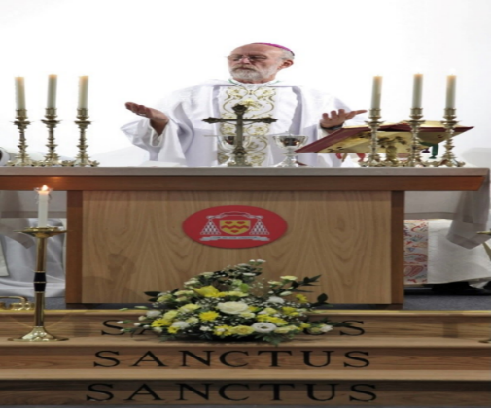

St John Henry Newman Catholic School

Contents

Page 3 | Welcome from the Headteacher
Page 4-5 | Mission Statement
Page 6 | About our School
Page 7 | Advert
Page 8 - 10 | Job Description and Person Specification

Also included with this application pack:
- Attachments - Notes to Applicant
- Application Form – Support Staff
- Rehabilitation of Offenders Form – issued at shortlisting stage
- Self-Disclosure Form – issued at shortlisting stage
- Recruitment Monitoring Form
- Consent to Obtain Reference Form
- Overarching Safeguarding Statement
- Staff Code of Conduct Policy
- School Privacy Notice - Staff
- Equality Act Reasonable Adjustment Statement

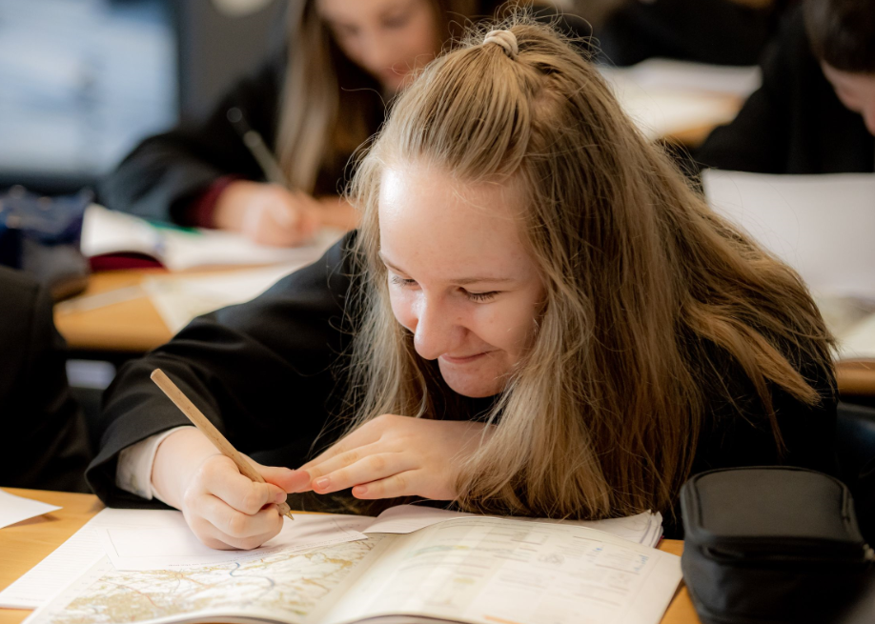

St John Henry Newman Catholic School

Welcome from the Headteacher
Dear Applicant
Thank you for your interest in the position of Receptionist at St John Henry Newman Catholic School.
We are a genuinely comprehensive school and believe that our mission is to nurture each child by placing Christ and the teaching of the Catholic Church at the centre of their lives.
We integrate Gospel values and the teachings of the Catholic Church into every aspect of learning, teaching and the totality of school life.
In the words of our patron St John Henry Newman, “To live is to change and to be perfect is to have changed often”; and so we have high expectations of our pupils; we expect them to work hard, to play hard and to take a full part in the life of the school. In return, we strive to provide the best teaching and guidance in a caring and supportive environment, where pupils are challenged and give of their best.
Strong pastoral care is vital to our success and creates a happy and caring atmosphere. As a smaller school, we get to know our pupils well; their well-being is our foundation. This strong pastoral care enables us to support our pupils, not only with their academic work, but also in the varied extra-curricular activities, which are hugely important as they develop into young adults.
It is an exciting time to join St John Henry Newman Catholic School. Following the flooding of our site in Carlisle we moved to a purpose-built modern school in a developing area of Carlisle in September 2020. After a turbulent time following the flood, the school is rapidly improving and was recently commended by Ofsted for the improvements being made in the quality of teaching, the progress of pupils, and for the highly effective pastoral support. Inspectors’ findings confirmed that a journey of school improvement is underway.
You will find here a wonderful and vibrant community of teachers and support staff committed to improve the life chances of all pupils and to develop a school that embraces the teachings of the Catholic Church.
We want our pupils to enjoy their education – to be happy, safe and secure and to grow in God’s love so that when they leave the school, they are equipped to change the world and make it a better place.

Yours
Declan McArdle
Headteacher

Declan McArdle
Headteacher

St John Henry Newman Catholic School

Mission Statement

Our mission is to educate our pupils in the wholeness of mind, body and spirit through the teachings of Jesus Christ as proclaimed by the Catholic Church by placing Him at the centre of pupils' lives. We encourage pupils to cultivate Christian virtue and an appropriate sense of social responsibility. We support the spiritual and mental well-being of all our community on a daily basis.

Our school commits itself to the principles of Catholic education and academic excellence, leading our pupils from shadows and images to the fullness of the Truth, as envisioned by the St John Henry Newman. We inspire an enthusiasm for life-long learning and are committed to success for all, ensuring that all our community has the highest aspirations to achieve the best outcomes in life.
St John Henry Newman Catholic School
Governors’ Strategic Vision 2023-2028
This text sets out our aspirations for St John Henry Newman Catholic School and provides a description of the school the governors would like to see evolve over the next five years.
In everything we do, we will aim to affirm Cardinal Newman’s inspirational maxim:
Cor ad Cor Loquitur (Heart Speaks to Heart)
We will strive to be a school which is marked by:
- Christian values, where Catholic teaching is at the centre of every aspect of school life
- equal respect for all members of the school community which is safe, inclusive and nurturing of all
- a staff team dedicated to our pupils and committed to professional self improvement no matter what our role
- a curriculum which fosters curiosity, challenges all pupils and enables them to explore wider horizons to make sense of the changing world around them
- promotion of positive career routes for all pupils, including through membership of our own distinctive sixth form
- active participation in the Bishop’s vision for Catholic education in the diocese as a member of the Mater Christi multi-academy trust

As a result of our collective efforts, we expect our pupils to be:
- become well rounded young people, open minded and receptive, honest and truthful
- grow into generous, grateful, hopeful adults able to fulfil their spiritual and personal potential
- be shaped by Christian values, discerning, compassionate and actively serving society
- know that they are valued and cared for, confident in their personal gifts and equipped to develop their unique strengths
- have respect for their own dignity and the dignity of others, able to act as both leaders and good team players
- develop into self-disciplined and courteous young people, conscious that they can be a positive example to others
The school will provide an environment which is:
- an inspirational place in which to learn: spacious, light, attractive and stimulating
- suitable to meet all needs – physical, academic, personal, social and spiritual
- furnished with a distinctive and prominent working chapel open to all, at all times, with regular Masses
- supportive of learning in all domains, flexible and responsive to the changing curricular requirements of the 21st Century
- responsive to the progression routes of all pupils, including the provision of high quality post-16 programs within its own distinctive sixth form.
- an environment which brings pupils together, with communal and recreational spaces conducive to a civilised experience
- safe, secure and appropriate to the diverse needs of the pupil’s community
- well-resourced with the equipment and materials required to provide the best contemporary education possible

St John Henry Newman Catholic School

About our School
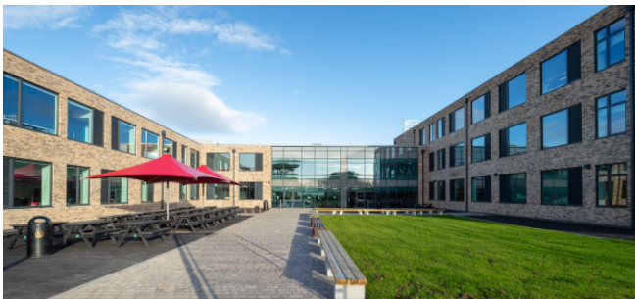
It is an exciting time for St John Henry Newman Catholic School, as we have moved to a new build school in the “garden village” area of Carlisle. Our school is a £15million new build in a rural location on the edge of the city. The school has been designed to provide the highest standards of education for our pupils and areas have been purpose built to allow staff to teach effectively in their subject areas.
St John Henry Newman Catholic School offers:
- An exciting, engaging curriculum underpinned by excellent teaching
- Committed and caring staff
- Continual Professional Development
- Governor support
At St John Henry Newman Catholic School, we are committed to the high achievement of all our pupils. We cultivate success and foster the highest aspirations through excellent teaching. We are a learning community which has high expectations and actively seeks to celebrate the good in every individual. St John Henry Newman Catholic School is built on the Christian values of trust, respect and compassion.
We inspire an enthusiasm for life-long learning and are committed to success for all.
St John Henry Newman Catholic School opened in 1967 and we are very proud of the long history of achievements gained by our pupils. Our expectations are high and we continue to ‘raise the bar’.
Our small sixth form ensures that all of our pupils’ individual needs are catered for which in turn ensures we are well placed to help each individual to make their expected progress.
Supported by a strong careers programme, our pupils continue to be successful in their transition from school to employment, apprenticeships and further education and training. Pupils receive individual guidance on their next steps and we are proud to say that our school leaver statistics are above the national average with close to 100% of our pupils selecting appropriate future steps.
St John Henry Newman Catholic School seeks to provide a distinctly Catholic education in partnership with parents, families, the local Church and wider community. Everyone is encouraged to be the best person that they can be and is both nurtured and challenged in a safe and secure environment. Mutual respect is at the heart of our school community and Gospel values of peace, justice and reconciliation are of paramount importance.

St John Henry Newman Catholic School

Receptionist
BS6 £22,666 per annum pro rata (full time equivalent £26,403)
St John Henry Newman Catholic School is seeking to appoint a receptionist to join our friendly office team. You will be an outgoing, confident and professional individual who thrives in a busy office environment and who prides themselves on providing exceptional customer service.

The successful candidate will:

- be organised, flexible and have a warm friendly and approachable manner

- be the face and voice of our school

- understand the importance of first impressions and customer care, representing both themselves and our school

Please see the job description within the application pack for further information about the role.
Current working hours are 37 hours per week, term time only, working:
Monday to Friday 8.00am – 4.00pm

With a 30 minute unpaid lunch

Our school has a distinctive caring and Christian ethos with the emphasis on the individual, supporting staff and pupils in fulfilling their full potential. We are committed to safeguarding and promoting the welfare of young people. This post will be subject to an enhanced DBS and health check.
For an informal chat about the post or to request to visit our school please contact Mrs James, Office Manager by email: SarahJames@newman.cumbria.sch.uk.
Application packs can be requested by emailing vacancies@newman.cumbria.sch.uk or downloaded from our website at http://newman.cumbria.sch.uk/vacancies/
The closing date for applications is 12pm Wednesday 13th May 2026. Interviews to be held week beginning Monday 18th May 2026. Completed application forms should be emailed to vacancies@newman.cumbria.sch.uk or by post, addressed to HR and Finance.
Short listed candidates will be contacted by telephone or email.

Job Description and Person Specification
Catholic Voluntary Aided School
St John Henry Newman Catholic School

Post Title: Receptionist
Responsible To: Office Manager
Job Profile: BS6 Scale Point: 7
Main Purpose: As principal receptionist, you will be a welcoming first impression of the school and the first point of contact for incoming telephone calls and visitors to the site.
In addition, and as a proactive member of the administration team, you will assist with office duties, as guided by the Office Manager and Headteacher.
Principal Accountabilities
Organisation:
- Undertake reception duties, answering the telephone, face-to-face enquiries and monitoring the signing in and out system.
- Ensure reception and main office area remain tidy and presentable at all times.
- Manage room booking systems, ensuring procedures are followed regarding bookings of additional services.
- Manage the signing in and out of visitors to ensure adherence with H&S regulations.
- Manage correspondence from the school’s general email addresses and responding to enquiries in a timely fashion.
- Answering enquiries regarding the school Ipay cashless and MIS systems.
- Administer staff and pupil first aid, looking after sick pupils and liaising with parents/staff.
Administration:
- Provide routine clerical support e.g. reprographics; emailing and parental communications.
- Undertake typing, word-processing and other IT based tasks.
- Sort and distribute incoming and outgoing mail.
- Undertake routine administration tasks.
- Maintain IT booking systems for laptops/IT rooms.
- Manage manual and computerised record/information systems.
- Provide administrative and organisational support to other staff.
- Recording parental communication.
- Maintaining and recording the pupil/staff accident books – completing online submissions
Resources:
- Operate and maintain office equipment e.g. school photocopiers and the franking machine.
- Arrange orderly and secure storage of supplies.
- Monitor and manage office supplies within an agreed budget, cataloguing resources and undertaking audits as required.
- Provide advice and guidance to staff, pupils and others.
General:
- Comply with policies and procedures relating to child protection, health and safety, confidentiality and data protection, reporting all concerns to an appropriate person.
- Be aware of and support equal opportunities for all.
- Contribute to the overall ethos/work/aims of the school.
- Establish constructive relationships and communicate with other agencies/professionals.
- Participate in training and other learning activities and performance development as required.
- Recognise own strengths and areas of expertise and use these to advise and support others.
- To carry out other related duties under the direction of the Headteacher and to carry out other administrative tasks as part of the school support staff.
- First Aid trained or willing to train

Other duties:
- Any other duties the head may direct within the conditions of service and workforce reform policy.

Review
This job description maybe reviewed from time to time with the Headteacher. While every effort has been made to explain the main duties and responsibilities of the post, each individual task will not necessarily be identified.

Declan McArdle
Headteacher
May 2026

Person Specification
Post Title: Receptionist
 | ESSENTIAL | DESIRABLE
Qualification/Training/  Competences | Relevant NVQ 2 or equivalent, or experience in a relevant discipline  Good numeracy and literacy skills  Ability to handle sensitive data  Ability to be confidential at all times | Evidence of further training in school-based support
Relevant Experience | Experience working as a receptionist or admin work  Confidence in communicating via phone, email and writing  Experience of working in a fast-paced environment  Experience in operating systems such as Word and Excel | Experience working in a school-based/education environment  Experience in operating systems (ARBOR)
Knowledge | Effective use of ICT packages  Use of relevant equipment/ resources  Good keyboard skills | Knowledge of relevant policies/codes of practice & awareness of relevant legislation
Skills | Ability to relate well to children and adults  First aider or willingness to undertake first aid training as part of their role | Work constructively as part of a team, understanding school roles & responsibilities and your own position within these
Special Circumstances | Occasional attendance at meetings/INSET/open evenings/parents evenings, outside normal hours

