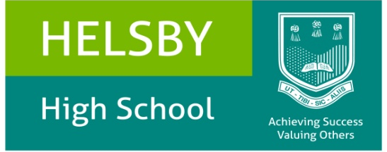

HELSBY HIGH SCHOOL
Reflection Room Manager - PERSON SPECIFICATION

Criteria | Essential | Desirable | Methods of Assessment
Qualifications | - Good standard of general education including 5 GCSE’s or equivalent (Graded A-C) including Maths and English |  | - Application  - References  - Interview
Training and experience | - Experience of working with young people  - High level of literacy  - Willingness to undertake further training | - Experience of working in the public sector. | - Application  - Interview  - References
Job related knowledge | - ICT competent and conversant with the Microsoft Office suite of applications  - Knowledge of safeguarding procedures and familiar with child protection issues  - Have good administrative organisation and communication skills.  - Knowledge and understanding of safeguarding standards and systems within an educational setting. | - Knowledge and understanding of issues relating to young people in the following areas: healthy eating; eating disorders; drugs, smoking and substance abuse; behaviour; sexual health; personal image; child sexual exploitation | - Application  - Interview  - References
Personal Attributes | - Ability to liaise effectively with parents and outside agencies.  - Enjoy working with a wide variety of young people  - Have excellent inter-personal skills and be able to work well as part of a team  - Have confidence to manage student behaviour  - Be resilient, firm and consistent  - Be comfortable with a challenging and varied workload and be able to prioritise effectively  - Able to maintain confidentiality where applicable  - Able to work in a professional manner with a wide range of people  - Ability to act on initiative within a team context  - To show commitment to safeguarding and ensuring the welfare of children and young people |  | - Interview  - Reference

