

**The Whitby Secondary Partnership Federation**



**Relief Learning Support Assistant**

**Required ASAP**

**Recruitment Information Pack**

Caedmon College Whitby,

Prospect Hill,

Whitby

YO21 1LA

## Contents

Welcome from the Principal 3

Our staff 4

Application process and how to apply 5

Job Description 9-10

Person Specification 11





Dear applicant,

A warm welcome from all the staff, students and governors at Whitby Secondary Partnership Federation comprising Caedmon College Whitby, Whitby Sixth Form and Eskdale School.

Thank you for expressing interest in coming to join our staff team. While every headteacher will say their school is special, I truly believe the Whitby Secondary Federation is

We are hugely proud of our students and privileged to serve them and this community. We see it as our professional and moral duty to prepare them for adult life by not only fulfilling their potential and gaining the best possible qualifications but also to develop them into active, well-rounded citizens prepared to contribute to the local, national and global communities they will live in. This commitment is manifested in the lessons we deliver, the extra-curricular opportunities we offer and in the wider opportunities we promote.

In recent years enormous strides have been made to further increase learning standards. This hard work has seen results improve consistently and led to Ofsted rating our school as ‘Good’ in 2013 and in 2017. We are a school with highly effective teachers producing good, if not outstanding outcomes for our students.

I hope you can see that this is an excellent career opportunity. If successful you will be joining a highly professional team of teaching and support staff who are ambitious for our students. We take pride in ensuring colleagues receive opportunities to develop their skills and experiences – and we have an enviable reputation for delivering high quality professional development.

Before submitting your application form you would be most welcome to come for a visit and look around the school or, if this is not convenient, to arrange to speak to me personally.

Good luck with your application.

J Norden

Principal

October 2021

**Our staff**

**Jo Cassell-Osowski is our Assistant Director of Science. She moved to the area in September 2020 from Barnsley.**

**What do you enjoy most about your job?**

I love my job because everyone shares the same vision and I work amongst a super-supportive team. The students are enthusiastic to learn and I find it very rewarding to inspire them.

**What’s the best thing about the community you work in?**

It is a close-knit community and the school has a reputation for supporting students. It is growing because of that. In my interview, I asked the student panel what they liked most about living in and around Whitby and many said the fish and chips! Food aside, the sense of community within the school and around it is strong and I appreciate being part of it.

**What’s the best thing about living and / or working on the Yorkshire Coast?**

The Yorkshire Coast is a beautiful place to work and could make even a bad day better. On my morning commute I admire the view from above the town of the Abbey and historic harbour. It feels as though this setting generates positivity in the students and staff. I’m very proud to work in Whitby and at Caedmon College.

Finally, being able to walk to the beach whenever you please has to be a huge positive about living on the coast.

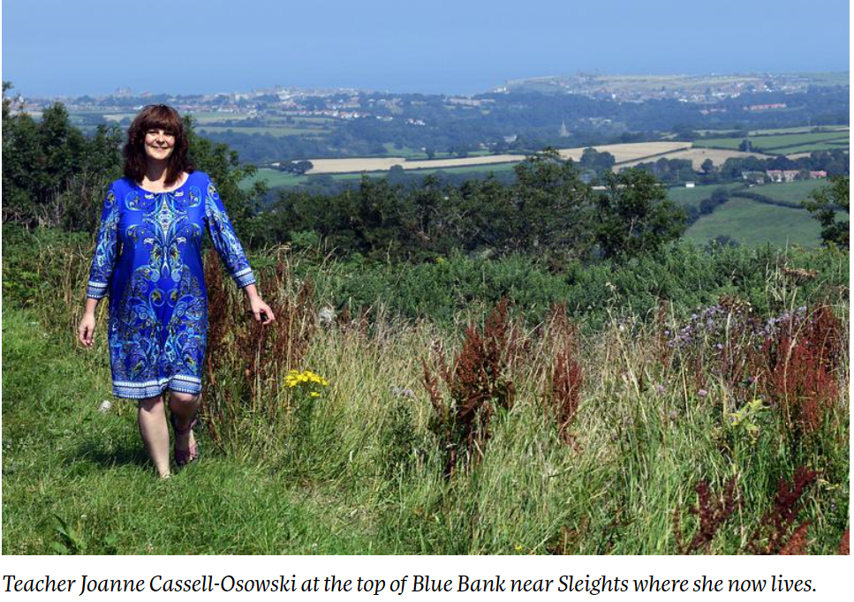

**Application Process**

The closing date for all applications is Friday 5th November 2021

Interviews will be held as soon as possible after the closing date.

Completed applications must be returned to Garry Morrison at [garry.morrison@northyorks.gov.uk](mailto:garry.morrison@northyorks.gov.uk)

If you do not receive confirmation of receipt of your application within one working day please call Garry on 07814935700.

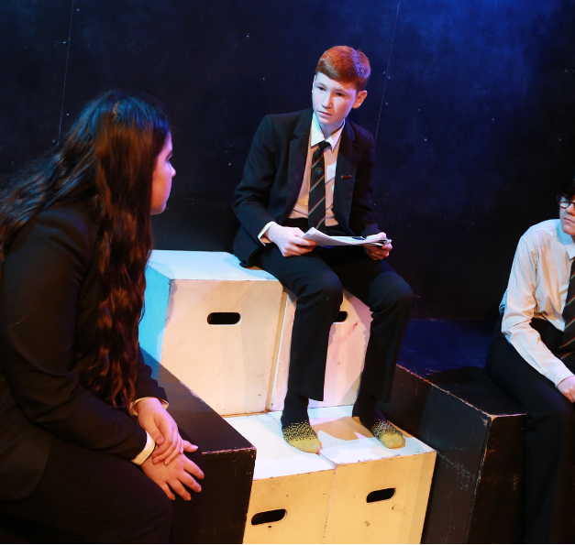**If you think you’re the person for the job, please complete the enclosed application form with a covering letter, no more than two sides of A4**, **and send to the email address above by the closing date.**

An email will be sent to shortlisted candidates with details of the interview process. If you have not heard from us within a week of the closing date please assume your application has been unsuccessful.

## Queries

Visits are warmly welcome. Please contact Garry to arrange.

We actively welcome you to contact Garry at North Yorkshire County Council to chat through the role and talk informally about the school/post and how working here will make a real difference to the children and young people on the coast.

**Job Description**

|  |  |  |
| --- | --- | --- |
| POST: | | Learning Support Assistant (GTA) |
| GRADE: | | NYCC Grade C (points 2 – 4) |
| RESPONSIBLE TO: | | The Special Educational Needs Co-ordinator (SENCo), working under the direction of classroom teachers |
| STAFF MANAGED: | | None |
| JOB PURPOSE: | To work with teachers to support teaching and learning by working with individuals or small groups of students under the direction of teaching staff/the SENCo. To be responsible for some learning activities within the overall teaching plan, to support staff and students. May work in the classroom or appropriate location within the |College, with access to support and guidance as required. | |
| **ACCOUNTABILITIES/MAIN RESPONSIBILITIES** | | |
| **Supporting Learning & Development** | * Support pre-planned learning/behaviour activities as directed by the teacher * Using agreed, structured observation as directed by the class teacher to feedback on learning, behaviour, participation and achievement, to support the planning and evaluation of the learning process in respect of groups and individual students * Interact with pupils in ways that support the development of their ability to think and learn, including the use of careful questioning * Assist teachers in the implementation of appropriate behaviour management and teaching & learning strategies * Support pupils in their social and emotional wellbeing, in implementing related programmes, including social, health and physical needs * Assist in escorting and supervising pupils on educational visits and out of school activities * Undertake break supervision as required | |
| **Communication** | * Under the general direction of the teacher, participate in establishing and maintaining effective relationships with pupils, parents/carers and with other agencies/professionals * Communicate effectively with all pupils, families, carers and other agencies/professionals | |
| **Sharing information** | * Share information confidentially about pupils with teachers and other professionals, as required * Pay due regard to professional boundaries, maintaining appropriate levels of confidentiality * Participate in staff meetings as required | |
| **Safeguarding and Promoting the Welfare of Children/Young People** | * Carry out tasks associated with pupils’ personal hygiene and welfare as necessary, including physical and medical needs, whilst encouraging independence * Be responsible for promoting and safeguarding the welfare of pupils in line with policy and legislation, raising concerns as appropriate | |
| **Administration/Other** | * Prepare classroom materials and learning areas, and undertake minor clerical duties, eg, photocopying and displaying students’ work * Support the use of ICT and adhere to relevant policies * Supervise and provide access arrangements for students sitting internal and external examinations and tests, where required, ensuring that examinations comply with the Examination Board Regulations under the direction of the Exams Officer/SENCo * Participate in appraisal, training and other learning activities, as required | |
| **Health & Safety** | * Be aware of and implement your health and safety responsibilities as an employee and where appropriate any additional specialist or managerial health and safety responsibilities as defined in the Health and Safety policy and procedure * Work with colleagues and others to maintain health, safety and welfare within the working environment | |
| **Data Protection** | * To comply with the County Council’s/College’s policies and supporting documentation in relation to information governance - this includes data protection, information security and confidentiality | |
| **Equalities** | * Promote inclusion and acceptance of all pupils * Within own area of responsibility work in accordance with the aims of the Equality policy, treating people with respect for their diversity, culture and values | |
| Customer Service | The County Council requires a commitment to equity of access and outcomes, this will include due regard to equality, diversity, dignity, respect and human rights and working with others to keep vulnerable people safe from abuse and mistreatment  * The County Council requires that staff offer the best level of service to their customers and behave in a way that gives them confidence. Customers will be treated as individuals, with respect for their diversity, culture and values | |
| **Date of Issue:** | October 2021 | |

**PERSON SPECIFICATION**

**JOB TITLE: General Teaching Assistant**

|  |  |
| --- | --- |
| **Essential upon appointment** | **Desirable on appointment** |
| **Knowledge**   * An awareness of child/young person’s development and learning * An understanding that children/Young people have differing needs | * Good understanding of child development and learning processes * Knowledge of behaviour management techniques * Knowledge of Child Protection and Health & Safety policies and procedures * Knowledge of inclusive practice |
| **Experience**   * Experience appropriate to working with children in a learning environment |  |
| **Qualifications**   * Relevant Level 2 qualification(s) or equivalent | * Relevant NVQ level 3 * SEN-support assistant related training * Appropriate first aid training if required |
| **Occupational Skills**   * Good written and verbal communication skills: able to communicate effectively and clearly and build relationships with a range of staff, children, young people, their families and carers * Good reading, writing and numeracy skills | * ICT Skills |
| **Personal Qualities**   * Demonstrable interpersonal skills * Ability to work successfully in a team * Confidentiality * Flexibility | * Creativity * Perseverance * Energy |
| **Other Requirements**   * Enhanced DBS Clearance * To be committed to the College’s policies and ethos * To be committed to continuing professional development * Appropriate motivation to work with children and young people * Ability to form and maintain appropriate relationships and personal boundaries with children and young people * Emotional resilience in working with challenging behaviours and attitudes * Ability to use authority and maintaining discipline * An empathy for equality and diversity * The ability to converse at ease with students and staff and provide advice in accurate spoken English |  |