
Reprographics and Design Technician


Recruitment Pack

MAXIMISING OUR POTENTIAL
Kirkby High School


CONTENTS
Letter from Headteacher
About us
Continuous Professional Development
Job Description
Person Specification
How to Apply
Application Form
Welcome
Dear Applicant,
Thank you for your interest in the Reprographics and Design Technician position at Kirkby High School.
We are seeking to appoint a dedicated and enthusiastic individual who is ambitious and has an excellent work ethic to start as soon as possible.
We are proud of our school’s success and are committed to providing an ambitious and inclusive environment with a strong pastoral care system that values every member of our community.
To help you decide if the job would suit you, please find enclosed some details, which we hope will give you a flavour of what Kirkby High School and The Rowan Learning Trust are about.
If your values and ambitions mirror ours and you believe you can deliver that vision, then we would be delighted to receive an application from you.
Visits to our school are welcome and can be arranged by contacting my PA, Jo Barrett on 0151 477 8710 or email j.barrett@kirkbyhighschool.net
We are committed to safeguarding all members of our community; therefore, all posts are subject to enhanced disclosure procedures and pre-employment checks.
Yours faithfully,
Mrs A Dobson
Headteacher
Kirkby High School

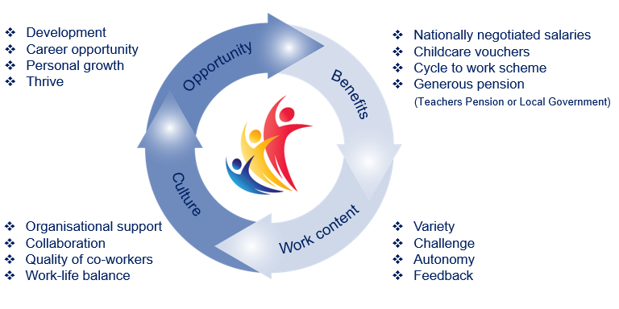
The Rowan Learning Trust
The Rowan Learning Trust (RLT) was established as a Multi-Academy Trust in 2012 to maximise potential of all children, students and adults in our schools.

We are an education charity. Our schools are working in collaboration, as one entity, to improve and maintain high educational standards across the group. We have a single legal and moral purpose: to advance education for the public benefit.

Currently the RLT family comprises 12 schools: 3 high schools, an
all-through alternative provision academy and 8 primary schools. Together we share a set of common values:

- Respect Kindness Integrity

Our strategic aim is to provide a world class education by:
- Attracting, developing and retaining people
- Embodying the values of the Trust
- Expanding our reach
- Optimising resources

The Trust in Numbers:
- 4250+ students 11 schools
- 10 sites 675+ employees
- 5 local authorities £37,000,000 annual budget

- 80+ governors

Kirkby High School
Kirkby High School is an Ofsted rated 'Good' 11-16 mixed comprehensive. All staff at Kirkby High School fully embrace our vision: “A community driven by high expectations and mutual respect providing all individuals with the belief and opportunities to succeed now and in the future”.
Kirkby High School stands at the centre of our local community and we believe that we offer our young people guidance and aspiration to be the best they can be in all aspects of life. Quality teaching and learning, supported by reliable pastoral systems, ensure that students are preparing well for later life.
We believe in building a culture of resilience and tolerance in which our students can thrive. Our aim is to increase our students’
self-belief and to show them that they can be what they want to be.
Confidence Kindness Aspiration Respect Resilience


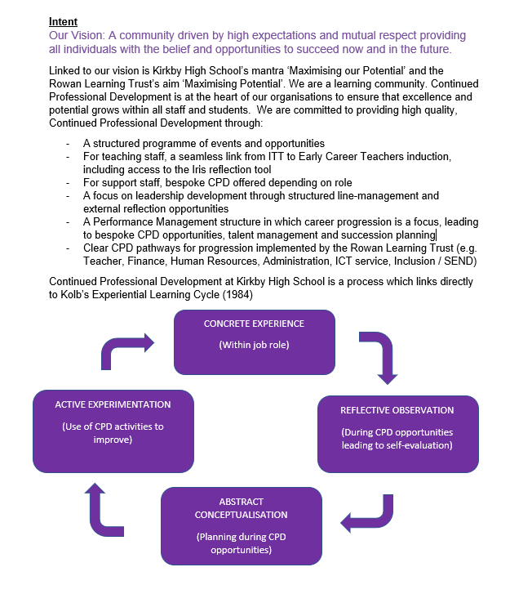
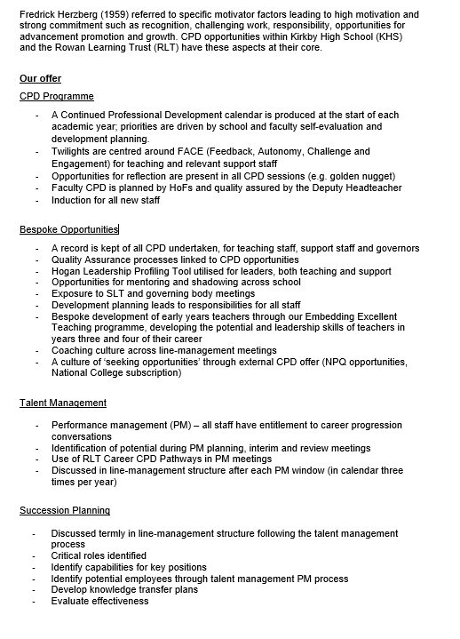
Continued Professional
Development Framework


Support for the school

• Be aware of and comply with policies and procedures relating to child protection, health, safety, security, confidentiality and data protection, reporting all concerns to an appropriate person
• Be aware of and support difference and ensure all pupils have equal access to opportunities to learn and develop
• Contribute to the overall ethos/work/aims of the school
• Appreciate and support the role of other professionals
• Attend and participate in relevant meetings as required
• Participate in training and other learning activities and performance management as required
• Other relevant duties as may be reasonably requested
Overall purpose of post
- Carry out the professional duties in line with the job profile
- Provide a full and comprehensive reprographics and design service to the school, its staff and students
- Produce professional documents for both internal and external use
- Support the aims and objectives of the school

Responsibilities:
- To manage the day-to-day reprographic and design service to staff and students, prioritising short, medium and long term tasks in line with the needs of the school
- To design, prepare and use specialist equipment / resources / materials.
- To provide a reprographics and design service to all staff within school in accordance with the timescales agreed
- To produce printed material for all departments, school publications, including reports, booklets, examination papers, leaflets, posters, signs, worksheets, etc. This list is indicative and not exhaustive.
- To finish copied items by trimming, binding or laminating
- To create and maintain a purposeful, orderly and productive working environment
- To maintain specialist equipment, checking for quality and safety in accordance with instructions, undertaking repairs/modifications within own capabilities and arrange for repairs / modifications by liaising with school IT technicians
- To ensure that the reprographics room is well organised and kept in a clean and tidy manner, ensuring that all Health and Safety Regulations are adhered to
- To prepare requisitions for new stock / supplies under the direction of the appropriate person as required. To manage systems for stock control, negotiating competitive prices of supplies and the ordering of those supplies.
- To organise the delivery and distribution of reprographic supplies throughout the site.
- To provide costing and charging details to departments as appropriate
- To proofread and edit text within designs to ensure clarity and accuracy.

Reprographics and Design Technician
Reports to: Senior Operations Manager
Location: Kirkby High School, Bracknell Avenue, Kirkby, L32 9PP
Salary: NJC Grade G, SCP 18-22
£30,559 - £32,654 pro rata (actual salary £27,032 - £28,886 per annum)

Hours: 36 hours per week - term time plus inset days and workback element

Please submit the enclosed application form and a supporting statement of no more than two sides of A4 outlining why you are interested in the opportunity and how your application addresses the requirements of the role.
Applications should be returned electronically to j.barrett@kirkbyhighschool.net
Alternatively, send a hard copy to:
Mrs A Dobson
Headteacher
Kirkby High School
Bracknell Avenue
L32 9PP

Closing date: 12 noon, Monday 15th September 2025

Desirable Criteria

- Relevant Level 3 qualification or equivalent experience
- Understanding Health and Safety issues relevant to the post.
- Experience of working in a school environment.
- Enjoy seeing jobs through to completion
- Have a positive attitude
- Have patience and determination
- Be able to work with and around staff and students in a school setting
- Be flexible
- Have an empathy with children
- Be approachable
- Have the ability to organise workload.
- Have the ability to work as a member of a team
- Excellent attendance and punctuality record.

The school will endeavour to make any necessary reasonable adjustments to the job and the working environment to enable access to employment opportunities for disabled job applicants or continued employment for any employee who develops a disabling condition.

Person Specification
Essential Criteria

- A commitment to safeguarding and equality
- GCSE grade 4 (C) or above (or equivalent) in English and Maths
- Competent in the use of Microsoft Office, Adobe and other relevant software applications
- A professional and mature approach that meets our expectations
- Methodical approach to tasks with a keen eye for detail
- Good understanding and ability to use relevant reprographics machinery and equipment
- Able to work on own initiative, prioritise and plan workload and meet deadlines
- Able to keep calm to work under pressure to meet deadlines
- Good communication skills both verbally and written
- Willingness to participate in development and training opportunities
- Ability to relate well to students, staff and external organisations
- Ability to work independently without direct supervision
- Understanding of the importance of confidentiality and an appreciation of the implications of the Data Protection Act
- Demonstrable experience in producing high-quality printed and digital materials to a professional standard.
- Strong understanding of layout, typography, colour theory, and visual hierarchy.
- Experience creating designs for various formats including posters, banners, leaflets, and online graphics.
- Ability to follow and apply brand guidelines accurately and to all designs.
- Excellent organisational and time-management skills; able to manage multiple design projects with varying deadlines.
- Ability to design clear, engaging materials for different audiences (e.g. students, parents, staff, visitors).
- Experience adapting designs to suit a range of formats, sizes, and purposes (e.g. A3 posters, roller banners, digital signage).
- Confidence working from scratch or from templates, depending on project needs.
- Competence in sourcing or creating appropriate imagery (e.g. icons, stock photos, illustrations) for designs while adhering to GDRP and copyright laws.
- Experience proofreading and editing text within designs to ensure clarity and accuracy.

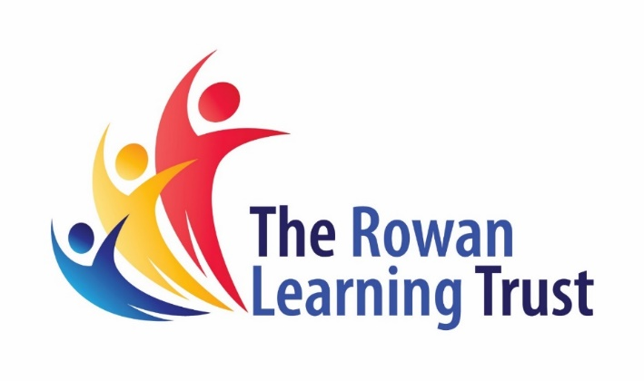
The Trust will make any necessary reasonable adjustments to the job and the working environment to enable access to employment opportunities for disabled job applicants or continued employment for any employee who develops a disabling condition.
All appointments are subject to satisfactory references, proof of qualifications and eligibility to work in the UK.
The Trust is committed to safeguarding and promoting the welfare of all children and young people and expects all staff to share this commitment. An enhanced DBS check will be required.

The Trust will make any necessary reasonable adjustments to the job and the working environment to enable access to employment opportunities for disabled job applicants or continued employment for any employee who develops a disabling condition.
All appointments are subject to satisfactory references and eligibility to work in the UK.
The Trust is committed to safeguarding and promoting the welfare of all children and young people and expects all staff to share this commitment. An enhanced DBS check will be required.


The Rowan Learning Trust
Registered Office: Carr Lane, Wigan, WN3 5NY
Company Number 8010464


KIRKBY HIGH SCHOOL

JOB APPLICATION FORM FOR SUPPORT STAFF IN SCHOOLS

The School and Governing Body are committed to equal opportunities in employment and welcome applications from all sections of the community.

BRACKNELL AVENUE,

KIRKBY, MERSEYSIDE, L32 9PP

TELEPHONE: 0151 477 8710

EMAIL: admin@kirkbyhighschool.net

- POST APPLIED FOR

Post Applied For:
School: | Kirkby High School
As advertised in: |  | On date:

2. PERSONAL DETAILS

SURNAME: |  | FORENAME:
TITLE:  (Optional) |  | Date of Birth:  (Optional)
Address:
POSTCODE: |  | Email:
Telephone No: |  | Mobile No:

3. CURRENT POST
CURRENT EMPLOYER AND JOB TITLE:
DATE OF APPOINTMENT: |  |  | SALARY:
NOTICE PERIOD:
MAIN DUTIES AND RESPONSIBILITIES
Reason for this application

4. EMPLOYMENT HISTORY
Post | Dates |  | Employer | Grade/Salary | Reason for Leaving
 | From | To

6. GENERAL EDUCATION
School | From | To | Qualifications – Grades, awarding bodies and dates

7. FURTHER AND HIGHER EDUCATION
Name of College/ University | From | To | Qualifications – Grades, awarding bodies & dates

8. ANY OTHER RELEVANT QUALIFICATIONS
Please give details of any other relevant qualifications you have for this post.

9. ADDITIONAL INFORMATION
- Are you related to, or a close friend of, any member of the Board of Trustees? If yes, please state relationship.
- Have you left any previous job for the reason of redundancy or are you in receipt of an occupational pension? YES/NO.
If yes, please give details, including dates, post held and employer.
- Have you ever been dismissed from any previous employment on the grounds of misconduct or incapability? YES/NO
If yes, please give details of dates and resources.
- Do you hold a current and valid driving licence? YES/NO
Please state category…………………………
- The Rowan Learning Trust is committed to providing equal opportunities and supporting all applicants. If you require any reasonable adjustments to allow you to participate in the application process, please let us know.
Do you require any reasonable adjustments? YES/NO
Do you have any unspent conditional cautions or convictions under the Rehabilitation of Offenders Act 1974? YES/NO

Do you have any adult cautions (simple or conditional) or spent convictions that are not protected as defined by the Rehabilitation of Offenders Act 1974 (Exceptions) Order 1975 (Amendment) (England and Wales) Order 2020? YES/NO

In line with Keeping Children Safe in Education, The Rowan Learning Trust will undertake general online searches for all shortlisted candidates which may include social media and video platforms. Online searches will only examine data which is publicly available, and the aim is to identify any incidents or issues. Any areas of concern will be discussed during the interview process.

9. STATEMENT IN SUPPORT OF APPLICATION
Please attach a supporting statement, indicating any matters which you feel may be relevant to this application. Please head additional documentation with your name and post applied for.

10. REFERENCES
Please state the names and addresses and telephone numbers of two persons from whom references may be obtained. One must be your current or most recent employer. In the absence of previous employment experience, a reference from your last place of full-time education will be a suitable alternative.
REFEREE 1 |  | REFEREE 2
TELEPHONE NO: |  | TELEPHONE NO:
EMAIL: |  | EMAIL:
Can this reference be taken up immediately  YES/NO |  | Can this reference be taken up immediately  YES/NO

11. FURTHER INFORMATION FOR CANDIDATES
- In the interests of the protection of children, all posts are subject to enhanced criminal record and other relevant disclosures through the Disclosure & Barring Service (DBS). A criminal record will not necessarily prevent you from obtaining a position.
- Please note that it is the policy of the Trust and the Governing Body to preclude employment of persons over the age of 65.
- You will receive no further communication unless selected for interview. If you have therefore not been contacted within three weeks of the closing date for applications, you should conclude that, unfortunately, you have been unsuccessful on this occasion.
- Under the Data Protection Act, the Trust and the Governing Body will use the information given for the purpose of recruitment and selection. Strict confidentiality will be observed and if you become an employee, the information will be used for personnel, pay and pensions administrative purposes only.

13. DECLARATION
To the best of my knowledge and belief all the particulars I have given are true. I understand that any false statements may disqualify me from employment or render me liable for dismissal. I also understand that no offer of employment made to me will be binding unless confirmed in writing.

I also understand that this post is subject to a satisfactory enhanced Disclosure & Barring Service Disclosure, to satisfactory medical clearance and the provision of documentary evidence (e.g. NI Number) that shows I am entitled to work in the U.K.

Signature:……………………………………………………………………………Date:…………………………………………………………

THANK YOU FOR YOUR INTEREST SHOWN IN THIS APPOINTMENT

