Rokesly Avenue
London
N8 8NH
Bola Soneye-Thomas
Head Teacher
Tel: 020 8348 0290
Fax: 020 8342 8410
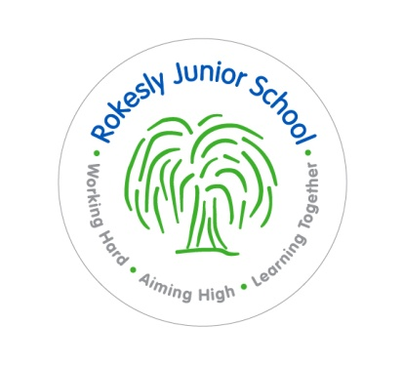
www.rokesly-jun.haringey.sch.uk

Are you an outstanding teacher looking for a new opportunity?

Teacher required for September 2022. ECTs welcome to apply

Rokesly Junior School is a supportive, dynamic and vibrant school providing children aged 7 to 11 with excellent education opportunities. Our vision is to create an environment that is purposeful, inclusive and engaging, a diverse community where children grow into resourceful, independent learners and develop a thirst for learning that will stay with them throughout their lives.

Our staff members share a collective aim to develop the whole child, ensuring that we lay the foundations for them to become responsible global citizens of the future. We aspire to create an atmosphere where individual strengths are nurtured so that they can achieve at an outstanding level.

Our staff at Rokesly are integral to working towards this vision. As a member of the Rokesly team, you will receive ongoing support and development in your role and have access to a range of enrichment opportunities.

We are looking for someone who:
- is an outstanding classroom practitioner;
- has good interpersonal skills;
- is a good team player;
- is creative and flexible;
- will be committed to the school and will contribute to all aspects of school life.

We can offer:
- a good school
- a friendly and supportive staff within a welcoming school environment;
- enthusiastic, well motivated and happy children who are keen to learn;
- strong governor and parental support;
- ongoing professional development.

Visits to the school by appointment are welcome. Please contact Shahnaz Hamid at the school to arrange an appointment.

Please download the application pack or contact Shahnaz Hamid at the school for a pack to be sent to you.

Closing date: 5pm Monday 23rd May 2022

Interviews will be on Wednesday 25th May 2022

Rokesly Junior School is committed to safeguarding and promoting the welfare of children and young people and expects all staff and volunteers to share this commitment.

