

Horizons Specialist  
Academy Trust  
Recruitment pack 2024

**CONTENTS**

|  |  |
| --- | --- |
| **Section** | **Page** |
| About Horizons Specialist Academy Trust | 2 |
| Why work for HSAT? | 4 |
| About the role | 8 |
| How to visit and apply | 9 |
|  |  |
|  |  |

**About Horizons Specialist Academy Trust**

Horizons Specialist Academy Trust (HSAT) is a specialist multi-academy trust,

underpinned by a single organisational and financial structure led by a Chief Executive.

The Trust comprises Abbey Hill Academy (including Abbey Hill Sixth Form), Archway Academy, Green Gates Academy, Hollis Academy, Mo Mowlam Academy, Westlands Academy and Woodlands Academy.

Together, these seven provisions support over 800 children and young people with a range of special educational needs.

Our vision of ‘*Providing Infinite opportunities, ensuring the best education for our children and young people* ‘ is a bold one - underpinned by the belief that we can *do more and do it better* at every level for our pupils, students and their families.

Our Trust champions the rights of students with special educational needs. We have 4 non-negotiable outcomes we must secure.

These 4 ***Vitals*** encompass:

• The ***Safety and Wellbeing*** of our vulnerable children and young people – thus

ensuring they are protected from harm and supported to keep themselves and

others safe.

• Educational ***Excellence*** at all levels, ensuring every child and young person

receives a high quality of education.

• Preparing ***for Adult Life*** by providing our children and young people with the

opportunities they need to become confident in their interaction with others and to

fully participate in society.

• An ***Effective MAT –*** maintaining a strong MAT infrastructure which supports

further development.

This will be achieved through improving the quality of expert teaching, providing a range of teaching and non-teaching professionals, and creating flexible pathways which expand student opportunities to experience success and progress to the next stage in their personal lifetime journey.

Partnership working ensures our students have access to bespoke experiences tailored to their individual needs and life skills.

We endeavour to work with other education and funding agencies to adapt and expand our buildings and equipment in order to better serve our student and parent community.

The shared core values of our Trust remain constant and relevant at all levels and our governance framework helps to drive excellence in all that we do.

*Horizons Specialist Academy Trust is committed to safeguarding and promoting the*

*welfare of children.*

**Our Academies**

      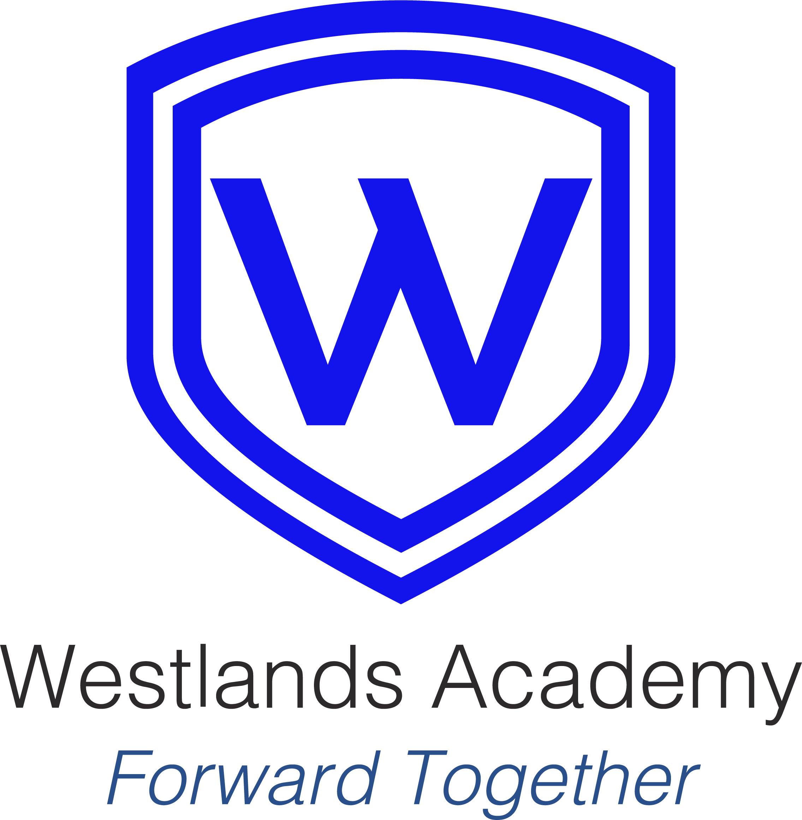



**Our Team**

Without exception, everyone is deeply committed to the very highest outcomes, regardless of their role, recognising the strength of collective contribution and effort.

**Leaders**

Academy leaders, driven by exceptional Principals, focus relentlessly on students and their outcomes. They are restless in their leadership, seeking better ways to improve in a culture of success. They do what it takes to make the difference to the lives of children and young people with SEN.

Central team leaders, motivated by an inspiring Chief Executive, lead high performing teams who add value to our academies by providing the environment in which others thrive. They unburden academy leaders, enabling them to keep a focus on the main thing- strong pupil outcomes.

Governance, for our academies and for the Trust, is robust, rigorous and proportionate, providing professional support and challenge so that leaders strive *to do more and do it better* with a sharp focus on successful outcomes for students with SEN.

Our leaders never allow the urgent to distract them from the important, navigating a clear route to long-term success.

**Teachers**

Our teachers are highly effective in the classroom, both in the uncompromising quality of their teaching and in the perceptive and individualised attention they give to students. They are passionate about the subjects they teach and dedicated to the children and young people in their care. Our teachers are carefully recruited and expertly supported to make sure they, like our students, are the very best they can be.

**Support Staff**

Our support staff are the backbone of our organisation and are specialists in their areas of responsibility. Like our teachers, they are well-trained and highly effective at ensuring the smooth operation of our Trust day in and day out.

**Why work for HSAT?**

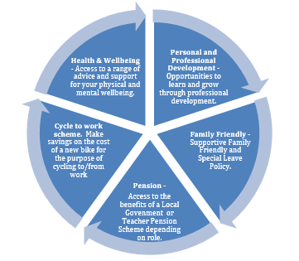

At HSAT, we want to be an employer of choice for employees and for that reason we are very proud to be recognised by *Investors in People* as a *Gold* organisation.

We believe that the children and young people in our care deserve the very best staff who are highly effective at what they do. We want our employees to take pride and satisfaction in their work. This means that one of our fundamental priorities is to ensure that all our employees feel valued, knowing that the role they fulfil is vital to transforming the life chances of our children and young people.

**Comprehensive Induction**

When joining HSAT, you will have access to a detailed induction programme which is designed to ensure you feel confident in your new role from your first day with us. This is led by our HR team in partnership with our Professional Learning Leads, and focuses on our culture, safeguarding, site orientation, key people and HSAT expectations, amongst other things. We know the importance of a great start for our children and young people when they join one of our academies, so we place just as much importance on the way new employees transition into HSAT.

**Tailored Training**

We believe in giving our children and young people the best daily deal. To this end, all of our employees have access to individualised performance development programmes and tailored training to ensure we continue *to do more and do it better.*

We work with respected training providers, as well as having our own team of in-house trainers, harnessing a blended training platform of virtual and face-to-face sessions.

**Tending the Team**

At HSAT, we recognise that working in schools is extremely rewarding, but we haven’t lost sight of the fact that it is often challenging and burdensome. All our employees have access to our HSAT wellbeing offer to promote positive mental and emotional wellness. This centres around a suite of staff provision such as bite-size online wellbeing training to help maintain work-life balance, free access to professional counselling and even a health and wellbeing week each half term, during which all meetings are cancelled. In short, we take care to care.

**HSAT Central Team**

As an employee at HSAT, you will benefit from our extensive and expert Central Team who are predominantly based at the Abbey Hill site. The Central Team deliver leadership, finance, estates, business operations, Safeguarding, HR and IT expertise to our academies with the intention of making it easier for others to do their job. Our Central Team work in partnership with our academy leaders to ensure that support is tailored to the needs of each academy.

Furthermore, we follow the School Teacher’s Pay and Conditions Document, the National Joint Council guidelines and recognise the continuity of service for all employees joining HSAT to ensure that our employees are looked after well compared with others in different settings.

**What do others say about HSAT?**

**Ofsted Summary Evaluation October 2022**

*“Trust leaders endeavour to provide pupils with ‘infinite opportunities’ as outlined in the trust’s vision. They speak with purpose about how all adults want the very best for each pupil.*

*Leaders and staff who have joined the trust recently describe high levels of satisfaction with the process. Staff received regular updates and were supported by the trust to understand clearly any new ways of working and the trust’s policies.*

*There are established, professional development opportunities available to teaching and support staff. Staff actively seek to improve their own practice. Trust leaders willingly support staff to do so. A range of staff across the trust have gained accreditation to support them in their role or gained practical experience which helps them to provide stronger support for pupils.*

*Staff support effectively those pupils who have a wide range of needs. Some pupils’ behaviour can be unpredictable. Staff are steadfast in their resolve to support each pupil as best they can. Staff have the pupil information they need and are trained well to deal with the situations that arise. Leaders provide swift and effective support for staff to manage pupils’ behaviour.*

*Trust leaders are outward facing. They strive to ensure all pupils receive the best education possible to help improve their attitudes to school and learning in general.*

*Safeguarding was judged to be effective in all inspections completed as part of stage one of this summary evaluation. The trust has appointed safeguarding leaders who are knowledgeable and have the skills and time to support staff and pupils’ safeguarding needs. Trust leaders with responsibility for safeguarding know pupils and their families well. They know who the most vulnerable pupils are. In addition, safeguarding leaders know their communities, the localities and the risks pupils may encounter in detail. They provide safeguarding training and regular updates for staff. Staff feel confident and have the skills to support pupils. They have the confidence and expertise to amend the safeguarding curriculum in each school further to ensure it meets the needs of each cohort, should emerging risks be identified”.*

**Investors in People November 2022**

*“Your people are hugely motivated by the fact that they are making a difference to young people’s lives and life opportunities…There was a lovely working atmosphere at your academies. It was great to arrive at some of your sites at 8.30am and see your staff logging in, full of enthusiasm.*

*People are very values-driven and a large proportion of people would challenge behaviours that sit outside the Trust values.*

*Relationships between Teachers and classroom support roles are mutually beneficial and supportive. How you work as a team is a strength, recognising when a team member needs to take a break and walk away from a situation. How you coach people to support each other in this way.*

*Your Academy model provides an instant network for schools that may have felt more isolated as part of a local authority. There’s a refreshing level of honesty and willingness to admit to mistakes. Due to the nature of the work, you all need to make judgement calls every day and react to situations. There was no sense of a blame culture at all. You drive change through your organisation in a meaningful way; it’s purposeful and it’s given time to ‘bed in’.*

*Your people engage with CPD and become sought-after experts, developing relationships with external partners that are mutually beneficial to the Trust.”*

**What do our staff say about HSAT?**

* 1. *“Everyone’s open to new ideas here. Everyone’s ideas are valuable”.*
  2. *“I just absolutely love it. I never go home thinking ‘thank god that day is over’. I am just so content with the job. Opportunities come up if I am interested. The people I work with are amazing.”*
  3. *“The training and career opportunities are really good. It was a small school before. I said I would like to progress my career and that’s happened.”*
  4. *“Professionalism and integrity; it feels like a professional organisation to work for.”*
  5. *“I love my job and feel very well supported. I couldn’t have asked for anything more as an employee. I am quite overwhelmed by the level of support.”*
  6. *“We make people feel welcome; new staff and supply teachers; they get the supportive culture immediately. People come on supply and like it, because of the way we are with each other. You don’t get the cliques here like you get in other schools. It comes from the top.”*
  7. *“I value the team. It’s a really supportive trust, I know people have got my back, there is a lot of responsibility in this role. Here, there is a collective responsibility that I didn’t have in my last job. The Trustees are good at recognising success. They’re challenging though. It’s about ‘How can we do more and do it better’?”*
  8. *“The staff and the support we give each other is what makes this a good place to work. It’s especially important in a SEMH setting. It can be quite wearing, but everyone empathises.”*
  9. *“The school itself-It’s the best place I have ever worked in. The leadership tea- I have never worked anywhere before where I wouldn’t jump if someone came in the classroom. Here, I don’t jump.”*
  10. *“There’s trust and integrity. They trust me to do my job and people are interested in what I am doing. People tell me I am good at my job.”*
  11. *“Seeing the kids happy and seeing them growing up, that’s what matters!”*

**How to Visit & Apply**

Please read the information in this pack. If you are interested in any of our job opportunities, please apply by downloading the application form from our website [www.horizonstrust.org.uk](http://www.horizonstrust.org.uk)

Completed application forms should be emailed to HSAT[HR@horizonstrust.org.uk](mailto:HR@horizonstrust.org.uk) or posted to:

HR Department

Horizons Specialist Academy Trust

Ketton Road

Stockton on Tees

TS19 8BU

If you have any questions about the vacancy or would like to visit Horizons Specialist Academy Trust or one of our Academies, please don’t hesitate to contact us by emailing HSAT[HR@horizonstrust.org.uk](mailto:HSATHR@horizonstrust.org.uk) or by calling 01642 677113 and asking to speak to a member of the HR team.

*\*Timeline may be subject to change*

|  |  |
| --- | --- |
| **Recruitment Timeline\*** | |
|  | Position advertised |
|  | Dates available for visits |
|  | Closing date for applications (noon) |
|  | Final shortlisting and contact with candidates  Reference will be requested at this stage |
|  | Final panel process |