Admin Assistant (Fixed term)
Friarage Community Primary School

Dear applicant,
Allow me to extend a warm welcome from all governors, staff and children of Friarage Community Primary School. I am delighted you have shown interest in joining us and I look forward to sharing with you what makes our school a very special place to work.
I am proud to be the Headteacher of an inclusive school, which provides a nurturing, safe and inspiring place of learning at the very heart of Scarborough town. At our very core, you will find teamwork and commitment, which makes our vision of ‘together we can’ a reality.
The school is unique; it serves a diverse community with 35 – 40% of its pupils having English as an additional language. The school is proud of how it supports all its pupils to learn and succeed.
You will find a real buzz about our school and a palpable sense of energy, excitement and a love of teaching and children. We are looking for a colleague who shares the same ethos and
values, understands our local context and can provide the inspired teaching our children thrive on and deserve!
This is an exciting time to join us. As part of the Coast and Vale Learning Trust we are working together to share, learn and create a primary hub our area can be proud of. Through our Trust we are able to access the support and resources from The Scarborough Teaching Alliance, which means as a staff member you have a wide range of colleagues, tools and resources to help you develop not just in the classroom but beyond.
I hope that you will take the time to come and see and experience for yourself the welcoming atmosphere and purposeful learning environment that makes our vision a reality.
Good luck with your application. I look forward to reading it.
Cheryl Cappleman
Headteacher

Dear applicant,
Coast and Vale Learning Trust is a growing family of schools based on the North Yorkshire Coast. We converted from our lead secondary school (Scalby School), welcomed Newby & Scalby Primary School in 2018 and in 2019 welcomed Friarage Community Primary as our first sponsored school. We welcomed Lady Lumley’s School in 2021, and our ambition is to continue to welcome new schools into our Trust where we can add capacity, resources, improvement and make sure all our young people have access to the very best education
We are growing organically and firmly building on the school improvement journeys of Scalby School, Newby & Scalby Primary and Friarage Primary. As a Trust we have added to our central team which includes our Chief Operating Officer, Trust Finance Services Manager and school improvement colleagues working within our lead schools.
Our Trust is currently based at Scalby School in Scarborough with both our founding secondary and primary schools being judged ‘good’ by Ofsted. Our success in making sure that our staff are our greatest resource, with ongoing investment into our teaching and support staff teams has placed us in a good position to meet current educational challenges.
Coast and Vale Learning Trust aims to improve education in the locality through establishing coherent and collaborative practice across schools and other educational institutions in the area.
In seeking to realise its mission statement and achieve its strategic objectives, the Coast and Vale Learning Trust board are committed to:
- The principle of meaningful educational partnership between primary and secondary schools.
- Expanding the number of schools in the MAT where this enhances the education of youngsters already under the care of the Trust and can realistically improve it in the joining school.
- Sustainable and measured growth as a Trust.
- Collaborative working with other stakeholders and institutions for the benefit of local youngsters whether they are in the Trust or not.
Choosing where to work and who to work for is one of the vitally important decisions in life. In choosing to work for Coast and Vale Learning Trust you are joining a team of colleagues dedicated to transforming the lives of 3000 children and young people. Our work is an important part of who we are, how we express ourselves, and working with young people is a tremendous privilege and at the same time a challenge and an adventure.
At Coast and Vale Learning Trust we believe that in order to transform young lives we need the highest quality staff who feel cared for and valued. Whether you are a teacher or receptionist, an IT technician or school leader, we want you to grow and develop in your role and to find your stay with the trust a fulfilling time in your working life.
Whenever you see the Coast and Vale logo you should spot the strapline “where learners and staff thrive.” Many organisations spend a great deal of time and effort in developing a strapline, yet at Coast and Vale we are more concerned about turning the strapline into reality. The word thrive indicates a place of healthy growth, plants thrive in the right environment and so we want to see our schools to be environments where learners (children as young at three up to young people aged eighteen) grow and develop and reach their potential. We also want to place the development of all our staff at the heart of what we do.
You will not be joining a single school, rather a family of schools that can thrive together, share resources and help each other through difficult times. We believe in ‘servant leadership’ where the principles of service underpin all we do. CEO
Coast and Vale Learning Trust structure
All the staff working for Coast and Vale are line managed by the leadership of one of our five schools or by leadership of the central team. The central team does not work in a specific school context, but for the whole trust.
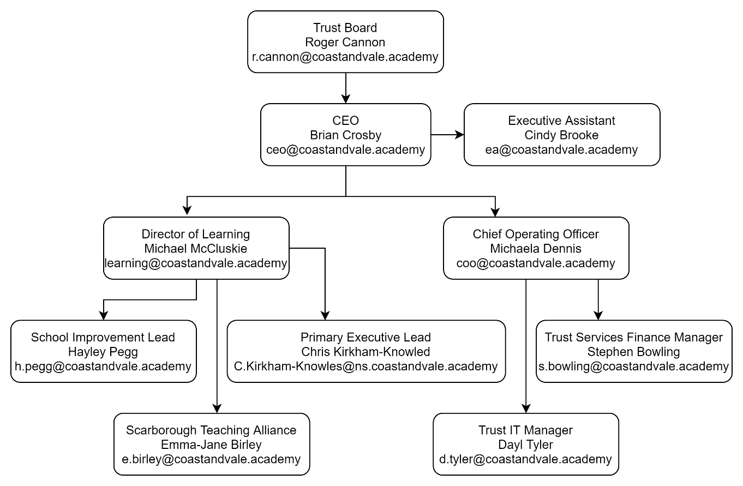

Our schools

Scalby School
Scalby School is a successful and popular 11-16 community school with approximately 1000 students currently on roll. In recent years it has become the school of choice in our local community. We were judged ‘good’ by Ofsted in 2019 and have repeatedly achieved results well above the national average over the last decade. Our P8 score in 2019 placed us in the top 20% of schools nationally again. We are proud of our broad and balanced GCSE based curriculum.
A ‘Good’ school in every area according to Ofsted in 2012 and in 2019. We are constantly looking at ways to improve our learning offer and are very ambitious improving the school further. Our aim is to provide a ‘Great’ education for the young people in our beautiful coastal community.
To learn more about us please visit - www.scalby.coastandvale.academy

Newby & Scalby Primary School
We are the school of choice in our community and we are within commutable distance of Whitby, Teesside, York and surrounding areas. Ofsted in 2018 judged us to be ‘good’ in all areas and as a school we are very much outward facing both in terms of teaching and learning, and in constantly thinking about how we can improve. As a result, our pupils achieve well. For example, in 2019, 84% of the year 6 cohort reached age related expectations in reading, writing and mathematics combined, compared to the national average of 65%.
Since our “good” Ofsted in 2018, we continue to build on our successes and we are a family and a team, where everyone is given the challenge and support to be the best they can possible be in a safe, welcoming and positive environment. Children and staff will work and play together developing skills so that we all become ambitious and reflective lifelong learners as well as being respectful and respected members of the community.
To learn more please visit - www.newbyandscalby.coastandvale.academy

Friarage School
Friarage School is a large Inclusive Primary School in the Castle Ward area of Scarborough; it has approximately 330 pupils on roll ranging from 3 to11yrs. 38% of its pupils have English as an additional language and 50% of its pupils are in receipt of pupil premium funding.
Our school motto is ‘Together we can’ and this team ethos is at the heart of everything we do. Children and staff work together, developing skills so that we all become ambitious and successful learners as well as being respectful and respected members of the community.
To learn more please visit - www.friarage.coastandvale.academy

Lady Lumley’s Secondary School
Lady Lumley’s is an 11-18, mixed comprehensive, community school of 900 students serving the town of Pickering, surrounding villages and warmly welcomes students from Scarborough to Rosedale. We strive to ‘Be our best’, working to improve the experience for all students, staff, and the community. Our broad and balanced curriculum is ambitious for all, and we place great value in academic qualifications alongside the arts and practical subjects. Set in an idyllic location, we make the most of fantastic sporting facilities and run an immensely popular Duke of Edinburgh experience alongside over 30 Enrichment clubs. Our students and staff are loyal to Lady Lumley’s and strive to improve our learning journey, whilst celebrating success.
To learn more please visit - www.ladylumleys.coastandvale.academy

Application Process
The closing date for all applications is: Wednesday 29th June 2022 at 4pm and Interviews will be held as soon as possible after the closing date.
Visits are warmly welcomed. Please contact Helen Poole, to arrange.
Completed applications must be returned to Helen Poole at helen.poole@northyorks.gov.uk
If you think you are the person for the job, please complete an application form, with either your supporting statement included or attached separately to the email address above by the closing date.
We are committed to safeguarding and promoting the welfare of children and young people and expects all staff and volunteers to share this commitment.
A copy of the Safeguarding Policy is available here:
www.friarage.coastandvale.academy/about-our-school/school-policies/
This post is exempt from the Rehabilitation of Offenders Act 1974 and the appointment is subject to a satisfactory enhanced level disclosure and S128 clearance from the Disclosure & Barring Service (DBS).

JOB DESCRIPTION

POST: | School Administrator
GRADE: | SCP 4-6
RESPONSIBLE TO: | Office Manager
STAFF MANAGED: | None
POST REF:
JOB PURPOSE: | To provide an administrative support service to the Headteacher and the school. The post holder is accountable for decision making, short term planning and dealing with unexpected problems within the school office. The post holder may be responsible for some basic finance duties depending on the size of the school.
JOB CONTEXT: | Works within the busy environment of the school office managing the administration for the school, providing an administrative, reprographics, budget monitoring and reception service, where excellent organisational skills are essential in order to handle the variety of tasks that need to be undertaken  This school is committed to safeguarding and promoting the welfare of our pupils and young people. We have a robust Child Protection Policy and all staff will receive training relevant to their role at induction and throughout employment at the School. We expect all staff and volunteers to share this commitment. This post is subject to a satisfactory enhanced Disclosure and Barring Service criminal records check for work with children.

ACCOUNTABILITIES / MAIN RESPONSIBILITIES
Operational Issues | - Provision of administrative, clerical and secretarial duties as required.  - Carry out research, analysis and evaluation of data to assist in the preparation of reports e.g, for the school’s Governing Body / Financial Management Committee.  - Take minutes at various meetings as required.  - Make arrangements for school lettings.  - Short term planning e.g. booking supply cover for absent teachers and keeping a record of work carried out.  - Administer basic first aid and contacting parents in the event of an accident or incident involving their child. Record accidents in accident book.  - Make appropriate decisions to problems/issues when they arise within the office.  - Report concerns and obtain support for any issues raised.  - Assist teaching and non-teaching staff with administrative queries
Communications | - Communicate effectively with other staff, Governors, visitors, contractors, pupils and their families/carers.  - Undertake reception service to the school, acting as the first point of in dealing with routine phone calls, taking messages and greeting visitors
Resource/People management | - Monitor stock levels, order office materials, equipment and services, negotiate on prices with suppliers and check incoming orders  - Assist in the induction of new employees  - Attend staff meetings and training days and management team meetings by agreement with the Headteacher  - Participate in the schools performance management scheme  - Highlight additional training and supervision needs to build on your skills and knowledge.  - Participate in training and other learning activities and performance development as required.
Safeguarding | - Know about data protection issues in the context of your role.  - Maintain confidentiality as appropriate.  - Be responsible for promoting and safeguarding the welfare of children and young people that you are responsible for and come into contact with, by knowing who to report your concerns to  - Have an awareness and basic knowledge where appropriate of the most recent legislation.
Systems and Information | - Be aware that different types of information exist (for example, confidential information, personal data and sensitive personal data), and appreciate the implications of those differences.  - Share information appropriately – in writing, by telephone, electronically and in person.  - Maintain and update accurate computerised and manual records as required
Data Protection | - To comply with the County Council’s policies and supporting documentation in relation to Information Governance this includes Data Protection, Information Security and Confidentiality.
Health and Safety | - Be aware of and implement your health & safety responsibilities as an employee and where appropriate any additional specialist or managerial health & safety responsibilities as defined in the Health & Safety policy and procedure.

PERSON SPECIFICATION – Admin Assistant
Essential upon appointment | Desirable on appointment
Knowledge
- Knowledge of administration and office systems
Experience  - Clerical or administrative experience  - Experience of working with Microsoft Office | - Cash handling experience  - Supervisory experience
Occupational Skills  - Computer literate  - Good written and verbal communication skills  - Good numeracy and literacy skills  - Judgemental skills  - Problem solving skills  - Analytical skills | - Budget management skills
Qualifications  - Literacy and Numeracy Qualification e.g. Level 2 qualification or equivalent | - Appropriate first aid training  - CLAIT Plus, ECDL or Level 2 Word Processing
Personal Qualities
- Attention to detail, neatness and accuracy
- Organisational skills
- Ability to work successfully in a team
- Confidentiality
- Ability to work to deadlines and prioritise own workload
Other Requirements
- To be committed to the school’s policy and ethos.
- To be committed to Continual Professional Development.
- Motivation to work with children and young people.
- Ability to form and maintain appropriate relationships and personal boundaries with children and young people.
- Enhanced DBS clearance required

