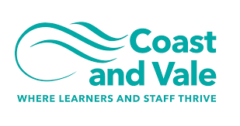

Being the best we can be

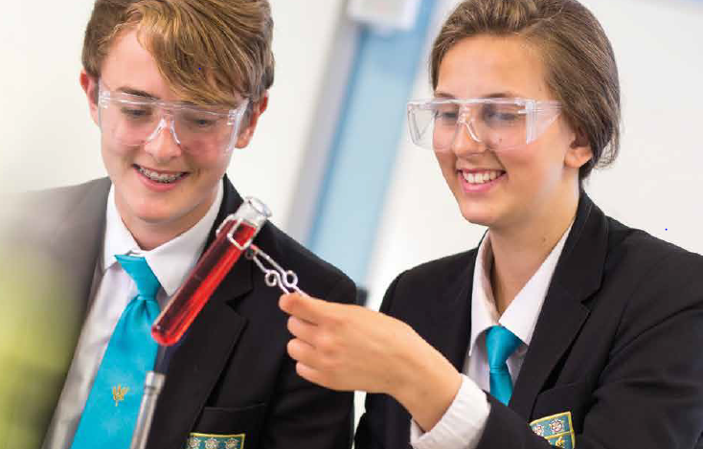

School Administrator
Closing Date Monday 27th June 2022, 9am
Recruitment Information Pack
Scalby School
Fieldstead Crescent, Scarborough, YO12 6TH

Contents

Welcome from the Headteacher 3
Our results 4
Our schools 5-6
Application process and how to apply 7
Job Description/Person Specification 8-10

Dear applicant,

Allow me to extend a warm welcome from all governors, staff and students of Scalby School.

I was delighted to be appointed Head of School and while any Head will say their school is special – I truly believe Scalby is.

It is hard to encapsulate in words the full dynamism and vibrancy of our school. We are hugely proud of our students and privileged to serve them and this community. We see it as our professional and moral duty to prepare them as individuals to play their part as 21st century citizens – rounded and centred and aware of all they might contribute to the world. In practical terms, this commitment is manifested in the lessons we deliver, the extra-curricular opportunities we offer and in the wider opportunities we promote.
Scalby is a school with a strong academic tradition but we are equally committed to the Arts, to sport and to collective and individual achievement beyond the classroom. Our annual productions held at the Stephen Joseph theatre are testament to this, and over the years we have seen productions of Macbeth, Romeo and Juliet, Our House to name but a few.
We have developed and benefited from our partnerships within Coast and Vale Learning Trust, Scarborough Teaching Alliance and local secondary and primaries – a few reasons to join us!

In recent years enormous strides have been made to further increase learning standards. This hard work has seen results improve consistently and led to Ofsted rating our school as ‘Good’ in 2012 and in 2019. I truly believe we are a school with highly effective teachers and support staff producing outstanding outcomes for our students.

I hope you can see that this is an excellent time to join Scalby. If successful you will join a staff team of wonderful professionals who have ambition for our students and for themselves. I take pride in ensuring colleagues receive opportunities to develop their skills and experiences – and we have an enviable reputation for delivering high quality professional development.

I hope that you will take the time to come and see and experience for yourself the warm and welcoming atmosphere which makes our vision a reality.

Good luck with your application.

Chris Robertson
Head of School

Our results
Scalby School’s last set of externally examined GCSE results in 2019 were characterised by high levels of achievement. We have worked hard during COVID to ensure students have also achieved in line with these results in 2020 and 2021 when TAGs were awarded.

Our students consistently make significantly better progress than their peers did nationally. Results in English, Maths and Science are above the national averages at Grade 4 and Grade 5, with 36% of students achieving a Grade 7 or better in English, 28% achieving Grade 7 or better in Maths and 21% achieving Grade 7 or better in two sciences.

Recent results are particularly pleasing because of the high number of students who achieved Grade 8 and 9 across a number of subjects.

None of these fantastic results would have been possible were it not for the professionalism and dedication of our teachers and learning support teams. These results mean that our students leave us now being able to access a wide range of post-16 courses at college and they have the skills and knowledge valued by employers.”

Our success in our GCSE results follows our positive Ofsted inspection in February 2019. We are delighted that the high quality of education on offer has been doubly validated at a national level.

Our schools

Newby and Scalby Primary School

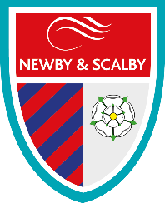
We are one of the schools of choice in our community and we are within commutable distance of Whitby, Teeside, York and surrounding areas. Ofsted in 2018 judged us to be ‘good’ in all areas and as a school we are very much outward facing both in terms of teaching and learning and in constantly thinking about how we can improve.
Since our “good” Ofsted, we continue to build on our successes and we are a family and a team, where everyone is given the challenge and support to be the best they can possible be in a safe, welcoming and positive environment. Children and staff will work and play together developing skills so that we all become ambitious and reflective lifelong learners as well as being respectful and respected members of the community.
To learn more about us please visit us at:
Newby and Scalby Primary School - Home (coastandvale.academy)

Friarage Primary School
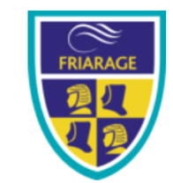
We are proud to serve the communities around the Castle Ward area of Scarborough as ‘Together we can’ make a real difference to the life chances of children and young people in Scarborough.

Children and staff will work and play together developing skills so that we all become ambitious and reflective lifelong learners as well as being respectful and respected members of the community.
We are committed to Restorative Practice Principles to nurture respect for all in our school community.

To learn more about us please visit us at: Friarage Community Primary School - Home (coastandvale.academy)

Scalby School
Scalby School is a successful and popular 11-16 community school and in recent years we have become the school of choice in our local community. We were judged ‘good’ by Ofsted in 2019 and in 2019 we celebrated sustained results. Our P8 score placed us in the top 20% of schools nationally. We are proud of our broad and balanced GCSE based curriculum.
To learn more about us please visit us at: Scalby School - Home (coastandvale.academy)

Lady Lumley’s School
Lady Lumley’s School (11-18) in Pickering is on a transformational journey. We are a school that is popular with parents and is easily accessible across North Yorkshire, East Riding and Wolds and Vale. The communities we serve around the Pickering, Ryedale and wider Coastal area deserve and need our school to play a leading role in terms of teaching, learning, progress and outcomes.

In April 2020 we welcomed our new Headteacher Clair Foden who joined us at the same time we joined our Trust - Coast and Vale Learning Trust. Lady Lumley’s is on an ambitious journey of school improvement.

To learn more about us please visit us at Lady Lumley's School - Home (coastandvale.academy)

Scarborough University Technical College

Scarborough UTC is a growing University Technical College (year 9 to year 13) based in a new building, with fantastic technical facilities in the centre of Scarborough. As a University Technical College, we offer a high quality academic and technical education for our students through the specialisms of engineering, health and cyber security. Our unique approach provides students with an excellent range of opportunities including Combined Cadet Force (CCF Navy), strong links to our industrial partners, project-based learning and our flagship Career Development Programme for our Sixth Form students.

Our work with employers and universities ensure we are able to deliver an innovative blend of technical, practical and academic learning which ensures our students make good progress and go on to outstanding destinations.

Our staff are our greatest resource and we have invested in both our teaching and support staff teams which has ensured that educational standards have improved significantly. We have built a staff team of key support and teaching practitioners who are proud to work at our University Technical College.

To learn more about us please visit us at: https://www.scarboroughutc.co.uk

Application Process
The closing date for all applications is Monday 27th June 2022, 9am

Interviews will be held as soon as possible after the closing date

Completed applications must be returned to Helen Poole at helen.poole@northyorks.gov.uk

If you think you’re the person for the job, please complete the enclosed application form and send to the email address above by the closing date.

An email will be sent to shortlisted candidates with details of the interview process. If you have not heard from us within a week of the closing date please assume your application has been unsuccessful.

Queries
Please contact Helen Poole at helen.poole@northyorks.gov.uk on 07890055186.

JOB DESCRIPTION

POST: School Administrator
GRADE: C (SCP 2-4)
RESPONSIBLE TO: PA to the SLT
STAFF MANAGED: None
JOB PURPOSE: | To provide an administrative and reprographic support service to  the school to ensure the smooth running of the school office on a  daily basis.
JOB CONTEXT: | Works within the busy environment of the school office  contributing to the administration for the school, providing an  administrative, reprographics, cash handling and reception  service, where excellent organisational skills are essential to cope  with the demands of having to deal with a variety of tasks.  Enhanced DBS clearance required
ACCOUNTABILITIES / MAIN RESPONSIBILITIES
Operational Issues | - File, sort and index paperwork, including incoming and outgoing post, transmit documents and photocopy.  - Compile standard letters, documents, orders and lists as directed by the PA to SLT.  - Undertake simple finance tasks e.g. collect and bank dinner/school trip money (cash/cheques) and recording money received on the appropriate system  - Maintain and update all necessary records and software using manual and computerised systems and check entries.  - Maintain a diary of appointments, room bookings and activities as required  - Redirect customers to other staff for specialist support as appropriate  - Ensure adequate checks are in place for visitors to the school, in line with processes  - Provide a reprographics service to the school, in a timely manner
Communications | - Undertake reception duties; act as first point of contact in response to telephone and face to face enquiries.  - Communicate effectively with other staff, visitors, pupils and their families/carers.  - Attend staff meetings and training days by agreement with the PA to the SLT
Resource management | - Participate in the schools performance management scheme.  - Monitor stationery stock levels, place orders as appropriate and check incoming orders.  - Participate in training and other learning activities and performance development as required  - Highlight additional training and supervision needed to build on your skills and knowledge.
Safeguarding | - Know about data protection issues in the context of your role.  - Maintain confidentiality as appropriate  - Be responsible for promoting and safeguarding the welfare of children and young people that you are responsible for and come into contact with.
Systems and Information | - Maintain and update all necessary records using manual and computerised systems and check entries.  - Be aware that different types of information exist (for example, confidential information, personal data and sensitive personal data), and appreciate the implications of those differences.  - Share information appropriately – in writing, by telephone, electronically and in person.
Data Protection | - To comply with the Trust’s policies and supporting documentation in relation to Information Governance this includes Data Protection, Information Security and Confidentiality.
Health and Safety | - Be aware of and implement your health & safety responsibilities as an employee and where appropriate any additional specialist or managerial health & safety responsibilities as defined in the Health & Safety policy and procedure.
Equalities | - We aim to make sure that services are provided fairly to all sections of our community, and that all our existing and future employees have equal opportunities.  - Ensure services are delivered in accordance with the aims of the equality Policy Statement.  - Develop own understanding of equality issues.
Flexibility | - The Trust provides front line services, which recognises the need to respond flexibly to changing demands and circumstances. Whilst this job outline provides a summary of the post, this may need to be adapted or adjusted to meet changing circumstances. Such changes would be commensurate with the grading of the post and would be subject to consultation. All staff are required to comply with Trust Policies and Procedures.
Customer Service | - The Trust requires a commitment to equity of access and outcomes, this will include due regard to equality, diversity, dignity, respect and human rights and working with others to keep vulnerable people safe from abuse and mistreatment.  - The Trust requires that staff offer the best level of service to their customers and behave in a way that gives them confidence. Customers will be treated as individuals, with respect for their diversity, culture and values.  - Understand your own role and its limits, and the importance of providing care or support.
Date of Issue: | - January 2022

Person Specification

Essential upon appointment | Desirable on appointment (if not attained, development may be provided for successful candidate)
Knowledge
- Some knowledge of administration and office systems
Experience
- Some clerical or administrative experience | - Cash handling experience
Occupational Skills
- Computer literate  - Interpersonal and communication skills  - Numeracy and literacy skills  - Judgemental skills | - Experience of Microsoft Office  - SIMS (School’s Management System)  - Experience of Telephone Systems
Qualifications
- Good GCSEs including Maths & English or equivalent | - Level 3 in Office Administration
Personal Qualities
- Attention to detail, neatness and accuracy
- Organisational skills
- Ability to work successfully in a team
- Confidentiality
Other Requirements
- To be committed to the school’s
- policy and ethos.
- Ability to form and maintain
appropriate relationships and
personal boundaries with children
and young people.
- Enhanced DBS clearance required
Equal Opportunities
- To assist in ensuring that Trust’s
equalities policies are considered within the school’s working practices in terms of both employment and service delivery.

