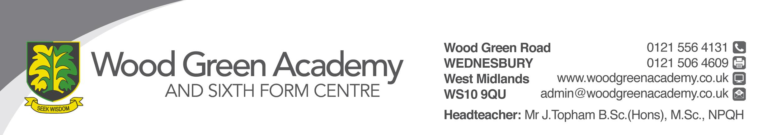
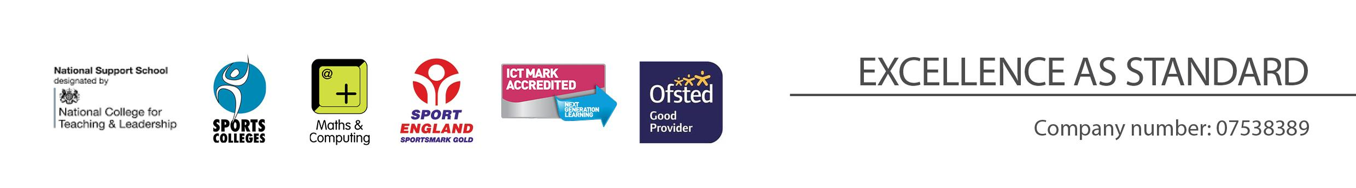
SCHOOL ATTENDANCE MANAGER
Person Specification

REQUIREMENT | ESSENTIAL | DESIRABLE
LEGAL REQUIREMENTS | Enhanced DBS Clearance  Unreserved endorsement of your suitability to work with children
QUALIFICATIONS  Principally assessed through letter and application form | Secondary Education  Minimum of Level 2 (GCSE Grade C+) qualifications in 5 subjects including English.  Full UK Driving Licence | Level 3 qualifications  “First Aid at Work” certificate  EH Training  Counselling Level 2  Child Protection level 1
EXPERIENCE, KNOWLEGDE and PROFESSIONAL COMPETENCE  Principally assessed through letter, application form and lesson observation | Excellent organisational skills together with the ability to meet deadlines.  Excellent Interpersonal Skills  Experience of working with young people aged 11-18  Experience of working with confidential data.  Confident ICT skills | Ability to use Microsoft Office packages, with the ability to adapt readily to new software  Knowledge of Class charts/SIMS
COMMUNICATIONS  Principally assessed through letter and interview process | Have excellent written and verbal communication skills
PERSONAL ATTRIBUTES  Principally assessed through references, letter and interview process | To be committed to safeguarding and promoting the welfare of children and young people  Interpersonal skills that equip the appointee to relate effectively to members of staff, students and parents  Ability to work under pressure, accurately and meet deadlines  Ability to prioritise  Ability to manage a range of priorities and prioritise responses  Flexibility and willingness to be involved in the school  Committed to continuing to learn through professional development  Helpful telephone manner  Good record of attendance and punctuality  Be an effective role model through presentation and personal conduct  Enthusiasm, energy, vigour, reliability and integrity

