
Eldene Nursery & Primary School!

We are an inclusive school based in the heart of the Eldene Community.
We invest in your career development and wellbeing – we want you to do well here.
Post: School Business Manager
Applications: by 12pm on Tuesday 3rd November 2026
Shortlisting: Tuesday 3rd November 2026
Interviews: w/b 9th November 2026
Salary: Q Midpoint-Top £44,611- £50,074
Eldene Nursery and Primary School is seeking an exceptional School Business Manager (SBM) to join our team. This is an exciting opportunity to contribute to shaping the future of our school at a time of change and development.
We are seeking a highly skilled and experienced School Business Manager to work as part of a new Senior Leadership Team (SLT). This is a strategic, non-teaching leadership position, working closely with the Headteacher and other SLT members to shape the future direction of the school. The SBM will lead on finance, HR, premises and operational strategy, ensuring the school runs efficiently and sustainably. You will ensure that resources are managed efficiently, ethically and sustainably - enabling the very best outcomes for our children.
The successful candidate will demonstrate commitment, drive, flexibility, vision and ambition to support the school in its future development. This is a perfect opportunity to develop your career.
The successful candidate will:
• Ensure resources, systems and learning environments directly support pupil achievement, safety and wellbeing.
• Lead, develop and inspire support staff - ensuring wellbeing and professional growth are prioritised.
• Provide strong financial and operational leadership, delivering value for money, sustainability and innovation.
• Strengthen parental, governor and community partnerships, maximising opportunities and raising the profile of the school.

We are looking to appoint someone who has
• a relevant professional qualification or degree level academic achievement;
• proven experience in financial, facilities and resource management
• excellent problem-solving and leadership skills, as well as being highly organised and good at prioritising
• experience of Human Resources management and excellent people skills
• significant experience of School Finance, Payroll and MIS systems
• excellent understanding of safeguarding and inclusion

What we can offer:
We have great facilities: Extensive well-maintained outdoor areas – including a woodland, playgrounds with 2 trim trails that support physical development and wellbeing, as well as large playing fields for sporting events. A refurbished well-stocked school library, 2 large halls and ELSA/nurture spaces and rooms. Also, a free large car park onsite.
We prioritise wellbeing with a dedicated wellbeing team: The wellbeing of staff at Eldene is paramount to maintaining a successful and forward-thinking school. We believe that the best asset in school for children are staff who are happy, motivated and focused. Eldene recognises that staff are our most important resource and are to be valued, supported and encouraged to develop personally and professionally. We have a Wellbeing Team who champion staff mental health and togetherness. We promote staff events where we can mix, relax and support each other. From Wellbeing breakfasts to drop-in sessions - we've got it covered!
We celebrate Diversity, Equity & Inclusivity: Eldene is proud to be a richly diverse community where equity, inclusion and belonging are at the heart of everything we do. We celebrate the different cultures, languages, faiths and experiences of our families - this diversity is a strength that enriches learning for all. Our curriculum reflects the world our children live in, ensuring every child can see themselves represented and valued, while our inclusive practices support all learners to thrive. We are committed to fair opportunities, high expectations and mutual respect. We actively promote a culture where every voice is heard and everyone feels safe, welcomed and empowered to succeed.


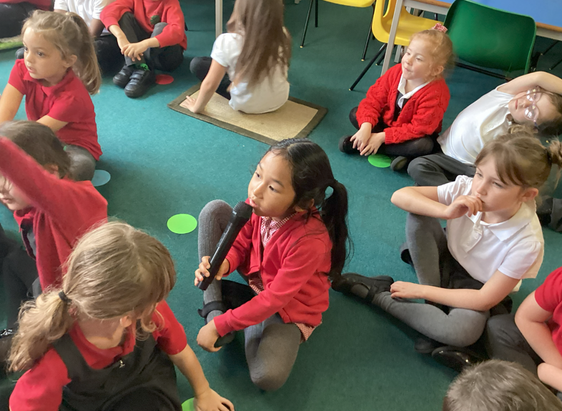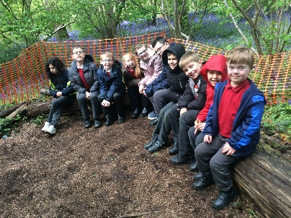


It’s worth looking at our website: Eldene Nursery & Primary School - Home

We look forward to welcoming you to Eldene!
Clare Pellew


Headteacher

Visits to the school are welcomed – please contact us on 01793 525908 or email admin@eldene.swindon.sch.uk
Application forms and job descriptions are also available from Eldene’s website Eldene Nursery & Primary School - Vacancies
As part of our commitment to safeguarding and promoting the welfare of children and young people, all employees employed within schools are required to undergo an enhanced DBS check. The post holder will be expected to carry out all duties in the context of and in compliance with the schools Equal Opportunities Policies.

The school reserves the right to close this vacancy early and appoint a suitable candidate prior to the closing date. Therefore, early applications are encouraged.

Appointments will be made subject to satisfactory references.

