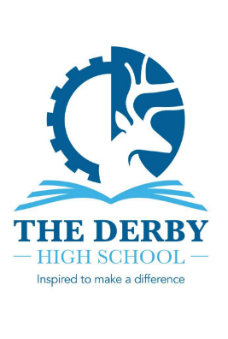

Dear applicant,
I would like to thank you for your interest in the role of School Business Manager at The Derby High School.
At The Derby High School we ‘Inspire to Make a Difference’. We have high ambitions for all our students. We are passionate about improving life chances and are committed to providing an outstanding education. We want each and every one of our students to achieve exceptionally well and succeed in life.
The school is an oversubscribed 11-16 Co-Educational Comprehensive (approx. 950 students on roll). We are situated in the Northwest of England in the heart of Bury, Greater Manchester and have good transport links to the city and neighbouring towns The intake of the school is truly comprehensive with students from a wide range of backgrounds. We have a strong and committed staff; 59 teachers (54 full-time and 5 part-time) and 53 support staff (46 full-time and 7 part-time). Our current budget allocation is £7.9 million with £360K to support Pupil Premium students (40% identified as disadvantaged). The School Business Manager plays a key role in ensuring this money is effectively deployed.
We have a school community ethos that unites us in common values. We celebrate our diverse intake putting equality at the heart of all we do. Our most recent Ofsted inspection in 2023 confirmed we continue to be a ‘Good School’ recognising our high expectations and the impact of strong leadership at all levels.
The Derby High School, built in 1959, is an iconic building within the town with its distinctive look and extensive playing fields. Over recent years there have been several unique additions to the school, and these have enhanced our curriculum offer: a bespoke Performing Arts building, INSPIRE, three state of the art science laboratories, DISCOVER and a multimillion-pound Sports Hall, EXCEL. In 2018 we built a STEAM Garden, a cross-curricular outdoor learning space, designed by our students for the school and wider community. Two years ago, we opened CREATE, a purpose-built Design & Technology block that enables our students to develop skills working with various materials, Food and Nutrition, Engineering and CADCAM. Reflecting our commitment to providing an outstanding education for our most vulnerable students we have also renovated an area of the school to house INCLUDE, a bespoke base for our SEND students. We have more projects that are in the planning stage to bring further opportunities for our students and the wider community.
We offer a huge range of external excursions for all curriculum areas, including to local colleges and universities, challenging stereotypes, raising aspirations and engendering a sense of awe and wonder from the world around us. Our curriculum is dynamic, challenging and engaging, enabling our students to excel in all areas.
There is a strong commitment to developing independent learners with the skills and experiences to thrive in a modern world. Through extensive opportunities to develop leadership skills we are preparing our students to become tomorrow’s leaders. We are a school where all matter and our pastoral care ensures our students feel safe and happy. We believe that enabling our students to flourish and reach their true potential is what drives our staff. Students at The Derby High School achieve outstanding progress, and we have been the highest performing school within the Local Authority since 2018. We are driven by strong moral values that puts students at the centre of all we do and so we are particularly proud of the positive progress of our Pupil Premium students. This commitment to excellence will be unceasing. We want to make a difference to the lives of the young people we serve.
At The Derby High School we value all our staff and their well-being. We place a huge emphasis on professional development and provide opportunities for staff to lead, collaborate and take part in action research. Staff are overwhelmingly proud to work at the school.
In recent years, despite challenges faced through the pandemic and school funding, our business practice, school organisation and school building has improved at pace with updated technology, greater efficiency in our work and a more inspiring learning environment.
I firmly believe though that The Derby High School has the capacity to further improve with the potential to develop as a leading proponent of forward-looking education. This view is shared by Governors and the leadership team. The new School Business Manager is crucial to delivering on our ambitions. In addition to your knowledge of financial management/human resources, I am seeking someone with strong interpersonal skills who would thrive in the school environment and possesses a desire and talent to innovate. They should bring an energy, enthusiasm and flexibility to the role and the ability to bring others with them.
Opportunities to visit the school in advance of your application are welcomed. To arrange this please contact Mrs Sandra Silgram-Clynes, the Headteacher’s PA at headteacherspa@thederbyhighschool.co.uk or via the school number 0161 764 1819.
To apply for this post, please download and complete the application form and provide a letter of application outlining how you meet the criteria detailed in the application pack. Application forms and the application letter should be emailed to the Headteacher’s PA at headteacherspa@thederbyhighschool.co.uk. You are reminded that the closing date for applications is Monday 20th April at 9.00 am
The Derby High School is committed to safeguarding and promoting the welfare of young people and expects all staff to share this commitment. The successful candidate will be subject to satisfactory enhanced DBS clearance and all pre-employment checks including references.
I hope that having read all the necessary information about our school, you are excited about applying for this position. I look forward to receiving your completed application and reading what you have to offer The Derby High School.
Good luck.
Warm regards,
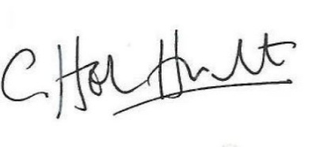
MS C HELEN HUBERT
Headteacher

