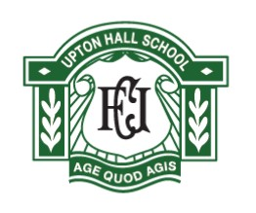

SCHOOL LIBRARIAN

The minimum level of experience and skills are outlined below as essential. Applicants that can offer any of the desirable indicators in addition to the minimum requirement will be at an advantage. It is unlikely that candidates unable to demonstrate the essential criteria will be selected for short-listing.

Qualifications | Essential | Desirable | Stage Identified
Educated to A Level standard |  |  | AR
Good Honours Degree |  |  | AR
Qualifications in Library management or equivalent |  |  | AR

Experience
Experience working in schools |  |  | AIR
Experience working with young people |  |  | AR
Experience in library, publishing or bookselling work |  |  | AR
Experience of management |  |  | AR

Knowledge & Skills
Meticulous and precise in their work of ordering, recording and caring for books |  |  | AIR
Friendly and customer-oriented for the outward-facing parts of their job. |  |  | IR
Up-to-date both in digital and print publishing |  |  | IR
Expert in resource and information provision and management |  |  | IR
Excellent communication skills |  |  | AIR
Excellent ICT skills and aware of current and emerging technologies |  |  | IR
Knowledge of how to encourage students at the school to read and the key organisations and events which promote this |  |  | AI
Well-read and with an enthusiasm for reading that is contagious |  |  | AI
Knowledge of the secondary school curriculum and appropriate study habits

Special Requirements
Good inter-personal skills |  |  | AIR
The ability to manage time demands and ensure deadlines and priorities are met |  |  | AIR
A commitment to offering a rich variety of extra curricular activities |  |  | AIR
A willingness to contribute to the school ethos |  |  | AI
Enhanced DBS check |  |  | AI
KEY : A = APPLICATION, I = INTERVIEW, R= REFERENCE

