

**School Meals Supervisory Assistant**

**Salary:** Grade B point 3 – pro rata

**Required From:** 1st September 2025

**Hours:** 6 hrs per week (Term Time)

**Contract:** Permanent

The Governors of St James CE Primary School invite applications for the above post from suitably qualified or experienced people who enjoy working with children. The person appointed will work for 6 hours/week (Monday to Friday) and will provide supervisory support in the dining hall and playground. The person appointed must be happy with working with pupils aged 4- 11 years old.

To fulfil this very rewarding and valuable role you will need:

* Experience of supporting young children
* Patience, resilience and an ability to nurture;
* A calm, organised and flexible approach to team working;
* An ability to build positive relationships.

In return we can offer a school with:

* Well behaved, friendly and motivated children who love to learn;
* A friendly and skilled staff;
* Commitment to the professional development of staff;
* A welcoming, caring atmosphere where everyone is valued.

Application packs are available from the Greater Jobs website and completed applications should be returned to Mrs Kirsty Diggle (Finance/HR Officer) at Archbishop Temple Trust.

Email: digglek@archbishoptempletrust.co.uk

Closing date: Wednesday 9th July 2025 at 12pm (Midday)

Observations/Interviews: Monday 14th July 2025 – please note this date cannot be changed

*This school is committed to safeguarding and promoting the welfare of children and young people and expects all staff and volunteers to share this commitment. Successful candidates will be subject to an Enhanced Disclosure by the Disclosure and Barring service.*

Visits to the school are welcomed. Please contact Kirsty Diggle, digglek@archbishoptempletrust.co.uk



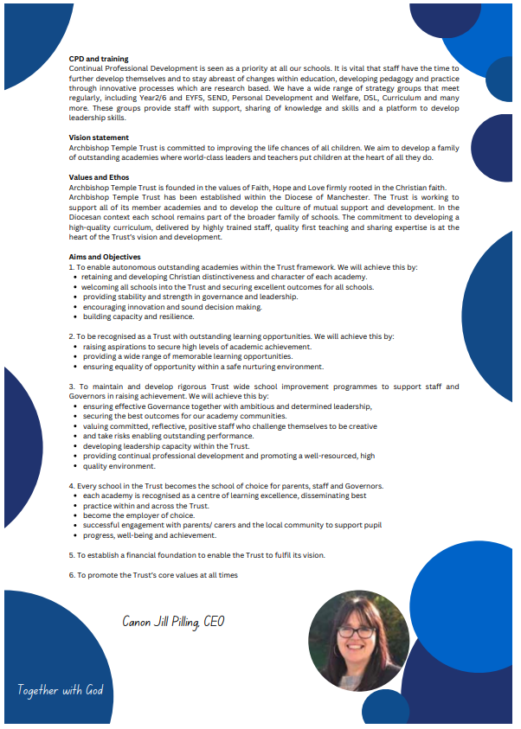

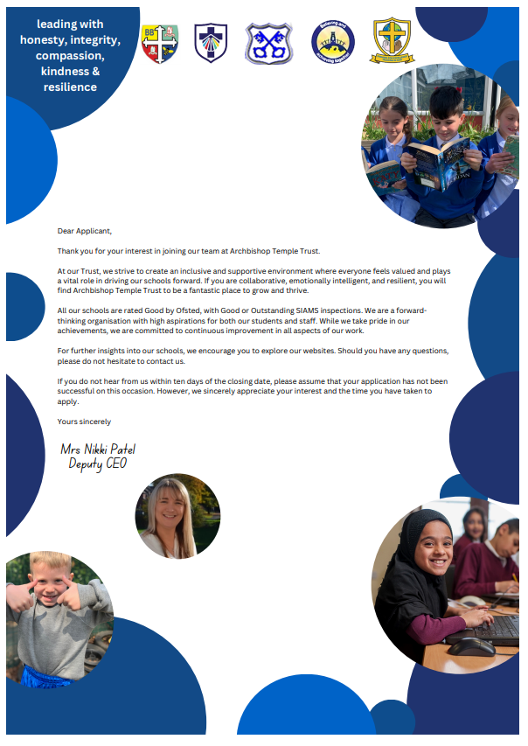



**JOB DESCRIPTION**

|  |  |
| --- | --- |
| **Department** | CHILDREN’S SERVICES |
| **Job Title** | School meals supervisory assistant |
| **Grade** | njc gRADe B POINT 3 |
| **Primary Purpose of the Job** | Supervision of children on school premises throughout the mid-day break. |
| **Responsible to** | Head Teacher |
| **Responsible for** | N/A |
| **Principal Responsibilities** | The supervision of children throughout the mid-day break. This includes all children on the school premises except those engaged in activities supervised by a teacher. |

|  |  |
| --- | --- |
| **MAIN DUTIES** | |
|  | Duties will be allocated by the Principal but will include the following:   1. Supervision of all areas both inside and outside where the pupils congregate during lunchtime. 2. Supervision of queues waiting to enter the dining room. 3. Ensuring that all pupils return to the classroom. 4. Leaving the dining room in a tidy condition. 5. Any other appropriate duties commensurate with the grade of the post which may be required from time to time. |
|  |  |

**Date job description prepared/updated** October 2020

**Job description prepared by** J Warburton/L Belfield



**PERSON SPECIFICATION**

|  |  |  |  |
| --- | --- | --- | --- |
| **Department** | | Children’s services | |
| **Job Title**  **Grade** | | SCHOOL MEALS SUPERVISORY ASSISTANT  B POINT 3 | |  |
| **MINIMUM ESSENTIAL REQUIREMENTS** | | | **METHOD OF ASSESSMENT** |
| **1. Skills and Knowledge** | | | |
| 1.1 | Ability to work effectively within a team environment | | Application Form/Interview |
| 1.2 | Ability to build effective working relationships with all pupils and colleagues | | Application Form/Interview |
| 1.3 | Ability to promote a positive ethos and role model positive attributes | | Application Form/Interview |
| 1.4 | Experience of working with &/or caring for children | | Application Form/Interview |
| 1.5 | **Customer Care -** Listen and respond to customer need, seek out innovative ways of consulting service users and engaging partners. Network with others to develop services for the benefit of the service users. | | Application Form/Interview |
| 1.6 | **Valuing Diversity** - Listen, support and monitor the diverse contributions made to service development without prejudice. Challenge behaviours and processes which do not positively advance the diversity agenda whilst being prepared to accept feedback about own behaviour. Recognise people’s strengths, aspirations and abilities and help to develop their potential. Understand how Valuing Diversity can improve our ability to deliver better services and reduce disadvantage. | | Application Form/Interview |
| 1.7 | **Developing Self and Others** - Ability to question, and request right training and development that links to the post, to seek opportunities that add to skills and knowledge, to respond positively to opportunities that arise. And to support others’ learning and share learning with others | | Application Form/Interview |

|  |  |  |  |
| --- | --- | --- | --- |
|  | |  | |
|  | |  | |  |
| **2 Work Related Circumstances – Professional Values & Practices** | | |  |
| 2.1 | High expectations of all pupils; respect for their social, cultural, linguistic, religious and ethnic background and a commitment to raising their educational achievements | | Application Form/Interview |
| 2.2 | Ability to build and maintain successful relationships with pupils, treat them consistently, with respect and consideration and demonstrate concern for their development as learners | | Application Form/Interview |
| 2.3 | Demonstrate and promote the positive values, attitudes and behaviour they expect from the pupils with whom they work | | Application Form/Interview |
| 2.4 | Ability to work collaboratively with colleagues and carry out role effectively, knowing when to seek help and advice | | Application Form/Interview |
| 2.5 | Able to liaise sensitively and effectively with parents and carers recognising their role in pupil learning | | Application Form/Interview |
| 2.6 | Able to improve their own practice through observations, evaluations and discussion with colleagues. | | Application Form/Interview |

|  |  |  |  |
| --- | --- | --- | --- |
| **STAGE TWO** | | Will only be used in the event of a large number of applicants meeting the minimum essential requirements | |
| **ADDITIONAL REQUIREMENTS** | | | **METHOD OF ASSESSMENT** |
| **1. Experience/Qualifications/Training etc** | | | |
| 1.1 | Current or recent experience of working within a school setting. | | Application Form |
| Note to Applicants**: Please try to show in your application form, how best you meet these requirements** | | | |

|  |  |
| --- | --- |
| **Date Person Specification prepared/updated** | October 2020 |
| **Person Specification prepared by** | L Belfield/J Warburton |

**These core competencies are considered essential for all roles within Bolton Council. Please be prepared to be assessed on any of these during the interview process and, for the successful applicant, throughout the probationary period.**

**Developing Self & Others**

Promote a learning environment to embed a learning culture.  Support others to develop their skills and knowledge to fulfil their potential. Actively pursue your own development. Support and promote the principles of Investors in People.

**Civil Contingencies**

Bolton Council has a statutory duty under the Civil Contingencies Act to respond in the event of an emergency. If Bolton Council’s Emergency Management Plan is activated, you may be required to assist in maintaining key Council services and supporting the community.  This could require working outside of routine working hours and working from places other than your normal place of work.

**Equality & Diversity**

Uphold the principles of fairness and the Equality Act in all undertakings as a Bolton Council employee, including providing a fair, accessible service irrespective of customer’s race, religion, gender, sexuality, disability or age.

**Customer Care**

The ability to fully understand, assess and resolve the needs of all customers including those who present with complex situations, in a manner that respects dignity and expresses a caring & professional image.

**Health & Safety**

Take responsibility for the health and safety of yourself and others who may be affected by your acts or omissions, and comply with all health and safety legislation, policy and safe working practice, including participating in training activities necessary to your post.

**Data Protection and Confidentiality**

Ensure that any personal data or confidential data you hold is kept securely and is not disclosed, whether electronically, verbally or in writing, to any unauthorised third party. Follow Council policies and procedures on dealing with personal information and information assets, including The Code of Conduct, Data Protection, Acceptable Use and Information Security policies. Personal or confidential data should only be accessed or used for council purposes.

**Fluency Duty**

Should you be required, as a regular and intrinsic part of your role, to speak to members of the public in English, you must be able to converse at ease with customers and provide advice in accurate spoken English, as required byThe Immigration Act 2016.

**Working Hours**

The nature and demands of the role are not always predictable and there will be an expectation that work will be required outside of normal hours from time to time.

**Safeguarding**

This Council is committed to safeguarding and promoting the welfare of children, young people and vulnerable adults and expects all staff and volunteers to share this commitment. Should the role involve working with the above groups, you will be subject to an Enhanced Disclosure and Barred List check by the Disclosure & Barring Service.

**The values of an organisation are those key principles by which people are expected to work to day to day. They’re our culture and help define what is expected of each and every one of us**.







**How to apply**

We hope that you have enjoyed reading about the Archbishop Temple Trust and our school and that you will feel able to apply for this post.

Please complete the **downloadable** **application form.** Please do not send CVs or open references as part of your application as these will not be considered.

It is important that you provide a complete employment history from when you left full time education. If the application form is not fully completed or has unexplained gaps in your employment history, your application will not be considered. Copies of your qualifications will be required at the interview stage; please do not send these with your application.

Please also write **a letter of no more than two sides of A4** to explain why you want to work within our Trust, why you are the best candidate for the post and what you would contribute to our schools, with examples from your recent work if possible.

Please let us have both the supporting letter and the application form by **noon** on **Wednesday 9th July 2025** as we will not be able to consider applications received after that.

In accordance with the Data Protection Act, the details provided in the application form will be used for selection and interview procedures, and for employment records if your application is successful.

If you are disabled, please give details of how we can ensure that you are offered a fair selection and interview process.

Successful candidates will be asked to provide, prior to taking up the appointment, documentary evidence (including National Insurance number) showing their entitlement to work in the UK. We will also carry out an enhanced DBS and declaration of health check. References will also be required in line with Keeping Children Safe in Education 2019.



|  |  |  |  |
| --- | --- | --- | --- |
| Dream | Believe | Learn | Achieve |

My name is Lisa Belfield and I am the very proud Principal of our special ‘St James Family’. Each day is an absolute pleasure, working with the staff and parents who are committed to make a difference to the lives of the pupils with whom we work. Our children are nurtured through the Christian values of respect, peace, love, forgiveness, honesty and hope. As a result, our pupils are kind, caring and polite; visitors always feel a warm welcome when they walk through our front door. The children of St James are utterly delightful, with exemplary behaviour and a real credit to the school and their families.

St James is situated in a very vulnerable catchment area, with above-average pupil premium and SEND figures. However, this does not stop our pupils from achieving what we set out for them, nor does it stop us as practitioners believing that our children CAN DO. I am very lucky to serve a staff who work incredibly hard to ensure the children in our care receive the very best that we can offer them. We are big advocates that ‘team work makes the dream work’ and we ensure that we are there to support, challenge and motivate each other. Staff new to school, or on supply, always comment on how helpful and friendly the staff team of St James are. We are always eager to grow our workforce with like-minded individuals, who have a passion to make a difference. Our children deserve a great education, with great professionals to ensure we achieve this.

Working within the Archbishop Temple Trust has opened many doors for school improvement and networking. Staff at St James have benefited from many CPD opportunities for training and sharing best practice. Strong and supportive relationships across staff flourish within our MAT. The impact for the children is also positive, with the opportunity to visit other schools in contrasting environments and to work on joined-up projects.



Thank you for considering our school and MAT to either start or further your career in education. I look forward to hearing from you.



Mrs Lisa Belfield

Headteacher