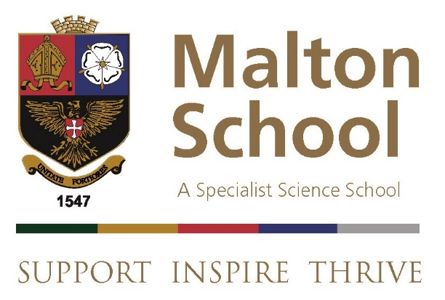

Receptionist

Information for Applicants

March 2023

Dear Applicant,

Thank you for your interest in the post of Receptionist at Malton School. This document aims to give you some information about the school and the application procedure.

Malton School serves a wide rural area of Central Ryedale, as well as the town of Malton itself. We currently have 921 students on roll, including 178 in the Sixth Form; there are 53 teaching staff and 47 support staff. We are fully comprehensive. Our staff student relationships are excellent. Behaviour is extremely good. Most of our students move on to university and many of them to Russell Group universities. We offer a very happy and supportive community in which colleagues can further develop their career. The school is over-subscribed.

We are seeking to appoint a full time Receptionist to provide excellent customer service at our front desk and on the phone in responding to queries from parents, prospective parents, external queries and all other customer and visitors to the school. Part time will also be considered.

The school is a member of the Red Kite Teaching School Alliance, a group of high achieving Yorkshire schools (including Harrogate Grammar School, Prince Henry’s Grammar School, Ilkley Grammar School, Rossett School and Roundhay School). We share staff development programmes and opportunities within the alliance, including leadership development and support for newly qualified teachers.

I hope you will be interested in this post and I look forward to reading your application.

Yours sincerely,

Rob Williams
Headteacher

Benefits of working at Malton School
The school prides itself in being a supportive employer, offering favourable terms and conditions to facilitate outstanding teaching and learning. Some of the main additional benefits of working at Malton School include:

- PPA above the national expectation in response to staff delivery of a Personal Development Activity (PDA – see below).
- A strong bespoke staff development programme for all staff.
- A major investment in support staff roles (e.g. allowing the provision of “no cover”) so that teachers can focus on planning and delivering outstanding lessons.
- Membership of the Red Kite Teaching School Alliance.

Malton School is committed to safeguarding and promoting the welfare of students and young people and expects all staff to share this commitment.

The Admin team
The school currently has a well-established team of admin staff supporting various aspects of the school such as finance, pastoral, reception, student data, reprographics, etc. The successful candidate will be responsible for the West Wing Reception service on Mondays and Fridays and assist the Lead Receptionist in organising some school events.

Main tasks/Duties/Responsibilities:
See Job description

The School Curriculum
We operate a four-period day within a ten-day cycle. Each lesson is 75 minutes long. Students have 26 hours curriculum time each week, with the extra hour on a Thursday set aside for personal development (see below).

Key Stage 3
Students are placed in mixed-ability form groups. In Year 7, teaching is in mixed ability groups. In Years 8 and 9 setting is for Science, Maths and the group of subjects English, Geography, History, French and Religious Education.

Key Stage 4
English (including Literature) Maths, Double Science, Religious Studies and Physical Education are compulsory. Students then choose four further options subjects (10% of curriculum time each). Where students choose triple science, this takes up one of their 4 option blocks. This is a popular choice with two triple science groups each year.

Key Stage 5
Advanced Level courses are currently taught in Art, Biology, Business Studies, Chemistry, Computing, Design Technology, Drama, Economics, English Literature, French, Geography, Food, Nutrition & Health, History, Information Technology, Maths, Maths (Further), Music, Photography, Physics, Physical Education, Politics Psychology and Sociology. BTECs are offered in Health and Social Care.

Re-sit GCSE courses are also offered in English and Maths, together with an open access provision for IT skills acquisition.

Personal Development Activity
One hour per week is devoted to personal skills development. Staff offer nearly 40 different courses. Students choose a different course each term. The scheme is focused on character education and the development of the whole child. New members of staff would be expected to contribute to this programme.

Citizenship
Citizenship is taught to all in Years 7 to 9 for one period per fortnight. This builds on a well-established programme of Personal & Social Education, complementing tutorial work and linking into the Careers programme.

Academic Structure
The academic work of the School is structured in Faculties. Each Faculty is led by a Faculty Leader and an Assistant Faculty Leader.

In-service training is managed in consultation with Faculty Leaders. Funding for books and equipment is derived from a formula which takes account of the numbers and ages of students as well as the nature of the subject. Faculties are also able to bid annually for additional funding from the School budget, the Endowment, and the PTA.

Pastoral Structure
The School has 7 Heads of Year (from Year 7 to Year 13) who are all line managed by the Director of Pastoral Care.

The School Site
We are fortunate to enjoy a large site on the edge of Malton with views of both the North York Moors and the Yorkshire Wolds. The sports field accommodates three hockey, four football, one rugby pitch, one cricket pitch and an athletics track as well as 7 hard court tennis courts / netball courts. Staff can use our sports facilities in the excellent sports centre. There is plenty of parking space for staff.

Malton School was founded in 1547, becoming a comprehensive school in 1971 with the merger of the original grammar school and the neighbouring county modern. The two buildings, known as East and West Wings, date from 1911 and 1958. As far as possible, subject departments are housed in one wing. Most members of staff are based permanently in one room.

We opened a new Science block with four new laboratories in 2004 on becoming a specialist Science School, resulting in a total of eight laboratories and associated preparation rooms. Our Food Technology rooms were totally re-furbished in 2011. In February 2011 Archbishop Sentamu opened a community sports centre and full-sized, floodlit, astroturf pitch on the school site, providing us with the best P.E. facilities in the area. A new dance and drama studio was opened in September 2013. Fully refurbished DT rooms opened in September 2016. A new 4 classroom Humanities block will be opened in September 2021.

School data

Address: Malton School
Middlecave Road
MALTON
North Yorkshire
YO17 7NH

Telephone: (01653) 692828

Email: admin@maltonschool.org
Website: www.maltonschool.org

Chair of Governors: Rod Anson
c/o Malton School

Clerk to the Governors: Helen Lowdell
Malton School

Corporate Director of Education: Stuart Carlton
County Hall
NORTHALLERTON
North Yorkshire
DL7 8AE
Telephone: 0845 034 9494

Application
You are invited to submit an application for the post of Receptionist at Malton School and to support your application with a letter.

Completed application form and supporting letter should be emailed to Samantha Hodsman sch@maltonschool.org by 9:00 am on Friday 24th March 2023. Your application will be acknowledged. Interviews are planned for Wednesday 29th March 2023. If you have not heard from us by then you should assume that your application has been unsuccessful on this occasion.

Thank you for your interest in the post of Receptionist. If you have any questions please do not hesitate to contact Samantha Hodsman on the email above.

Malton School is committed to safeguarding and promoting the welfare of its students. All staff must have enhanced DBS Clearance and are expected to adhere to safe working practices.

