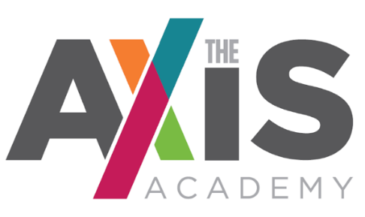

Receptionist – The Axis Academy Crewe
Permanent, term time, 37 hours per week
£15,886 - £16,794 (actual pay)
Be Our Welcoming Face!
The Axis Academy is a beacon of exceptional practice and offers outstanding education for vulnerable young people from Primary to KS4. We want all our staff to empower children to succeed and show a patient and nurturing approach in order to unlock a child’s potential.
As our Receptionist, you will run our front desk, act as first contact for visitors, other professionals and our students. You will also have the opportunity to support general administration and get involved in all aspects of school life.

We can offer you:

- School holidays off
- Pay split over 12 monthly instalments
- Access to training and the opportunity to progress
- Local Government Pension Scheme
- Staff support – GP services, physio, counselling
- Perkbox – wellbeing services and retail discounts
- A supportive team environment
- Lunch for free every day
- On-site parking
- Free DBS check to enable you to work safely in a school setting

PLEASE APPLY FOR THIS ROLE VIA THE SCHOOL WEBSITE -: http://theaxisacademy.org/index.php/about-us/vacancies
Application deadline: 5pm on 20th January 2022

