

School Site Technician

APPLICATION

PACK

**Full-time position – 37 hours/week**

**Grade 5 - £21,968-£23,194**

***(£1925 pay award pending –***

***increasing to £23,893-£25,119)***

**Full Year**

Information about the school

Hednesford Valley High School is a generic Special School set in Cannock Chase, an Area of Outstanding National Beauty. We educate students on two sites, with years 7-11 at our main site and our Sixth Form is set in a dedicated building at Cannock Chase High School. We currently have 179 students on roll.

We have amazing students with a range of learning needs, who are supported by dedicated staff with a passion for transforming the lives of our students. If you join our team, you will be part of a school where students love to learn, and staff love to teach. We truly are a family. This is not just a statement; our data supports this. Our attendance and positive behaviour are above national data and we have just received amazing feedback from our recent parent/carer questionnaire.

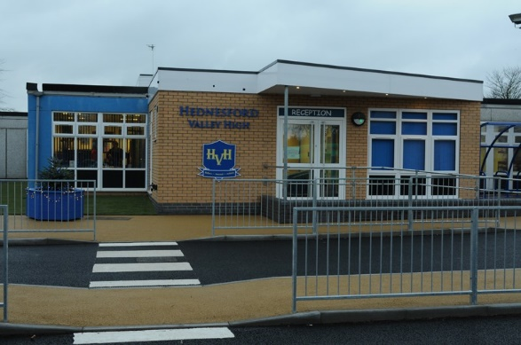

The latest Ofsted Inspection dated 6th March 2019 – the school was judged to be Good.

“*The curriculum for key stage 4 pupils has been designed to provide a broad curriculum experience with a combination of vocational and academic subjects which effectively prepare pupils for their next steps in education. This continues into the sixth form, where the curriculum is centred around work experience, work-based activities and careers advice.”*

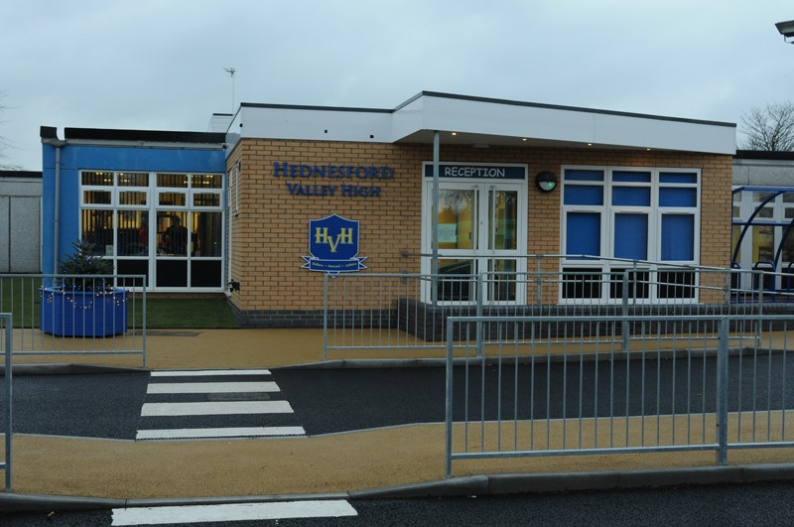

|  |  |  |  |
| --- | --- | --- | --- |
| Job No. | Post Title | Grade | Date |
| AA6970 | School Site Technician including Grounds. | Grade 5 | Apr 2008 |

|  |  |  |
| --- | --- | --- |
| Statement of Purpose | | |
| To work under the direction and instruction of senior staff to provide:   * routine cleaning and/or caretaking tasks to support the effective operation of the school. * To take responsibility for the grounds, ensuring that the sports facilities are maintained to the standards required by Health and Safety. * To maintain the specialist equipment required to carry out the role. | | |
| Line Management | | |
| |  |  | | --- | --- | | * | May be required to supervise a small team of site staff/cleaners in the absence of the senior site supervisor. | | | |
| Health & Safety and Security | | |
| |  |  | | --- | --- | | * | Unlock and secure premises at agreed times and maintain the key(s) in their possession for emergency call-out. | | * | Liaising with school management in relation to the formulation of risk assessments where applicable. | | * | To maintain appropriate records including intruder alarm log book and fire alarm book. To test alarm systems weekly and lighting when appropriate. | | * | Undertake risk assessments and COSHH procedures as appropriate. | | * | To assist with fire evacuation procedures. | | * | To undertake portable appliance testing | | * | To ensure heating plant and equipment is efficiently and effectively operated, make adjustments as necessary and report defects and malfunctions to designated member of the Senior Leadership Team. | | * | To be responsible for maintaining the security of the premises (buildings and grounds) and its contents. | | * | To clean light fittings replacing where necessary minor parts such as tubes, bulbs, fuses, starters and diffusers, in accordance with safe working practices. | | * | Remedial action after break-ins, for example boarding up broken windows, to organise the reglazing small and large internal windows. | | * | Ensure that premises are in a safe, tidy and satisfactory condition prior to use. In the morning this will normally require attendance until a member of staff arrives. | | * | Maintain vigilance for Health and Safety concerns in and around the building including checking outside area for syringes, broken glass etc. and disposing appropriately. | | | |
| |  |  | | --- | --- | | Maintenance and Cleaning | | | * | Replace such consumables on the premises in appropriate locations as are not covered by alternative arrangements, e.g. toilet rolls, soap, towels, etc. | | * | To arrange to clear blockages, remove foreign matter from sinks, toilets, drains, and clean up spillages as required. | | * | In the event of a burst or leaking water pipe, the water supply should be turned off, spillage removed and furnishings cleaned. | | | |
| * | Remove spillages and resultant stains from floors and other surfaces. |
| * | To ensure that gullies, drains etc. are kept free from debris and that the school and ground are litter free. Litter bins are to be emptied and the contents disposed of on a daily basis. |
|  |  |

School Site Technician with Grounds

Job Description

|  |
| --- |
| Maintenance and Cleaning continued |
| |  |  | | --- | --- | | * | To be responsible for ensuring clear and safe pedestrian access to the school particularly in adverse weather conditions (e.g. snow clearing, gritting). | | * | Replace such consumables on the premises in appropriate locations as are not covered by alternative arrangements, e.g. toilet rolls, soap, towels, etc. | | * | To arrange to clear blockages, remove foreign matter from sinks, toilets, drains, and clean up spillages as required. | | * | In the event of a burst or leaking water pipe, the water supply should be turned off, spillage removed and furnishings cleaned. | | * | Remove spillages and resultant stains from floors and other surfaces. | | * | To ensure that gullies, drains etc. are kept free from debris and that the school and ground are litter free. Litter bins are to be emptied and the contents disposed of on a daily basis. | | * | To be responsible for ensuring clear and safe pedestrian access to the school particularly in adverse weather conditions (e.g. snow clearing, gritting). | |
| Maintenance and Repair |
| |  |  | | --- | --- | | * | *Painting and Decorating*   * Temporary making good of colour wash e.g. when cabinets are moved, and the blotting out of graffiti. Making good paint work e.g. touching up scratch damage. To undertake repairs, projects and redecoration tasks as appropriate. * ***Joinery*** * First line maintenance of fixtures and fittings. Minor repairs as a temporary measure after break-ins, vandalism etc. Minor repairs to fixtures and fittings such as replacing locks, * Minor repairs to furniture, replacing door and window catches. * Minor improvements such as the erection of small shelves, display and notice boards. * Advice, and/or undertake, where appropriate renovation projects   ***Plumbing***   * Unblocking sinks, traps and waste pipes. Adjustment and rewashering of taps. Stopping leaks. * Liaison with contractors in relations to larger building maintenance projects.   ***Grounds Maintenance***   * Grass cutting of lawned areas. * Treatment and care of flower beds and shrubbery. This includes planning attractive year-round displays, and the propagation of appropriate plants. * Hedge cutting/trimming, Strimming, brush cutting. | |
| Resources |
| |  |  | | --- | --- | | * | To undertake porterage tasks as required including setting up and clearing away furniture. | | * | To control the provision of toiletry items including requisition, storage and distribution of such items. | | * | Responsibility for replacement of paper towels, toilet rolls and soap in toilets and teaching areas e.g. Technology, Science, Art and Craft | | * | To monitor stock levels of consumable items such as grit, toiletries, light bulbs/tubes and cleaning materials for which the college is responsible and arrange to replenish supplies in accordance with current procedures. | | * | To report emergencies in the case of faults with gas, electric and water supply to the designated member of the Senior Leadership Team or where not immediately available, Technical Services, and report minor faults on site to the designated member of the Senior Leadership Team. | | * | To attend to, where necessary, personnel visiting the site such as contractors, representatives of utilities (gas, electric) and monitor any work being carried out within the postholder's area of responsibility. | |



|  |
| --- |
| Safeguarding |
| |  | | --- | | School is committed to keeping children, young people and vulnerable adults safe. The post holder is responsible for promoting and safeguarding the welfare of the children, young people and vulnerable adults for whom she/he is responsible for or comes into contact with. | |
| Health & Safety |
| |  | | --- | | The post holder will be responsible for his/her own health and safety. All duties and responsibilities must be carried out in line with the specific requirements detailed in the school Health & Safety policies. | |
| Policies & Procedures |
| |  | | --- | | The post holder will be accountable for ensuring that he/she is aware of relevant school policies and that all duties and responsibilities are carried out in line with the appropriate policies and procedures. | |

**Other Conditions**

|  |
| --- |
| Equal Opportunities |
| |  | | --- | | School is committed to Equal Opportunities and expects all staff and volunteers to recognise and value differences and to treat everyone with dignity and respect. | |
| Variation to Job Descriptions |
| |  | | --- | | Due to the changing customer demands, duties and responsibilities are likely to vary from time to time and the School therefore retains the right to amend job descriptions to reflect changing requirements. | |

***Note 1:***

***The content of this job description will be reviewed with the post holder on an annual basis in line with the School’s performance and development review policy. Any significant change in level of accountability that could result in a change to the grade must be discussed with the post-holder and the relevant trade union before submitting for re-evaluation***



School Site Technician including Grounds

Person Specification

|  |  |
| --- | --- |
| **Post Title** | **School Site Technician including Grounds** |
| **Salary Grade/Range** | **Grade 5 – Pt 6-Pt 9**  **Starting salary £21,968 (£1925 pay award pending will rise to £23,893)** |
| **Hours/Weeks** | **37 hours/week Full Year**  **Mon-Thurs 7:00 am-3:00 pm, Fri: 7:00 am-2:30 pm** |
| **Responsible to:** | **School Business Manager** |

|  |  |
| --- | --- |
| Essential Criteria | Measured By |
| Experience   * Several years experience of working in a security, safety, cleaning or maintenance environment or Good DIY Skills | AF/I |
| Qualifications/Training   * NVQ 2 or equivalent qualification in a relevant discipline. * Appropriate Health and Safety qualifications related to the use of weedkillers/fertilisers etc. * Will be required to undertake the Staffordshire County Council Minibus Driver Assessment. | AF |
| Knowledge/Skills   * Good understanding and ability to use specialist equipment/ resources. * Gardening skills to include the use of lawn mowers and strimmers to produce a high quality finish and appearance. * Ability to maintain the equipment and machinery. Ability to work constructively as part of a team. * Ability to relate well to children and to adults. * Knowledge of the requirements of Health & Safety, other relevant legislation. * The initiative to design and ability to carry out minor grounds projects. | AF/I |
| **Behavioural Attributes**   * Customer focused * Has a friendly yet professional and respectful approach which demonstrates support and shows mutual respect. * Open, honest and an active listener * Takes responsibility and accountability * Committed to the needs of the pupils, parents and other stakeholders and challenge barriers and blocks to providing an effective service. * Demonstrates a “can do” attitude including suggesting solutions, participating, trusting and encouraging others and achieving expectations * Is committed to the provision and improvement of quality service provision * Is adaptable to change/embraces and welcomes change. * Acts with pace and urgency being energetic, enthusiastic and decisive * Communicates effectively * Has the ability to learn from experiences and challenges |  |

|  |  |
| --- | --- |
| **Behavioural Attributes**   * Is committed to the continuous development of self and others by keeping up to date and sharing knowledge, encouraging new ideas, seeking new opportunities and challenges, open to ideas and developing new skills**.** |  |

AF - Application form

I - Interview

***Note 1:***

***In addition to the ability to perform the duties of the post, issues relating to safeguarding and promoting the welfare of children will need to be demonstrated these will include:***

* + ***Motivation to work with children and young people.***
  + ***Ability to form and maintain appropriate relationships and personal boundaries with children and young people.***
  + ***Emotional resilience in working with challenging behaviours and***
  + ***Attitudes to use of authority and maintaining discipline.***



**Vacancy Closing Date:** 10:00 am 22nd September 2023

*However, should we receive sufficient applications the advert may close before the deadline.*

**Interviews:** Week commencing 25th September 2023

**Start Date**: As soon as possible.

If you do not hear from us by Wednesday 27th September 2023 your application has been unsuccessful, and no further correspondence will be issued. Candidates who are shortlisted will be informed by telephone/email.

Selected candidates must be available to attend interview on the dates shown below. Further details of the interview process and arrangements will be provided to those shortlisted.

Hednesford Valley High School,

Stanley Road,

Cannock

Staffordshire

WS12 4JS

Tel: 01543 423714

Email: [l.fox@hvh.staffs.sch.uk](mailto:l.fox@hvh.staffs.sch.uk)



Application is by completion of the Application form which is available on the school website: [www.hvh.staffs.sch.uk/vacancies](http://www.hvh.staffs.sch.uk/vacancies) please note that CVs are not accepted. Please ensure that any covering letter is not longer than 2 sides of A4 paper.

Application should be returned to school c/o Mrs Louise Fox, Support Business Manager, it can be returned to the address above or by emailing [l.fox@hvh.staffs.sch.uk](mailto:ssm@hvh.staffs.sch.uk)

For shortlisted candidates, references will be sought ahead of the interview process. Please provide details of two people who can provide you with a professional reference, one must be from your current employer. Email addresses must be professional emails and not personal emails. If you work in a school the reference must be from your Headteacher. Please also advise them that you have given their name and that they may be approached to provide a timely reference. Shortlisted candidates may be subject to online social media checks.

The School is committed to safeguarding and promoting the welfare of children and young people/vulnerable adults and expect all staff and volunteers to share this commitment.

This position is subject to a criminal records check from the Disclosure and Barring Service (formerly CRB) which will require you to disclose details of all unspent and unfiltered spent reprimands, formal warnings, cautions and convictions in your application form.

The following policies are available on the school website <https://www.hvh.staffs.sch.uk/Policies/>

* Safeguarding Children & Adults Policy
* Safeguarding Policy
* Safer Recruitment Policy
* Link to Privacy Notice for job applicants

Thank you for your interest in this vacancy.

APPLICATION PROCESS