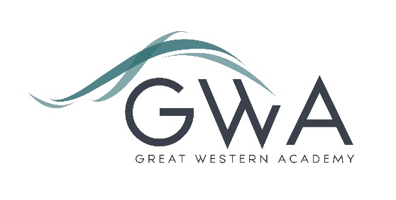

# Information for Applicants

**Science Laboratory Technician**

37.5 Hours per week. Full or part time considered.

Great Western Academy opened in brand new, state-of-the-art facilities in North Swindon in September 2018. The Academy is heavily oversubscribed and our first cohort of Year 12 students formed our expanding Sixth Form in September 2019.

We are seeking an organised, well qualified and resourceful technician to support our Lead Science Technician and Science teachers to help ensure that all students make fantastic progress in Science.

An applicant’s briefing pack with full information about Great Western Academy and the role is available on the GWA website at <https://www.gwacademy.co.uk/vacancies> The salary for the role will reflect the experience of the successful candidates.

Application process

Please complete the application form supplied and enclose a supporting letter, either in the space provided on the application form or as a separate document. The application form should be completed in full in black ink or type. A CV is not requiredand should not be submitted as part of the application.

Your supporting letter should be no more than 2 sides of A4 (with a font size no smaller than 11) and should enhance your application by providing further information, matched to the person specification, about your suitability for the post.

Electronic applications should be returned via email to [recruitment@gwacademy.co.uk](mailto:recruitment@gwacademy.co.uk)

**Closing Date:** **Tuesday 12th December 2023**

**Interviews:** **Interviews will take place later in that week**

**References:** References will be taken up prior to interview.

*Great Western Academy is committed to safeguarding and promoting the welfare of children, young people and vulnerable adults and we expect all staff to share this commitment and undergo appropriate checks. All posts within the Trust are therefore subject to an Enhanced DBS and barred list check.*