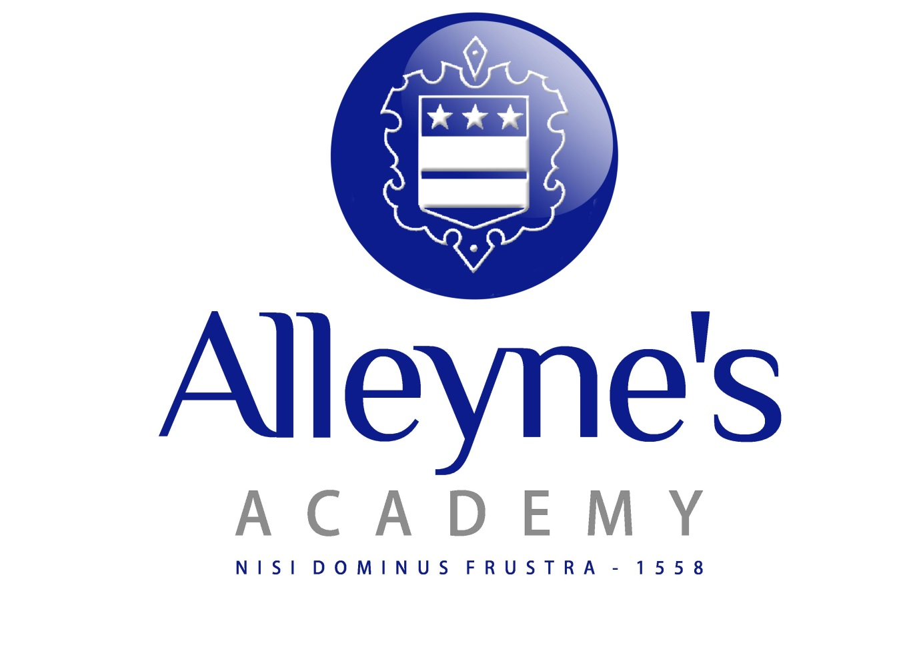
Science Faculty

The aim of the Science department is to inspire a love of learning in our students igniting curiosity about how the world works and to make all students enthusiastic about learning scientific ideas, encouraging the scientists of the future.

We want to develop all students’ scientific skills and in an ever-developing scientific world, ensure that all our students can embrace new ideas and understanding of the world around them.

The Science department is a fantastic learning environment. It currently has nine teaching staff supported by two science technicians. There are nine laboratories, equipped with interactive whiteboards, plus an ICT room for which the faculty has the timetable priority.

Our partner middle schools follow a common science course to ensure a smooth transition from Year 8 to Year 9 where on entry to Alleyne’s they complete the KS3 national curriculum before they begin their GCSE Science courses in year 10. Pupils follow either AQA GCSE Combined Science (Trilogy) or AQA GCSE Biology, GCSE Chemistry and GCSE Physics. At Key Stage 4 classes are taught by three teachers working in one of their specialised areas.

Uptake of A-level sciences is very good at Alleyne’s usually with one or two teaching groups for each of biology and chemistry and Physics. We also offer the Level 3 Applied Science BTEC for students wishing to pursue a vocational pathway.

September 2023

