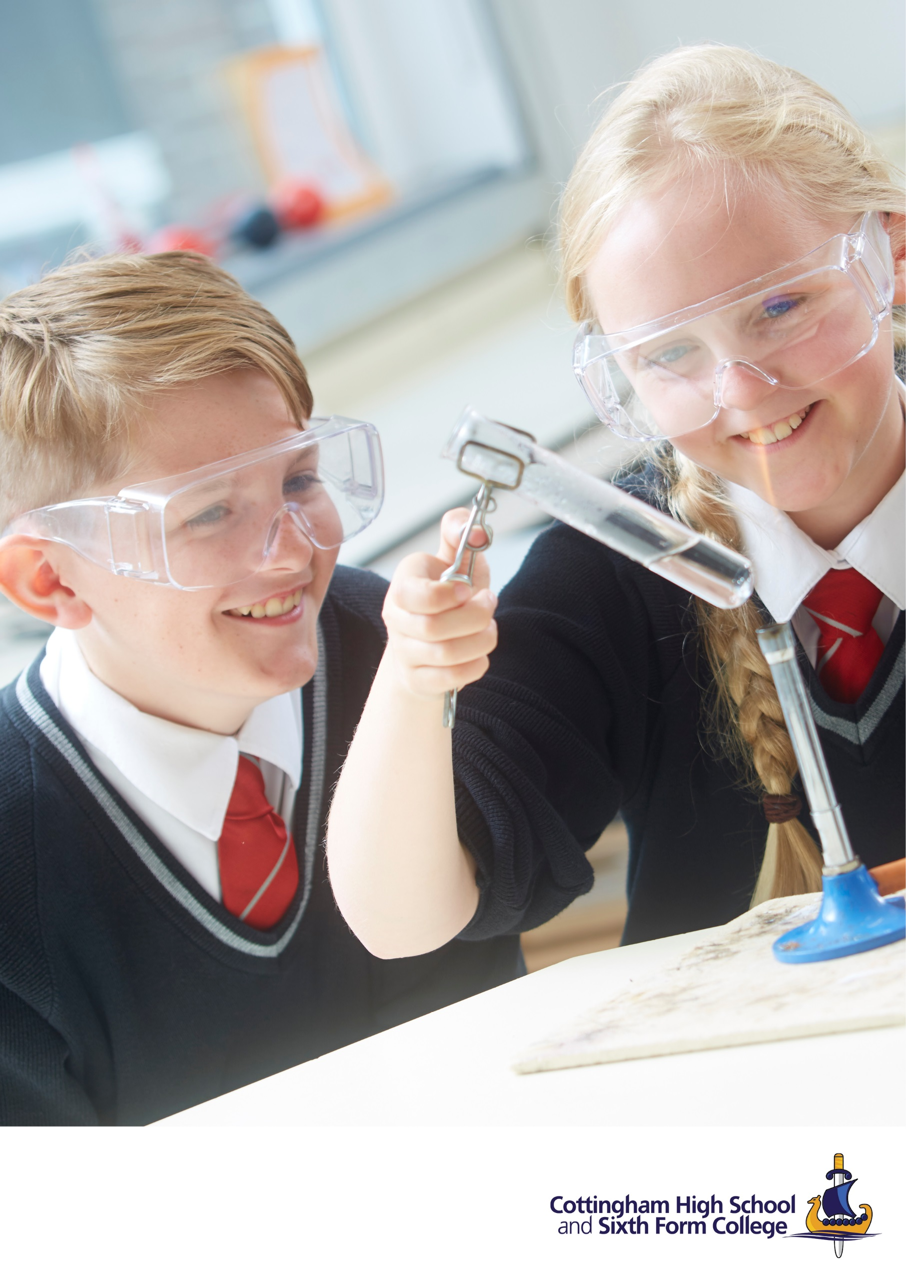

**Teacher of Science**

**Information Pack**

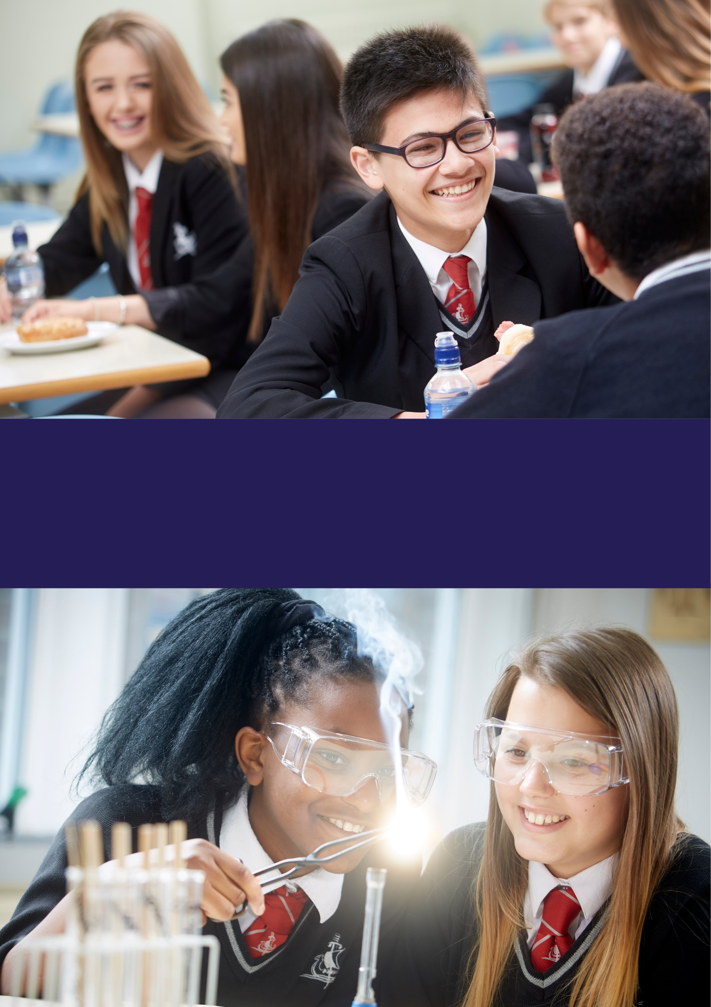



Believe. Achieve. Succeed.

A school that provides all students with exciting opportunities that build confidence, develop skills and promote academic excellence.

**OUR VISION**

**General Information about the school**

Cottingham High School is a secondary comprehensive based in the East Riding of Yorkshire. We are a founding member of The Consortium Academy Trust formed in September 2017 by the coming together of Cottingham Academy Trust, The Hessle Academy Community Trust and Wolfreton School and Sixth Form College.

The 3 founding schools have a successful history of partnership working, having operated Consortium Sixth Form arrangements for over 25 years. We are extremely proud of this relationship which has led to a strong, vibrant and successful community for our Post 16 students. We have 950 students, including about 120 in our very successful Sixth Form.

**

*Pupils presented as self-assured, mature, polite and friendly when inspectors chatted with them.*

*Students are proud to be part of the sixth form. They are unequivocally positive about their experiences.*

Cottingham High School is sited on the north-western edge of Cottingham – once a large village and now a suburban community. The school site comprises 2, separate complexes: one built in the 1950s and the other when the school expanded in the late 1970s. The school gardens date from a Georgian residence previously on the site and evidence of the garden management related to this house and grounds can still be seen in the planting arrangement and variety of trees in the school grounds. This is a school with history.

The site has benefitted from nearly £2 million of investment over the last 4 years with new roofs, new boiler, Sixth Form café and study areas, new windows and replacement of all the school lights to LED.



*Pupils feel safe.*

*Pupils demonstrate positive attitudes to their learning.*

*Improvements in teaching have led to enhancements in progress for groups of pupils across all year groups.*

**At Cottingham High School we are all members of a friendly and supportive community. We respect each other; we take responsibility for placing learning at the heart of everything we do; we have the confidence to embrace innovation and we are inspired to achieve our very best. We place significant importance on creating a caring and supportive environment for all our students where every child really does matter.

We pride ourselves on our inclusivity and we have a strong reputation for providing excellent pastoral care and

guidance throughout all years, including the Sixth Form. We’re proud of our past and the strengths that have made our school what it is. We combine these with a forward thinking approach and place teaching and learning at the heart of everything that we do. Our focus is on developing outstanding teaching, learning and assessment and we recognise, nurture and celebrate all of our students’ differing talents and gifts; academic, sporting and artistic.

*subjects and a range of vocational opportunitie*

*Leaders have ensured that a wide range of courses of study are available for pupils, including academic routes, qualifying pupils for the English baccalaureate, as well as artistic and creative subjects and a range of vocational opportunities.*

**

By investing in all our staff through high quality and personalised continuous professional development, and training our teachers to the highest standards, we aim to excel in everything we do. We strive to give each of our students the very best education. We are here to enrich their lives and inspire their minds; to encourage their success; to prepare them for adult life and to give them every opportunity to reach their full potential.

Should you choose to apply, you will be sure of a warm welcome and you will be joining a highly committed, professional and friendly staff group in a very supportive and forward thinking Trust.

For more information about the school and everything we have to offer, please visit [www.cottinghamhigh.net](http://www.cottinghamhigh.net)

**Our Trust**



The Consortium Academy Trust (TCAT), based in the East Riding of Yorkshire, was formed in September 2017 by the coming together of Cottingham Academy Trust, The Hessle Community Academy Trust and Wolfreton School and Sixth Form College to form a new Multi Academy Trust. These three schools have a successful history of partnership working, having operated Consortium Sixth Form arrangements for over 25 years. The Trust has grown rapidly and TCAT currently comprises of six secondary schools and three primary schools, as well as an associate member, with a total of approximately 7700 learners and a significant staff team. Our academies include Croxby Primary, Cottingham High School and Sixth Form College, Hessle High School and Sixth Form College, Holderness Academy and Sixth Form College, Howden School, Keyingham Primary, Penshurst Primary, Winifred Holtby Academy and Wolfreton School and Sixth Form College.

**Our vision**

We believe in putting our children and young people first and that everything we do has that as its goal. Our vision is to be:

A Trust that promotes academic excellence, where exciting opportunities allow students to excel in all that they do, and leave prepared to achieve all their ambitions.

A Trust whose schools deliver the maximum potential for progress through inspirational teaching and learning, and outstanding school to school support.

A Trust with a leading community role, whose schools are the preferred choice for students, parents and staff.

Our core values underpin everything we do. They are developed in each academy to meet their needs.

**Aspiration.**

We are ambitious and we aim high for ourselves and for others. We believe that we can make a real difference.

**Respect.**

We respect ourselves and we respect each other. We respect our diverse environment and the community.

**Integrity.**

We are honest with each other and ourselves. We do the right thing for the right reasons.

**Responsibility.**

We take responsibility for everything we do. We see mistakes as an opportunity to improve and get things right next time. We do this in an environment where we can take appropriate risk in the pursuit of success

**Introduction from the Headteacher**

Thank you for your interest in the post of Teacher of Science at Cottingham High School.  I hope that, after reading the information provided, you will feel not only encouraged to apply, but excited by the opportunities that this post offers.

Cottingham High School has fantastic students, supportive parents, passionate teachers and enormous potential: this is an exciting time to join a rapidly improving school. In May 2017, Ofsted judged the school as good in all areas and the upwards trajectory of our student outcomes continues to evidence this.

Cottingham High School is a true comprehensive with an exciting and eclectic mix of students who are, of course, our greatest assets. Staff are challenged in their teaching by both our High Starters, many of whom secure places at Russell group universities, and by those who rely on us for the extra support and care they can sometimes need.  Our students are an absolute delight. They help each other and have a strong sense of responsibility for each other and for their school.

The staff, teaching and non-teaching, are a team of professionals dedicated to supporting all our students in realising their potential. Relationships between staff and students are one of the primary reasons that outcomes are strong: excellent classroom practice, interventions and pastoral care have resulted in impressive whole school examination performance and an excellent retention rate in our Sixth Form.

Additional to the academic focus are the exciting enrichment opportunities we offer all our students, ranging from challenge activities delivered to our High Starters, regular sporting events to whole school concerts and performances. Please look at our archive of Headline magazines on the school website to explore the vast range of these opportunities and the remarkable talents of our students.

I have no doubt that Cottingham High will become an outstanding school, but this is not the driver for us. We want to provide the very best educational experience for every young person in our local area. This is our motivation.

The school has always been at the heart of Cottingham, with most of our students walking or cycling to school and therefore interacting with their community. Our parents work in partnership with us and hold the school in high esteem, as is clear from Parent View with 100% stating that they would recommend our school to another parent. As a consequence of our parents’ faith in the school and the continuous improvement seen over a sustained period, we are delighted to be oversubscribed again for next year’s intake. Our Consortium Sixth Form Partnership strengthens us post-16 and we know that many Sixth Form students still prefer the feel of a through school. We encourage our Y12 and 13 students to be role models and give assistance to the younger students and they do not disappoint.

I would strongly encourage visits to the school. If you wish to take advantage of this, please contact the Human Resources Department to arrange a convenient time to be shown around.

This is undoubtedly an exciting time to join Cottingham High School. We very much look forward to hearing from you and again thank you for taking an interest in our school.

Best wishes



Loz Wilson

Headteacher

**Cottingham High School Development Plan**

**2020 – 2021**

* This document is intended to provide a summary of the main strategies and actions that the school will take over the next twelve months. Detailed plans sit behind, for example, Pupil Premium Strategy.
* Progress towards the targets will be assessed through the school’s quality assurance schedule along with external scrutiny from TCAT Improvement Partners and Peer Review from local school leaders.
* The latest data and a brief commentary will be added to Progress Checks 1, 2 & 3 at the end of the autumn, spring and summer terms. The targets will be RAG rated and the strategies amended accordingly.

|  |  |  |
| --- | --- | --- |
| **Key Priorities**  Vision: A school that provides all students with exciting opportunities that build confidence, develop skills and promote academic excellence.  Aim: **To be the secondary school of choice for the Cottingham community.**  Aim: **To be the secondary school of choice for the Cottingham community**  Aim: **To be the secondary school of choice for the Cottingham community** | **Focus Area** | **Outcomes (for more detailed targets see each section)** |
| 1. Consistently promote the wellbeing of staff and the wellbeing and spiritual, moral, social and cultural development of students, preparing them for future success in education, employment or training | * 1. Support staff and students in a full return to school, monitoring wellbeing   2. Implement and monitor a CHS Wellbeing Charter for staff   3. Foster an environment in which pupils understand how to keep themselves emotionally and physically healthy, feel safe, and in which bullying, discrimination and peer-on-peer abuse are not accepted   4. Develop and deepen pupils’ understanding of the fundamental British values of democracy, individual liberty, the rule of law and mutual respect and tolerance, fostering an appreciation of the range of different cultures in order to celebrate diversity   5. Develop pupils’ age-appropriate understanding of healthy relationships through appropriate relationship and sex education   6. Embed careers education across the curriculum   7. Develop an extra-curricular entitlement for all students | * Staff and student voice indicates that wellbeing concerns are being effectively addressed * Parent view indicates that 95% of parents agree that their child feels safe at school * Student voice indicates that students feel safe and happy at school, they understand how to keep themselves emotionally and physically healthy and they understand and can implement British Values * The Staff Wellbeing Group meets regularly and monitoring evidences the effectiveness of the CHS Wellbeing Charter * An effective programme of tutoring, assemblies, PSHCEE and ACDs delivering on all aspects of wellbeing and personal development is embedded * CHS is meeting new statutory guidance on RSHE * Gatsby benchmarks are achieved * All students participate in at least one extra-curricular enrichment activity |
| 1. Close or eliminate achievement gaps between key groups of students across all years | * 1. Ensure an effective disadvantaged first strategy is impacting positively towards diminishing the achievement gap   2. Accelerate the progress made by all key groups of students, (especially disadvantaged and vulnerable), in all subjects so that it is improving towards that of other students nationally who have similar starting points   3. Ensure that students who are not making expected progress or who are falling behind are swiftly identified and are provided with appropriate and effective targeted intervention | * Progress 8 for DA students is in line with similar cohorts nationally (2019) * DA students make progress towards closing the gap with non-DA students (2019) * Progress 8 for SEND students is in line with similar cohorts nationally (2019) * Trend is stable for progress of CLA, CIN, CPP and other students identified as vulnerable * Boys make progress above 0 and are closing the gap with girls across the school * All ability bands perform above national average for students with similar starting points with a focus on low and mid ability students |
| 1. Raise standards and address disadvantage through effective teaching, learning, assessment and opportunity | * 1. Ensure curriculum design is used to combat disadvantage, facilitating literacy, numeracy and vocabulary rich SoL and student understanding of vocabulary in context   2. Facilitate sustained improvements in the quality of teaching, learning & assessment and student progress through research-led, professional enquiries and membership of professional learning communities targeting collaboration, leadership, cognitive load and memory and embedding formative assessment   3. Improve our management of assessment across all key stages so that it facilitates student progress through being precise, personalised and sufficiently diagnostic to allow meaningful intervention and therapy through student response to Next Steps   4. Focus early training on low-stakes, formative assessment to identify gaps in K,S,U arising from school closure   5. Facilitate an enrichment curriculum for all, allowing access to cultural capital and developing a willingness in our students to participate in and respond positively to artistic, musical, sporting and cultural enrichment opportunities   6. Deliver outstanding outcomes in the Sixth Form | * P8 is positive overall and for key cohorts * Basics standard is 70**%** and good is 42% * All subjects demonstrate positive Subject Progress Indicator and are at least in line with national figures (% from 2019) * All teaching is judged as at least effective, including RQTs * Our DA first strategy is evident in all classrooms * All staff can measure the impact of the implementation of their enquiry strategy and share approaches where progress is significant * All teachers can articulate our curriculum intent * All PoS in all subjects implement our curriculum intent and show clear progression from KS2 to KS5 * Word of the Week accessed by all * Reading School culture established and improvements in reading are evidenced * Every child participates in our enrichment curriculum * Positive VA/ALPs T score of 3 or higher and no subjects 7-9 |



**The Science department**

**Staffing**

The Science department currently has 9 teaching staff including 2 TLR post holders: Head of Chemistry (KS3 coordinator), Head of Physics (KS4 coordinator). There are also 2 Science Technicians.

**Curriculum**

**KS3**

• 2.5-year programme for years 7, 8 & part of year 9

• All students currently have 3 hours per week of science

• Currently assessed using a combination of low stakes topic tests, termly How Science Works assessments and through observational judgements against key skills

• In house Schemes of Learning are differentiated to address students with different starting points

• Homework – A combination of Educake tasks, assignments and research projects

**KS4**

• Outcomes are improving, with Sig + results in chemistry and biology

• All students have at least 5 hours of curriculum time in Y10 and 4 hours in Y11

• All students study AQA Combined Science Trilogy specification or;

• Triple Science is an option choice for Y10 onwards giving a total of 7 hours in Y10 and Y11

• Standardised internal assessment consists of regular low stakes assessment in conjunction with end of topic assessments, and end of year mock examinations

• All groups follow a centrally scheduled Diagnosis, Testing, Therapy delivery model

• Homework is either Educake tasks, differentiated content-based question sheets or research tasks

**Post 16**

We have 3 different courses running within the faculty in both Y12 and Y13.

|  |  |
| --- | --- |
| **Specification** | **ALPs score in 2019-20** |
| Biology - AQA new spec | 4 |
| Chemistry - Edexcel new spec | 2 |
| Physics - OCR Advancing Physics new spec | 6 (small cohort) |

**JOB DESCRIPTION**

|  |
| --- |
| **Job Title**: Classroom Teacher **Reporting To:** Line Manager (Area Improvement Leader)  **Line Reports:** |
| **Overall Purpose of the Job**: Facilitating and encouraging learning which enables students to achieve high standards; to share and support the corporate responsibility for the well-being, education and discipline of all students. |
| **Principal Accountabilities:**  All staff at Cottingham High School need to act as a cohesive team if we are to achieve high professional standards implement our ethos of working together. For this reason, all staff, including the Senior Leadership Team, teaching and support staff, have common sections to their job descriptions. Obviously, each person will implement these general requirements with relevance to their own areas of responsibility.   * To implement the aims and ethos of the school * To support actively the implementation of the School Development Plan * To ensure that all staff work towards high standards of teaching and learning * To actively maintain order and discipline in the school as well as to reward good conduct * To ensure the implementation of all school policies * To meet deadlines for assessment and reporting and to mark work regularly * To maintain practices that ensure the highest standards of pastoral care * To attend meetings as and when required, according to level of responsibility * To ensure that the school is represented at any pertinent out of school meetings * To maintain an attractive environment in the classroom and the school in general * To undertake all duties to the standards set by the whole school community * To welcome visitors to the school * To liaise with parents and Consortium colleagues as appropriate * To represent the school at all times with appropriate professional characteristics to enhance the school’s reputation in the community * To ensure own professional development and attend in-service training courses as appropriate * To suggest changes to the work of the school to enhance teaching, learning and assessment * To implement the most recent conditions of service set by the Department for Children, Families and Schools * To maintain the relevant teacher standards as indicated in the ‘Professional Standards for Teachers’ framework * To ensure ‘Safe Working with Children’ as described in the school’s guidance documentation * To undertake such activities as can be reasonably expected by the Headteacher |
|  |
| **Specific-**   * Prepare and teach lessons of a high standard to students assigned * Following designated programmes of study * Carrying out the necessary assessments * Providing information/comments for records * Monitoring students in accordance with agreed area strategies * Maintain discipline in accordance with school policies and demonstrate good practice in the classes taught with regard to attendance, appearance, uniform, punctuality, behaviour, homework * Contribute to the corporate tasks of development, record keeping, monitoring, and evaluation of lessons and maintenance of materials * Participate in the applications of the school homework policy which includes setting and marking, and monitoring of homework * Follow guidance issued on safeguarding children and report any concerns to a line manager at the earliest opportunity * Work closely with and consult those teachers who are responsible for similar curriculum areas, ensuring continuity and progression for students |
| **General Information:** |
| * The above principal accountabilities are not exhaustive and may vary without changing the character of the job or level of responsibility. |
| * The Health and Safety at Work etc. Act, 1974 and other associated legislation places responsibilities for Health and Safety on all employees. Therefore it is the postholder’s responsibility to take reasonable care for Health and Safety and Welfare of him/herself and other employees in accordance with legislation. |
| * The above duties may involve having access to information of a confidential nature which may be covered by the Data Protection Act. Confidentiality must be maintained at all times. |
| * Cottingham High School & Sixth Form College is committed to safeguarding and promoting the welfare of children, young people and vulnerable adults and expects all employees and volunteers to share this commitment. |

**Person Specification**

**Post title: Teacher of Science 0.6 FTE**

*Attributes tested by application, interview, task and references*

|  |  |  |
| --- | --- | --- |
|  | **Essential** | **Desirable** |
|  |  |  |
| **Qualifications and Professional Development** |  |  |
| Degree/Equivalent | √ |  |
| PGCE/Equivalent | √ |  |
| Positive GTP report | √ |  |
| Good Honours Degree |  | √ |
| **Experience** |  |  |
| Effective planning and teaching 11-16 | √ |  |
| Post 16 teaching and/or capacity to do so |  | √ |
| Ability to teach engineering |  | √ |
| **Knowledge, Skills and understanding** |  |  |
| Thorough understanding of the National Curriculum | √ |  |
| Ability to communicate effectively and appropriately in a variety of situations | √ |  |
| Ability to work under pressure and achieve deadlines | √ |  |
| Effective behaviour manager | √ |  |
| ICT compliance | √ |  |
| Involvement in extra-curricular activities |  | √ |
| **Personal attributes** |  |  |
| Energy, ambition and enthusiasm | √ |  |
| Good organisational skills | √ |  |
| Good interpersonal skills | √ |  |
| Good health record | √ |  |
| Ability to establish good relationships with colleagues | √ |  |
| Commitment to raising standards |  | √ |
| High level of self-motivation |  | √ |
| Professional ambition |  | √ |