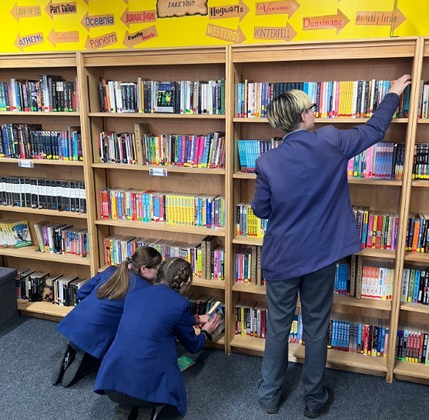
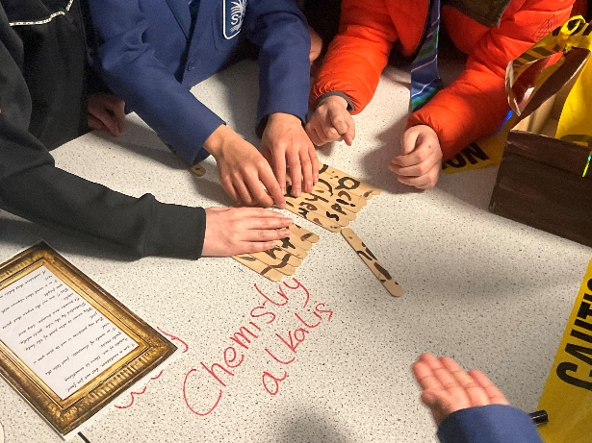
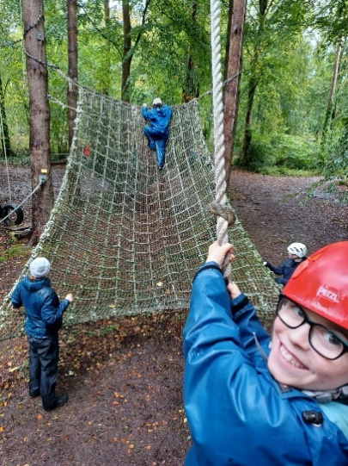
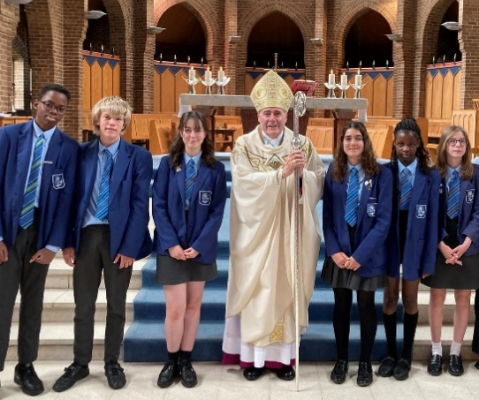
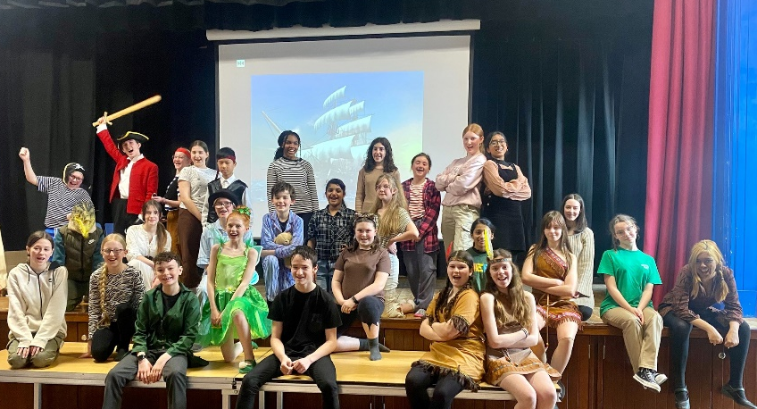
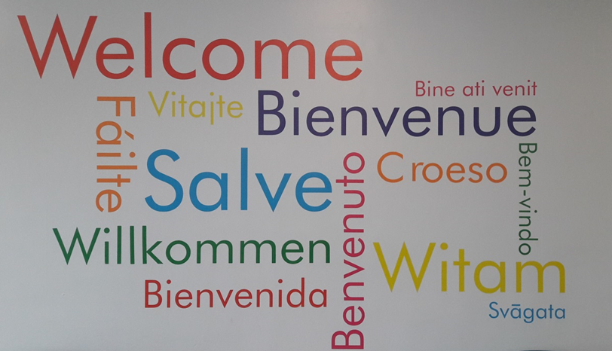
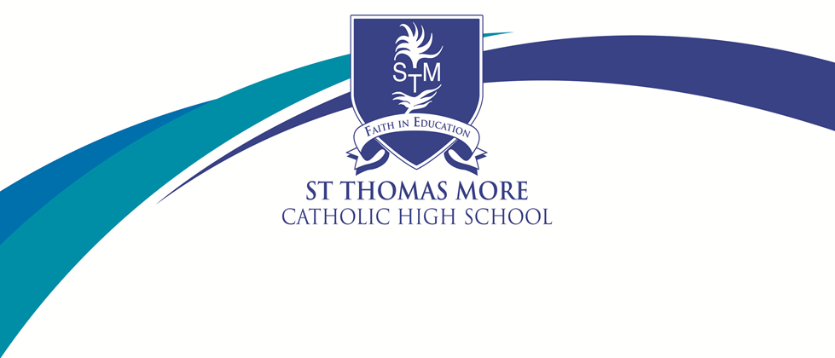
Recruitment Pack for the Position of:
TEACHER OF SCIENCE
Welcome to St Thomas More Catholic High School

Thank for taking time to consider the post of Curriculum Leader for English here at St Thomas More Catholic High School. The role is a vitally important one in our school and will impact directly on our continued success and future development.

Our OFSTED inspections of September 2007, April 2012, January 2016, March 2020 and November 2024, together with our pupils’ examination results at Key Stage 4 establish our wider reputation as a school with excellent results and pupil progress. The Diocese of Shrewsbury graded the school outstanding in December 2023

I hope that in finding out more about the school and its secure basis on Gospel Values you will feel motivated to apply for the post of Curriculum Leader for English. I would encourage you to visit the school and meet our exceptional pupils. Please do not hesitate to contact the school if you have specific questions. However do look at our website if you would like more information about our school.

Your application form and covering letter, including referees should be returned by the advertised closing date.

The application form and covering letter can be emailed to:
recruitment@st-thomasmore.cheshire.sch.uk

Kind regards
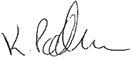

Mrs Katherine Packham
Headteacher




St Thomas More Catholic High School
Keeping Faith in Education

St Thomas More Catholic High School is a high performing, oversubscribed, 11-16 school in the South Cheshire Catholic Multi Academy Trust in the Diocese of Shrewsbury which was once again rated Good by Ofsted in 2016. Our most recent inspection by Shrewsbury Diocese rated us as an Outstanding Catholic school.

We have a well-deserved reputation for academic excellence balanced by outstanding pastoral care and support which allows our pupils to flourish and develop as rounded individuals.

During 2024-25 we continue with our focus on the quality of teaching to support excellent results for pupils, very high expectations of behaviour to create a calm and happy school, a strong good pastoral system to care for pupils and their needs, and a range of enrichment activities to engage and motivate pupils to contribute to their wider education to ensure that St Thomas More Catholic High School provides an outstanding education for all pupils.

Every school in the country with high ambitions for its young people would probably say the same, but we have a distinctive foundation or inspiration for our pursuit of excellence: our Catholic Christian values, based on the Gospel of Jesus Christ, which regards every person as a unique creation of God with an ‘original gift’ to offer the world. Our aim is to help pupils to discover the person they are called to be.

In the day to day life of the school, Gospel and British values are evident in the culture of respect and the strong ‘family’ atmosphere which all our visitors comment on and our staff and pupils value highly. Our values and common purpose has enabled us to create a thriving community who experience a full and balanced education which prepares them to live a fulfilling life and able to grasp all job, career, high education and leisure opportunities which the world offers.

What is special about a Catholic School?

 Form prayers each day |  Links with Global Schools
 Assemblies |  Caring ethos
 Retreats |  Inclusion for all
 Liturgical events |  Wellbeing Days
 Faith in Action |  Curriculum Core RE
 Equality and Respect of all |  Supporting the Church Catechetical Programmes
 Relationship and Sex Education |  Chaplaincy Team

KEY FACTS
LOCATION: Crewe, Cheshire
DENOMINATION: Roman Catholic
DIOCESE: Shrewsbury
AGE RANGE: 11 - 16
NO OF PUPILS: 647
NUMBER OF STAFF: 97
% OF PUPILS ON FREE SCHOOL MEALS: 19.17

ACADEMIC ACHIEVEMENTS:
2024 GCSE Exam Results:
Progress 8: + 0.26
Attainment 8: 47.9
Achieving Grade 5 and above inc English & Maths: 42%
EBACC (Average Point Score) 4.35

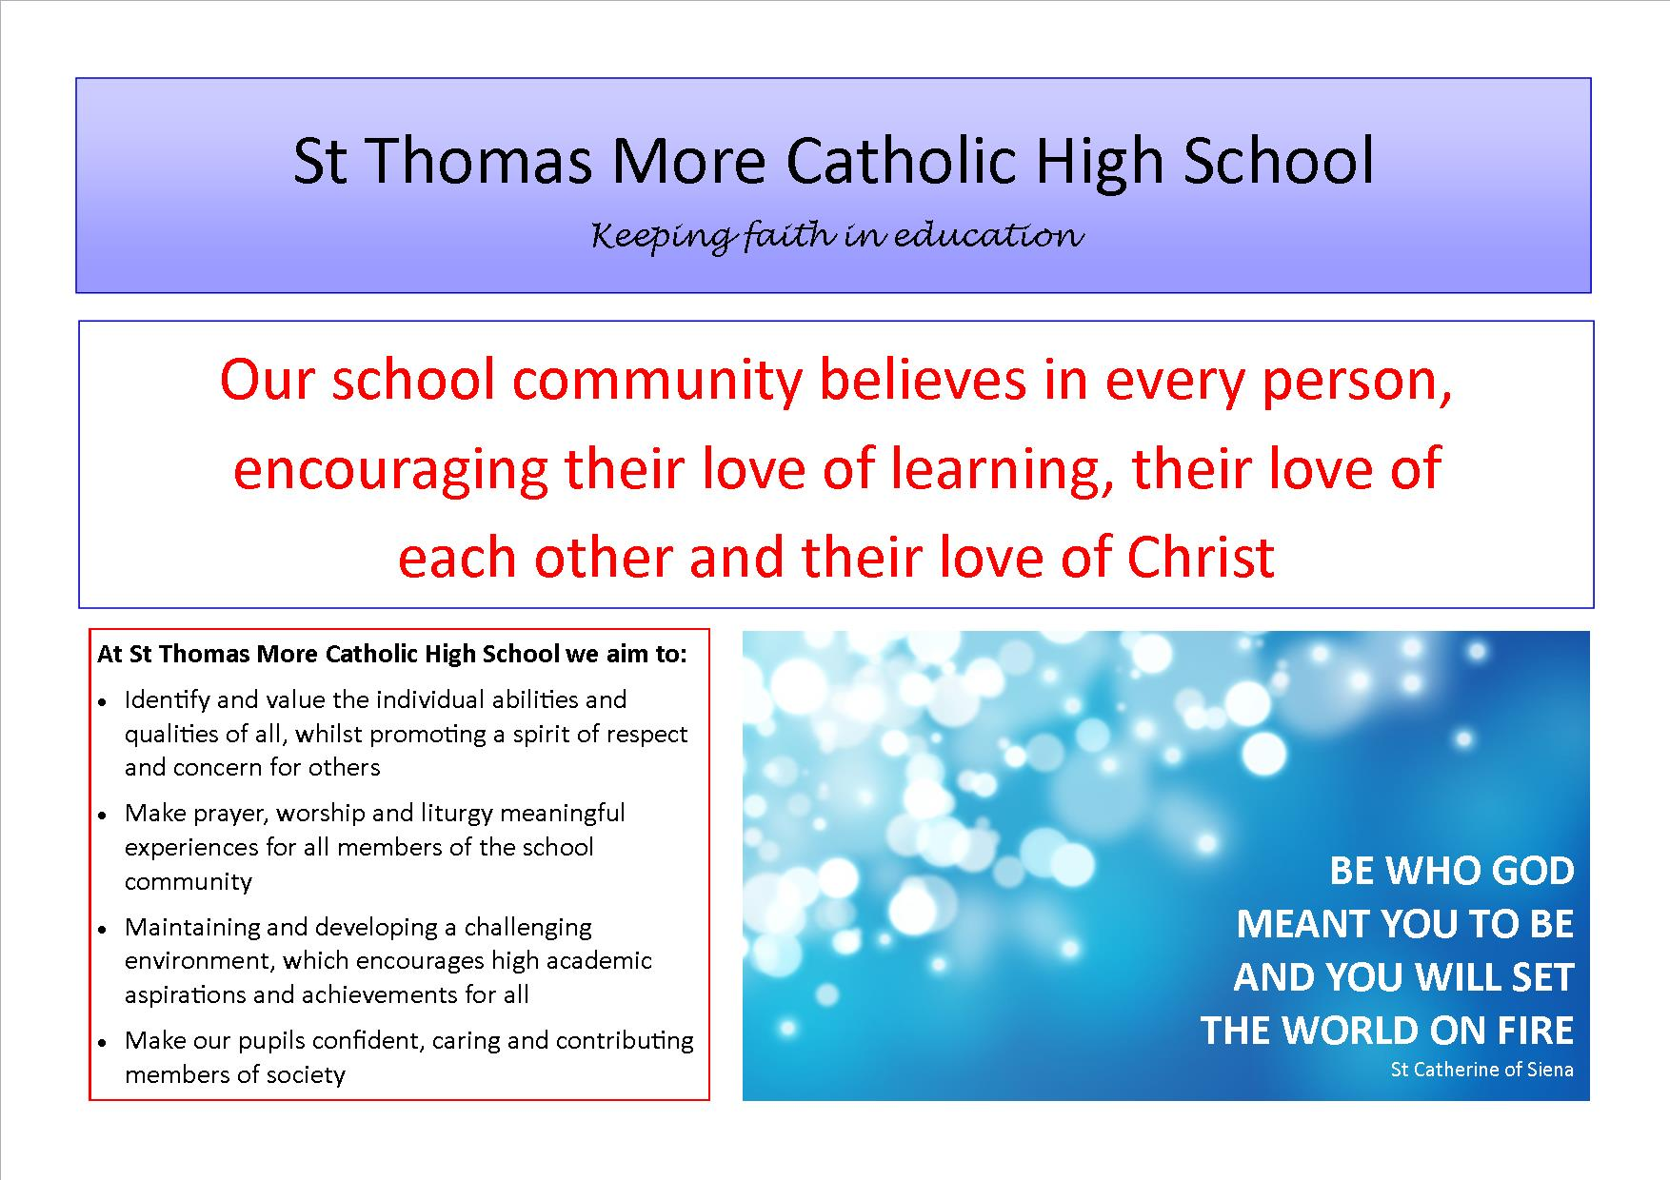

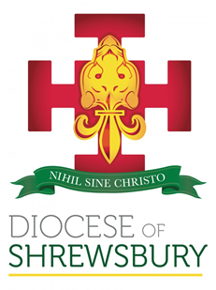
Crewe is an established town in Cheshire with a population of approximately 84,000. Crewe is known for its large railway junction and its history of manufacturing and overhauling locomotives. Crewe was also the home of Rolls-Royce Motors from 1946 until 2002. The Pyms Lane factory now produces Bentley Motor Cars exclusively.

St Thomas More Catholic High School is located within the parish of St Mary’s the Immaculate, Crewe, under the Diocese of Shrewsbury. We work closely with our partner feeder primary schools, St Mary’s Catholic Primary School, Crewe; St Anne’s Catholic Primary School, Nantwich and St Gabriel’s Catholic High School, Alsager. With a PAN of 128 and approximately 650 pupils on roll the school is increasingly oversubscribed.

St Thomas More Catholic High School has an excellent reputation within the Catholic and local community. We are a successful and popular school. Examination results and Levels of Progress are above local and national averages across Key Stage 3 and 4.

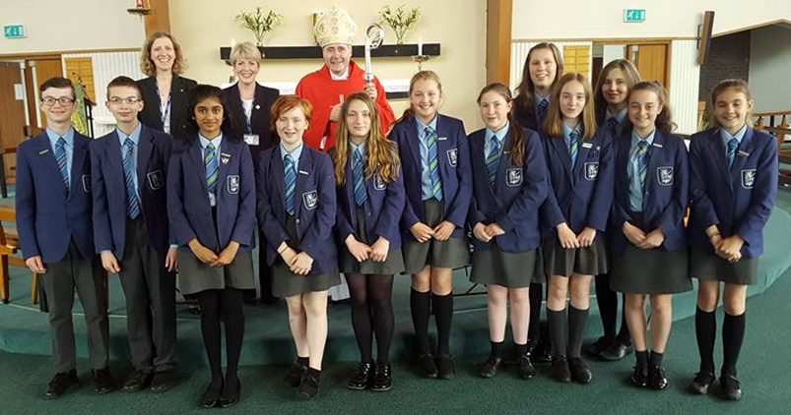

Welcome from the Science Department
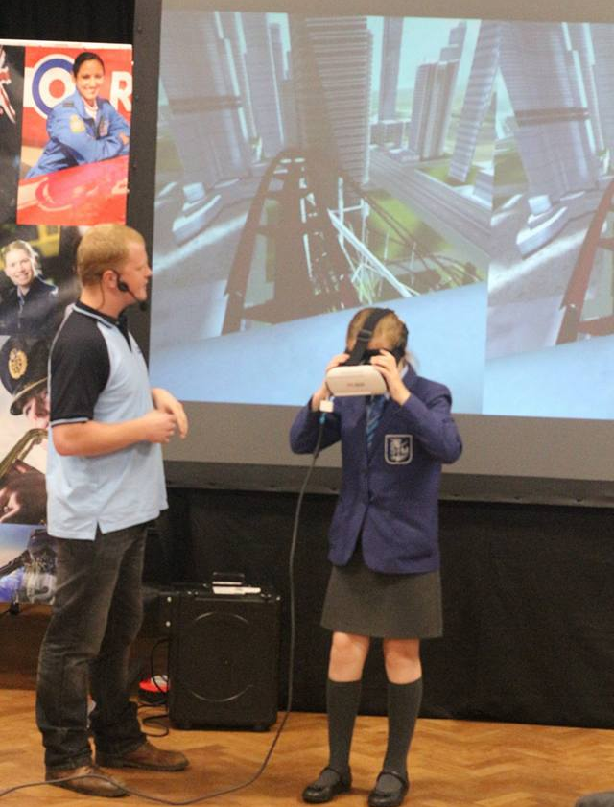
The Science Department aims to provide pupils with a rounded Science education with a view of having as many as possible choosing the Sciences Post-16. We want the pupils to leave St Thomas More as critical thinkers with an appreciation of the role of the sciences in everyday life and our impact upon the environment through the choices we make.

The Science department is situated in its own block of six laboratories. All have water, gas and electric islands and one has a suite of PCs around the perimeter. They are serviced by one full time technician and a part time assistant in the prep room. There are various places in the block used to store additional equipment. All rooms are equipped with an interactive smart board with a dedicated laptop. Each member of the department is based in one room for the majority of their lessons.

At the moment the department follows its own schemes of work through Years 7 to 8, based on the KS3 PoS. These are regularly reviewed and we are in the process of adapting our KS3 program to help prepare our students for the GCSE course. In Year 9 Students start the AQA Combined Science (Trilogy) course. This continues into Year 10 during which some students continue on to the Separate Science course whilst others will have enrichment in Year 11 to allow the best outcomes for the Combined Science (trilogy) award. We also take some pupils through the AQA Entry Level Certificate in parallel to this to help support their introduction to the course.

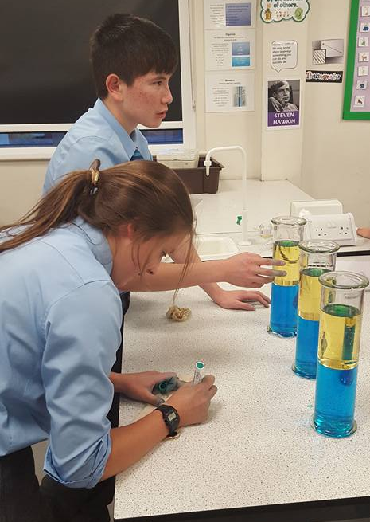
The department is works with the Technology and Mathematics departments to ensure pupils receive as much information as possible regarding careers in the STEM subjects. We have had activities taking place during National Science Week in the past and we hope to continue to build upon this. We also want to make the relevance of Science to careers much stronger so that we can motivate pupils into greater progress and achievement. This has already included an RAF Roadshow for Year 7 and 8, four pupils attending a “Girls into Engineering” course at Warwick University and the STEM club taking part in a rocket building competition.

Attainment and progress in Science is very good, however, we are not content with this and work together to maintain and raise these levels of progress and achievement. Any new members of the team would be committed to sharing this goal with us and helping to continue with the evolution of our department.
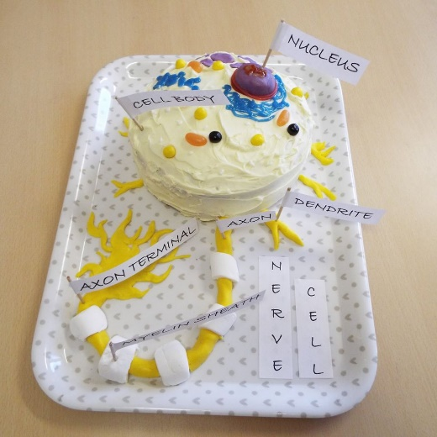
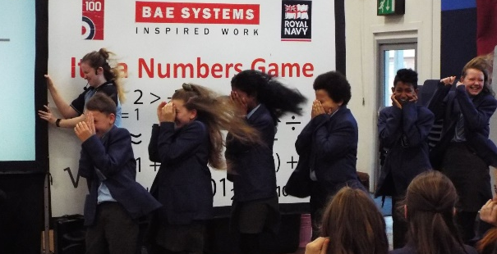

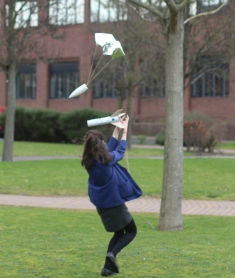

.

Job Description: Science Teacher

Reports to: Curriculum Leader for Science

Key purpose of the job
To teach pupils in allocated classes in order to ensure that their learning is of the highest quality.

Responsibilities of a classroom teacher
► Teach pupils within allocated classes, enhancing their learning and providing the opportunity for achievement for all pupils;
► Planning and preparing tasks which challenge pupils and ensure high levels of interest during lessons;
► Monitor the academic progress of pupils within allocated classes and implement appropriate strategies to address underachievement;
► To assess, record and report on the progress and attainment of all pupils within allocated classes;
► To register the attendance of pupils in class;
► To set appropriate homework;
► To mark pupil’s work and give appropriate and constructive feedback;
► To research new topic areas, maintain up-to-date subject knowledge, and devise and write new curriculum materials;
► Manage pupil behaviour in the classroom and on school premises, and apply appropriate and effective measures in cases of misbehaviour;
► Communicate with parents and carers over pupils' progress and participate in departmental meetings, parents' evenings and whole school training events;
► Undergoing regular observations and participating in regular in-service training (INSET) as part of continuing professional development (CPD); and
► Undertake critical self-evaluation and then participate in continuous professional development designed to enhance the quality of teaching or other working practices.

Responsibilities of a form tutor
► To address any issues concerned with the wellbeing, personal development and academic progress of pupils within the tutor group;
► To check uniform and general appearance on a daily basis; and
► To monitor the behaviour of pupils in the tutor group.

Performance Management responsibilities
► All members of staff are required to participate fully in the school’s performance management system.

Other professional requirements
► Have a working knowledge of teachers’ professional duties and legal liabilities;
► Operate at all times within the stated policies and practices of the school;
► Establish effective working relationships and set a good example through their presentation and personal and professional conduct; and
► Contribute to the corporate life of the school through effective participation in meetings and management systems necessary to coordinate the management of the school.

Person Specification : Science Teacher

Qualifications:
► A suitably qualified graduate.
► Evidence of relevant and ongoing CPD.
► Any further relevant qualifications.
► This role would be suitable for an NQT or an experienced teacher.

Experience:
► An excellent Teacher with the ability to secure consistently high levels of student achievement.
► Experience of teaching KS3 and KS4 including an up-to-date knowledge of the KS3 and KS4 curriculum.
► Knowledge of recent national developments in Secondary Education.
► Experience of teaching the full range of abilities.
DESIRABLE:
► Experience of a pastoral / form tutor role.

Skills and Knowledge:
► Excellent teaching skills, including effective communication skills, ability to motivate students and the capacity to create good learning environments.
► A clear understanding of the characteristics of high quality teaching and learning and achievement for all pupils.
► Knowledge of current issues and recent developments in the curriculum area.
► Capacity to use ICT as an integral part of teaching.
► Knowledge and understanding of the value added agenda, including levels of progress.
► Ability to lead initiatives, support the process of change and work effectively in a team.
► Secure commitment to a clear aim and direction for the subject.
► Understanding of equal opportunities issues and their application to work.
DESIRABLE:
► Understanding of particular needs of pupils with SEN.
► Awareness of factors affecting language and learning across the curriculum.
► Knowledge/involvement in other cross curricular initiatives/projects or whole school developments.

Personal Qualities:
► Willingness to support the ethos of a Catholic school.
► Enthusiasm for the subject.
► Ability to use own initiative.
► A commitment to the vision of the school.
► Ability to form good working relationships with pupils and staff.
► High standards and expectations.
► Ability to use pupil assessment data to raise achievement.
► Outstanding communication skills.
► Reliability and integrity.
► A commitment to safeguarding and promoting of welfare of children issues.
► A commitment to personal and professional development.
► A willingness to contribute to extra-curricular activities.

ENHANCED DISCLOSURE

Thank you for interest in St Thomas More Catholic High School. The post you are applying for involves working with young people. It is therefore exempt from the Rehabilitation of Offenders Act and any offer of employment will be subject to an Enhanced Disclosure.

As this post is exempt from the Rehabilitation of Offenders Act, you must declare any convictions, including pending convictions, cautions, reprimands and warning which would otherwise be regarded as “spent” under this Act. Further details will be sought prior to appointment.

An Enhanced Disclosure is carried out by the Disclosure and Barring Service and will check criminal records for information on any convictions, cautions, reprimands and warnings held on Police National Computer and on local Police records.

All information on criminal records provided both by you and within the Enhanced Disclosure will be used, stored and disposed of in confidence and in line with the Disclosure and Barring Service Code of Practice of Disclosure Information.

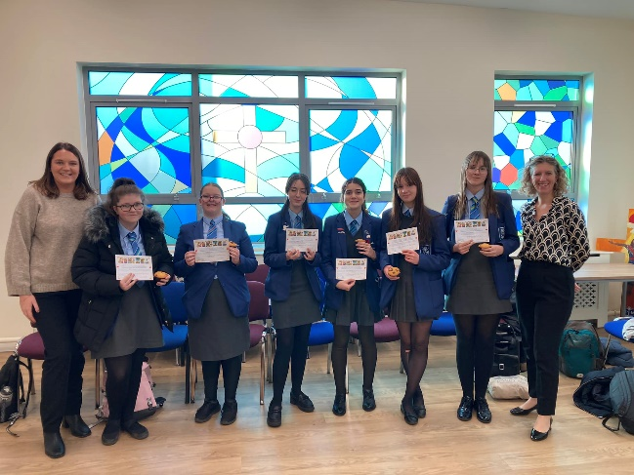
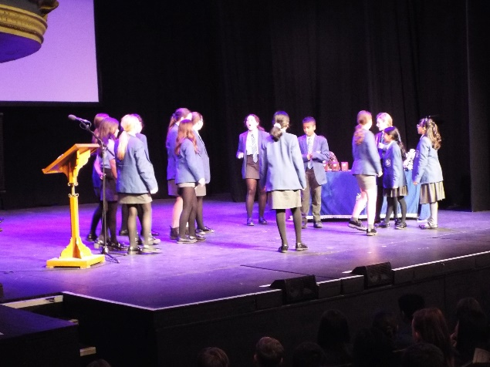
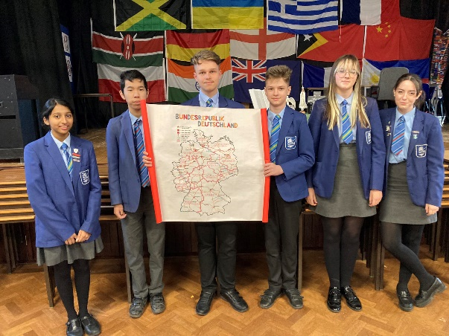
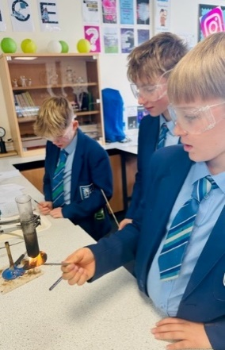
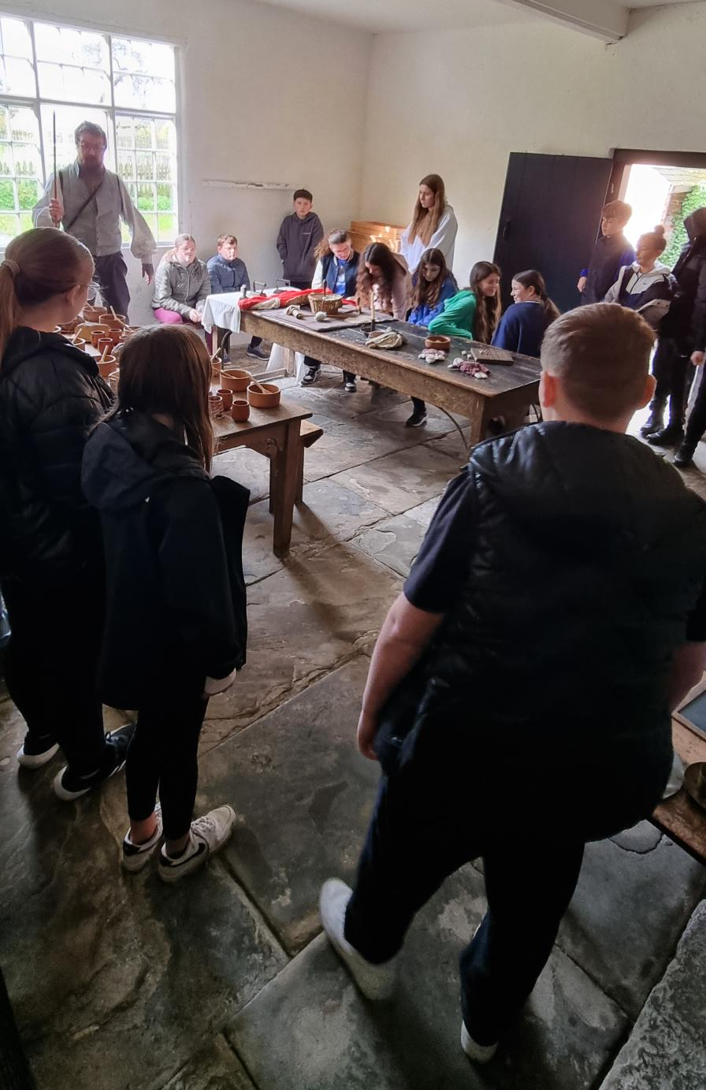
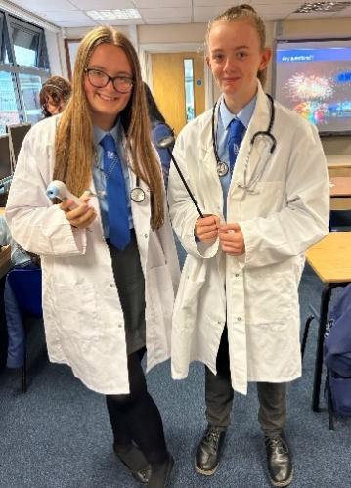
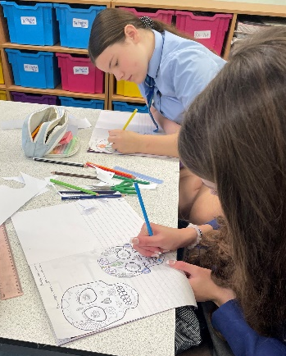
If your application is successful, you will receive further information on how to complete the Enhanced Disclosure.

