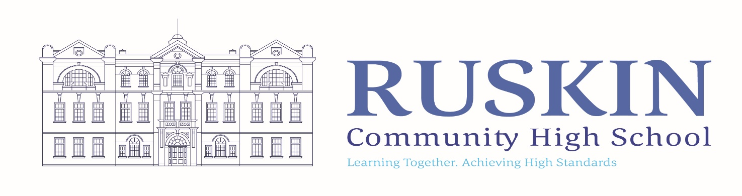
TEACHER OF SCIENCE

FULLTIME/PERMANENT: M6/UPR (ECTS are welcome to apply)

CLOSING DATE: Friday 21st January 2022. 12 noon
TO COMMENCE: September 2022

Ruskin Community High School is seeking to appoint a talented and ambitious Teacher of Science to teach across KS3 and KS4. The successful candidate will have excellent subject knowledge and an understanding of curricular content and delivery.

Our team is well established and experienced and we would like an enthusiastic colleague with a passion for Science and is current with learning and teaching strategy.

We would welcome a colleague that has a presence in the classroom and someone seeking to be part of a strong team and wider school community.

If you would like a tour or wider discussion around the role, please contact the school. You can also visit our website.

For an application pack and further details of this position visit the School Website at www.ruskinhighschool.co.uk or email recruitment@ruskin.cheshire.sch.uk
Application forms must be returned for the attention of Miss H Goodwin, School Business Manager. It is acceptable to send applications via email to recruitment@ruskin.cheshire.sch.uk or by post to Ruskin Community High School, Ruskin Road, Crewe, CW2 7JT.

Please note – CVs will not be accepted.

Ruskin Community High School is an equal opportunities employer. Our school is committed to safeguarding and promoting the welfare of children and expects all staff to share this commitment. All posts are subject to enhanced DBS check, medical and references.

Telephone enquiries about the post will be welcomed if applicants require any further information at any time on 01270 560514.

The vacancy will close sooner if we receive a large number of applications.

Please be advised that this post will also be advertised on CEC Website, Ruskin Website and internally.

