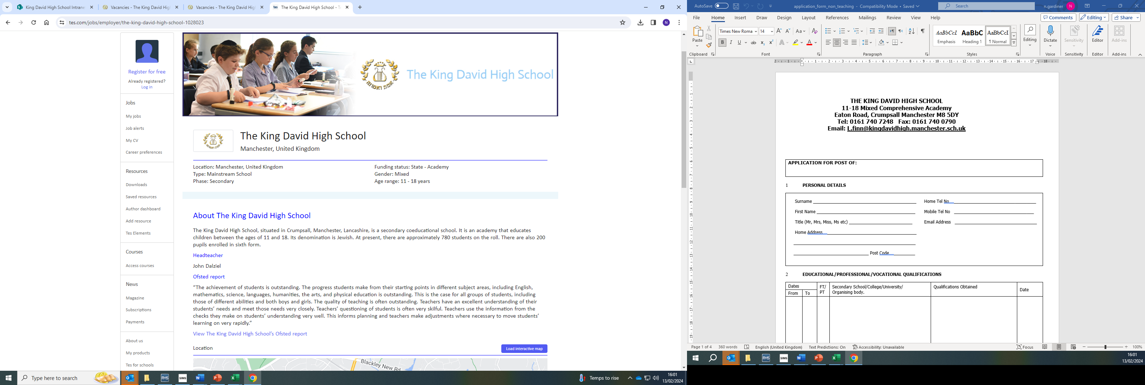
Teacher – Job Description

To be responsible for the teaching and learning of all courses offered at Key Stages 3 and 4. This will involve the monitoring of pupils’ progress and performance in order to ensure that expected learning outcomes are achieved.

Duties and Responsibilities
1. To teach throughout the age and ability range as detailed in the National Curriculum and examination board requirements.
2. To assess and record pupils' progress within the guidelines of National Curriculum and the agreed procedures of the faculty.
3. To maintain an up-to-date knowledge and understanding of the requirements of the curriculum.
4. To contribute to all aspects of work in the faculty, to ensure that the department is successful and continues to offer the pupils of the Academy a safe and stimulating environment.
5. To work as an important member of a team committed to teaching, developing resources and courses and to assist the Senor Leadership team to ensure the successful operation of the faculty.
6. To work collaboratively and cooperatively that is conducive to maintaining the efficient management and organisation of the Academy, which includes weekly duties.
7. To assist in the delivery of the faculties qualifications and to have a secure knowledge and understanding of the subject, its requirements and related pedagogy.
8. To engage in a process of continuing professional development in order to keep knowledge, skills and understanding updated in order to achieve the best possible impact in terms of learning outcomes.
9. Have an awareness of and implement Health & Safety legislative requirements and procedures in order to maintain a safe teaching environment where practical activities can take place.
The above list of job duties is not exclusive or exhaustive and the postholder will be required to undertake such tasks as may reasonably be expected within the scope and grading of the post.
Teacher – Person Specification

QUALIFICATIONS / PROFESSIONAL MEMBERSHIP
- Qualified Teacher Status in specialist area (Essential)
- Honours Degree in relevant subject (Essential)

PROFESSIONAL EXPERIENCE
- To have experience of teaching at KS3 and KS4 (Essential)
- To have had successful teaching experience across the age range and ability (Essential)
- To have an awareness of good practice in identifying individual needs and providing appropriate, differentiated teaching (Essential)

KNOWLEDGE AND SKILLS
- Ability to work as part of a team and develop working relationships with all key stakeholders (Essential)

- Clear evidence of current knowledge and views in subject and curriculum development (Essential)

- Ability to plan coherently and implement developments effectively (Essential)
- Communicate effectively and concisely both in verbal and written form (Essential)

PERSONAL QUALITIES

- To have a positive attitude to all aspects of college life and make contributions towards new initiatives and developments (Essential)

- Ability to review, evaluate and implement schemes of work and syllabus (Essential)

- To be highly organised, with the ability to manage your own workload (Essential)

- To ensure high standards of motivation and self-esteem in the work and attitudes of pupils (Essential)

- A commitment to your own continuous professional development (Essential)

- Personal commitment to the Academy’s professional standards, including dress code, as appropriate (Essential)

The post will require an enhanced DBS clearance.

