f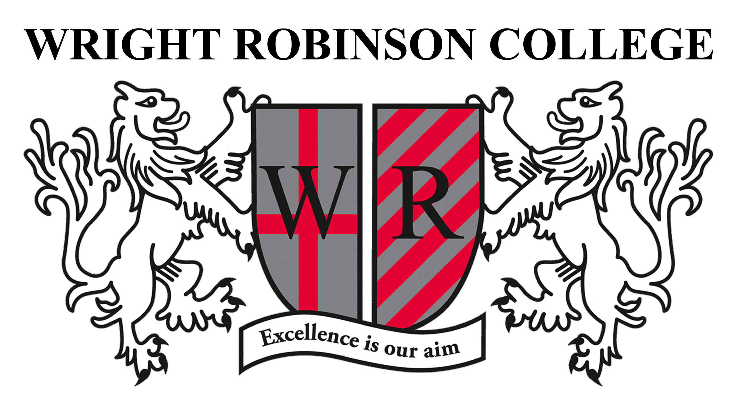

TEACHERS OF SCIENCE

Start Date: September 2021
Main Pay Range / Upper Pay Range

Do you want to work in an Outstanding School? If so, we are seeking to appoint Teachers of Science to join our supportive and successful science department. We are looking for applicants with the desire to take the next step in their career with the skills, expertise and passion to enthuse our young people to achieve across KS3 and KS4.

We welcome applications from NQTs and experienced individuals. A Recruitment and Retention allowance is available for exceptional candidates.

This is an exciting opportunity for you to shape, enjoy and develop your career in our challenging and highly supportive College environment. You will be provided with the best resourcing and a programme of professional development that will enable our learners to access consistently good and outstanding pastoral care.

Wright Robinson College is outstanding in every area of the Ofsted Inspection Framework. As an ‘Outstanding School’ we are totally committed to continuing to further raise academic standards and attainment, across an academic curriculum.

We have a fantastic building which is supported by the latest resources to support learning. We are located on the east side of Manchester with fantastic communication links across the Greater Manchester Conurbation.

Wright Robinson is a friendly and supportive school where you will be able to hone and develop your teaching skills.

Have you got the desire, experience and ambition to join our Team? Is so, we would be delighted to hear from you. Informal enquiries are welcomed and can be directed to Mrs K McGuire (k.mcguire@wrightrobinson.co.uk).

Please apply via TES.
Deadline: 9am on Monday 8th February 2021.
www.wrightrobinson.co.uk.

Wright Robinson College is committed to safeguarding and promoting the welfare of children and young people and expects all staff and volunteers to share this commitment. All appointments are made subject to an enhanced DBS check.
