
SCIENCE TECHNICIAN

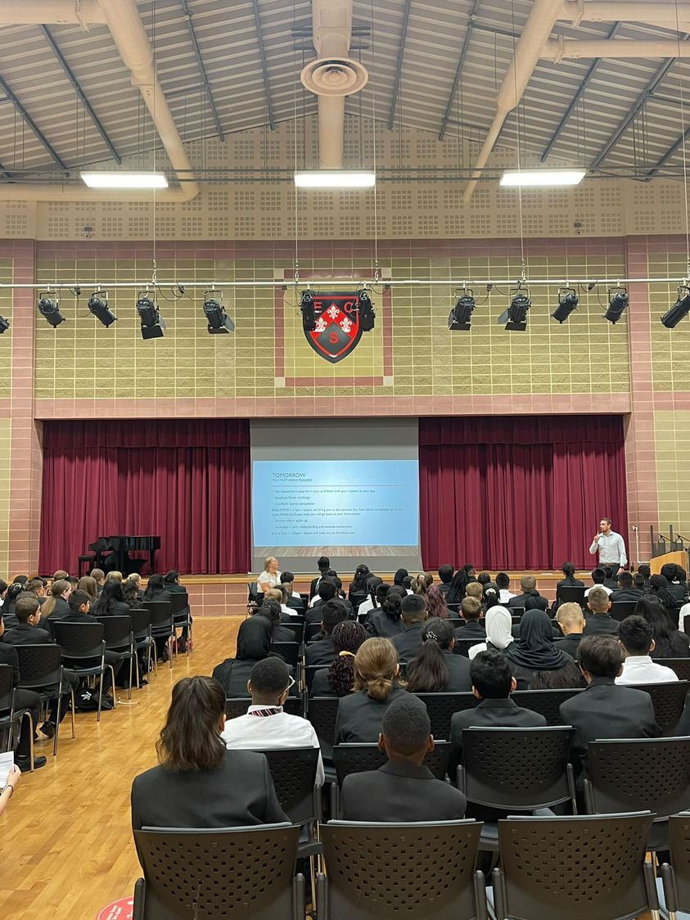

Contents
Headteacher’s Welcome. 4
The Recruitment Process. 5
Advertisement. 6
Department Information. 10
Job Descriptions. 11
Person Specification. 15
Our Ethos and Strategic Direction. 17

Headteacher’s Welcome
Welcome to Eastbury Community School, and thank you for expressing an interest in applying for the position of Science Teacher.
For me, our school is where our young people are given the opportunities to allow them to realise their potential, and that potential can and does manifest itself in a range of ways.
Our young people need to see that success comes in a range of different forms, and ECS is where they can explore where and how they can and will be successful. Our pupils get some of the best progress results in GCSEs in the local area, our 6th Form- judged outstanding (March 2024) achieves some of the best results in the Barking and Dagenham, and over half of these young people go on to attend Russell Group universities.
Our young people need to have a voice in the school, the local community and the wider world. As part of our commitment to this belief we are a Rights Respecting School – Silver award at the moment, but we are confident that within the next year we will achieve Gold – one of the only 3-19 schools in London to do so.
Sir Tim Brighouse said “If a teacher makes the weather the school creates the climate.” and I firmly believe this. It is our role as a leadership team to create the best possible learning environment for our teachers to teach in. In return we expect the best possible teaching from them and our results show this over time. We have created systems and structures that support high quality learning, whilst minimising workload and maximising impact.
Our recent Ofsted report – March 2024 stated:
“Pupils are proud to be part of this inclusive community where people respect and care for each other. They appreciate the support they receive from staff if they have a concern” .
“Leaders are ambitious for all pupils to achieve well”
“The school takes effective steps to address behaviour that does not meet its high expectations. Pupils conduct themselves well and enjoy their time at school. Low level disruption in lessons is rare”
“Staff, including early career teachers, said that leaders have carefully considered their workload and well-being. They value the many opportunities to improve their professional practice.”
If you share our ethos and values and absolutely believe in the potential of all young people then we can offer you the chance to make a difference and change our community for the better, and look forward to receiving your application form and welcoming you to our school.
 Sharon Gladman – Executive Headteacher

The Recruitment Process

Key Dates
Closing Date for Applications Friday 1 November 2024
Interviews w/c Monday 11 November 2024
Please note all dates are subject to change.

Completed applications should be sent to: kdunnell@eastbury.bardaglea.org.uk
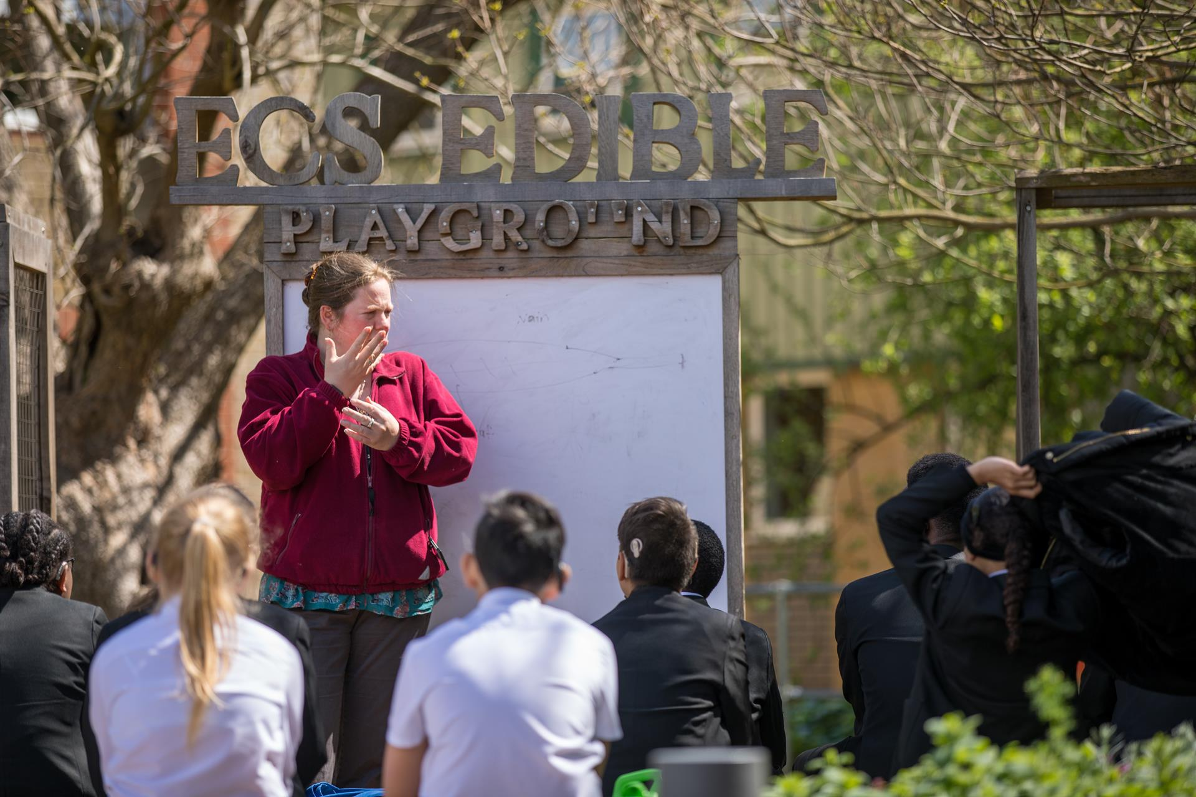
Advertisement

Advertisement

SCIENCE TECHNICIAN

REQUIRED As soon as possible

CONTRACT: One year fixed term/Permanent

SALARY: Scale 3 (Junior) £22,934 - £23,280 (actual salary)

Scale 4 (dependent on experience) £23, 634 - £24,724 (actual salary)

HOURS 35 hours per week term time only

Eastbury Community School is seeking a dedicated, organized, and enthusiastic Science Technician to support our thriving Science department. This is an exciting opportunity to be part of a large, vibrant school community where we strive to inspire young minds and provide a high-quality education for all.

About Us:
Eastbury Community School is a diverse and inclusive 3-19 school that values academic excellence, personal growth, and community engagement. With state-of-the-art science facilities, we are committed to delivering hands-on, engaging science lessons that fuel curiosity and foster a love for learning in our students.

The Role:

As a Science Technician, you will play a key role in supporting the delivery of practical science lessons in Biology, Chemistry, and Physics. You will ensure that materials and equipment are prepared and maintained to high standards, helping teachers provide students with engaging and safe practical experiences. Responsibilities include:
- Preparing, setting up, and clearing away equipment and materials for lessons and demonstrations.
- Ensuring the safe handling, storage, and disposal of chemicals and biological specimens in line with health and safety regulations (COSHH, CLEAPSS).
- Maintaining laboratory equipment and supplies, and placing orders as needed.
- Assisting with the maintenance of an organized and safe laboratory environment.
- Supporting teachers and students during practical lessons.
ECS celebrates its diversity, and we positively welcome applications from all sections of the
community. If you are interested in making a difference in young people’s lives, whatever your background or history please apply.
In return we can offer:

- A pupil centred, progress focused ethos.
- A welcoming and supportive community.
- The opportunity to work with a passionate, hardworking and supportive staff.
- A commitment to develop your skills through continued professional development.
- A supportive and committed Leadership Team and Governing Body.
- A cohort of pupils with high aspirations and a willingness to learn.
- A school which understands the importance of staff well-being and workload management

“Pupils value the opportunities that they have to work with leaders to further improve the
school, for example through the school council. Older pupils, and students in the sixth
form, help pupils in the primary phase with their reading. Pupils benefit from a range of
extra-curricular clubs, both at lunchtime and after school.” (Ofsted March 2024)
Please click here to find out more information about what it is like to work at ECS:
https://www.eastbury.bardaglea.org.uk/
The school is located less than 10 minutes’ walk from Upney tube and 15 minutes from Barking mainline station.

For full details of the post and an application form, please visit the school website www.eastbury.bardaglea.org.uk and return the application form to the Headteacher’s PA, Karen Dunnell kdunnell@eastbury.bardaglea.org.uk. The closing date for applications is Friday 1 November 2024 and interviews will be held w/c 11 November 2024.
ECS is committed to safeguarding and promoting the welfare of children and is an Equal Opportunities Employer.
This post is exempt from the Rehabilitation of Offenders Act 1974 and a comprehensive screening process, including Disclosure check, will be undertaken on all successful applicants.

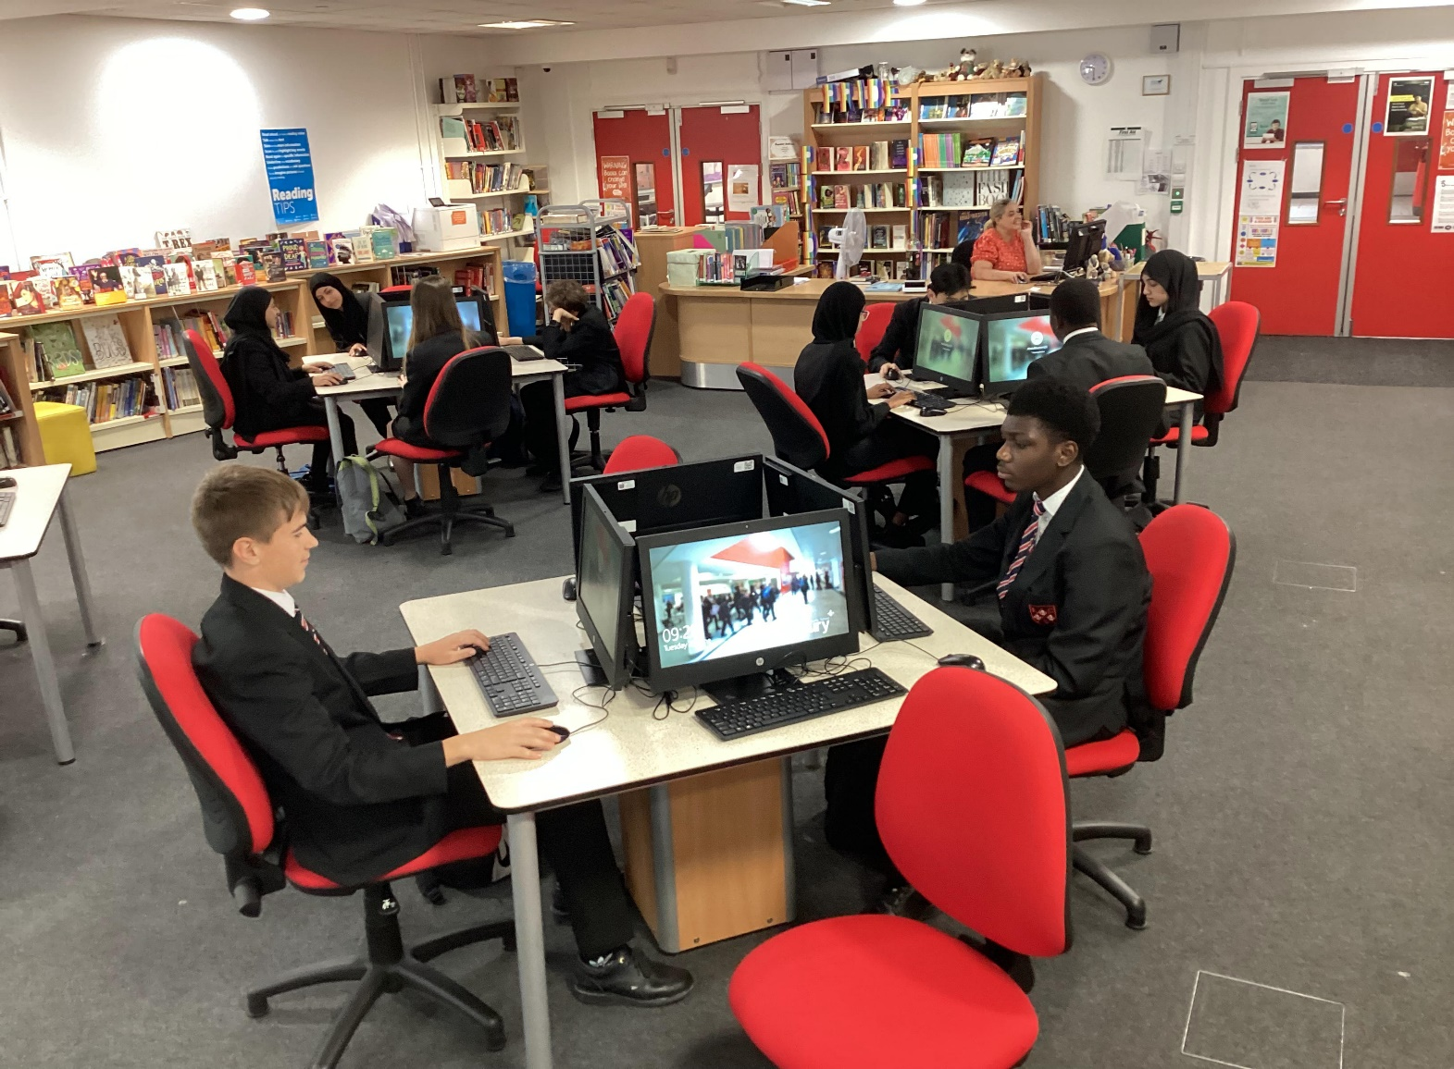




Department Information

Job Description

SCIENCE DEPARTMENT

The Science curriculum at Eastbury Community School is designed to develop the skills needed for our students to become successful learners, curious individuals and confident scientists. At Eastbury, our teaching ethos stems from the idea that all our learners have the potential to be scientists of the future. Through practical work, scientific inquiry and the continuous exploration of vital links between the science curriculum and everyday life, we endeavoUr to ignite a passion for discovery in our students that will last a lifetime. We educate our students about the importance of future advancements and discoveries to enable them to engage with an increasingly technical world and encourage them to explore the possibility of pursuing a career in science.

- At Key Stage 3, all students study science – learning about the fundamentals of biology, chemistry and physics.
- At Key Stage 4, students follow the AQA GCSE trilogy specification. Students are given the opportunity to choose separate or combined science
- At Key Stage 5, the faculty offers A-levels in all three subjects, following the AQA syllabus for Biology and the OCR syllabus for Chemistry and Physics.

Job Description

Job Description

Supervising Officer: Head of Department & Senior Science Technician

Grade/Scale: Scale 4

Review date: October 2024

Designation: Science Technician

Role and nature of job: To assist in the provision of practical resources in the Science Department

Main Duties:

In general;

- Ensure compliance with the LA’s Equal Opportunities in Employment policy.

- Ensure compliance with the Health and safety Legislation as set out by the LA, School and Department

Further to;

Key responsibilities | Activities that are likely to be  carried out | Suggested frequency
Under the direction of the Senior technician, to coordinate the use of practical resources and facilities and provide assistance and advice in the practical needs of the science  curriculum, including liaising with teaching staff and support staff outside the department. | Preparation of resources, assembling  apparatus.  Obtaining materials by local  purchase.  Giving technical advice to teachers,  technicians and pupils / students.  Carrying out risk assessments for  technician activities.  Assisting in practical classes &  carrying out demonstrations.  Manage the daily operation of LabLogger for resource and practical request tracking.  Monitor and process practical requests through LabLogger, ensuring timely allocation of resources.  Generate reports from LabLogger. | Daily  Weekly  Daily  Daily  Weekly  Daily  As required  Weekly
To ensure the maintenance of a healthy & safe working environment through:  • Actively contributing to the assessment,  monitoring and review of both health &  safety procedures and information  resources;  • Keeping up to date with current procedures and practices through continuing professional development;  • the provision of technical advice and  support on health & safety issues to  teaching and trainee technical staff;  • the safe treatment & disposal of used  materials including hazardous substances and responding to actual or potential  hazards;  • the healthy & safe storage and accessibility of equipment and materials. | Keeping up-to-date with health &  safety requirements and with developments in practical science.  (Attending courses, keeping professional portfolio & reading  publications.)  Giving health & safety advice to  technical staff, teachers and  students.  Assist with disposal of waste materials.  Check and audit fume cupboards, pressure vessels and first-aid kits; electrical and other safety checks,  etc.  Organising, storing and checking the  condition of chemicals and  equipment. | As required  Daily  As required  As required  As required
To assist the Senior technician with the day-to-day organisation and development of trainee staff to ensure that essential performance standards are achieved | Organising and supervising trainee  technicians as required. | Daily
To contribute to the choice, development and maintenance of specialist resources. | Constructing & modifying apparatus.  Setting up and caring for plant and  animal collections.  Preparing standard solutions,  purifying chemicals, treating waste. | As required  Daily  As required
To support the Senior technician  in ensuring the availability of suitable materials and equipment, helping to compile orders and liaising or negotiating with suppliers and finance departments. This will include sourcing, costing and suggesting economic alternatives to maintain stock levels. Keeping up-to-date stock records. | Checking stock, ordering.  Keeping stock records.  Maintaining resources. | As required  Annually  As required
Under the (overall) guidance of the Senior technician, to ensure that both routine and non-routine checking, cleaning, maintenance, calibration, testing and repairing of equipment are carried out to the required standard. | Collecting, checking and returning  equipment to stores.  General laboratory cleaning of bench  surfaces and fixed equipment.  Cleaning and repair of equipment. | Daily  Weekly  Monthly
Under the supervision of the technician (and/or higher grades), carry out administrative duties deemed appropriate by the Senior Science Technician. | Distribution of stationary.  Photocopying.  Prepare and deliver cover work.  Filling of paper resources. | As required  As required  As required  As required
Working as a team and collaborating effectively with teaching staff and fellow technicians to ensure lessons and experiments run smoothly.  A sense of humour is preferable for maintaining a positive and approachable atmosphere in the department. | Setting up lab equipment in coordination with others.  Helping with departmental projects.  Troubleshooting technical issues together.  Day-to-day activities might involve light-hearted interactions with students and colleagues, supporting team morale during busy times, with a positive, fun outlook. | As required  As required  As required  As required
First Aid Duties as required

Job Description : Junior Science Technician

Name:

Supervising Officer: Head of Department & Senior Science Technician

Grade/Scale: Scale 3

Review date: October 2024

Designation: Trainee/Junior Science Technician

Role and nature of job: To assist the Senior Science/ Assistant Technicians

Main Duties:

In general;

- Ensure compliance with the LA’s Equal Opportunities in Employment policy.

- Ensure compliance with the Health and safety Legislation as set out by the LA, School and Department

Key responsibilities | Activities that are likely to be  carried out | Suggested  frequency
Under the direction of the team-leader technician, (senior and/or technician where appropriate), to provide assistance and information as required in the preparation of resources for practical lessons that meets both the health & safety standards and the requirements of the classes involved. | Preparation of solutions, materials,  cultures for living organisms.  Assembling apparatus.  Trialling practical activities.  Carrying out risk assessments for  technician activities.  Constructing and modifying  apparatus.  Giving technical advice to teachers, technicians and pupils/students.  Manage the daily operation of LabLogger for resource and practical request tracking.  Monitor and process practical requests through LabLogger, ensuring timely allocation of resources.  Generate reports from LabLogger. | Daily  Daily  As required  Daily  As required  Daily  Daily  As required  Weekly
Under the supervision of the technician (and/or higher grades), to provide general assistance in the safe storage, transit and accessibility of resources, including helping to:  • Ensure that stock levels are maintained and future requirements are identified;  • Ensure the availability of suitable  resources;  • Compile orders and to liaise with suppliers and finance departments as/when required. | Delivery of equipment, materials and  organisms to rooms.  Collection of, checking and returning  resources to stores.  Checking stock, ordering.  Keeping stock records.  Maintaining resources, including routine repairs.  Organising, storing and checking the condition of chemicals and equipment.  Caring for plants and animals. | Daily  Daily  As required  Annually  As required  As required  Daily
Assisting the technician team to ensure a healthy, safe and productive work environment through the routine maintenance and cleaning of equipment, laboratories and prep rooms. | Organising and storing resources.  General cleaning of laboratory bench  surfaces and fixed equipment.  Cleaning laboratory sinks.  Cleaning used equipment.  Disposing of waste materials. | On-going  Weekly  Monthly  Daily  As required
Under the supervision of the technician (and/or higher grades), carry out administrative duties deemed appropriate by the Senior Science Technician. | Distribution of Stationary.  Non bulk photocopying.  Lay out cover work for supply staff.  Filling of paper Resources. | As required  As required  As required  As required
Working as a team and collaborating effectively with teaching staff and fellow technicians to ensure lessons and experiments run smoothly.  A sense of humour is preferable for maintaining a positive and approachable atmosphere in the department. | Setting up lab equipment in coordination with others  Helping with departmental projects  Troubleshooting technical issues together.  Day-to-day activities might involve multiple interactions with students and colleagues, supporting team morale during busy times, with a positive outlook | As required  As required  As required  As required
First Aid Duties as required
Proposed Other Specific Duties:
To undertake personal professional development as agreed with the Headteacher and attend nominated training courses for professional development when necessary.

Whilst every effort has been made to explain the main duties and responsibilities of the post, each individual task undertaken may not be identified.

Employees will be expected to comply with any reasonable request from a manager to undertake work of a similar level that is not specified in this job description

Employees are expected to be courteous to colleagues and provide a welcoming environment to visitors and telephone callers.

The school will endeavour to make any necessary reasonable adjustments to the job and the working environment to enable access to employment opportunities for disabled job applicants or continued employment for any employee who develops a disabling condition.

Reporting to: | Senior Science Technician,/Head of Department
Responsible for:
Liaising with: | Staff and students, parents, outside agencies, local authority.
Working Time: | 35 hours per week, full time
Salary/Grade: | Scale 3
Disclosure level | Enhanced

Person Specification

Person Specification

PERSON SPECIFICATION
Science Technician
Scale 3
EDUCATION, QUALIFICATIONS
Essential criteria

- A good standard of general education with demonstrable English and mathematics skills.
Desirable criteria
- A levels in physics, biology or chemistry or BTEC in science or equivalent
EXPERIENCE, SKILLS AND KNOWLEDGE:
Essential criteria
- Genuine demonstrable interest in Science, with evidence of a desire to develop your career as a technician, a commitment to personal development, continuing professional development.
- Basic IT skills e.g. Outlook and Microsoft Office

Desirable criteria
- Basic technical skills relevant to the role; to include experience of working, and knowledge of relevant health and safety processes, with chemical and biological reagents
- Experience of working in a UK Laboratory environment and/or, experience of working in a UK teaching and learning laboratory environment

COMMUNICATION AND INTERPERSONAL SKILLS:
Essential criteria:
- Good interpersonal skills, with a friendly and approachable style and the ability to communicate effectively both verbally and in writing with people from a range of backgrounds and professions and able to deal confidently with students and customer focussed
- Punctual and reliable with good organisational skills with the ability to follow procedures in an accurate and timely manner and to be to quickly identify the most efficient and effective way of completing a task

TEAMWORKING, PERSONAL ATTRIBUTES AND QUALITIES:
Essential criteria:
- Flexible, adaptable and collaborative approach to the job
- Excellent organizational skills, able to manage multiple tasks
- Ability to work as a team member
- A proactive, can-do attitude with the ability to work independently, anticipate needs, and solve problems
- Have a good sense of humour
- Commitment to and understanding of equality and diversity issues within a diverse and multicultural environment
SENSORY AND PHYSICAL DEMANDS:
Essential criteria:
- Good level of general fitness and well-being and able to cope with physical demands of role, e.g. manual handling tasks

OTHER ESSENTIAL CRITERIA:
- Willingness to undertake other roles, such as becoming a Fire Warden or a First Aider

RSON SPECIFICATION
Science Technician
Scale 4
EDUCATION, QUALIFICATIONS
Essential criteria

- A good standard of general education with demonstrable English and mathematics skills.
Desirable criteria
- A levels in physics, biology or chemistry or BTEC in science or equivalent
EXPERIENCE, SKILLS AND KNOWLEDGE:
Essential criteria
- Experience of a Science setting, with evidence of a desire to develop your career as a technician, a commitment to personal development, continuing professional development.
- Experience of using IT systems e.g. Outlook and Microsoft Office, Lablogger
- Excellent organizational skills with the ability to manage and maintain laboratory stock levels and place orders for consumables and equipment.

Desirable criteria
- Basic technical skills relevant to the role; to include experience of working, and knowledge of relevant health and safety processes, with chemical and biological reagents

- Experience of working in a UK Laboratory environment and/or, experience of working in a UK teaching and learning laboratory environment

- Experience in adhering to and implementing health and safety regulations, including handling hazardous substances, preparing risk assessments, and safe waste disposal.

- Excellent organizational skills with the ability to manage and maintain laboratory stock levels and place orders for consumables and equipment.

COMMUNICATION AND INTERPERSONAL SKILLS:
Essential criteria:
- Good interpersonal skills, with a friendly and approachable style and the ability to communicate effectively both verbally and in writing with people from a range of backgrounds and professions and able to deal confidently with students and customer focussed
- Punctual and reliable with good organisational skills with the ability to follow procedures in an accurate and timely manner and to be to quickly identify the most efficient and effective way of completing a task

TEAMWORKING, PERSONAL ATTRIBUTES AND QUALITIES:
Essential criteria:
- Flexible, adaptable and collaborative approach to the job
- Excellent organizational skills, able to manage multiple tasks
- Ability to work as a team member
- A proactive, can-do attitude with the ability to work independently, anticipate needs, and solve problems
- Have a good sense of humour
- Commitment to and understanding of equality and diversity issues within a diverse and multicultural environment
- Willingness to contribute to the wider school community, including supporting extracurricular activities or science-related events.
SENSORY AND PHYSICAL DEMANDS:
Essential criteria:
- Good level of general fitness and well-being and able to cope with physical demands of role, e.g. manual handling tasks

OTHER ESSENTIAL CRITERIA:
- Willingness to undertake other roles, such as becoming a Fire Warden or a First Aider



Our Ethos and Strategic Direction

Our Ethos and Strategic Direction



