Science Technician, Winchester

# APPLY BY:

*Monday 27th June 2024 (midday)*

# INTERVIEWS:

*Week commencing 1st July 2024*

# SALARY:

*2 days (15 hrs) 39 weeks per year*

*Grade C 23,115 FTE 15 hours a week actual salary £8,015 PA*

# START DATE:

*September 2024*

*Do you want to be part of ‘an inclusive school community where pupils are happy and proud of their achievements’ [Ofsted 2023]*

*Do you want to make a difference to the outcomes for all students in a school where staff ‘have high expectations’ [Ofsted 2023]*

We have a vacancy for a Science Technician and are eager to appoint someone with enthusiasm and good organisational skills to provide technical support to the Science department. You will need a flexible approach to work, and an ability to work to deadlines to join our established successful Science team. Previous experience is not essential as training can be given.

Work experience in a science-based occupation or a science qualification (particularly in Chemistry or Physics) would be beneficial.

This role is supported with an advanced Apprenticeship in Laboratory Technician L3, which would prove hugely beneficial for candidates seeking progression to senior Science Technician.

The successful candidate will:

* Be committed to comprehensive education
* Have students at the heart of what drives their decision making

If you would to like work in a vibrant and progressive environment, we would love to hear from you. You will join a committed, successful and supportive team. As a school, colleagues benefit from a complementary package of health- related support provided by Education Mutual. This is an excellent opportunity to join a successful secondary school where our students are ‘happy and proud of their achievements’ [Ofsted 2023].

If you are interested in discussing this post, please contact Sonia Atkins, Academic Leader for Science, by email:

[sonia.atkins@staff.beaufort.hants.sch.uk](mailto:sonia.atkins@staff.beaufort.hants.sch.uk)

*To apply:*

*Applications should be made to the Headteacher. To apply please complete an application form, available from our website* [*www.beaufort.hants.sch.uk/workwithus*](http://www.beaufort.hants.sch.uk/workwithus) *and return to* [*recruitment@staff.beaufort.hants.sch.uk*](mailto:recruitment@staff.beaufort.hants.sch.uk)

*or please complete an application via TES.*

**The school is committed to safeguarding children and promoting their welfare. All successful candidates will be subject to a Disclosure and Barring Service check along with other relevant pre-employment checks. Including an online search for all shortlisted candidates.**

**All Candidates shortlisted for interview will be subject to an online profile search in line with keeping children safe in education (KCSIE) recommendations.**

JOB DESCRIPTION- Technician Reports to: Academic Leader Science

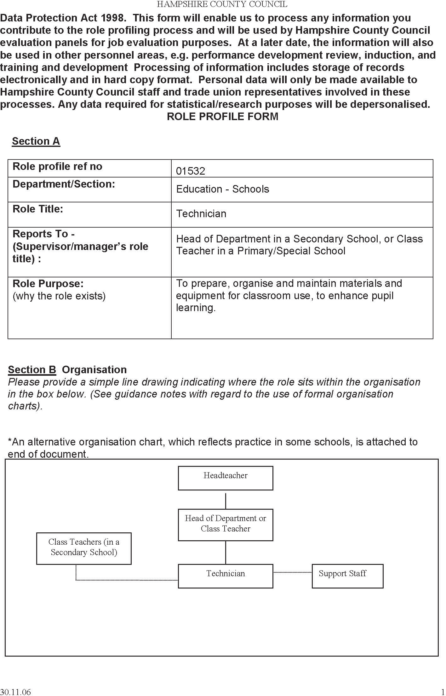

JOB DESCRIPTION- Technician Reports to: Academic Leader Science

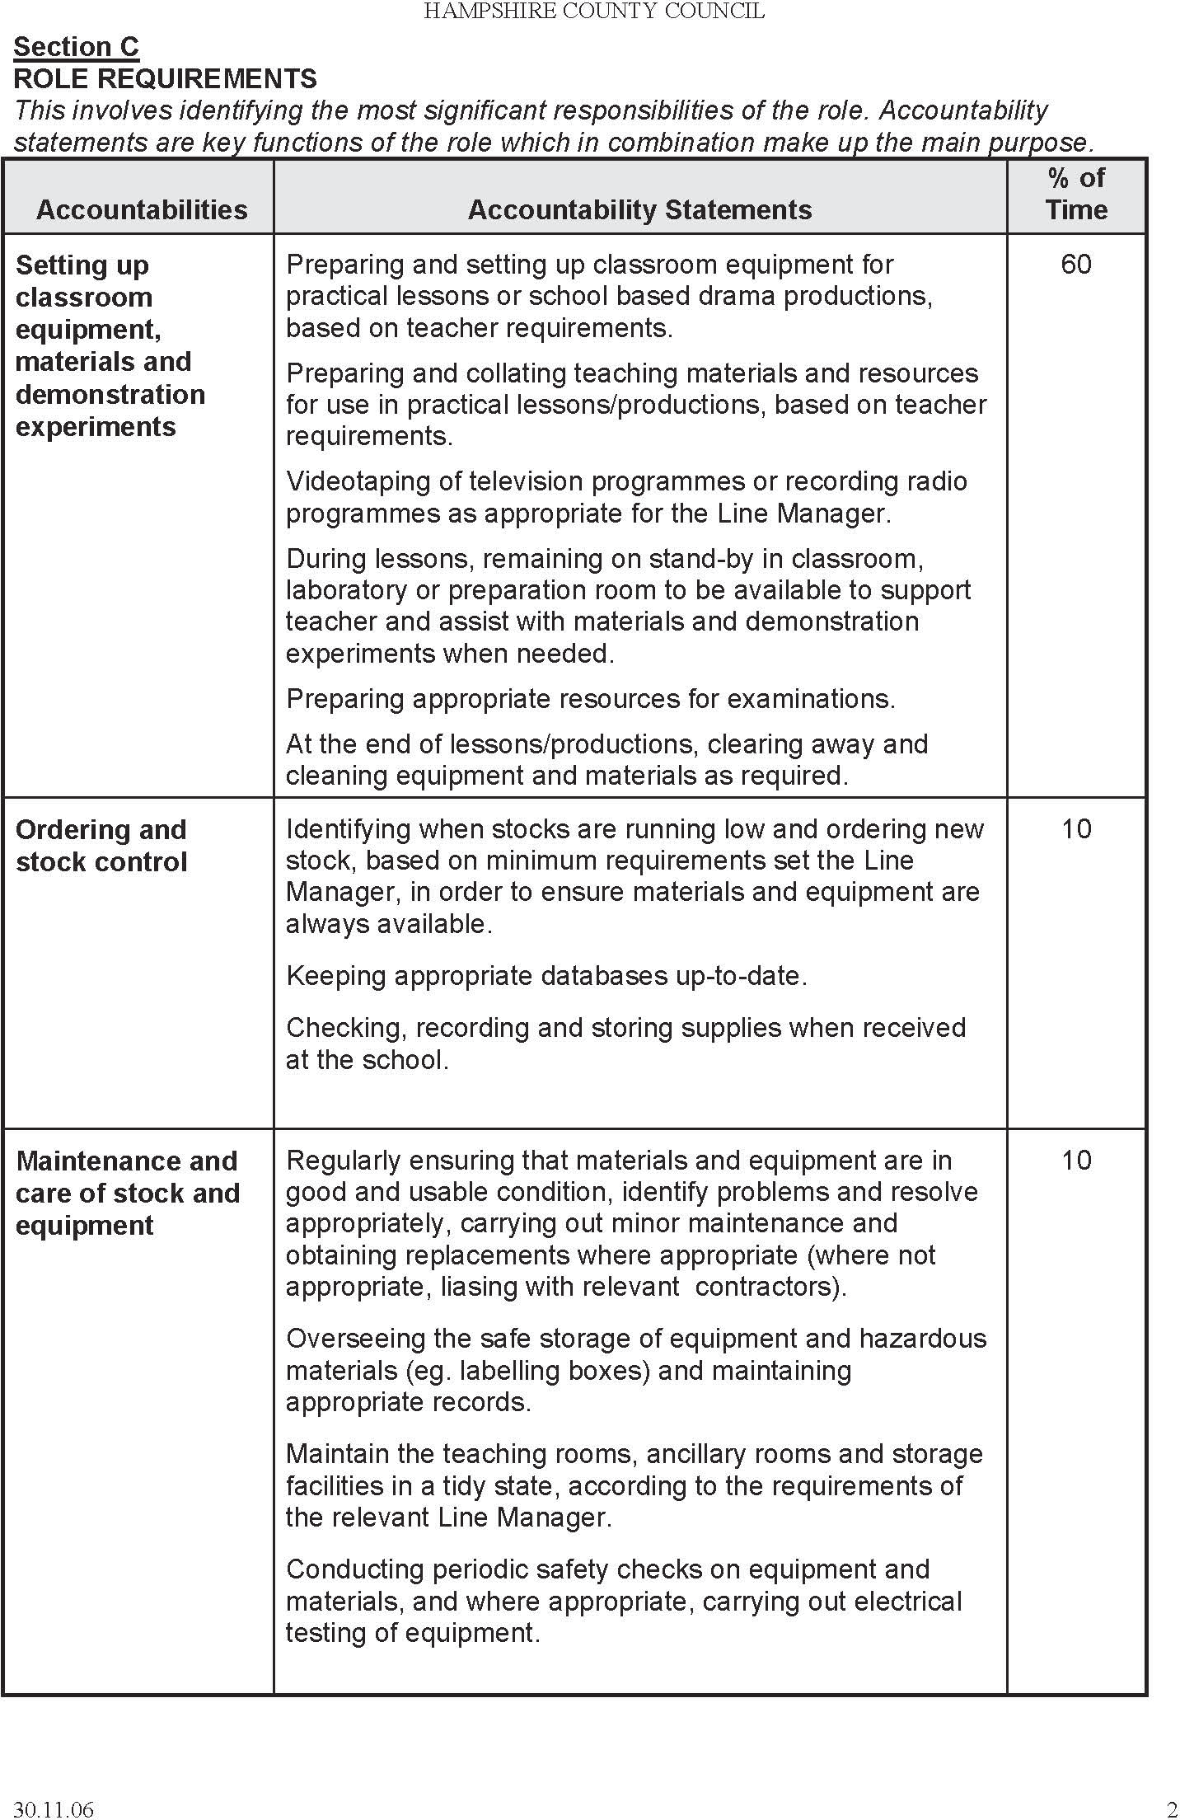

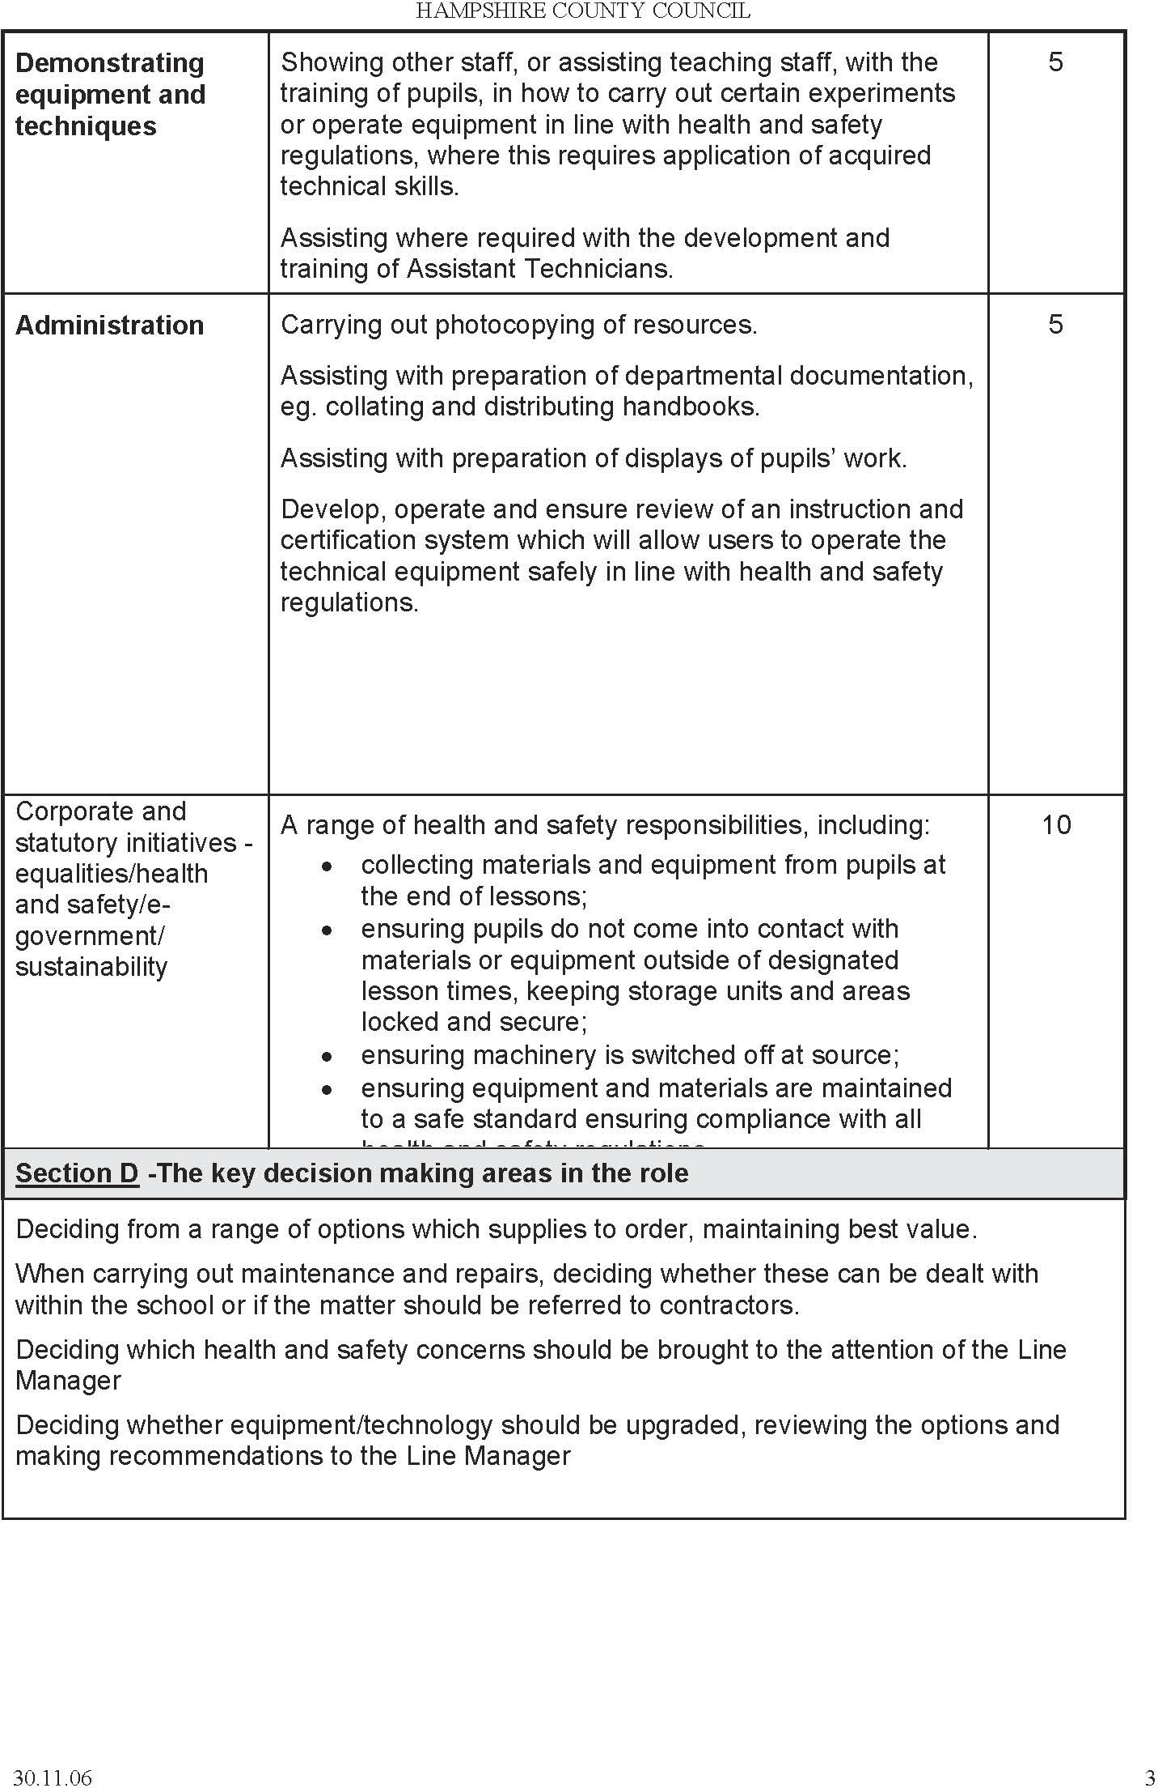

JOB DESCRIPTION- Technician Reports to: Academic Leader Science

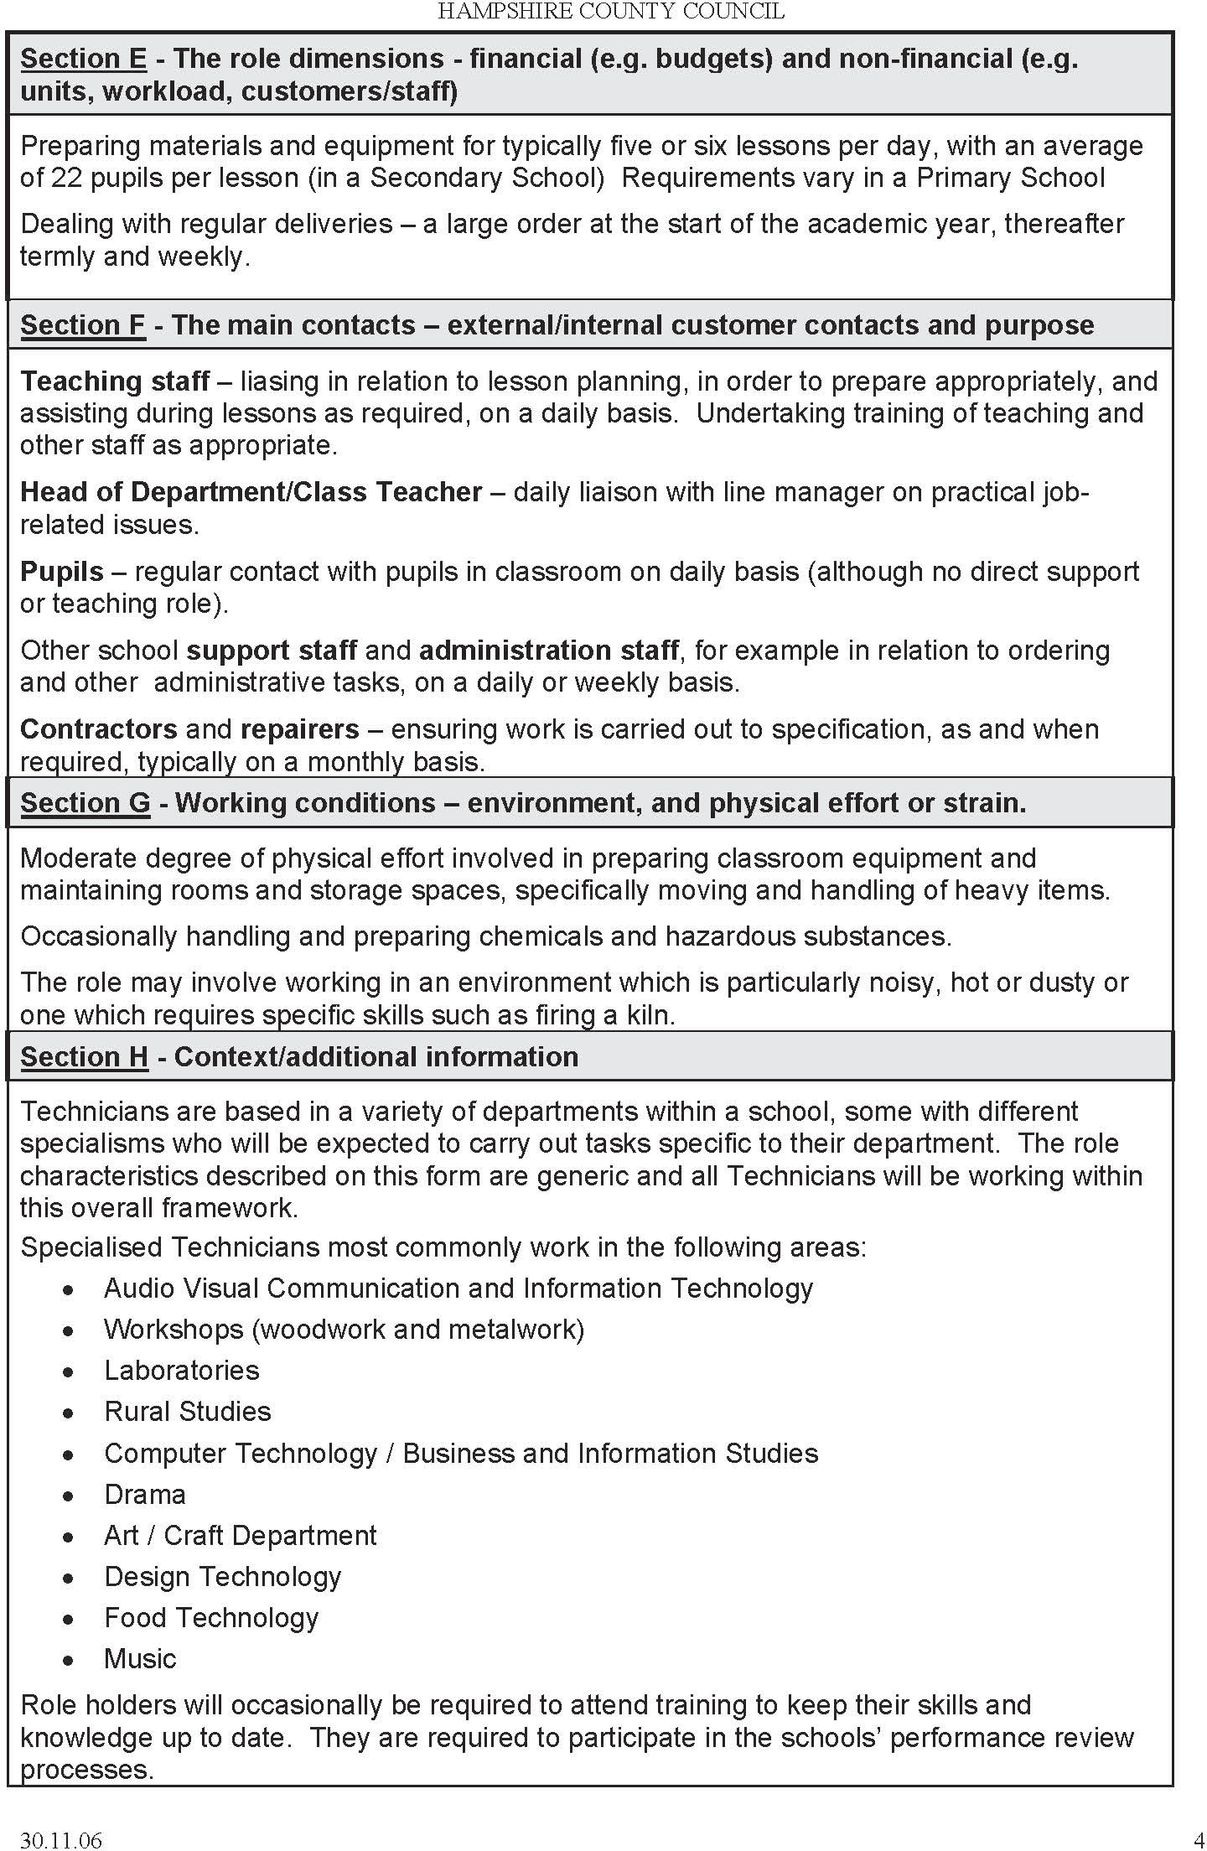

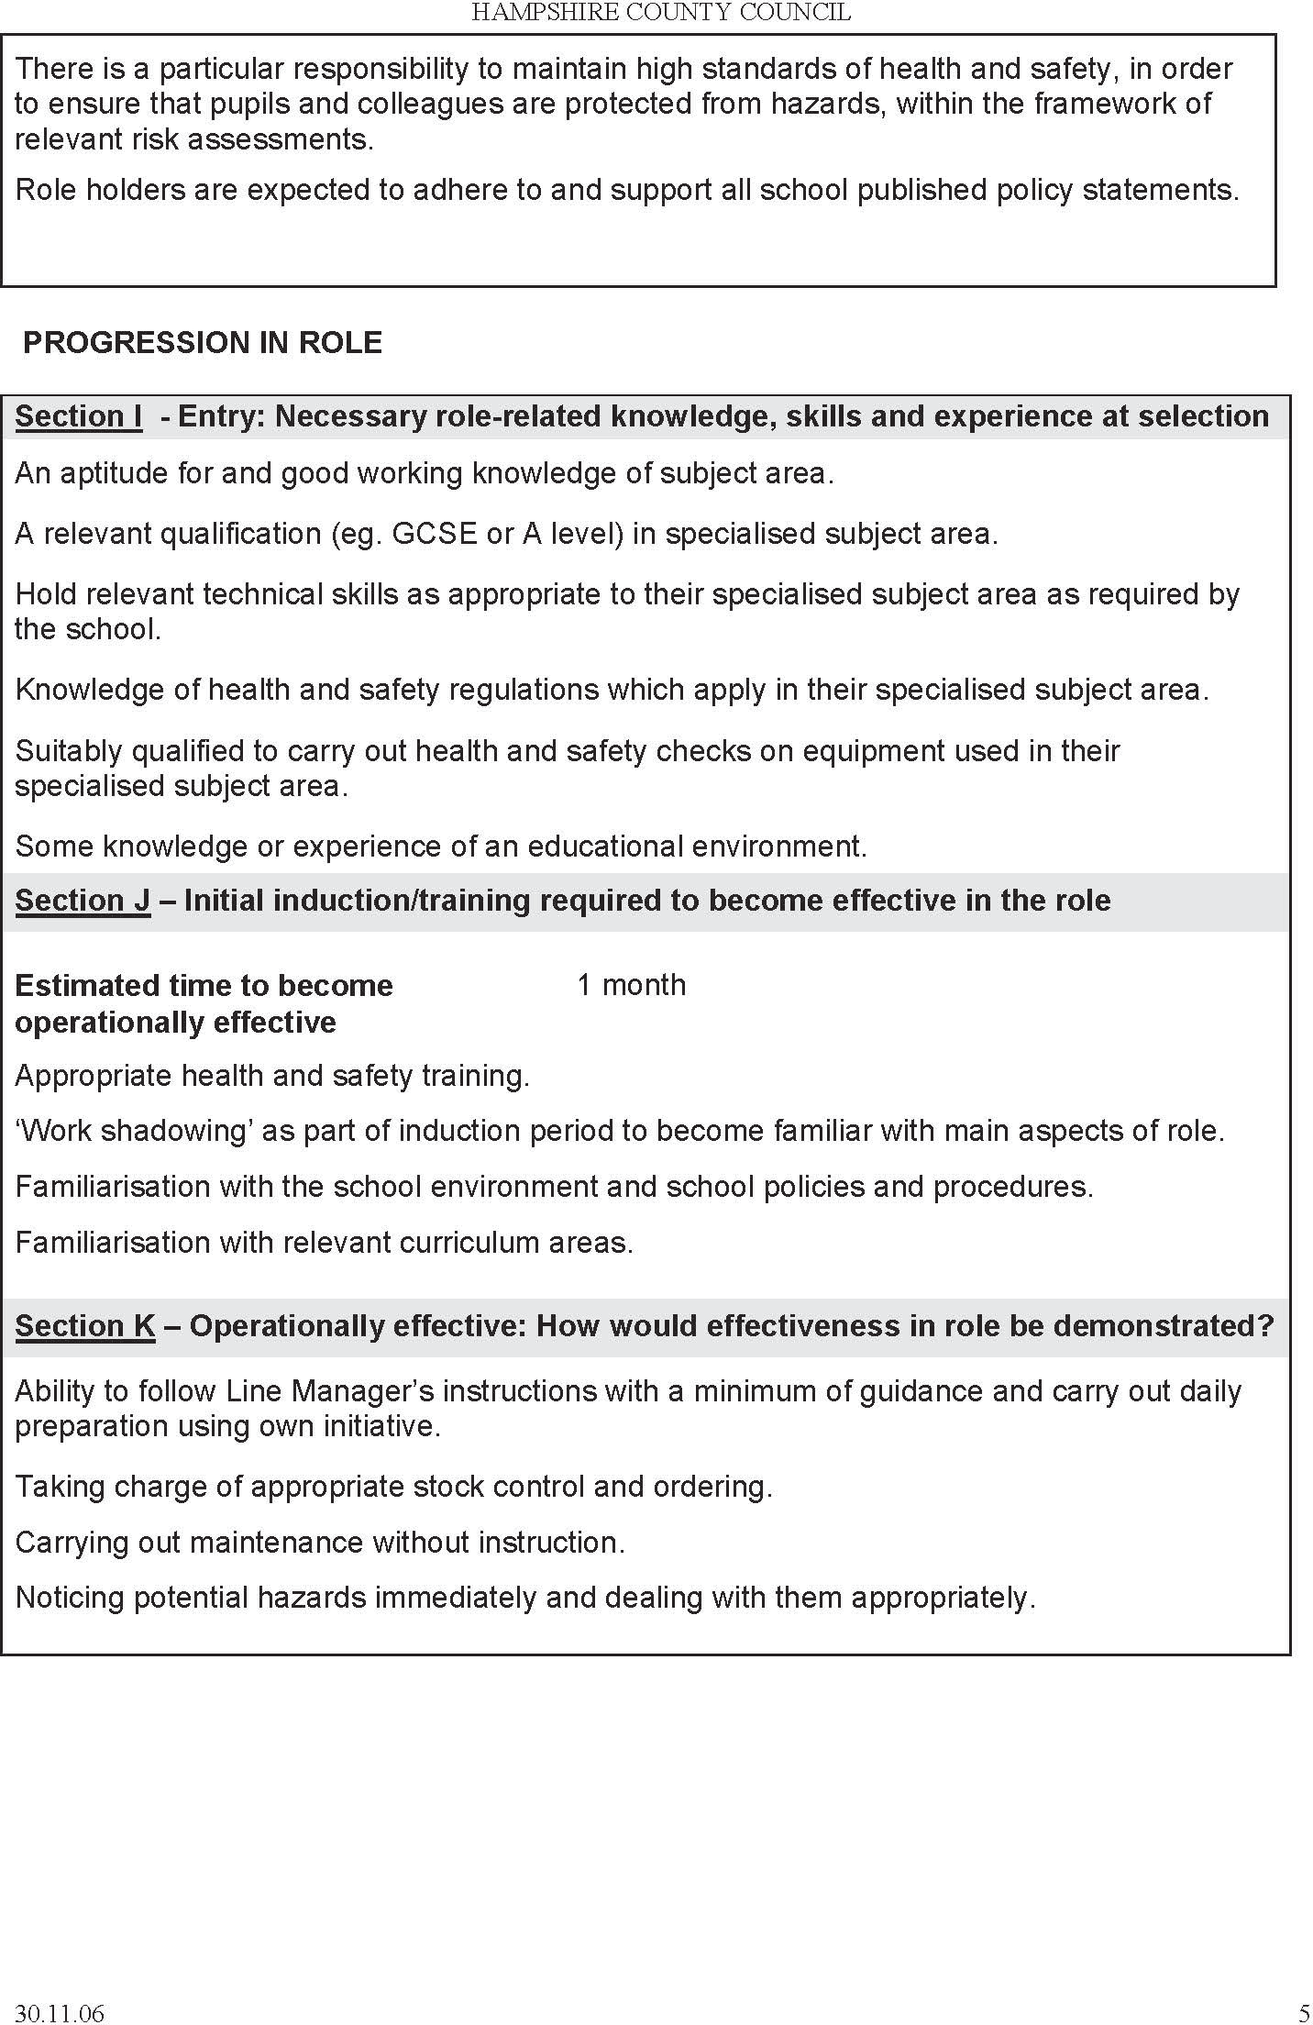

JOB DESCRIPTION- Technician Reports to: Academic Leader Science

