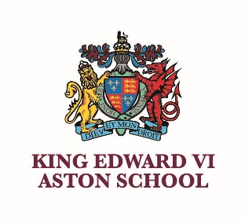 | KING EDWARD VI ASTON SCHOOL  Frederick Road, Aston,  Birmingham B6 6DJ  A selective grammar school for boys  and one of the eleven Schools of King Edward VI in Birmingham | 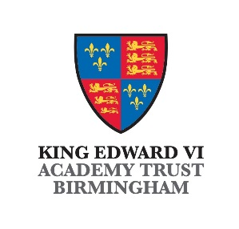
 | NOR: 998

SCIENCE TECHNICIAN
Required from September 2024
(earlier start date would be considered for a suitable candidate)

PERMANENT, FULL TIME (or term time only +2 weeks)
NJC Point 6 - Salary £23,893 (FTE)

We are seeking to appoint a permanent, full time, Science Technician from September 2024 (earlier start date would be considered for a suitable candidate) to assist teaching staff in the preparation of practical work in Physics and/or Chemistry at all key stages.

This is a full-time position of 36.5 hours per week with some flexibility available with regards to working hours during the school holidays.

Previous experience of working in a school or scientific field is an advantage but is not necessary for this role. The successful applicant should have a genuine interest in the subject backed up by a passion for working with young people.

As a grammar school, we are privileged to work with able learners with a thirst for knowledge. However, it is equally important to note that successful applicants would join a school with kindness and integrity at the heart of our values system. We pride ourselves on being a friendly and inclusive school in which you can develop the love for your subject and share it with keen learners.

King Edward VI Aston School is one of the six King Edward VI Grammar Schools in Birmingham and a member of the King Edward VI MAT. The school is committed to safeguarding the wellbeing of its students and the successful candidate will be required to undertake DBS and Prohibition checks.

Applicants should send a completed school application form, including the names and addresses of two referees, to the Headteacher at vacancies@keaston.bham.sch.uk The school application form and further information can be downloaded from our website www.keaston.bham.sch.uk

NO AGENCIES OR CVs

Closing date: 9.00am on Wednesday 19th June 2024
Interviews: Scheduled to take place on Monday 24th June 2024

King Edward VI Aston School is committed to safeguarding and promoting the welfare of children and young people and expects all staff and volunteers to share this commitment.
The successful applicant will be required to undergo DBS and Prohibition checks.

