Information for candidates

**Science Technician**

Salary Range

C1 TTO + 5 days or Full Time all year round if preferred

£19,037 - £21,018 (TTO actual salary)

£22,183 - ££24,491 (Full time salary)

Ralph Thoresby School

Holtdale Approach

Leeds

LS16 7RX

Telephone: 0113 3979911

Email: [headteacher@ralphthoresby.](mailto:headteacher@ralphthoresby.)com

Headteacher: Mr Will Carr

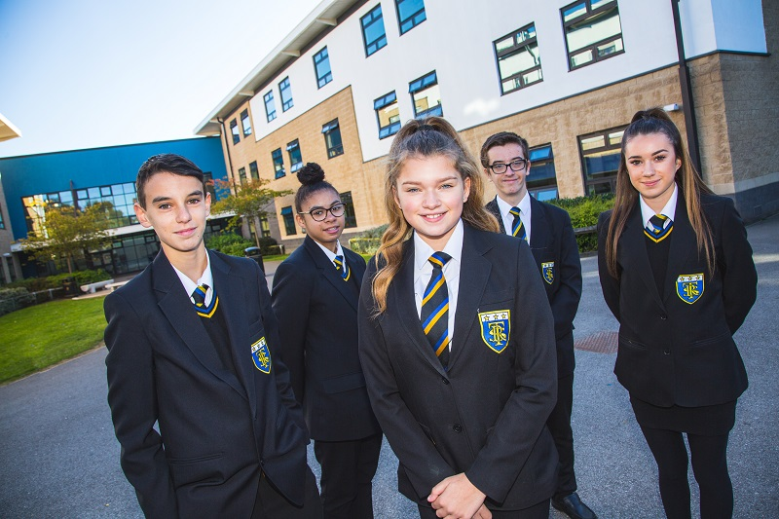

**Contents**

|  |  |
| --- | --- |
| **Page** | **Item** |
| 3 | Letter from the Headteacher |
| 4 | The Selection Process |
| 5 | Information for candidates |
| 6 | Job Description |
| 7 | Person Specification |
| 10 | Beliefs, aims and expectations |

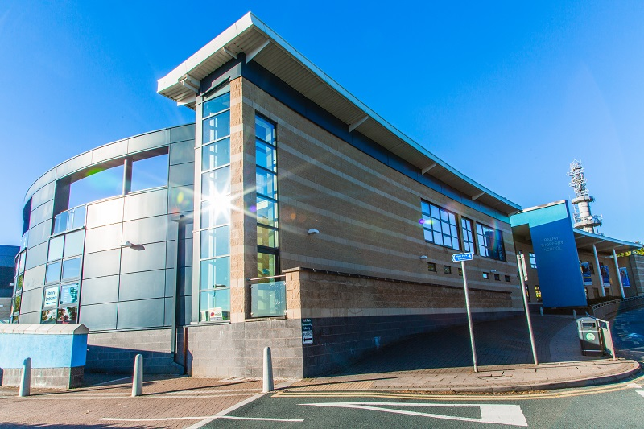January 2022

Dear Candidate,

Thank you for expressing an interest in applying for the post of Science Technician at Ralph Thoresby School.

This is an exciting time to be joining Ralph Thoresby School. The school was judged as GOOD by Ofsted once again in October 2018, consolidating the significant improvements made in recent years. Educational outcomes are consistently strong at all levels. Students make good progress here because, ‘the working atmosphere in classrooms is positive’ and ‘pupils take pride in their work’ (Ofsted). We have a strong focus on staff and student well-being, an ambitious and exciting curriculum and a brilliant, dedicated and supportive staff team.

The School is a mixed comprehensive community school with over 1,000 students on role. 30% of our students come from ethnic minority backgrounds and we have a resource provision for physically impaired students which really adds to the positive and harmonious atmosphere around school. Our superb, modern school building further enhances the atmosphere and supports students’ learning. ‘This is a school where staff and pupils celebrate diversity and promote values of tolerance, mutual respect and care for others’ (Ofsted).

We have an excellent 6th form partnership arrangement with Lawnswood School (another GOOD local school) and together we offer post-16 provision to rival the best in the city – ‘The quality of provision for post-16 students remains good. Students make consistently good progress over time’ (Ofsted). We are a Trust school in partnership with several of our local partner Primary schools. We are also part of the successful and highly regarded Red Kite Alliance teaching school hub and work closely with the Red Kite Learning Trust. ‘Partnership working is strong’ (Ofsted).

Our school motto is ‘ambition and achievement for all’. We firmly believe in giving all students the opportunity to achieve their very best regardless of the circumstances in which they find themselves.

We are excited about the future here at Ralph Thoresby and, having read the information included in this pack, I hope you feel you can play an important part and submit an application. Please also ensure that you visit our website which will give you an insight into the work of the school. I look forward to welcoming you to the school as a candidate in the near future.

Yours faithfully,



Mr Will Carr (Headteacher)

**THE SELECTION PROCESS**

**How to Apply**

Thank you for taking time to read and digest our information. If you wish to apply for the post of Science Technician at Ralph Thoresby School then you should:

* Complete fully the enclosed application form, ensuring all details are accurate and all declarations are signed. Please ensure you enclose two professional referees with one being your current employer (with email addresses if possible). Do not enclose additional CVs.
* Write a letter of application which:

*Details how your career to date fits you to the Qualifications and Experience, Skills & Knowledge and Personal Qualities and Skills sections of the Personnel Specification.*

Please use a font with a point size of 12 – 2 sides of A4 MAXIMUM.

* Submit your letter and application to be received by 12noon on Friday 22nd January 2022. To be received by email no later than 12noon on this date.

Please address all return mail to Mrs D Maw, PA to the Headteacher and Senior Leadership Team and email your application to: headteacher@ralphthoresby.com

________________________________________

**Timetable for the selection process**

* Post advertised: Monday 10th January 2022
* Closing date for applications: 12noon on Friday 22nd January 2022
* Short listing: w/c Monday 24th January 2022
* Invitation to interview by telephone: w/c Monday 24th January 2022
* Confirmation by email: w/c Monday 24th January 2022
* Reference requested: w/c Monday 24th January 2022
* Selection day scheduled: w/c Monday 24th January 2022

|  |  |
| --- | --- |
| **Science Department information at Ralph Thoresby School.**  At Ralph Thoresby, we believe that a high quality science education provides the required foundations for understanding and making sense of the world around us. It is our responsibility to ensure that the teaching we provide for our students equips them fully for the next stages of their education and beyond.  **Staffing**  The science department at Ralph Thoresby School is made up of 8 specialist teachers from all three areas of science, as well as one science technician. The team is highly supportive of each other and works collaboratively in both planning and delivery of the curriculum. Recent quality assurance data shows that the quality of teaching is consistently improving in the department and that significant steps have been taken to ensure that students receive a high quality education in all lessons. The successful candidate will support and contribute to the achievement of every child’s outcomes by providing technical support that enhances teaching and learning in science.  **Accommodation and Resourcing**  All science teaching takes place in a suite of 8 dedicated science laboratories, which provide an outstanding environment for quality teaching and learning to take place. In addition, there is an ICT suite as part of the science corridor, which can be used to support learning and develop different styles of teaching. Collaborative planning is being developed to ensure that excellent resources are available for learners of all ages and abilities.  **Courses and Qualifications**  All students at Key Stage 3 study science for 6 hours per fortnight, and follow a programme of study developed by the science team. These units are designed to cover the essential knowledge and skills that we believe are necessary to fully equip students for their studies at Key Stage 4.  At Key Stage 4, GCSEs are delivered from the AQA specification. In Y11 students have been guided towards one of three science pathways; Triple Science, Core and Additional Science or Core Science alone for a small group of students. In Y10 and all future cohorts following the new GCSE curriculum, students either study Triple Science or Combined Science, with a small group of Combined Science students also entered for Entry Level Certificate.  Post 16 students follow either a traditional academic route or vocational route. Within our partnership, we deliver A Levels in all three sciences from AQA. Our vocational pathway students now complete the Level 3 Extended Certificate in Applied Science.  The role of Science Technician at Ralph Thoresby offers an excellent opportunity for an enthusiastic, passionate and dedicated individual to work within an established team, at a very positive time for both the school and the department. |  |

|  |  |
| --- | --- |
| **Ralph Thoresby School** |  |
| **Job Description**  **Job Title: Science Technician** |  |

This job description will be reviewed annually and may be subject to amendment or modification at any time after consultation with the post holder. It is not a comprehensive statement of procedures and tasks, but sets out the main expectations of the School in relation to the post holder’s professional responsibilities and duties.

Elements of this job description and changes to it may be negotiated at the request of either the Headteacher or the incumbent of the post.

|  |  |  |  |
| --- | --- | --- | --- |
| **Accountable to:** | Head of Area for Science | **Line Managing:** | N/A |
| **Post type:** | Permanent | **Salary/Grade:** | C1 TTO + 5 days or Full Time all year round if preferred |
| **Liaising with:** | Students, Subject Leaders/Teachers, Support/Administration staff. | | |

**Safer Recruitment Statement:**

*We are committed to safeguarding and promoting the welfare of children and young people and we expect all staff and volunteers to share this commitment. This post requires Enhanced Disclosure (CRB).*

|  |
| --- |
| **Every member of staff is required to:** |
| * Work towards and promote the vision, beliefs, aims and expectations outlined in the School Improvement Plan * Support and contribute to the achievement of every child’s outcomes * Support and contribute to the safeguarding of all students * Undertake professional development activities to enhance personal development and performance * Maintain high personal professional standards of attendance, punctuality, appearance, conduct and positive relations with students, parents and staff. |

|  |
| --- |
| **All Technical staff are required to:** |
| * Able to communicate professionally with a wide range of people * To work as part of a team to provide a customer focused service * To liaise with colleagues in order to prioritise work to meet conflicting deadlines * To provide technical support that enhances the teaching and learning in the science areas * Project a positive, pro-active approach to their duties within the school * To be responsible for the day-to-day safety, maintenance, and first line servicing of all machinery and equipment in the science areas. |

|  |
| --- |
| **Main duties:** |
| * To work with the Head of Science on ordering resources for the Science area * Be aware of the relevant Health & Safety legislation (HASAWA, COSHH, CHIPS) * Carry out Audio visual aids duties within the department * Collect, assemble, prepare, issue, clear away, maintain and store apparatus and other items required for practical science classes or demonstrations. * Clean, polish and treat bench tops and fittings in laboratories and ancillary rooms * Prepare stock solutions and replenish re-agent bottles * Maintain and supervise animal and plant experiments and livestock * Unpack, check and store deliveries of apparatus, chemicals and specimens * Maintain stock of necessary materials and any stock records required * Annually check and take stock of equipment and materials * Construct models and apparatus for use in the science area * Carry out repairs to damaged apparatus * Undertake, in any department of the school, any of the science work appropriate to the grading   and skills of the technician   * Maintain stock record and departmental inventories * Issue materials to teachers and students * Be aware and comply with policies and procedures relating to child protection, health, safety, confidentiality and data protection, reporting all concerns to an appropriate person * Be aware of and support difference and ensure equal opportunities for all * Appreciate and support the role of other professionals * Attend and participate in relevant meetings as required * Participate in other learning activities and performance development as required |
| **Additional Duties** |
| * Contribute to the life of the Ralph Thoresby School community, and to support its ethos and policies. * Undertake any other duties that are commensurate with the role. |

|  |  |  |  |
| --- | --- | --- | --- |
| **Compiled by:** | W. Carr | **Date:** | January 2022 |

**Science Technician – Person Specification**

|  |  |  |  |
| --- | --- | --- | --- |
|  | Essential | Desirable | Evidence |
| Skills & Knowledge | Hard working and self-motivated  Good communication with both staff and pupils  Ability to relate to young people  Ability to manage time well  Self-motivated | Knowledge of relevant Health and Safety legislation  Work safely with and around chemicals  Basic ICT skills  Science – Biology, Chemistry and Physics  Working within an educational environment | Application form  Selection Process |
| Personal qualities and skills | Good health, attendance and punctuality  Flexibility | Good sense of humour  Willingness to learn new skills | Application form.  Selection Process  References |

***Beliefs, aims and expectations***

**At Ralph Thoresby School we BELIEVE in:**

* High expectations for all.
* Excellence in all we do.
* Determination and resilience.
* Respect and tolerance.
* Creativity and independent learning.

**At Ralph Thoresby School we AIM to:**

* Achieve success in all areas of school life.
* Ensure that all students enjoy school and are fully engaged in learning.
* Create an inspiring place to learn where all students are safe and well supported.
* Be fully inclusive and committed to opportunity for all.
* Prepare students for life through strong links with local businesses and excellent career development.
* Build strong community links, including with parents and carers.
* Develop confident, articulate and responsible young citizens.
* Create an ethos of mutual support and encouragement amongst our students.
* Promote values of tolerance and respect.

**Our EXPECTATIONS are:**

**For Students:**

* To arrive at school and lessons on time every day, correctly dressed, fully equipped and ready to learn
* Calm, polite and considerate behaviour towards all others.
* To aim high, be committed and make the most of your ability.
* To take responsibility for your learning – be an active learner.
* To always uphold school values, aims and expectations.

**For Staff and Governors:**

* To be positive, professional role models in promoting school values, aims and expectations.
* To be committed to student achievement and demand the best from our students.
* To develop an engaging curriculum and deliver consistently excellent lessons.
* To demonstrate and encourage independence and leadership.
* To treat everyone with dignity, building relationships rooted in mutual respect.

**For Parents / Carers:**

* To support your children in achieving their goals.
* To fully support school staff, policies and initiatives.
* To encourage students to achieve their potential.
* To take an active role in your child’s learning, attending school events wherever possible.
* To ensure that your child attends school and arrives on time every day, fully equipped and ready to learn.