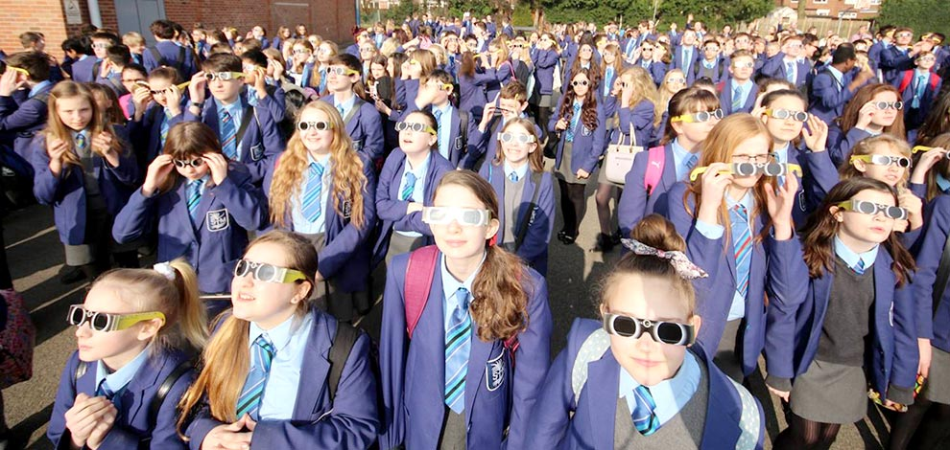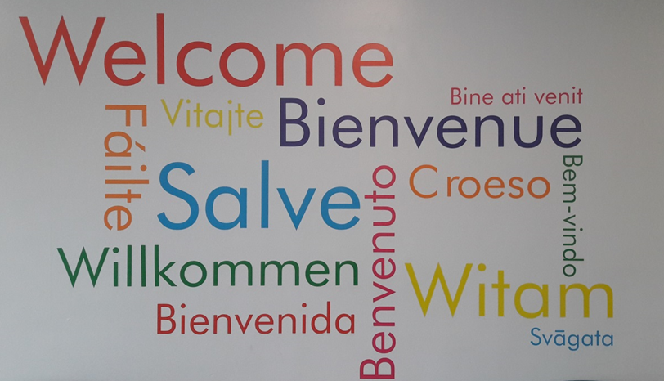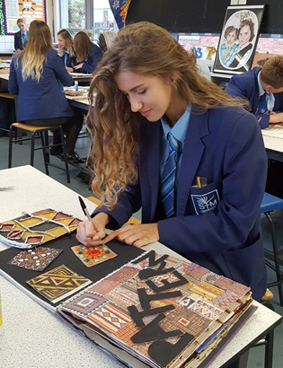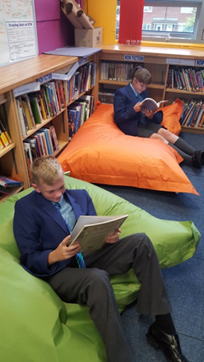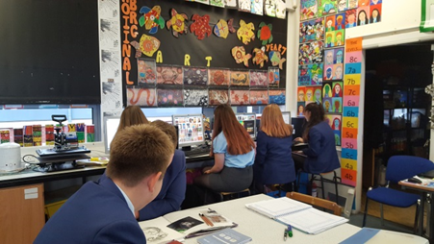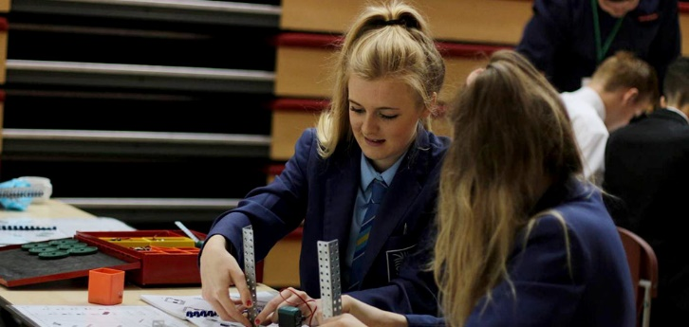

**Recruitment Pack for the Position of:**

**SCIENCE TECHNICIAN**

Welcome to St Thomas More Catholic High School

Thank for taking time to consider the post of Science Technician here at St Thomas More Catholic High School. The role is a vitally important one in our school and will impact directly on our continued success and future development.

Our OFSTED inspections of September 2007, April 2012, January 2016, March 2020 and November 2024, together with our pupils’ examination results at Key Stage 4 establish our wider reputation as a school with excellent results and pupil progress. The Diocese of Shrewsbury graded the school outstanding in December 2023

I hope that in finding out more about the school and its secure basis on Gospel Values you will feel motivated to apply for the post of Science Technician. I would encourage you to visit the school and meet our exceptional pupils. Please do not hesitate to contact the school if you have specific questions. However do look at our website if you would like more information about our school.

**Your application form and covering letter, including referees should be returned by the advertised closing date.**

The application form and covering letter can be emailed to:

recruitment@st-thomasmore.cheshire.sch.uk

Kind regards

Mrs Katherine Packham

**Headteacher**

**St Thomas More Catholic High School**

**Keeping Faith in Education**

St Thomas More Catholic High School is a high performing, oversubscribed, 11-16 school in the South Cheshire Catholic Multi Academy Trust in the Diocese of Shrewsbury which was once again rated Good by Ofsted in 2016. Our most recent inspection by Shrewsbury Diocese rated us as an Outstanding Catholic school.

We have a well-deserved reputation for academic excellence balanced by outstanding pastoral care and support which allows our pupils to flourish and develop as rounded individuals.

During 2024-25 we continue with our focus on the quality of teaching to support excellent results for pupils, very high expectations of behaviour to create a calm and happy school, a strong good pastoral system to care for pupils and their needs, and a range of enrichment activities to engage and motivate pupils to contribute to their wider education to ensure that St Thomas More Catholic High School provides an outstanding education for all pupils.

Every school in the country with high ambitions for its young people would probably say the same, but we have a distinctive foundation or inspiration for our pursuit of excellence: our Catholic Christian values, based on the Gospel of Jesus Christ, which regards every person as a unique creation of God with an ‘original gift’ to offer the world. Our aim is to help pupils to discover the person they are called to be.

In the day to day life of the school, Gospel and British values are evident in the culture of respect and the strong ‘family’ atmosphere which all our visitors comment on and our staff and pupils value highly. Our values and common purpose has enabled us to create a thriving community who experience a full and balanced education which prepares them to live a fulfilling life and able to grasp all job, career, high education and leisure opportunities which the world offers.

**What is special about a Catholic School?**

|  |  |
| --- | --- |
|  Form prayers each day |  Links with Global Schools |
|  Assemblies |  Caring ethos |
|  Retreats |  Inclusion for all |
|  Liturgical events |  Wellbeing Days |
|  Faith in Action |  Curriculum Core RE |
|  Equality and Respect of all |  Supporting the Church Catechetical Programmes |
|  Relationship and Sex Education |  Chaplaincy Team |

**KEY FACTS**

**LOCATION:** Crewe, Cheshire

**DENOMINATION:** Roman Catholic

**DIOCESE:** Shrewsbury

**AGE RANGE:** 11 - 16

**NO OF PUPILS:** 647

**NUMBER OF STAFF:** 97

**% OF PUPILS ON FREE SCHOOL MEALS:** 9.5%

**ACADEMIC ACHIEVEMENTS:**

**2024 GCSE Exam Results:**

**Progress 8:** + 0.26

**Attainment 8:** 47.9

**Achieving Grade 5 and above inc English & Maths:** 42%

**EBACC (Average Point Score)** 4.35

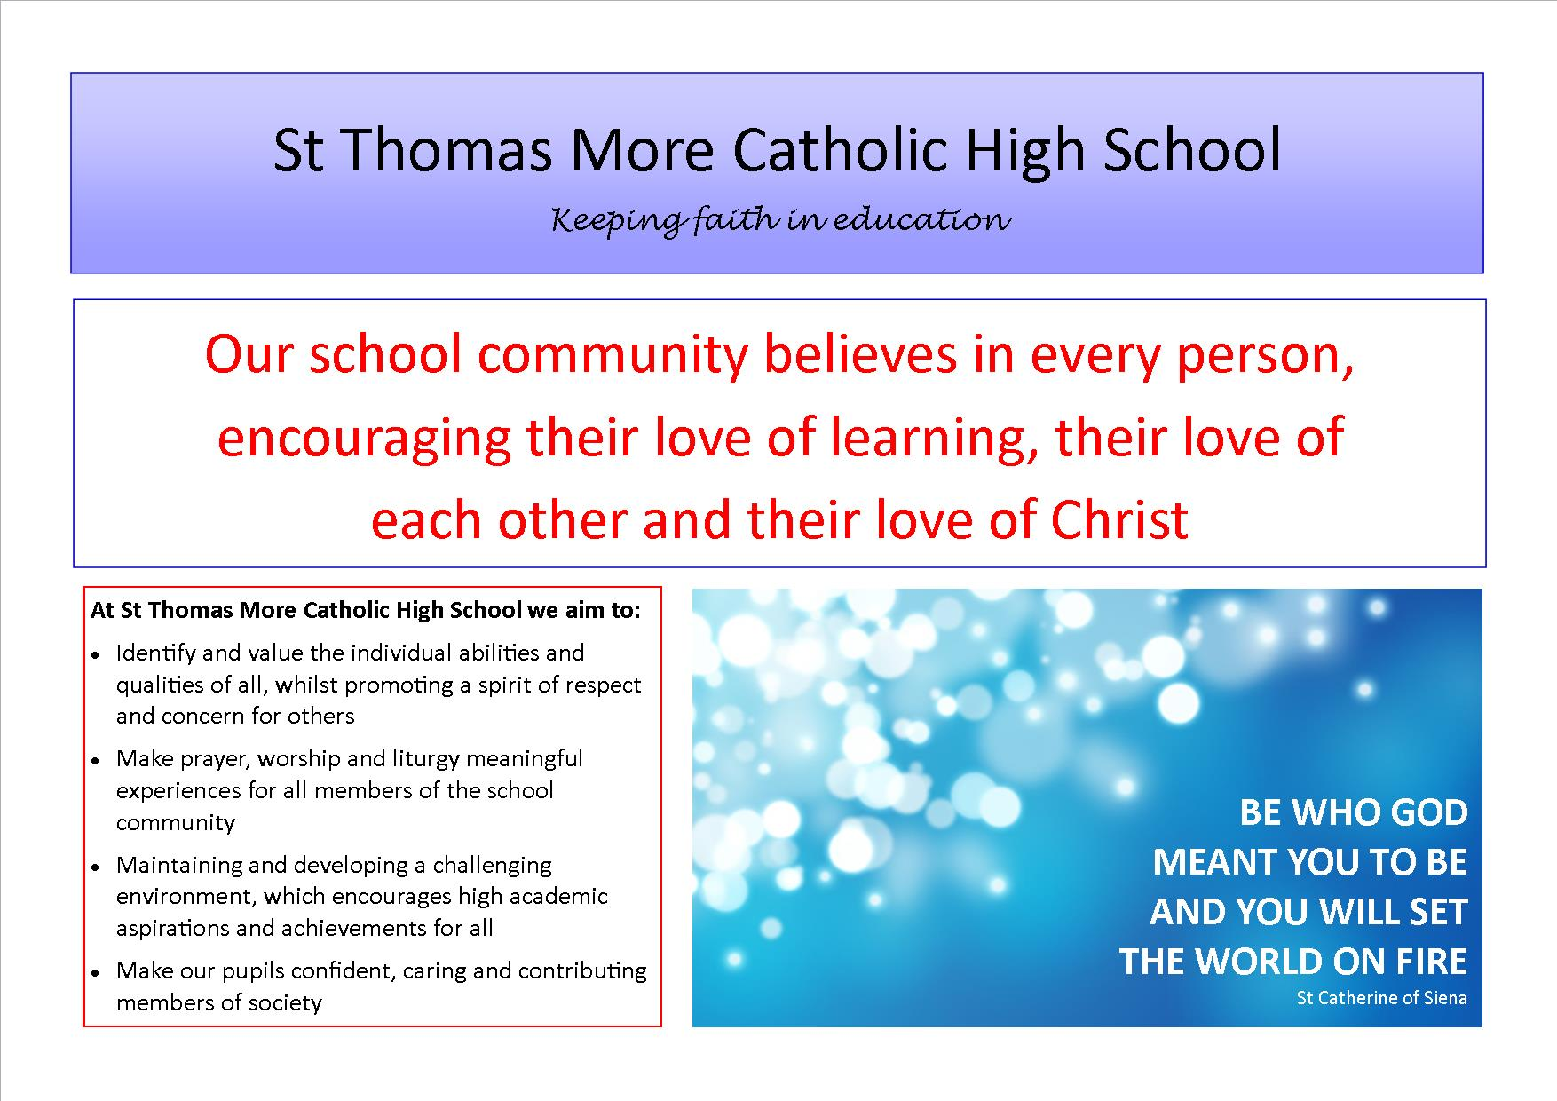

Crewe is an established town in Cheshire with a population of approximately 84,000. Crewe is known for its large railway junction and its history of manufacturing and overhauling locomotives. Crewe was also the home of Rolls-Royce Motors from 1946 until 2002. The Pyms Lane factory now produces Bentley Motor Cars exclusively.

St Thomas More Catholic High School is located within the parish of St Mary’s the Immaculate, Crewe, under the Diocese of Shrewsbury. We work closely with our partner feeder primary schools, St Mary’s Catholic Primary School, Crewe; St Anne’s Catholic Primary School, Nantwich and St Gabriel’s Catholic High School, Alsager. With a PAN of 128 and approximately 650 pupils on roll the school is increasingly oversubscribed.

St Thomas More Catholic High School has an excellent reputation within the Catholic and local community. We are a successful and popular school. Examination results and Levels of Progress are above local and national averages across Key Stage 3 and 4.

St Thomas More was inspected by Ofsted in November 2024 and was judged as a “Good” school. Here are some of the main findings from our recent inspection:

• ‘St Thomas More is a friendly, caring and inclusive school’

• ‘The school is ambitious for all pupils including those with special educational needs and/or disabilities’

• ‘Pupils achieve well’

• ‘Pupils and the community are proud of their school’

• ‘Pupils feel safe and happy in school’

• ‘The school is calm and orderly’

• ‘Relationships between pupils, staff and visitors are courteous and respectful’

• ‘The school has implemented a broad curriculum that makes clear what pupils need to learn and remember’

• ‘Where teachers are new to the school or the subject they teach, they are well supported’

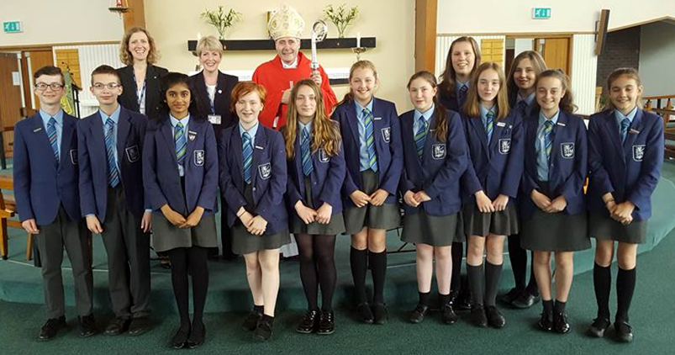

**Welcome from the Science Department**

The Science Department aims to provide pupils with a rounded science education with a view of having as many as possible choosing the sciences post 16. We want the pupils not wishing to follow science further to leave St Thomas More as critical thinkers with an appreciation of the role of the sciences in everyday life and our impact upon the environment through the choices we make.

The Science department is situated in its own block of six laboratories. All have water, gas and electric islands and one has a suite of  PCs around the perimeter. They are serviced by one full time technician. There are various places in the block used to store additional equipment. All rooms are equipped with an interactive smart board with a dedicated computer.

At the moment the department follows its own schemes of work through years 7 to 8, based on the KS3 PoS. These are regularly reviewed and we’re in the process of adapting our KS3 program to fit in line with the school’s new assessment and reporting strategies.

The department works with the Technology and Mathematics departments to ensure pupils receive as much information as possible regarding careers in the STEM subjects. We have had activities taking place during National Science Week and we continue to build upon this. We also want to make the relevance of science to careers much stronger so that we can motivate pupils into greater progress and achievement.

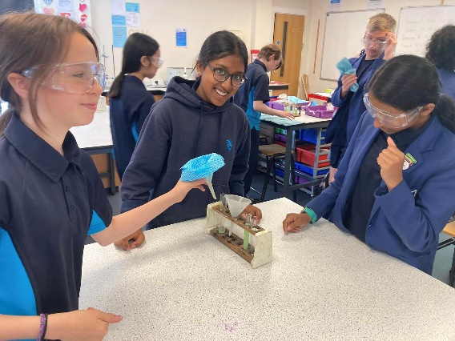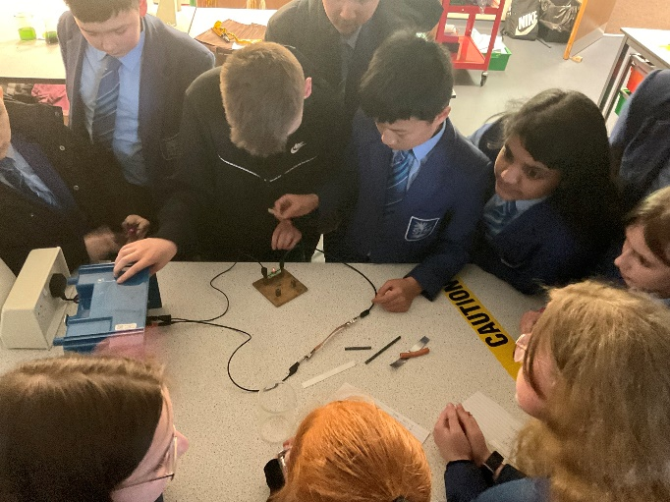

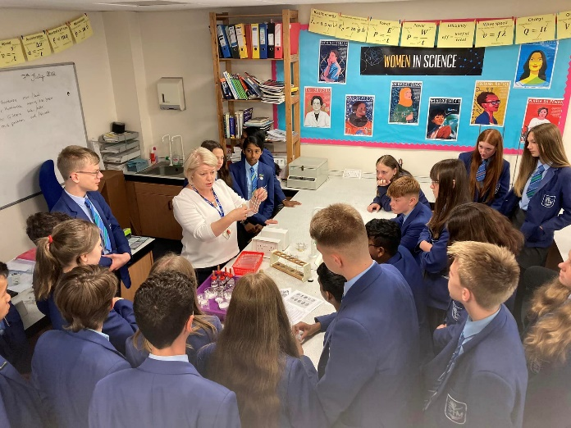

**Job Description: Science Technician**

Reports to: Curriculum Leader for Science

**Key purpose of the job**

To be responsible to the Curriculum Leader of Science in coordinating the use of, and development of, practical resources and facilities including the provision of guidance and support in meeting the practical requirements of the Science curriculum.

**Duties & Responsibilities**

* To ensure that the preparation rooms and labs are clean and well organised at all times.
* To ensure daily preparation requirements are fully understood and met.
* To develop an understanding of the Science curriculum and what resources are required.
* To assist the teaching staff in the setting up of practical sessions and demonstrations, including computer and audio visual equipment in accordance with teaching staff requests.
* To clear up after lessons to include the washing of used glassware, cleaning of benches and sinks and ensuring that materials and apparatus are returned to their correct place.
* To maintain, construct and modify apparatus and equipment in a clean and safe condition.
* To carry out safety checks including on electrical equipment, fume cupboards, spills kits, the condition of Bunsen burners and tubing, eye protection, glassware and chemicals that deteriorate.
* To maintain tidy organised storage and labelling of apparatus and equipment.
* To undertake a resource management/stock control including chemicals and order replacement equipment as necessary.
* To purchase teaching materials for lessons, such as seeds, household chemicals or animal parts.
* To undertake requisitioning and receipt of supplies and equipment.
* To maintain stores of departmental textbooks and store any which are not in current use.
* To ensure stationery is available in each lab.
* To support with paperwork including photocopying teaching materials and examination papers as requested.
* To maintain display areas and change posters as requested.
* To check and record the condition of utilities. Advise the Site Manager of any necessary work and check that the work is carried out.
* To attend trips and visits where required.
* To actively seek opportunities for professional development and attend and undergo suitable training.
* To deal quickly/calmly with any emergencies.

**Professional Standards**

* To undertake statutory safeguarding training.
* To be aware of and comply with related policies and procedures relating to child protection, health, safety and security, confidentiality and data protection, reporting all concerns to an appropriate person.
* To be a role model to pupils through personal presentation and professional conduct.
* To co-operate with the School Business Manager in all matters concerning Health and Safety and specifically to take reasonable care of their own Health & Safety, and that of any other persons who may be affected by their acts or omissions at work.
* To be familiar with the School and Department handbooks and support all the School’s policies.
* To ensure the working environment is kept tidy and confidential information is safeguarded at all times.
* To be aware of and support difference and promote equal opportunities for all.
* To contribute to the overall ethos/work/aims of the school.
* To appreciate and support the role of other professionals.
* To participate in training and other learning activities and performance development as required.
* To establish effective working relationships with professional colleagues and associate staff.
* To strive for personal and professional development through active involvement in the School’s appraisal system and performance management procedures.
* To undertake any reasonable task as directed by the Headteacher.

Notwithstanding the detail in this job description, in accordance with the School’s Flexibility Policy the post holder will undertake such work as may be determined by the Headteacher / Governing Body from time to time, up to or at a level consistent with the Main Responsibilities of the job.

**Person Specification: Science Technician**

|  |  |  |
| --- | --- | --- |
| **Area** | **Essential** | **Desirable** |
| **Qualifications** | * GCSE in English, Maths and Science or equivalent | * A-Levels / Degree in a Science discipline * First Aid qualification |
| **Experience** | * Working in a laboratory or similar environment * Working as part of a team in a busy environment * Working on his/her own initiative | * Experience of working in the education sector * Pastoral experience in a setting working with young people (school, church, Scouting/Guiding movement, youth club etc) |
| **Knowledge and Skills** | * A responsible and conscientious approach, especially with regard to Health and Safety * Knowledge of appropriate use of laboratory equipment (including handling chemicals safely) * Good numeracy and literacy skills * Basic IT skills * How to work under pressure and multi-task | * Current national child protection and safeguarding policies (e.g. Keeping Children Safe in Education) |
| **Personal and Professional Qualities** | * Belief in sustaining high standards of excellence * Ability to prioritise, plan, organise well and work as part of a team to achieve objectives * High standards in dress, attendance and punctuality * Suitability to work with children and satisfactory Enhanced Disclosure with the DBS |  |

**ENHANCED DISCLOSURE**

Thank you for interest in St Thomas More Catholic High School. The post you are applying for involves working with young people. It is therefore exempt from the Rehabilitation of Offenders Act and any offer of employment will be subject to an Enhanced Disclosure.

As this post is exempt from the Rehabilitation of Offenders Act, you must declare any convictions, including pending convictions, cautions, reprimands and warning which would otherwise be regarded as “spent” under this Act. Further details will be sought prior to appointment.

An Enhanced Disclosure is carried out by the Disclosure and Barring Service and will check criminal records for information on any convictions, cautions, reprimands and warnings held on Police National Computer and on local Police records.

All information on criminal records provided both by you and within the Enhanced Disclosure will be used, stored and disposed of in confidence and in line with the Disclosure and Barring Service Code of Practice of Disclosure Information.

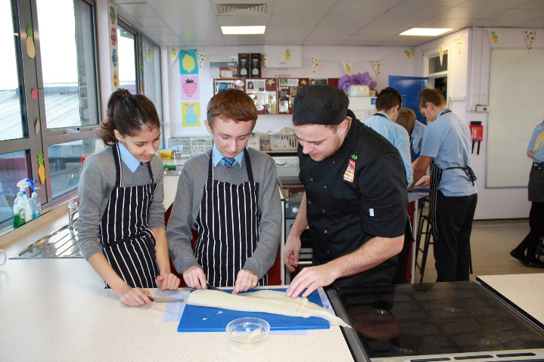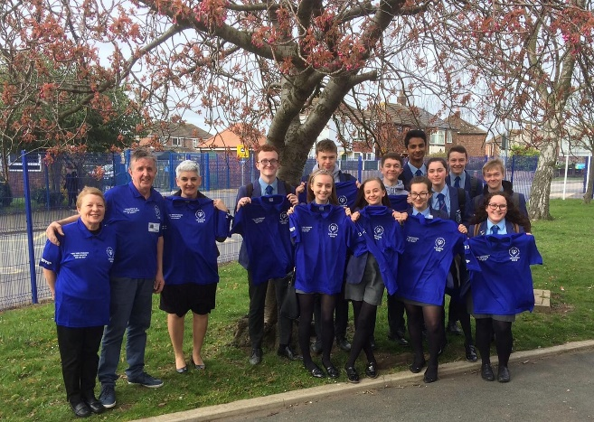If your application is successful, you will receive further information on how to complete the Enhanced Disclosure.

