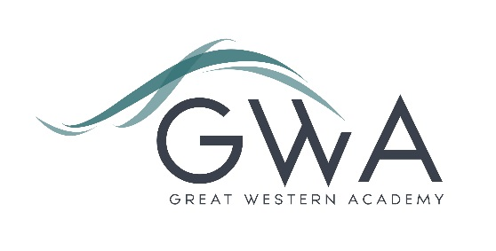

Information for Applicants

Teacher of Business and Economics, Second in faculty
Great Western Academy opened in September 2018 in North Swindon. The Academy is heavily oversubscribed in years 7, 8, 9, 10 and 11 and our first four cohorts of A-level students celebrated their exceptional results in summer of 2021-24, with strong destinations for all including three Oxbridge students and several prestigious apprenticeships. Both subjects are popular choices at A-level and Business and also have strong take-up at GCSE. Business is also a current offering in year 9 as a ‘pre-GCSE’ option and has proven very popular.
The successful applicant will have a fundamental role in shaping the teaching and learning within the Academy. As second in faculty you will have an area of leadership that will be agreed with you. You will need to be able to teach Business and/or Economics to A-level. However, it is equally important that you have the skills to develop and lead exceptional practice across all subject areas.
An applicant’s briefing pack with full information about Great Western Academy and the role is available on the GWA website at https://www.gwacademy.co.uk/vacancies
Application process

Please complete both the application form and equalities forms supplied and enclose a supporting letter, either in the space provided on the application form or as a separate document. The application form should be completed in full in black ink or type. A CV is not required and should not be submitted as part of the application.

Your supporting letter should be no more than 2 sides of A4 (with a font size no smaller than 11) and should enhance your application by providing further information, matched to the person specification, about your suitability for the post. This should include evidence of the impact on student outcomes you have made in your current and previous roles, and how you believe your leadership will help grow outstanding practice in Business, Economics and Computing at Great Western Academy.

Electronic applications should be returned via email to recruitment@gwacademy.co.uk .

Closing Date: 9am Monda 9th December 2024
Interviews: will take place before the end of the school term

The interview process will include observation of your teaching, a short presentation, and a variety of other tasks and activities.
Great Western Academy is committed to safeguarding and promoting the welfare of children, young people and vulnerable adults and we expect all staff to share this commitment and undergo appropriate checks. All posts within the Trust are therefore subject to an Enhanced DBS and barred list check.

References: References will be taken up prior to interview.

