BROUGHTON HALL CATHOLIC HIGH SCHOOL
Yew Tree Lane

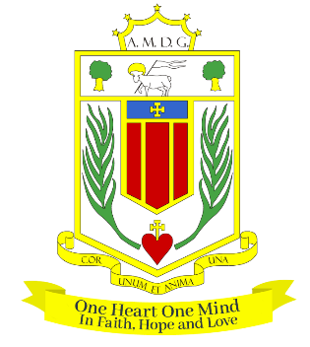
Liverpool, L12 9HJ

Telephone 0151 541 9440 / Fax 0151 259 8448
E.mail: smithg@broughtonhall.com
Head Teacher: Mrs S O’Rourke B.A. (Hons), PGCE

SECOND IN HUMANITIES (HISTORY SPECIALIST)

Required for September 2025

SALARY: MPS/UPS with TLR (appropriate to experience)
CONTRACT: Permanent
HOURS: 1.00 FTE
CLOSING DATE: Tuesday, 4th March 2025
INTERVIEWS TO BE HELD: To be confirmed

The Governors wish to appoint a first rate Second in Humanities. You will be an enthusiastic teacher of History with the ability to teach across the full age and ability range, and the necessary leadership skills and experience to fulfil this role. If you are hardworking, highly motivated, have a passion for your specialism and have the ability to inspire our pupils and staff then we would love to hear from you.

The Humanities Department is a successful one and offers qualifications at both Key Stages 4 and 5. Uptake and results are above national. The department is equipped with 8 new classrooms and is well-resourced.

The successful candidate will be:
- An outstanding classroom practitioner
- Someone who is passionate about their subject and has the ability to inspire a love of learning
- Committed to the school’s vision and demonstrating compassion through the mission statement
- Dedicated in ensuring students achieve the best outcomes

About Broughton Hall Catholic High School
Broughton Hall is a Catholic High School is an Ofsted rated Good provider (2022). We are proud of our strong Catholic ethos and values. The school has an excellent reputation and promotes an inclusive education which develops creativity, confidence and independence. The school is committed to the continuous professional development of all staff including Aspiring Leaders, NPQML and NPQSL programmes.

The Trustees are the Sisters of Mercy

For further information about the school and Application Pack please visit the school’s website www.broughtonhall.com. Visits to the school by arrangement.

__________________________

Broughton Hall Catholic High School is committed to safeguarding and promoting the welfare of children and we expect all staff and volunteers to share this commitment to keeping children safe. Any offer of employment will be subject to statutory pre-employment checks including satisfactory references and Enhanced DBS and Barred List checks. This post is exempt from the provisions of the Rehabilitation of Offenders Act - accessed here - and shortlisted candidates will be required to disclose any relevant criminal history prior to interview.

