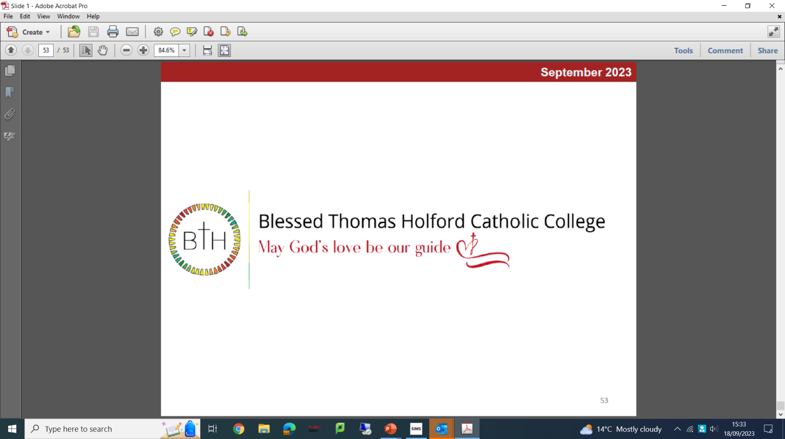

Job Description
Second in Religious Education

Purpose of the Role:

To support the Head of RE in leading, managing and developing the department, maximising achievement, and progress in RE. To work alongside the Head of department and additional TLR holders to develop the Catholic life of the school.

Responsibilities:

Second in Department
- To lead the pupil achievement and progress
- To assist the Head of Subject in leading, managing and developing the department including:
- curriculum provision & development in accordance with exam specification
- co-ordinating exam entries with exams officer
- generate exam reports and liaise as appropriate with Head of Sixth Form
- quality control systems
- data management
- communications
- departmental resources
- To deliver INSET and CPD sessions as required
- To lead extra-curricular activities
- To deputise for the Head of department in their absence

Teaching
- To teach, pupils according to their educational needs, including the setting and marking of all class work and coursework carried out by pupils
- To assess, record and report on the attendance, progress, development and attainment of pupils and to keep such records as are required.
- To provide, or contribute to, oral and written assessments, reports and references relating to individual pupils and groups of pupils.
- To ensure a high quality learning experience for pupils.
- To prepare and update subject materials.
- To use a variety of delivery methods that will stimulate learning appropriate to pupil needs and demands of the curriculum.
- To maintain discipline in accordance with the School procedures, and to encourage good practice with regard to punctuality, behaviour, standards of work and home learning.
- To undertake assessment of pupils as requested by external examination bodies, curriculum areas and School procedures.
- To liaise with the SENCO and the form tutor over SEND pupils, modifying teaching accordingly.

Form Tutor
- To support pupils in all aspects of their School life and in preparation for their adult life
- To develop an understanding and knowledge of each pupil as an individual
- To enable pupils to play an active role in all aspects of the tutorial and PSHE programme
- To undertake administrative-related tasks

Duties
- To undertake duties before School and at break, on a rota basis.
- To play a full part in the life of the School, to support its mission and ethos

Health and Safety
- To support the Head of Subject in ensuring the departmental area is a safe environment, completing risk assessments and any other necessary health and safety documentation for direct reports

General
- To participate in the performance and development review process, taking personal responsibility for identification of learning, development and training opportunities in discussion with line manager
- To comply with individual responsibilities, in accordance with the role, for health & safety in the workplace

