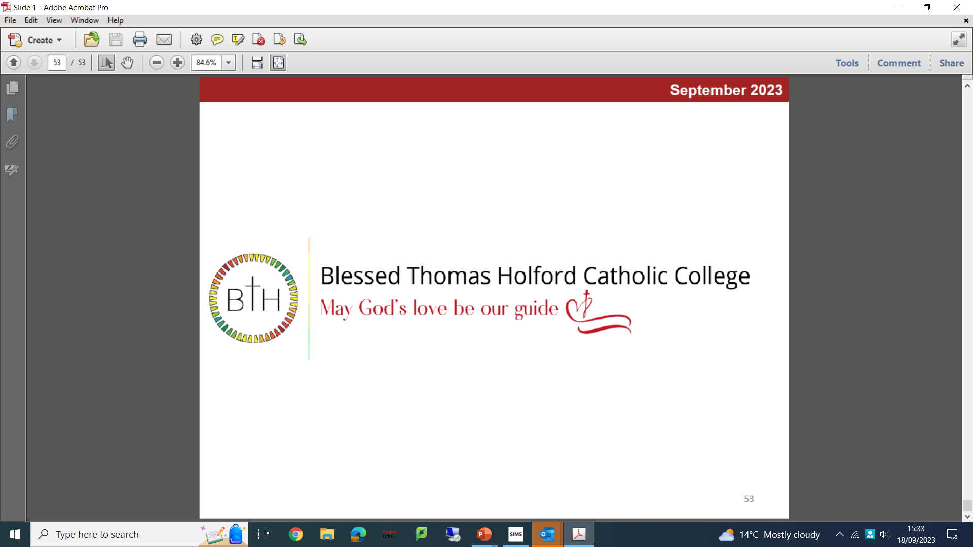

Second in Religious Education
Required for September 2024
Salary: MPR/UPR + TLR 2A (£3,214)

We are an 11-18 Catholic College with 1,600 students on roll, including 220 in the Sixth Form. GCSE and A level results have been consistently excellent over several years and we are determined to make ourselves an exceptional educational provider. Our college is very popular with parents/carers, and we are oversubscribed every year.

We are looking to appoint an enthusiastic and inspirational Second in Religious Education with strong interpersonal skills, passionate about teaching and results, and a desire to make pupils’ experience of RE exceptional.

The successful candidates will have:
- A love of their subject
- A sound and detailed knowledge of Religious Education
- The ability to inspire, engage and enthuse students

We offer:
- A supportive and committed college family
- Continuous Professional Development and formation
- Ambitious and hardworking staff and students

To Apply:
The job description and application forms are available on the college website: https://www.bthcc.org.uk/vacancies

Applications should be made using the CES application form
Applicants must have the Right to Work in the UK to be considered for the role.

Completed application forms should be sent to: recruitment@bthcc.org

Closing date for applications is: 9.00 a.m. 20th May 2024
Interviews will be held on: 23rd May 2024

Our college is committed to safeguarding and promoting the welfare of children and young people and we expect all staff and volunteers to share this commitment. In line with Keeping Children Safe in Education (KCSIE) online/social media checks may be undertaken for shortlisted applicants. An enhanced Disclosure and Barring Service (DBS) disclosure will be sought, along with other relevant pre-employment clearances, for the successful applicant.

