SEMHS Teaching Assistant Application Pack
November 24

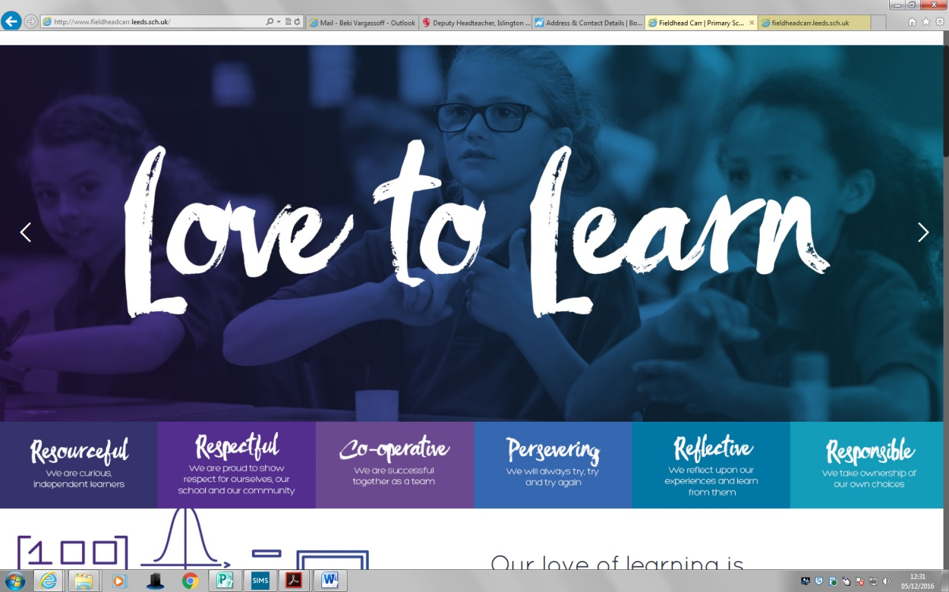

Deputy Headteacher

Dear Applicants,

Welcome and thanks for your interest in our school. We are looking for a highly motivated and energetic SEMHS teaching assistant to join our hardworking team. Our SEMHS teaching assistant will work under the instruction and guidance of our SENDCo and Inclusion Support lead to deliver person centred support to individuals who present high levels of complex needs and challenging behaviours associated with learning disabilities, autistic spectrum conditions and mental health problems.

From this process we are looking for someone who has the child at the heart of all they do. We have a socially diverse intake and so our team need to be skilled in understanding that the life of every child is different and as a result their need will be too. The right candidate is someone who cares and will build strong relationships with our children so that they look forward to coming to school each day! This is a great opportunity, to help enrich and develop vulnerable young people's lives.

You will be working with children and young people who need 1:1 support for multiple reasons, such as:
• Children in Looked After Care
• Anxiety
• Exclusion
• Speech and language difficulties
• Physical and mental health issues, disabilities and learning difficulties

The candidate must have:
• Some experience working with children and young people who display challenging behaviour
• Experience of de-escalation training would be advantageous
• The school would also consider candidates from youth work backgrounds, or similar roles
• Confidence to make decisions
• Excellent communication and the ability to build positive relationships with the students
• Empathy and understanding
• Willingness to enhance skills with professional training and development

It is a really exciting time in the journey of our school, as we continue to grow from a 1 form entry school to a 2 form entry. You will join an expanding inclusion team who work closely together to meet the needs of all pupils in school so a love of team working will be important in this role.

We would welcome those interested to come and have a look at the setting. To make a 1-1 appointment please contact my Business Manager d.hillerby@fieldheadcarr.leeds.sch.uk or contact us on 0113 2930226.

We look forward to receiving your applications.

Best wishes

Mrs Jo Murphy
Head Teacher

Role of SEMHS Teaching Assisstant- Job Description

Job Title: SEMHS Teaching Assistant @ Fieldhead Carr Primary School
Pay Range: B3 Point 7-11. £24,294 - £25,979 (actual term time only £17,885 -£19,125) pay award pending
Working hours: 8:30am – 3:30pm Mon-Fri term time (32.5)
Responsible to: SENDCO/ Inclusion Team Lead/Senior Leaders

Purpose:
To work under the instruction and guidance of SENDCO/ Pastoral Lead/Senior Leaders. To support the school in addressing the needs of all pupils but especially those pupils who need particular help with behaviour management to overcome barriers to learning. Establishing productive working relationships with pupils and acting as a role model. Work may be carried out in the classroom or outside the main teaching area. This may involve 1:1 sessions or small group work

This document lays out the fine detail of the job role of SEMHS Teaching Assistant

Professional Behaviours
- SEMHS TA to demonstrate professional behaviours appropriate to your role. This includes sustained support and promotion of the school’s philosophy, culture, ethos and climate for learning
- SEMHS TA to maintain a calm professional manner when dealing with children, parents and staff
- SEMHS TA to maintain levels of professional integrity and confidentiality when dealing with children and families information
- SEMHS TA is to follow safeguarding protocols to ensure school practice is consistent for children and families
- SEMHS TA will support in planning for staff training and development of policies within the inclusion team, particularly the Behaviour, PSHCE and SEMHS Policy

Responsibilities
- To establish good working relationships with children, acting as a role-model
- Implement strategies to support those children with social, emotional and behavioural difficulties
- To support individuals or small groups of children in class or on a withdrawal basis who are experiencing emotional or behavioural difficulties
- Encourage pupils to interact with others in a positive manner
- Promote self-esteem and independence
- Provide feedback to pupils in relation to progress and achievement
- Assist in the planning or work programs for individuals and groups of pupils for example: Personalised Learning Plans/Positive Handling Plans and Personal Care programmes
- To promote the inclusion and acceptance of all pupils
- Create and maintain a purposeful, orderly and supportive environment, in accordance with personalised learning timetables
- To keep accurate records of behavioural incidents
- Assist in the development and organisation of classroom resources and activities
- To communicate with parents/carers to advise them of sanctions and incidents
- To provide feedback to pupils in relation to progress and achievement under guidance of the teacher
- To use strategies, in liaison with the teacher, to support pupils to achieve learning goals
- To assist with the planning of learning activities
- To monitor pupil’s responses to learning activities and accurately record achievement/progress as directed
- Provide detailed and regular feedback to teachers on pupil’s achievement, progress, problems etc.
- To promote good pupil behaviour, dealing promptly with conflict and incidents in line with established policy and encourage pupils to take responsibility for their own behaviour
- To establish constructive relationships with parents/carers
- To provide clerical/admin support - photocopying, typing, filing, money, administer coursework
- To undertake structured and agreed learning activities/teaching programmes, adjusting activities according to pupil responses

- To prepare, maintain and use equipment/resources required to meet the lesson plans/relevant learning activity and assist pupils in their use
- To be aware of and comply with policies and procedures relating to child protection, safeguarding, welfare, health, safety and security, confidentiality and data protection, reporting all concerns to an appropriate person
- To be aware of and support difference and ensure all pupils have equal access to opportunities to learn and develop
- To contribute to the overall ethos/work/aims of the school
- To appreciate and support the role of other professionals
- To attend and participate in relevant meetings as required
- To participate in training and other learning activities and performance development as required
- To assist with the supervision of pupils out of lesson times, including playtimes and at lunchtime
- To accompany teaching staff and pupils on visits, trips and out of school activities as required and take responsibility for a group under the supervision of the teacher
- To ensure promotion and support of Equal Opportunities and Health and Safety
- To undertake any other duties that are commensurate to the post

Safeguarding Statement

At Fieldhead Carr we are committed to providing a caring, friendly and safe environment for all of our pupils so they can learn in a relaxed and secure atmosphere. We believe every pupil should be able to participate in all school activities in an enjoyable and safe environment and be protected from harm. This is the responsibility of every adult employed by or invited to deliver services at Fieldhead Carr Primary School.

We recognise our responsibility to safeguard and promote the welfare of all our pupils by protecting them from physical, sexual or emotional abuse, neglect and bullying.

We also exercise this responsibility by educating our children so that they grow in their understanding of their rights and responsibilities to themselves and others, in safety consciousness, and, in their maturity and abilities to keep themselves and others safe.
Please be aware that it is an offence to apply for this post if you have been barred from working with children

We perceive this to be part of our role in promoting British values.

Closing date for applications:
9th December 2024
Interviews: 11th December 2024
Start date: as soon as possible

Interviews will be undertaken in person on site at Fieldhead Carr Primary School. We welcome any pre application emails to ask any questions about our school. We will also welcome visits to the school to meet the team and tour the setting.

To arrange this, or for an application pack, please contact the School Business Manager, via email d.hillerby@fieldheadcarr.leeds.sch.uk
All applications to be returned to Debbie Hillerby

More information can be found on our website: https://www.fieldheadcarr.leeds.sch.uk/

SEMHS

 | Ess | Des | MOA
KNOWLEDGE/QUALIFICATIONS
Relevant child care and/or educational qualifications |  | * | A/C
An awareness of current issues affecting children and young people | * |  | A/I
Understanding of health and safety issues and good practice | * |  | A/I
Working knowledge of the common assessment framework (CAF) |  | * | A/I
Ability to facilitate/deliver a parenting programme/EHP or similar |  | * | A/I
GCSE or equivalent Maths and English Grade A - C | * |  | A/C
Qualification in Positive Handling | * |  | A/C
EXPERIENCE
Working with families and young people | * |  | A/I
Support the implementation of action plans | * |  | A/I
SKILLS
Good organisational and personal management skills | * |  | A/I
Full driving licence and own transport |  | * | A/I
Ability to maintain own caseload under supervisor | * |  | A/I
Ability to respond to challenging circumstances | * |  | A/I
Effective planning and organisation skills | * |  | A/I
Effective behaviour management skills | * |  | A/I
Work independently and being a team player | * |  | A/I
An ability to develop good working relationships with school staff and other agencies | * |  | A/I
Effective time management | * |  | A/I
Ability to work with class teachers and support them with inclusion of children with additional needs | * |  | A/I
The ability to prioritise workload and have a flexible approach to working | * |  | A/I
The ability to meet deadlines | * |  | A/I
Good ICT skills | * |  | A/I
BEHAVIOUR AND OTHER RELATED CHARACTERISTICS
Commitment to self and team development | * |  | A/I
Commitment to inclusive practices and achieving positive outcomes for children and their families | * |  | A/I
Work in ways that promote equality of opportunity, participation, diversity  and responsibility | * |  | A/I
A commitment to abide by and promote the school’s Equal  Opportunities, Health and Safety and Child Protection Policies | * |  | A/I
A professional responsibility to promote and safeguard the welfare of  children and young people | * |  | A/I
The post holder will require an enhanced DBS | * |  | C

Key: MOD=Method of Assessment, Ess=Essential, Des=Desirable, A=Application, I=Interview and assessment, R=Reference, C=Certificate

