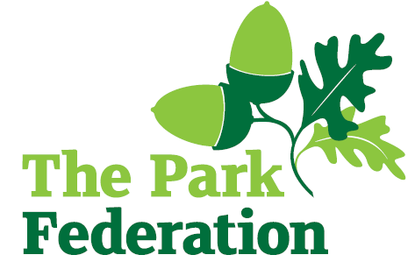

**SEN Learning Support Assistant**

**Salary (actual)**: £17,484 - £17,748

**Grade**: 2

**Hours**: 28.75 per week

**Work Pattern:** Term time only – 38 weeks

**Contract**: Permanent

Cranford Park Academy is a large, vibrant, highly successful, multi-cultural school in West London. Inclusion is at the heart of all we do. Cranford Park Academy is a highly successful, very popular multicultural school with a good OFSTED judgement.

The academy is part of The Park Federation Academy Trust, allowing us to benefit from a wealth of expertise across our eight academies, as well as enabling us to provide opportunities for sharing of good practice and high quality training.

We are looking to appoint a 1:1 SEN Learning Support Assistant to support children with more complex needs. The successful candidate will ideally have experience of working as an LSA and/or 1:1 support in a school environment.

The ideal candidate will be caring, patient, self-motivated and be able to work from their own initiative. They will have a confident, positive attitude to behaviour management and be willing to support sensitively with any personal care needs linked to a child’s special educational need. They will need to take direction from both the class teacher and SENCo (Special Educational Needs Coordinator).

Please note that the contracts maybe amended or ended for these positions should the allocated child leave or have a reduction in their entitlement to support.

For the right candidate, we will offer

* extensive support and CPD;
* the opportunity to work with other professional colleagues across the Multi-Academy Trust;
* a welcoming school, with friendly, enthusiastic and supportive staff team;
* an ambitious and dynamic Senior Leadership Team;
* a dedicated Governing Body;
* supportive parents and children who are keen to learn;
* an employee assistance programme (EAP).

We warmly welcome candidates coming to visit the school prior to application; please contact the school to arrange. Please visit the school website for an application pack.

**Closing Date:** As and when we receive successful applications. We do not accept CV’s.

***“The School is committed to safeguarding and promoting the welfare of children and young people and expect all staff and volunteers to share in this commitment. The successful applicant will be required to undertake an Enhanced DBS Check with a check of the DBS Barred List”.***