March 2023
Dear candidate,

Thank you for your interest in the position of teacher at Mossbrook school. This position presents a fantastic opportunity for somebody who shares our values and beliefs to join our team. We are keen to appoint positive, flexible staff who will support our children to reach their potentials, and to enhance our already successful team.

Mossbrook is a maintained primary special school in Sheffield where staff have the knowledge and skills to meet the needs of pupils aged four to eleven years old, who have Autism and learning difficulties. In addition, many of our children have social emotional and mental health needs which result in complex behaviours.

As Headteacher, I feel privileged to be working with such wonderful children and with a team of staff who are caring, dedicated and highly skilled.

If you think you have got what we are looking for, we look forward to receiving your application for consideration.

For further information, please contact Nicky Phipps on 01142 372768 or email nphipps@mossbrook.sheffield.sch.uk

I wish you well in your application.

Yours faithfully
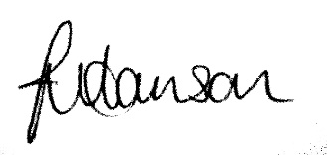

Jo Harrison
Headteacher

