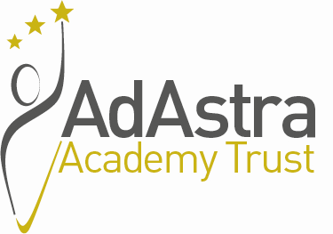
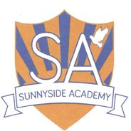

SUNNYSIDE ACADEMY

Manor Farm Way, Coulby Newham, Middlesbrough, TS8 0RJ

SEN Classroom Teacher (SEN Allowance 1) – Required for September 2024.
Fixed-term covering a maternity leave which is expected to cease on 31st August 2025

Sunnyside Academy, part of Ad Astra Academy Trust, and following the ‘Good’ Ofsted judgement, in November 2023, is entering into an exciting chapter in the development of the school.

The school is seeking to appoint an experienced, talented and dynamic SEN teacher to work in our Higher Needs Base, who is able to engage and excite team members and young learners within a diverse, inclusive setting. The post will commence on 1st September 2024,

We are seeking to appoint a passionate, highly-skilled teacher to join our dedicated, caring team, and who, in turn, will benefit from access to a wide range of professional opportunities as an employee of Ad Astra Academy Trust.

Applicants are asked to demonstrate their skills and experience that they will bring to the post and how they will meet the requirements of the Person Specification.

The successful applicant will:

- Have substantial experience of working directly with children with special educational needs;
- Have knowledge and an understanding of the National Curriculum and its implications for children with complex learning difficulties.
- Demonstrate outstanding teaching skills.
- Embrace and continue to uphold the caring, nurturing ethos of the school.
- Demonstrate real enthusiasm and commitment towards raising standards within a diverse school community.
- Be able to contribute to creative curriculum development.
- Demonstrate excellent behaviour management and communication skills.
- Have opportunity to further develop their skills through a variety of professional development opportunities within an inclusive and supportive environment.

The successful candidate will work in a designated Higher Needs Base classroom, teaching pupils with SEN which will require the exercise of a teacher’s professional skills and judgement in the teaching of children with SEN and for this a SEN Allowance 1 will be payable.

Sunnyside Academy is committed to safeguarding and promoting the welfare of children and young people and expects all staff and volunteers to share this commitment. As such the successful candidate will be required to undergo an enhanced DBS check.

This post is exempt under the Rehabilitation of Offenders Act 1974 (Exceptions) Order 1975 (2013 and 2020).

For an informal discussion about this position please contact Julie Sutton, Headteacher on 01642 596422 or via julie.sutton@sunnyside.adastraschools.org.

Requesting an application form

Application forms and further details are available via the Ad Astra website site:
http://www.adastraacademytrust.com/careers/

Completed application forms to be emailed to recruitment@adastraacademytrust.com

Candidates must only apply using the application form provided; CV’s will not be accepted.

Closing Date – Tuesday 7th May 2024 9am
Interviews will be held on – Wednesday 22nd May 2024

