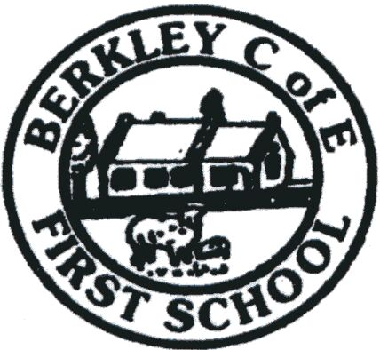
Headteacher Berkley C of E First School
Mrs S Thompson Berkley, Frome, Somerset
BA11 5JH

Tel: 01373 887390

E-mail: sch.030@educ.somerset.gov.uk

SEN Teaching Assistant
We are excited to be recruiting a SEN Teaching Assistant to provide learning support to children from Reception through to year 4. At Berkley First School our children are highly motivated and excited by learning, creativity is at the heart of our school and we are looking for a special person to join our team who shares our vision and values.

The main aim of the Teaching Assistant is to support teachers in the delivery of academic excellence, with professionalism and enthusiasm. As the SEN Teaching Assistant, you will support our teachers to take the correct approach to teaching pupils according to their educational needs, maximising children’s achievement and ability to develop.

This is a great opportunity, the role will include group interventions, some 1:1 and whole class support.

The ideal Teaching Assistant will;
- Be Enthusiastic, Compassionate, Creative and Resilient.
- Have experience of working with children with a range of needs.
- Work collaboratively, supporting the team and contribute to the wider life of our school.
- Be willing to adapt quickly to change.
- Also work in the classroom as a teaching support for our older children.
In return we can offer:
- An idyllic rural village school environment, with a supportive team and governing body.
- Imaginative and enthusiastic children, who experience a broad range of learning opportunities (curricular and co-curricular).
- Supportive families and a warm and welcoming church community.
- A commitment to developing a healthy work/life balance
- A school in which children are genuinely at the heart of everything we do.
- Opportunities for self-growth

Applications should be emailed to Sch.030@educ.somerset.gov.uk
Application forms can be downloaded from the homepage on our website.

Pay: Grade 14, (range 6-
Hours: This post will cover 20 hours per week and will be term time only, the hours will be spread across the week, with some flexibility.
Contract Type: Temporary for the first 3 months, leading to permanent contract.
Closing Date: Thursday 17th February
Interview Date: TBC
Commencement date: As soon as possible

Berkley First School is committed to safeguarding and promoting the welfare of children and young people and expects all staff and volunteers to share this commitment. All applicants will be subject to a full Disclosure and Barring Service check before appointment is confirmed.

