

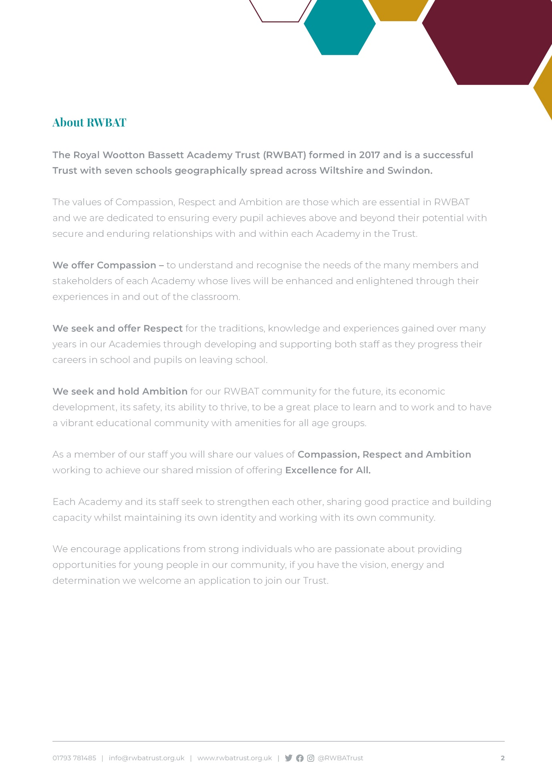

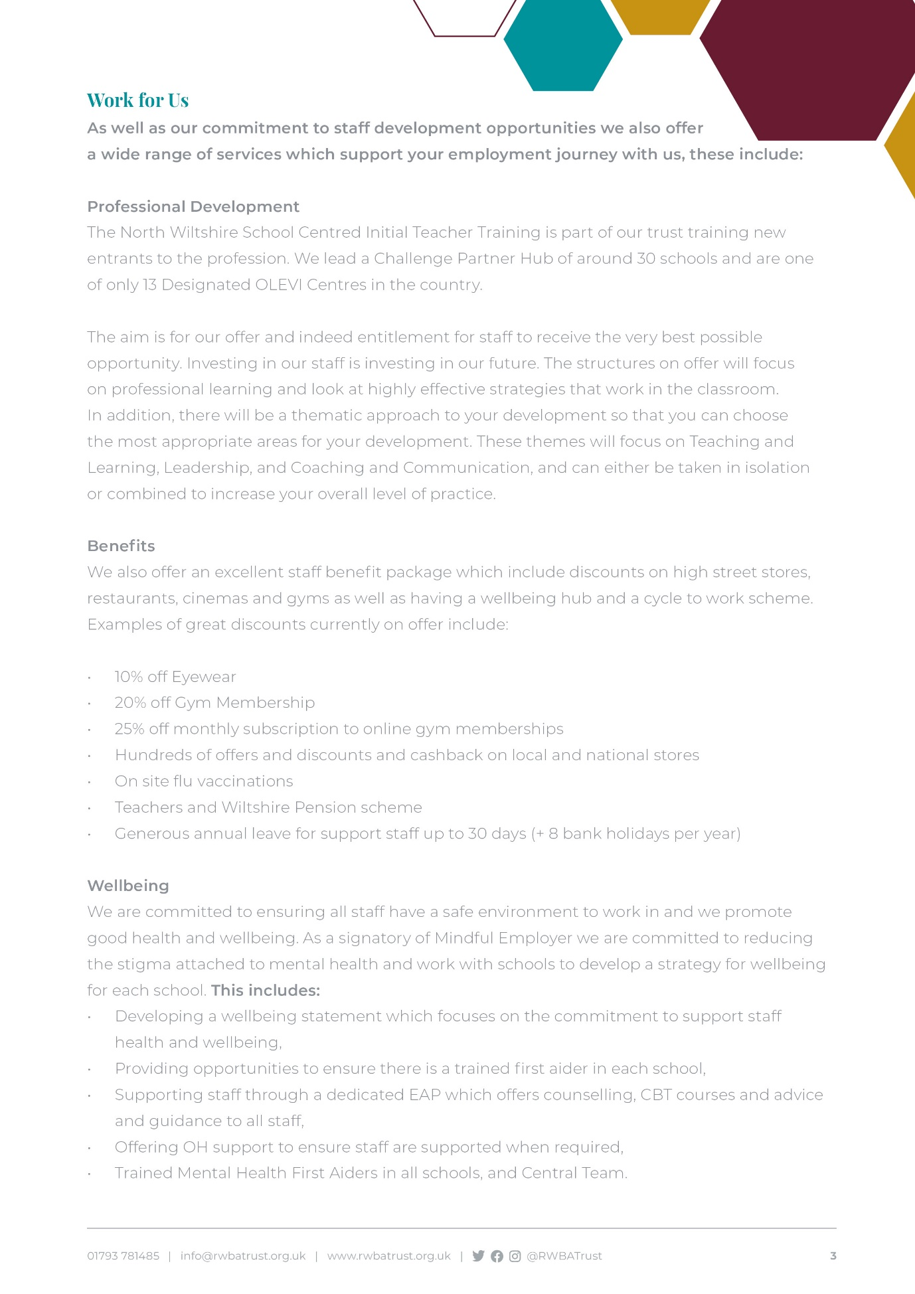

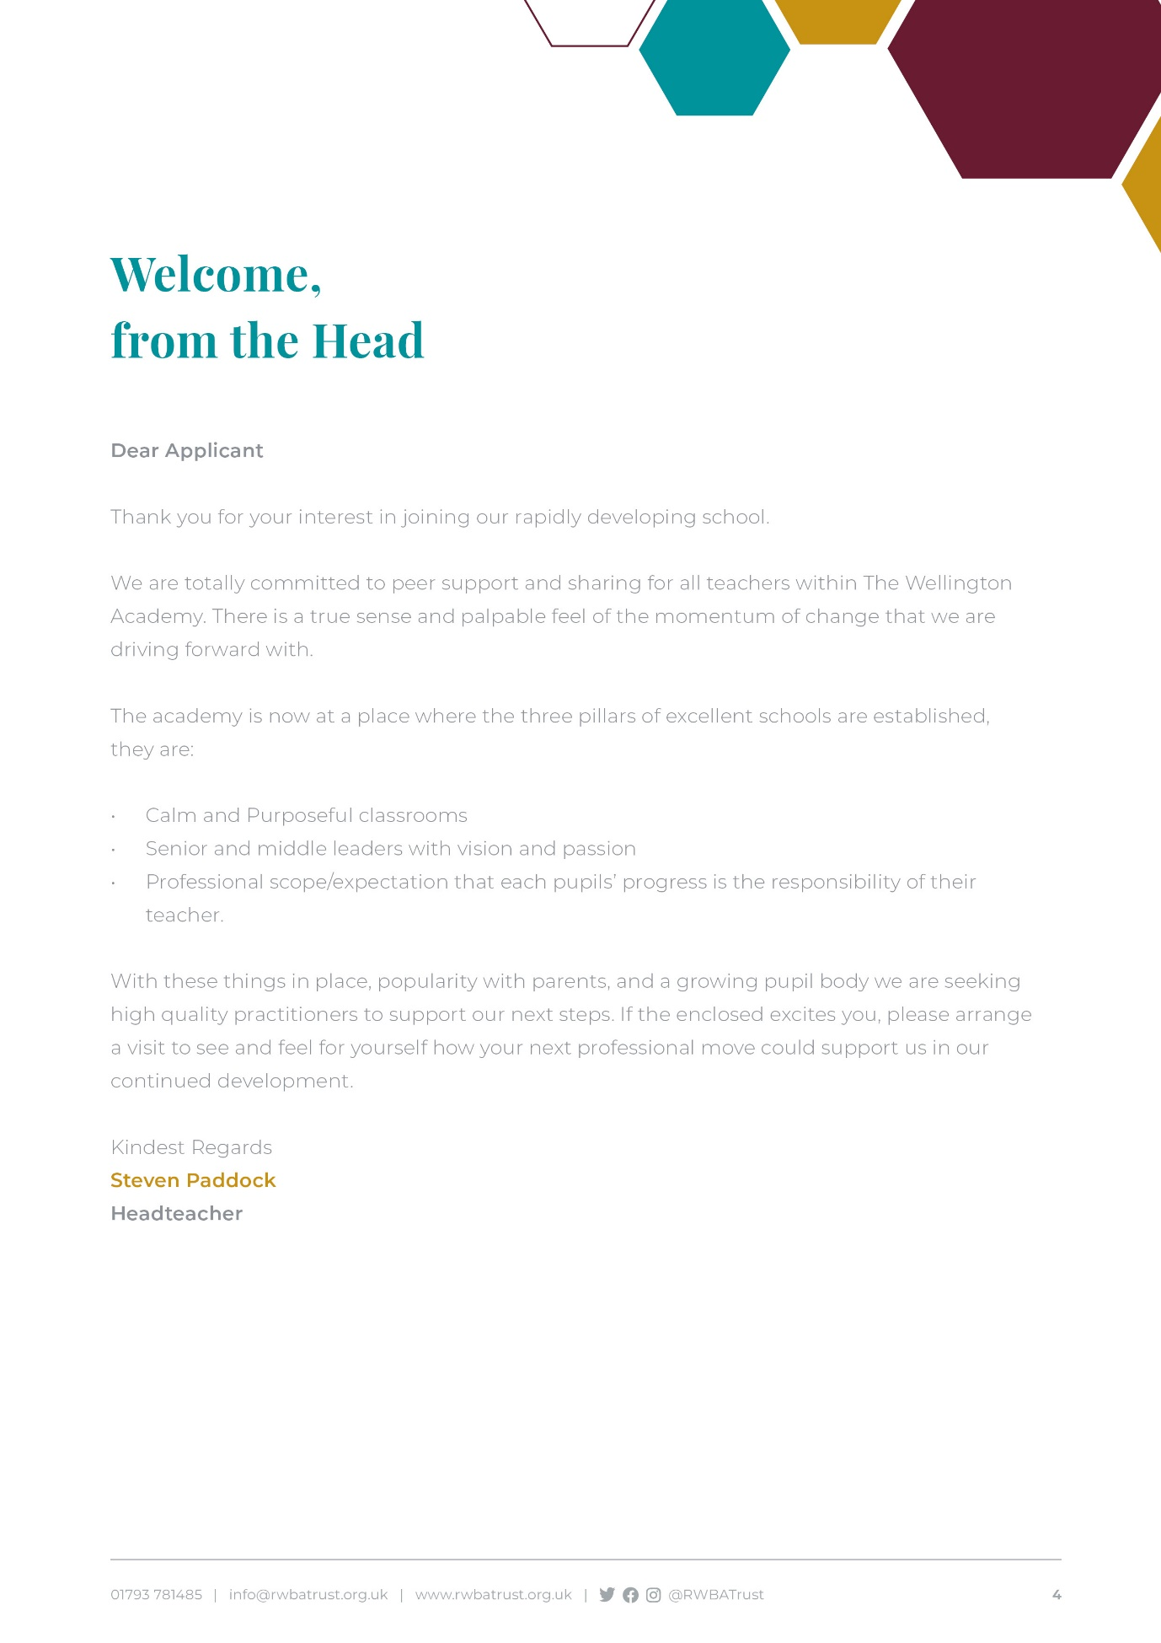

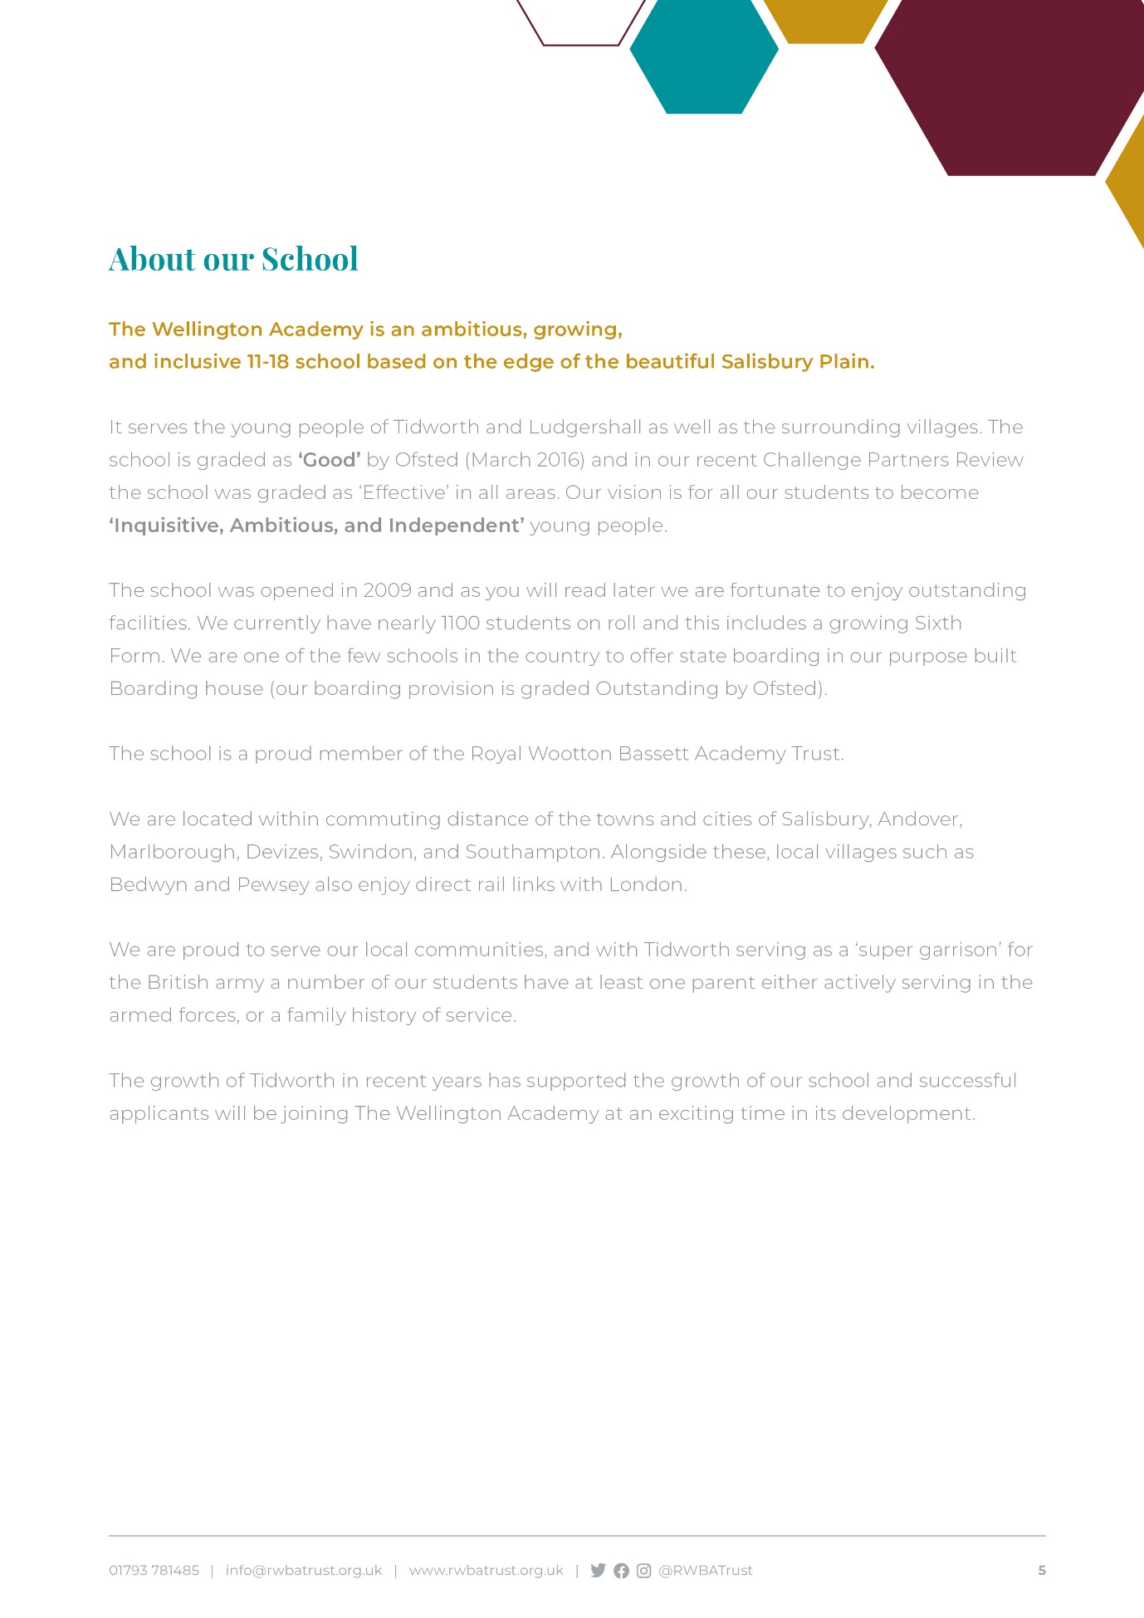

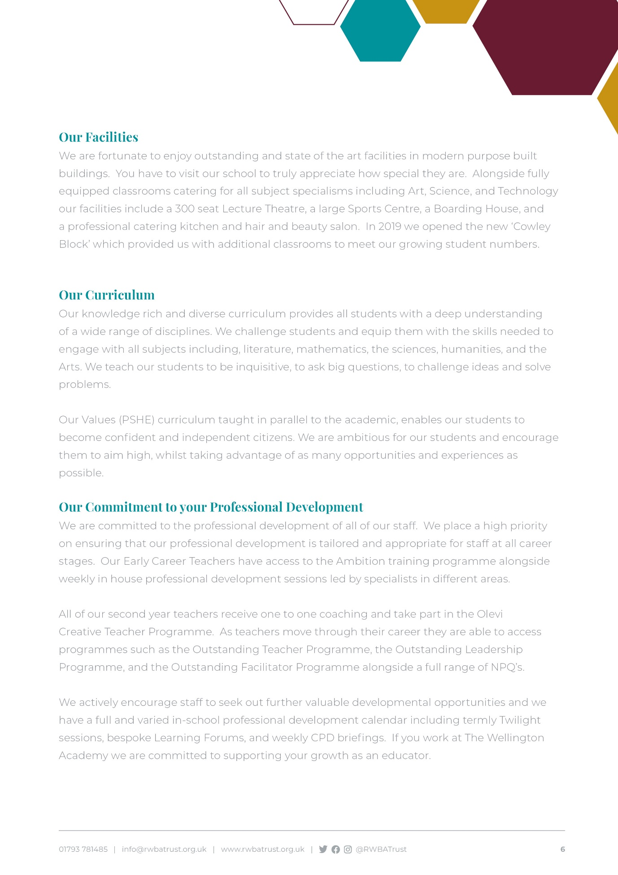

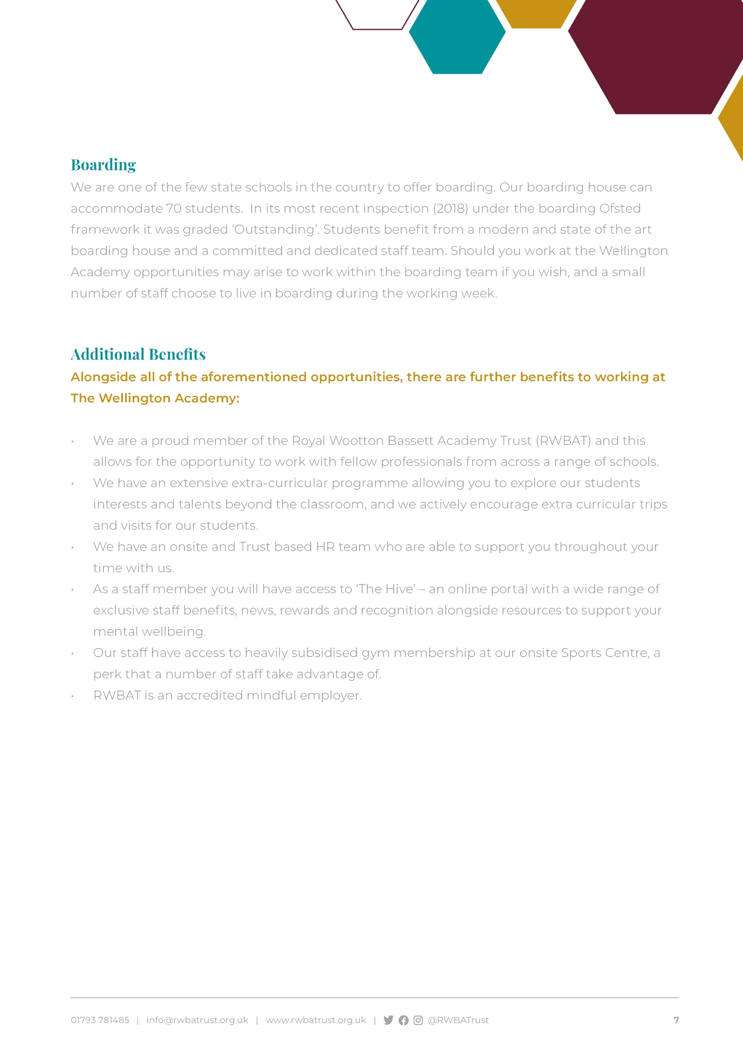



**Job Title: SENCo Administration Assistant**

**Accountable to:** Assistant Head Teacher SEND (SENCO)

**Main Job Purpose:** To work closely with the SENCo and other members of the Personalised Learning Department to provide full and comprehensive administrative support to the department.

**Responsible for: N/A**

**Main Duties**

* Administrative duties to include but not exclusive, preparing relevant meetings in liaison with the SENCO, managing the SENCO’s diary, photocopying, post, filing etc;
* Arranging, attending and minuting meetings regarding EHCP and Support Plans and any other parental and or multi agency meetings as required by the SENDCO.
* Booking courses specific to SEND, data inputting for SEND children to create an operational Provision Map of need.
* Ensure all the SEND paperwork is ordered systematically to include needs and interventions for all children on the SEND list.
* Ensure that Teaching Assistants who deliver interventions or work 1:1 with any named child have the correct information as to the types of interventions required.
* Ensure that SEND resources are categorised so teaching staff and TAs have a clear understanding of what is available to them.
* Oversee the day-to-day management of SEND files, ensuring that files are kept up to date with external reports as required.
* Liaise with staff and external agencies to ensure they have the correct information on SEND children at the school.
* Liaise with the previous schools of students with Additional Needs to procure information.
* Maintains the Teaching Assistant timetables in consultation with the Director of Additional Needs
* Mentor students with social, behavioural or emotional difficulties.
* Administrate Termly Provision Maps and prepare Individual Provision Maps.
* Monitor the Special Educational Needs Register.
* Complete AR and SP review paperwork post meetings for SENCO review.
* Manage the provision of Exam Access Arrangements for SEND students, in conjunction with the Exams Officer.



**Training and Development of Self and Others**

* Set personal targets and take responsibility for your own continuous professional development.
* Be proactive in identifying training needs ensuring that they are appropriately met, and that other staff members are active in their own personal CPD .

**General Requirements**

All Trust staff are expected to:

* Work towards and support the Trust vision and the current Trust objectives outlined in the Trust Development Plan
* Contribute to the Trust’s programme of extra-curricular activities
* Support and contribute to the Trust’s responsibility for safeguarding students
* Work within the Trust’s health and safety policy to ensure a safe working environment for staff, students and visitors
* Work within the Trust’s Diversity Policy to promote equality of opportunity for all students and staff, both current and prospective
* Maintain high professional standards of attendance, punctuality, appearance, conduct and positive, courteous relationships with students, parents and colleagues
* Engage actively in the performance review process
* Adhere to policies as set out in the Governing Body Regulations and staff handbook
* Undertake other reasonable duties related to the job purpose required from time to time

This job description should be seen as enabling rather than restrictive and will be subject to regular review.



**Person Specification – SENDCo Administration Assistant**

**Qualifications and Training**

**Essential:**

* Grade C or above GCSE English and Maths or equivalent
* Experience of working in a busy environment

**Desirable:**

* Experience of working within the Special Educational Needs system.
* Relevant work, training or further development
* Administration qualifications or equivalent experience
* Safeguarding training
* Additional professional courses relevant to school experience

**Successful Experience**

**Essential**

* At least 2 years’ experience working within an administration role
* Experience of working in a school environment
* Experience of working with pupil databases
* Experience in dealing with parents and visitors, face to face and through written communication in a clear and professional manner
* Good understanding and knowledge of additional needs

**Desirable**

* Experience in dealing with members of the public
* Knowledge and experience of Child Protection issues
* Knowledge and experience of working with children with Special Educational Needs

**Expertise**

**Essential**

* Efficient under pressure with the ability to remain calm and professional especially during busy times
* Excellent interpersonal and communication skills including the ability to relate well to adults and young people on all levels with the ability to enthuse, inspire, influence and motivate others
* Excellent IT skills including Word, Excel and Outlook
* Excellent administration skills, with a high level of attention to detail
* Ability to work effectively on own initiative and as part of a team
* Ability to multitask prioritise and work to time schedules
* Able to maintain confidentiality and be discreet

**Desirable:**

* Evidence of being able to build and sustain effective working relationships with children, staff and parents

**Personal Attributes**

* A fundamental belief that every child matters
* A fundamental belief that aspirations and achievement can be significantly altered
* A flexible approach to people and situations
* Empathetic and understanding of students with additional needs
* Creative, forward thinking and innovative
* Enthusiastic and positive
* Resilient and tenacious
* Diplomatic and discrete
* Reliable under pressure
* A commitment to personal development and life long learning
* Excellent standard of personal conduct including use of social media



|  |  |
| --- | --- |
|  |  |
|  |  |

**Permanent role:**

32.5 hrs a week

Term Time + 1 Week

Paid Week: 45.80

Salary Grade: H £25,419 FTE

Actual Salary: £19,618.43

MPS/UPS

Permanent Position

Required September 2022

Closing Date for applications 09.00 am Friday 20th May 2022

