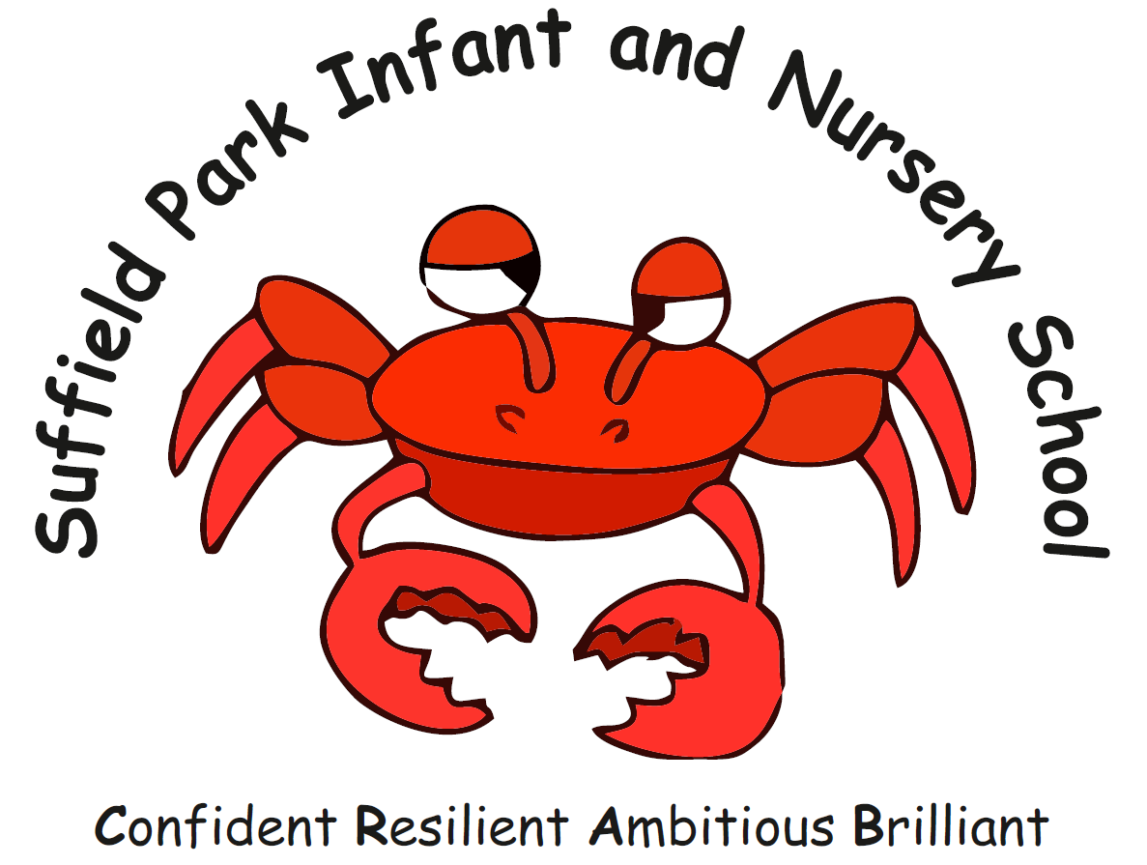
Suffield Park Infant and Nursery School

We are looking to appoint a part time SENCO for end January/ beginning February 2023 to cover a period of maternity leave who:

- Is passionate about provision and outcomes for children with SEND
- Has teaching experience in Early Years or Key Stage One
- Has a National Award for SEN co-ordination or has previous experience as a school SENCO
- Has experience of working with children with SEND
- Can demonstrate a sound knowledge of SEND code of practice and its application
- Can demonstrate an ability to work with pupils and their families in a sensitive and positive way
- Can work effectively with staff and external agencies
- Has excellent verbal, written and organisational skills
- Has the ability to work as both part of a team and independently
- Is professionally assertive and capable of prioritising workload

We can offer:

- A friendly, caring school where we expect the best from all our children
- A committed team of staff who are skilled and experienced in supporting children with SEN
- A supported SMT who can support the SENCO
- Supportive parents and Governors

The post is for 1-3 days each week with negiotable working days. The post is a temporary role to cover a period of maternity leave.

Pay range: Negiotable

Suffield Park Infant and Nursery School is committed to safeguarding and promoting the welfare of children and expects all staff to share this commitment. Appointment is subject to satisfactory enhanced disclosure from DBS

We would love to show potential candidates our school. For an informal visit or telephone call please contact office@suffieldpark.norfolk.sch.uk .

Closing Date: Monday 5th December 2022
Interviews: TBC
You will be contacted by telephone or email if you are selected for interview

