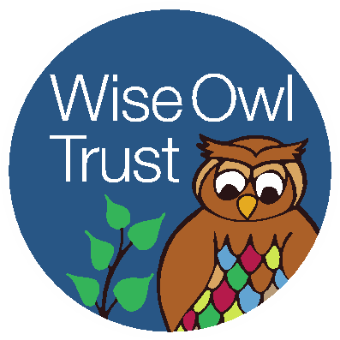

Wise Owl Trust
SEND Coordinator with Teaching Responsibility – Two Vacancies

We are looking to appoint two qualified, dynamic and enthusiastic SEND coordinators to work at two of the Academies within our Trust (Old Hall Drive Academy & Seymour Road Academy).

Together Everyone Achieves More

We are seeking two SENDCOs who can provide dynamic and strategic SEND leadership in addition to being excellent classroom practitioners, delivering quality first teaching throughout the curriculum. Whether you are making referrals to health professionals, leading multi-agency meetings, assessing children, modelling interventions, carrying out learning walks or responding to parents, you will impress us with your ability to multi-task and thrive under pressure. Supporting teachers, analysing data, leading staff meetings and ensuring children are receiving the appropriate interventions and the support they require, are all elements of this interesting, exciting and varied role.

Your experience will include working with a wide range of special educational needs and preferably having already had some experience of the role of a SENDCO or working alongside an experienced SENDCO. You are also used to delivering interventions and providing quality first teaching within the classroom. Your experience of meeting the needs of children with SEND is extensive as is your knowledge of the SEND Code of Practice is thorough. You strive to diminish gaps in attainment between pupils and peers through consistent high standards. You are able to write detailed reports, to make referrals to a range of agencies, producing a wide range of written communications in various formats. You are very keen to support the SEMH needs of children and will be instrumental in further developing our nurturing provision. You will play a key role in our organisational growth and change. In addition to the SENDCO role, you will be able to share class responsibility too and fulfil all the requirements of a class teacher. Above all you are adaptable, creative and energetic, with a high level of integrity as well as the ability to maintain confidentiality and build positive relationships at all levels and with a wide range of professionals and outside agencies.

About us
Based in the heart of East Manchester, Wise Owl is a small Multi Academy Trust with big ambitions – for our children, families and our communities.

Formed in May 2012, the Trust currently has three large Primary academies, with plans to find like-minded schools to grow our Wise Owl family in the near future. Just like thousands of children in other inner city areas, our pupils face real challenges in the world beyond the school gates. But here at Wise Owl we face those challenges together, with a RESPECT curriculum and family ethos that runs right across everything we do, at all three sites. We take our Trust motto, Together Everyone Achieves More, seriously when it comes to staff as well as student wellbeing. Our intake is diverse and a real reflection of the community that we serve. Our dedication is to providing the very best education for all of our pupils. Our ambition is that we help prepare them for the tests of life, not just a life of tests. We want Wise Owl Trust to be a place where ambitions are achieved, where aspirations are encouraged, including among our staff, and are dedicated to the professional development of all our employees.

We would be delighted to hear from you if you have/are:
- Someone who puts children first and is prepared to go the extra mile
- Enthusiasm, resilience and the ability to think imaginatively
- An understanding of learners’ needs and how to support them to reach their full potential
- Fun, hard-working and able to work as part of a dynamic team
- Empathy, humour and communication skills needed to lead effectively
- Passionate about making a difference for disadvantaged children

Working as part of Wise Owl Trust will offer:
- The opportunity to work in a friendly and diverse school community
- The chance to teach in a stimulating learning environment
- A supportive and forward thinking leadership team
- Future opportunities for promotion across the Trust

Teachers’ Pay and Conditions.

Salary: MPS (Commensurate with experience) + TLR2a

Contract length: Permanent

Start date: 31st August 2021
If you are interested in joining our happy and thriving Trust please download and complete an application form, and return it to k.walton@seymourroad.manchester.sch.uk
Wise Owl Trust is committed to safeguarding the welfare of children, young people and vulnerable adults and expects all staff and volunteers to share this commitment. An enhanced Disclosure and Barring Service (DBS) check is required for all successful applicants. WOT is an equal opportunities employer.

Please note that the Childcare Disqualifications Regulations 2009 apply to this position and therefore you may be required to complete the “Childcare Disqualification” declaration form. Should you be successful in your application for this post, your appointment can not be progressed without this.
The closing date for applications is 12 noon on Monday 17th May 2021.

Interviews will take place on Thursday 20th May 2021.

Applications are now open. Applicants who are not notified of an interview should assume that they have not been short-listed.

