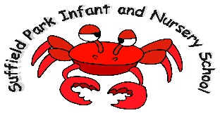
Suffield Park Infant and Nursery School

This is a unique opportunity to join our established team of staff.
We are looking to appoint a part time Early Years teacher for September 2021 to support a small group of aged SEND children in close partnership with two existing reception classes. We are looking for a candidate who:

- Has knowledge and experience of teaching SEND children
- Is passionate about improving outcomes for all children
- Is keen to create bespoke learning plans for a few specific children
- Is an excellent and committed teacher who has the drive and desire to improve the quality of education and can deliver an exciting curriculum
- Can demonstrate high standards and expectations in all aspects of school life
- Is keen to develop and share their own knowledge and expertise
- Is able to communicate effectively to all members of the school team and with external agengies
- Is able to support varying needs dynamically
- Is passionate about quality first teaching
- Is keen to progress their career in this area of SEND provision

We can offer:
- A team approach to planning and provision with experienced teachers
- Support from the school SENCO
- Supportive, enthusiastic, dedicated and talented staff
- Friendly and supportive parents and Governors

The post is for 50% contact plus additional PPA time with working days Monday-Friday. The post is initially a temporary contract for one year.

Pay range: Negiotable

Suffield Park Infant and Nursery School is committed to safeguarding and promoting the welfare of children and expects all staff to share this commitment. Appointment is subject to satisfactory enhanced disclosure from DBS

We would encourage potential candidates to contact our school for an informal before applying.

To arrange a visit or request an application pack, please contact the school office

Closing Date: Friday 21st May 2021
Interviews: TBC
You will be contacted by telephone or email if you are selected for interview

