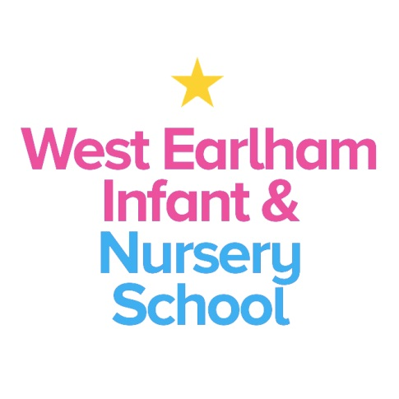
West Earlham Infant & Nursery School
Scarnell Road
Norwich
NR5 8HT
Tel 01603 451299
Email office@westearlhaminfant.norfolk.sch.uk
0.4 SEND Teacher
One year fixed term contract
Required from September 2021
Governors are seeking to appoint an outstanding teacher to join our school set in the dynamic neighbourhood of West Earlham in Norwich. The post holder will work alongside the SENDCo in supporting children with special educational needs across the school. This is a non- class based role and an exciting opportunity to work in an outstanding school (OFSTED 2017).
We are looking for a teacher who has:
- Experience in SEND within a mainstream setting
- Excellent communication skills
- Strong problem-solving skills and an ability to consider the ‘whole’ child when planning support
- An understanding of trauma and attachment behaviour and needs
- A firm understanding of Speech, Language and communication needs.
- Understands how young children think, learn and develop
- Has high aspirations for all children and can demonstrate how to enable all children to make accelerated progress from their starting points
- Has experience in using effective team management skills and has excellent inter-personal skills, energy, resilience, creativity
- Has the ability to build strong positive relationships with colleagues and families
- Can demonstrate how to plan to maximise speech and language development and early reading skills
- Has an enthusiasm and willingness to take part in the broader life of the school

Your work will involve:
- Supporting teachers in class with identifying need, assessing and implementing the graduated approach.
- Liaising with class based staff to share information.
- Delivering intervention to individuals and small groups across EYFS and KS1
- Supporting the SENDCo in preparing EHCP applications and referrals into other services
- Attending meetings in the SENDCo’s absence
- Updating electronic records
You can expect:
- To work in a dynamic and lively community
- To work with a forward thinking and a highly committed outstanding team
- To be welcomed and supported by staff, governors, children and families
- To learn with us from our expert ‘resident’ speech and language therapist
- To work closely with our EYFS (including nursery) and KS1 colleagues
- To develop as a teacher and receive appropriate support and opportunities to enable you to do this
- To contribute to school improvement and development
How to Apply
Applicants should access more information about our school via our website www.weins.co.uk. We actively welcome applicants from out of Norfolk.
Visits to the school, by appointment, are warmly welcomed, though this would not prejudice those applying from out of county. Please get in touch with the Head Teacher or Deputy Head Teacher on 01603 451299, to book a visit or for additional information.
You can find an application form by clicking on the orange “Apply for Job” button. Please return your application to us, via email to office@westearlhaminfant.norfolk.sch.uk or by post to the school address.
Please do not apply if you are unable to attend for interview on the day below.
Closing date: 12 noon Monday 17th May 2021
Interviews to be held on: Monday 24th May 2021
Our school is committed to safeguarding and promoting the welfare of children and young people and expects all staff and volunteers to share this commitment. An Enhanced DBS check will be carried out before the post begins.
This post is likely to come under the requirements of the Childcare (Disqualification) 2009 Regulations and the successful applicant will be required to complete a declaration form to establish whether they are disqualified under these regulations

