St Luke’s Primary School |  | 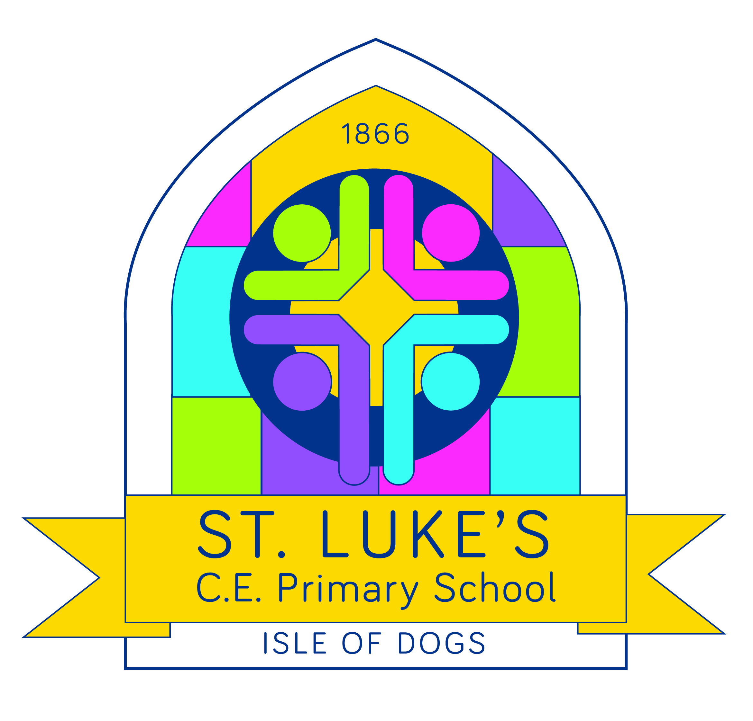
Saunders Ness Road, Isle of Dogs, London E14 3EB 020 7987 1753
SEND Teaching Assistant

Contract Type: | Fixed term with the possibility to become permanent
Salary: | Scale 3 – 4 (depending on experience)
Working Arrangement: | Full Time – 32.5 hours per week  Starting January 2024, or as soon as possible
Closing date for all applications: | Thursday 7th December, at 5pm
Are you an enthusiastic and highly motivated individual, with a passion for ensuring children learn and achieve?
Do you have the drive and energy to make a difference to children’s futures? Are you looking for an exciting and vibrant school to teach in?

If yes, then we would very much like to hear from you as we have a vacancy for a teaching assistant just like you.

Our school is a two-form entry primary school, with a Nursery, located on the southern tip of the Isle of Dogs close to Island Gardens DLR Station and a short walk from Greenwich. We are a creative, visionary and forward-thinking school with exceptional children at our heart. For an inner-city school, we have a surprising amount of educational space both inside and outside including a swimming pool suitable for younger children learning to swim.
Our school was rated as GOOD by Ofsted in October 2021.
Our school was rated OUTSTANDING in our SIAMS inspection in December 2017.
‘The distinctiveness and effectiveness of St Luke’s as a Church of England school are outstanding’ – SIAMS December 2017
‘The effectiveness of the leadership and management of the school as a church school is outstanding’ – SIAMS December 2017

The ideal candidate is a teaching assistant who is:

- Committed to attaining the best outcomes for all children
- Able to communicate in a highly effective manner with children, teachers, parents and other members of staff
- Discreet and understands the need for confidentiality
- Able to distinguish between the roles and responsibilities of a teaching assistant and class teacher
- Dedicated to a child-centred approach
- Bursting with innovative ideas
- Committed to inclusion and values diversity
- A dedicated team player
- Flexible and willing to work throughout the school with any age group
- Willing to engage in professional feedback from peers
- Supportive of the Christian values at the heart of our school

In return we offer the successful candidate:

- Fantastic children
- A creative curriculum
- A young, dynamic & highly supportive staff
- Access to school leaders who excel at coaching & mentoring
- A spacious environment with lots of outdoor space
- A strong ethos of high expectations and challenge for all
- Excellent induction, individualised professional development and career enhancement opportunities
- A supportive governing body
- Excellent public transport links and onsite parking

We believe this is an exceptional opportunity for the right person.

To enable you to have the best opportunity to demonstrate your strengths pre application, we ask that you visit the school. This will also enable you to get a feel for the school as well as meet our children and staff.

If this sounds like the job for you then, please contact us to find out more.

Further information is available along with an application form from the school or from the school’s website www.st-lukes.towerhamlets.sch.uk

We hope this is an exceptional opportunity that appeals to the right person.
To enable you to have the best opportunity to demonstrate your strengths pre application, we ask that you visit the school.

Visits can be arranged between 8am & 6pm.
Ring or email the school, we’d love to hear from you.
Tel. 0207 987 1753 or email: office@stlukeslondon.org

St Luke’s is committed to safeguarding and promoting the welfare of children and expects all staff and volunteers to share this commitment. The successful candidate will require an enhanced DBS clearance, cleared health check and suitable references before commencing employment.

We are dedicated to equality and valuing diversity.

How to apply:
An application form is available from the school or from the school’s website:
Email: office@stlukeslondon.org
www.st-lukes.towerhamlets.sch.uk/vacancies

Please return your application to: office@stlukeslondon.org

Shortlisting will take place on: Friday 8th December 2023
Interviews will take place on: Monday 18th December 2023

