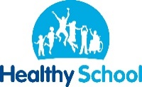
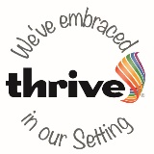
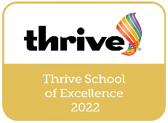
Benefits List for Employees of Hagley Primary School
Hagley Primary School employees enjoy many benefits we have introduced to show the support and recognition we have for our staff members. These include:
- Wrap Around Care Club (WACC) staff discount 50%: All staff are eligible for our WACC discount within the school.
- Outstanding Features of our Ofsted Report (June 2022): We were awarded outstanding features from our most recent Ofsted for our pupils’ behaviour, personal development and leadership and management. Wellbeing for staff and pupils is a school priority.
- Tea, Coffee and Sugar: Free tea, coffee and sugar.
- Clothing: Hagley Primary School crested sports clothing for Teachers, but also fleeces and coats available to all staff.
- Special occasion staff meals: In times of success and celebrations, the school provides a free buffet lunch for all staff.
- Lunches: Catering supplied meals at a negotiated discounted rate.
- Mental Health First Aid: We have several staff members who are trained Mental Health First Aider who hold wellbeing drop in sessions.
In addition to this, Worcestershire County Council offer the following:
- Brilliant Pension Scheme: The Local Government Pension Scheme (LGPS) is a nationwide, career average pension scheme and is a valuable part of the pay and reward package for employees working in local government.
- Hilton Worldwide – Up to 30% off (www.hilton.com)
- O2 Open – Up to 25% discount on airtime plans and up to 20% of accessories (www.o2.co.uk)
- Kaarp Benefits: Access hundreds of discounts on holidays, entertainment, gifts and more!
- Clarence Park Health Suite – Discount on a monthly membership (www.clarenceparkhealthsuite.co.uk)
- Freedom Leisure – Discounted gym memberships (www.freedom-leisure.co.uk)
- Nuffield Health – 20% discount on monthly membership (www.nuffieldhealth.com)
- Free eye tests and ability to reclaim money on prescribed spectacles
- Enhanced Maternity, Paternity and Adoption Leave: We offer an enhanced entitlement above the national average.
- Enhanced Sick Leave: We offer an enhanced entitlement above the national average.
- Business Expenses and Fuel Payments: Staff are able to claim their expenses back for work related training etc.
- Bike Scheme: Enjoy the many benefits of cycling to work and hire a bicycle and equipment of your choice with a long-term tax-free loan.
- Great Holiday Entitlement: As well as bank holidays, you'll get 25 days paid holiday (pro rata for part-time staff). This goes up to 30 days when you have been with us for 5 years. If you get more than 25 days where you work now, don't worry because if you join us without a break, we'll match your holiday up to 30 days.

