


Application Pack
SENDCO

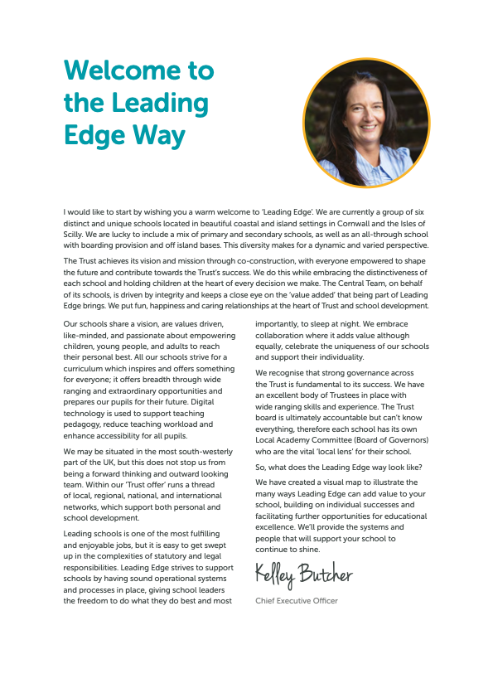

Principal – Mr S Royle BA (Hons) PGCE NPQH
Mounts Bay Academy
Boscathnoe Lane
Heamoor
Penzance
TR18 3JT
www.mountsbay.org

Salary scale Salary/Grade L10-L14
Contract Type: Permanent

Sendco

Special Educational Needs Co-ordinator

We are looking for a SENDCO to take our SEND provision to the next level. We believe in academic and social progress for all students and the SENDCO will ensure that no child is left behind in making this progress. The SENDCO is a non-teaching role and will sit on the leadership team, such is the Academy’s commitment to raising standards of academic and social progress of our students with SEND.

We want all learners to feel safe and valued, and able to access all areas of the curriculum so that they can make academic and social progress.

We are looking for an expert in the field of SEND who is an outstanding practitioner showing focus and the ability to be forward thinking. They must be able to form effective relationships with students, parents, carers as well as the staff. They will show drive and enthusiasm to ensure that Mounts Bay Academy continues to make significant improvements in its provision for those with special educational needs.

Applicants should be flexible, organised and able to work under their own initiative. Attention to detail and accurate record keeping are essential along with competent ICT skills. Applicants must be able to work collaboratively, both as a team leader and a team member.

Discussions are currently happening concerning the SENDCO being the DSL and further thoughts on this would be welcomed during the recruitment process.

Application forms and information packs are available via our school website or on request by telephoning the Academy on 01736 363240.

Informal visits prior to application are welcomed and can be arranged by contacting Mrs Jess Kearey, PA to the Principal at jkearey@mountsbayacademy.org

Closing Date: 25/04/2025
Interviews W/C 28/04/2025
Start date: Sept 2025.
Principal – Mr S Royle BA (Hons) PGCE NPQH
Mounts Bay Academy
Boscathnoe Lane
Heamoor
Penzance
TR18 3JT
www.mountsbay.org

Welcome

Dear Applicant

Thank you for expressing an interest in this post at Mounts Bay Academy, a member of the Multi Academy Trust called Leading Edge Academies Partnership (Leading Edge). I hope you find this information pack helpful and that in due course we shall receive an application from you.

Mounts Bay Academy is located in Penzance, West Cornwall with 950 students aged 11-16 years. This is a beautiful part of the world, enjoying a varied coastline surrounding rugged hills and moorland and it is a wonderful place to live and work.Mounts Bay school converted to Academy status in 2011 and a year later was awarded an Outstanding grade in a full Ofsted Inspection. In November 2017 the Academy was inspected by Ofsted to review its safeguarding arrangements and the HMI visitors noted that the Academy had a fully inclusive culture and provided excellent support for vulnerable students. Since then, we were awarded a good grade in 2021 under the new Ofsted Framework introduced in 2019.

I have been the proud Principal of Mounts Bay since March 2024, and I am passionate about the Academy and the path that we need to follow. Whilst enjoying an enviable reputation in the local area, there is work to do in terms of outcomes, attendance and the quality of teaching and learning. Our priorities are explicit, and my style is very open and honest – there are no hidden agendas here! We have recently introduced a new behaviour policy which is having very positive effects and our teaching and learning policy has been stripped back to provide very clear expectations of staff and students. All strategies are supported by a comprehensive evidence-based programme of CPD, both internal, and through external bodies such the PTI, the Cornwall Research School, which we are delighted to lead, the Challenge Partner network, where we are delighted to be the lead school in the Cornwall hub.

The Academy enjoys a range of impressive physical resources including a purpose-built science area, subject specific teaching areas in the Creative Arts as well as a lively and bouncing Music block. Sports facilities are strong, including a large sports hall, a 3G pitch and extensive outside field areas, all of which have significant community use. Plans are currently being made with Cornwall Council for an on-site ARB to provide further support to learners.

Mounts Bay Academy is an Apple Distinguished school, and each student and staff member is provided with a digital device to support their learning and work. We believe that students should be prepared for the world in which they will live when they leave the Academy and strive daily to ensure that we update our knowledge accordingly.
We are a learning community that aspires to success for all without exception, convinced that everyone can learn at the highest level, lwhen presented with learning experiences that are as engaging as they are adventurous. We believe that all young people can achieve; it is our job to nurture the very best in each person by identifying their strengths and talents and removing any barriers to learning.
Mounts Bay is a caring and dynamic community where students are placed at the centre of everything that we do. We provide a broad and balanced curriculum which is delivered by a team of skilled and dedicated staff, with the MBA way visible throughout the school, putting ‘Relationships, Respect and Responsibility’ at the centre of everything.
Talent is celebrated, curiosity is nurtured, and every individual is given the chance to shine. We help to develop young people with a positive attitude to learning and life, ready to take on the challenges of our fast-changing world and to make a creative contribution to their community.
The successful candidate will be a brave, creative and visionary person, to join our staff to enable all to thrive in this ever-changing world. We are looking for a professional with a spirit of adventure who understands that high personal and academic standards and exciting learning can combine to change young people’s lives. Mounts Bay Academy is committed to safeguarding and promoting the welfare of young people and we expect the candidate to share this commitment.

Since I joined the Academy, I have felt safe, I have been happy, I have felt challenged, and I have been genuinely welcomed into the Mounts Bay community. Is this not what all of us want from a school?

Please do get in touch if you would like to come and visit. I look forward to meeting you.

Yours sincerely


Simeon Royle
Principal

Job Description

Post Title: | SENDCO
Purpose: | Purpose:  - Lead and co-ordinate approach across the school to ensure the needs of all students and those students with SEND are met, holding staff to account for the quality of this provision.  - To ensure that students feel safe and valued and that the inclusion and Student support team make a significant and sustained contribution to this provision via the Academy’s facilities such as the Learning Support Mentor team, ICollege, and Reintegration.  - To generate and make a significant contribution to the provision of high-quality teaching and learning at a whole school level.
Reporting to: | Principal
Responsible for: | Assisting named Sendco and leading the work of the Special Educational Needs Team, including the Teaching Assistants and the Deputy Heads of Year.
Liaising with: | Heads of Faculty, SEN teachers, SEN TAs and HLTAs, Learning Mentors, Senior Leadership Team, Senior Management Team, Heads of Year, Pupil Support Services, the Governing Body, LA representatives, external agencies and parents.
Working time: | Full time
Salary/Grade: | Salary/Grade for suitably qualified teachers holding the SEN qualification is L10 – L14
Disclosure level: | Enhanced

Page 5 – Key functions

Key Functions – Strategic Leadership | Key Functions  - Advise the Principal, the Senior Leadership team (SLT) and the Local Academy Committee (LAC) on the strategic direction of SEN policy and provision, In line with Academy vision and Development plan and working closely with Trust SEN experts.  - Design and oversee a dynamic programme of interventions for relevant students.  - Be accountable for provision mapping for pupils with SEND, leading the assess-plan-do-review cycle.  - Oversee the EHCP application process, ensuring that students who need additional support and funding have access to this.  - Ensure that there is effective provision for those students who are holding EHCPs.  - Ensure that there is effective provision for those students who are on the SEN record of need.  - Design and deliver a programme for testing students for different types of SEN.  - Working with the Leadership Team and the Exams Officer, oversee the testing procedures for access arrangements for external and internal exams.  - Monitor the progress and attainment of pupils with SEND, identifying where pupils need additional support and designing that support alongside teachers.  - Ensure that the Pupil Passports develop students’ individual learning and have the desired effect of raising standards. Students and parents/carers should be actively involved in this process.  - Support incoming Year 7 pupils, including undertaking a transition programme for a small number of students with additional needs.  - Establish an effective partnership with parents/carers ensuring that they are informed about SEN provision, progress and the need of their child and how the Academy is providing for these needs, giving detail of what the Academy is doing, what the young person needs to do and what the home needs to do  - Provide regular information to the Principal, named Sendco and the Leadership Team, the Trust, and the Local Area Committee concerning the effectiveness of provision for students with SEND, to inform decision making and policy review.  - Liaise with the Principal and leadership Team concerning those students who are in receipt of alternative provision. Maintain links with the AP provider and include QA of this provision.  - Liaise with DSL and DDSLs to ensure Safeguarding and Child Protection Policies are implemented.
Personnel management | - Organise, manage, and lead a team of student support workers, comprising teaching assistants and Deputy Heads of Year, ensuring that these staff are deployed to ensure best value in supporting students access the curriculum and make good academic and social progress.  - To lead the members of staff who are carrying out SEN admin work.  - Undertake staff appraisals, as required, accordingly to Academy policy
Teaching and learning | - Support the vision and direction for SEND provision and oversee the day–to-day operation of the Academy’s SEND policy.  - Co-ordinate effective support to enable those with SEN to make accelerated progress  - Co-ordinate screening programmes and additional testing as relevant  - To lead the SEN aspect of the Academy’s CPD programme, working collaboratively with the Assistant Principal leading this programme to ensure an improvement in staff performance in support learners with SEN  - Support all staff to understand the needs of pupils with SEND and ensure staff can meet those needs in their classroom and/or in small group and 1:1 support. This could require the design and delivery of specific training sessions.  - Ensure an effective learning environment and support for other staff in the implementation of the MBA culture ensuring the  - Act as a key point of contact for external agencies in panning referrals and reintegration programmes
Accommodation and Resources | - Manage the SEND budget efficiently and effectively achieving best value for the Academy.  - Ensure that Health and Safety practises, including risk assessments, are in line with school policy
Knowledge and Skills | - Keep up to date with national developments regarding SEND, teaching methodologies and leadership initiatives
Quality Assurance | - Monitor the effectiveness of SEND provision across the school with confidence and coordinate a multi-agency approach.  - Working with the Leadership Team and the named Sendco, QA the quality of SEND provision in the classroom.
Meetings | - Meet regularly and as required with line manager  - Chair and facilitate Sen meetings  - Attend relevant SLT meetings and briefings  - Attend LAC meetings on request  - Attend relevant pastoral and multi-agency meetings  - Attend statutory SEND meetings with parents and students, as appropriate
Other | - To take action to enable all students to have the best outcomes academically and socially.  - To fulfil criteria for the standard teaching contract including national standards for teachers
All teachers have a duty to: | - To remain and adhere to the Trust’s Safeguarding Policy and child protection procedures.  - To play a full part in the life of the Academy community, to support its distinctive mission and ethos and to encourage staff and students to follow this example.  - To actively promote the Academy’s corporate policies.  - Be responsible for your own continuing self-development, undertaking training as appropriate.  - To be aware and adhere to applicable rules, regulations, legislation, and procedures e.g. the Trust Equality and Diversity Policy, Staff Code of Conduct, national legislation and GDPR Data Protection Regulations.  - To comply with the Academy’s Health and Safety Policy and undertake Risk Assessments as appropriate.  As a restorative organisation we:  - Apply the principles of mutual respect and responsibility in all our internal and external relationships.  - Actively work to prevent, address and repair harm.  - Engage in continuous learning to further develop our communication and problem-solving skills.

Please note that this is illustrative of the general nature and level of responsibility of the role. It is not a comprehensive list of all tasks that the postholder will carry out. The postholder may be required to do other duties appropriate to the level of the role, as directed by the principal. This job description may be amended in consultation with the postholder.
Person Specification

Requirements | Essential | Desirable | Demonstrated By
Qualifications & Training | QTS SENDCo qualification (NASENCO). Those without a SENDCo qualification should expect to complete this with 3 years of taking the post.  - Relevant teaching qualification  Degree in National Curriculum subject | Middle or senior leadership qualification eg NPQSL or NPQH or equivalent | Interview / Application Form
Experience | Proven track record of leading staff  Ability to promote high standards academically and socially  Experience of teaching children with special needs and showing accelerated progress  Experience of leading staff in securing whole school improvement | Coaching experience  Record of using evidence-based research to inform leadership of SEND | Application Form / Interview
Skills | Ability to teach to a high level – outstanding classroom practitioner  Excellent communication skills  IT skills that enable effective planning, teaching, and administration  Able to lead teams ensuring improved performance  Ability to use data to raise standards with own classes |  | Application Form / Interview
Knowledge | Excellent knowledge of classroom skills and teacher standards.  Understanding of current SEND development / research on classroom practice  Thorough working knowledge of the secondary curriculum |  | Application Form / Interview
Management | Able to manage own workload  Able to prioritise  Able to show initiative with excellent organisational skills | Evidence of or interest in further professional development. | Application Form / Interview / Task
Aptitude and Personal qualities | Empathy with Staff and Students  Demonstrate leadership of others  Able to work as part of a team  Clear understanding of inclusion and willingness to be an advocate for all learners  An interest and ability to make a positive contribution  Good team player  GSOH  Good communication skills with students, staff and parents and the ability to adapt manner based on audience and purpose of interaction  A ‘can do’ positive attitude that seeks solutions to problems |  | Interview
Special knowledge and Skills | Up to date knowledge of the SEN code of Practice  Able to use data effectively to track student progress and to provide effective intervention

