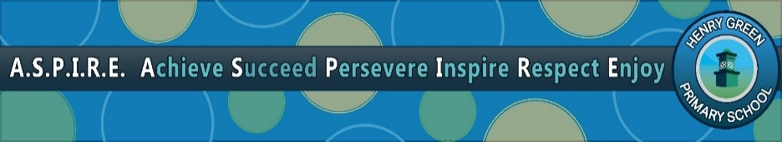
Learning Together, Learning for Life.

SENDCo
Salary: MPS/UPS/TLR

Start date: Jan 2023 or Sooner

"Pupils are very proud to attend Henry Green Primary School. They are safe and happy. Pupils typically use the word ‘special’ to describe what it is like being a pupil here.
"Ofsted December 2021.

This is an exciting opportunity to join our professional, caring and supportive team. We are looking to appoint an exceptional and inspiring SENDCo who can lead a great team of support staff. At Henry Green we are passionate about fairness, inclusion, and staff well-being and development. We are looking to appoint an experienced, passionate and enthusiastic Special Educational Needs Co-ordinator, who will lead, develop and teach in our new In School SEND Provision daily, as well as working closely with the leadership team and teaching staff to ensure SEND provision is highly effective across the school.

The successful candidate will demonstrate a track record of helping pupils to be the best they can be and will demonstrate an excellent understanding of current thinking in SEND education.
The successful candidate will be:
- Experienced in supporting children in all areas of SEND for 2 years or more.
- Committed to securing positive outcomes for all students with SEND including children with High and Complex needs.
- Experienced, well qualified and highly motivated, having already achieved or be willing to achieve the NASENCO qualification.
- Able to demonstrate high professional standards with the highest expectations of what our students can achieve.
- Able to Lead our developing In School Provision.
- Be an exemplary teacher, who is able to accept challenges, inspire and motivate others.
We offer you:
- An environment where students have excellent attitudes to learning.
- A diverse and supportive community of friendly children, who are eager to achieve & deserve the best
- A comprehensive and personalised professional development programme to support your individual career goals.

Visits to the school are actively encouraged. Please contact Krystal Britton (SBM) on 0208 270 4466 to arrange a visit, or by email on office@henrygreen.bardaglea.org.uk

Closing date for applications: 16th September 2022
Interviews: Week Commencing 26th September 2022
For an application form and further details, please contact Ms K Britton(SBM) office@henrygreen.bardaglea.org.uk

Early applications are encouraged as we will review applications as we receive them: applicants may be contacted before the closing date.
Our school operates a rigorous recruitment process to ensure candidates’ suitability to work with children. All posts in school are subject to disclosure of criminal records.

