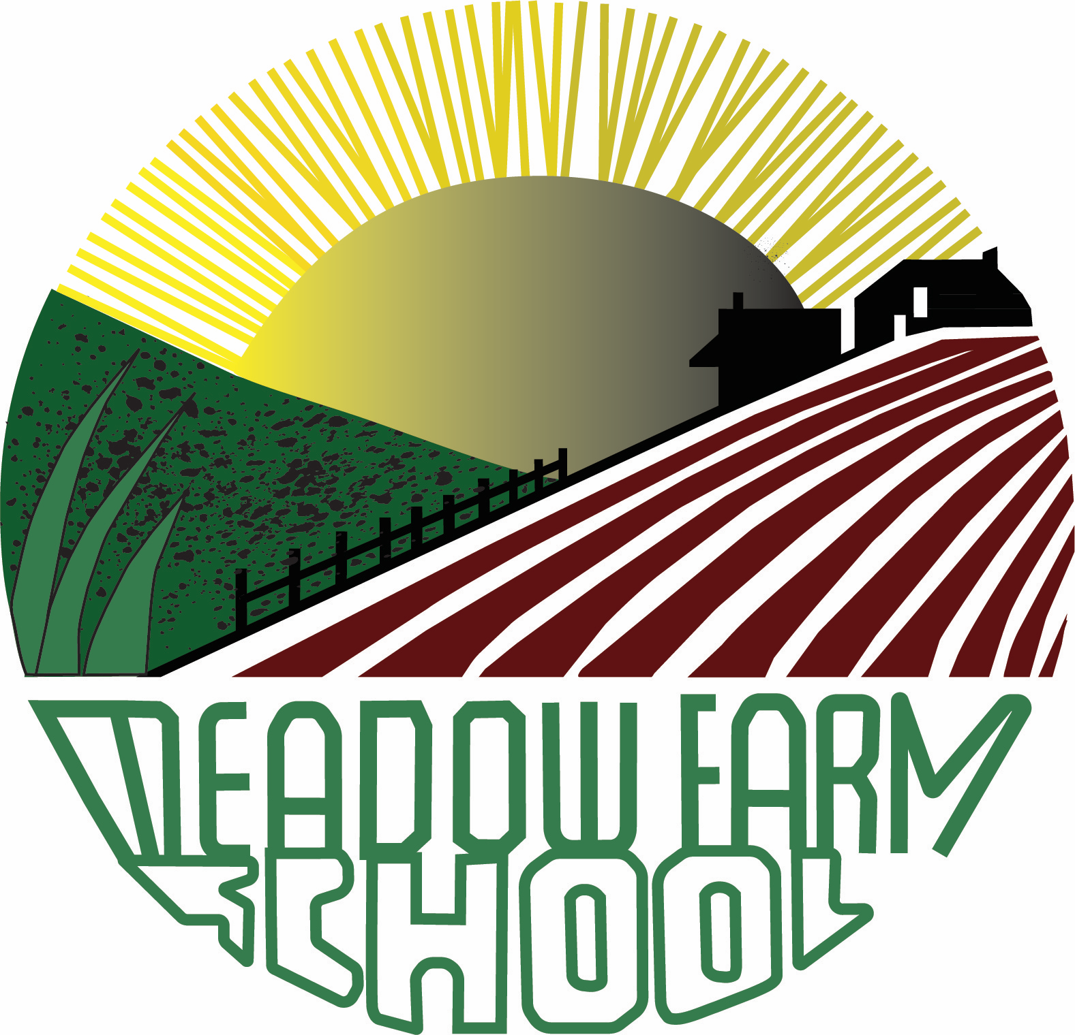

SENDCo

Employer: Meadow Farm Community Primary School
Salary: Teachers Main Pay Scale/ UPS + SEND Allowance (£2,476) Pro rata
Hours: Part time, temporary 3.5 days. 2 day teaching commitment – Maternity Cover or Secondment opportunity
Required from: 1st December 2023 or earlier until 2nd April 2024
Closing date: Wednesday 4th October 2023 at 12 noon
Summary Description
Meadow Farm Primary School is fully committed to safeguarding. The successful candidate will require enhanced DBS clearance and social media check.

“This post is exempt from the provisions of the 1974 Rehabilitations of Offenders Act. It is an offence to apply for the role if you are barred from engaging in regulated activities relevant to children”
“Before applying for this post, please refer to our school website https://www.meadowfarmschool.co.uk/policies-and-documents/ and view our child protection / safeguarding policy”.
Governors are inviting applications for the above post. The role will be to undertake the role of SENDCo at the school, whilst continuing to hold the responsibility for a class of children. This is a job share in year three. The appointed SENDCo will form part of the school’s Senior Leadership Team.
Meadow Farm Primary School is a friendly, welcoming and nurturing school, with an emphasis on promoting high standards and providing a broad and inclusive curriculum. We believe in our children and school community. At our school we are Confident, Caring and Accomplished. We know this combination ensures that our children thrive and achieve their best.
The school was last inspected by Ofsted in March 2018, who confirmed that the school remained ‘good’ in all areas.

We are looking for someone who is:

- An excellent classroom practitioner, with a proven track record of improving outcomes for all pupils, including those within the field of SEND.
- Passionate about inclusion and the learning and development of every child.
- Well organised and meticulous with paperwork, with a high level of attention to detail
- Able to work effectively as a member of the staff team and lead and support other staff.
- In possession of the personal skills needed to be able to communicate effectively within the school and with a range of external professionals.

In return, the successful applicant will be assured of a high level of good quality support and encouragement to develop professional skills and interests.

Please submit a letter of application, detailing how you meet the requirements laid out in the Person Specification, and envisage the area of SEND developing at Meadow Farm, to: admin@meadowfarm.derby.sch.uk

Closing date for applications: Wednesday 4th October 2023 at 12 noon

We are looking for someone who:
- Is a strong classroom practitioner who achieves great results.
- Has high expectations of pupils' progress and behaviour.
- Has a good understanding of progression and expectations in EYFS and Year One.
- Has proven classroom management and organisation skills.
- Embraces creativity and has a positive outlook on life.
- Has an ability to inspire children to enjoy learning.
- Has a commitment to enable children to reach their full potential and be committed to educating the 'whole child'.
- Is fascinated by the learning process and actively seeks new ideas and research.
- Loves supporting and inspiring fellow staff and children.
- Has great ideas and wants to share them!
- Sincerely values every member of the school community.
- Believes in each and every child and has high aspirations for their achievement.
- Has the ability to make learning fun and engaging whilst ensuring all children are appropriately challenged.
- Is prepared to go the extra mile with a smile on their face!

In return, we can offer you:
- A supportive and committed Governing Body.
- Hardworking, friendly and talented staff.
- Well behaved, enthusiastic children.
- A commitment to continued professional development.
In order to support you in making the very best of this role, you will receive allocated Leadership time and PPA time. In addition, you will have access to professional development tailored to your needs.
Meadow Farm Primary School is fully committed to safeguarding. The successful candidate will require enhanced DBS clearance and clear social media check.

Visits to the school are welcomed. Please contact the school office on 01332 662631 to make an appointment for a visit.

To apply, please complete the attached Application form and return it with your letter of application to admin@meadowfarm.derby.sch.uk For a paper copy, please send a large, self-addressed and stamped envelope to: Meadow Farm Primary School, Foyle Avenue, Chaddesden, Derby DE21 6TZ

The closing date for this vacancy is Wednesday 4th October 2023 at 12 noon. Any application forms received after the closing date will not be accepted.

