Senior Academy Business Manager

Dormanstown & Wilton Primary Academy

DPA327

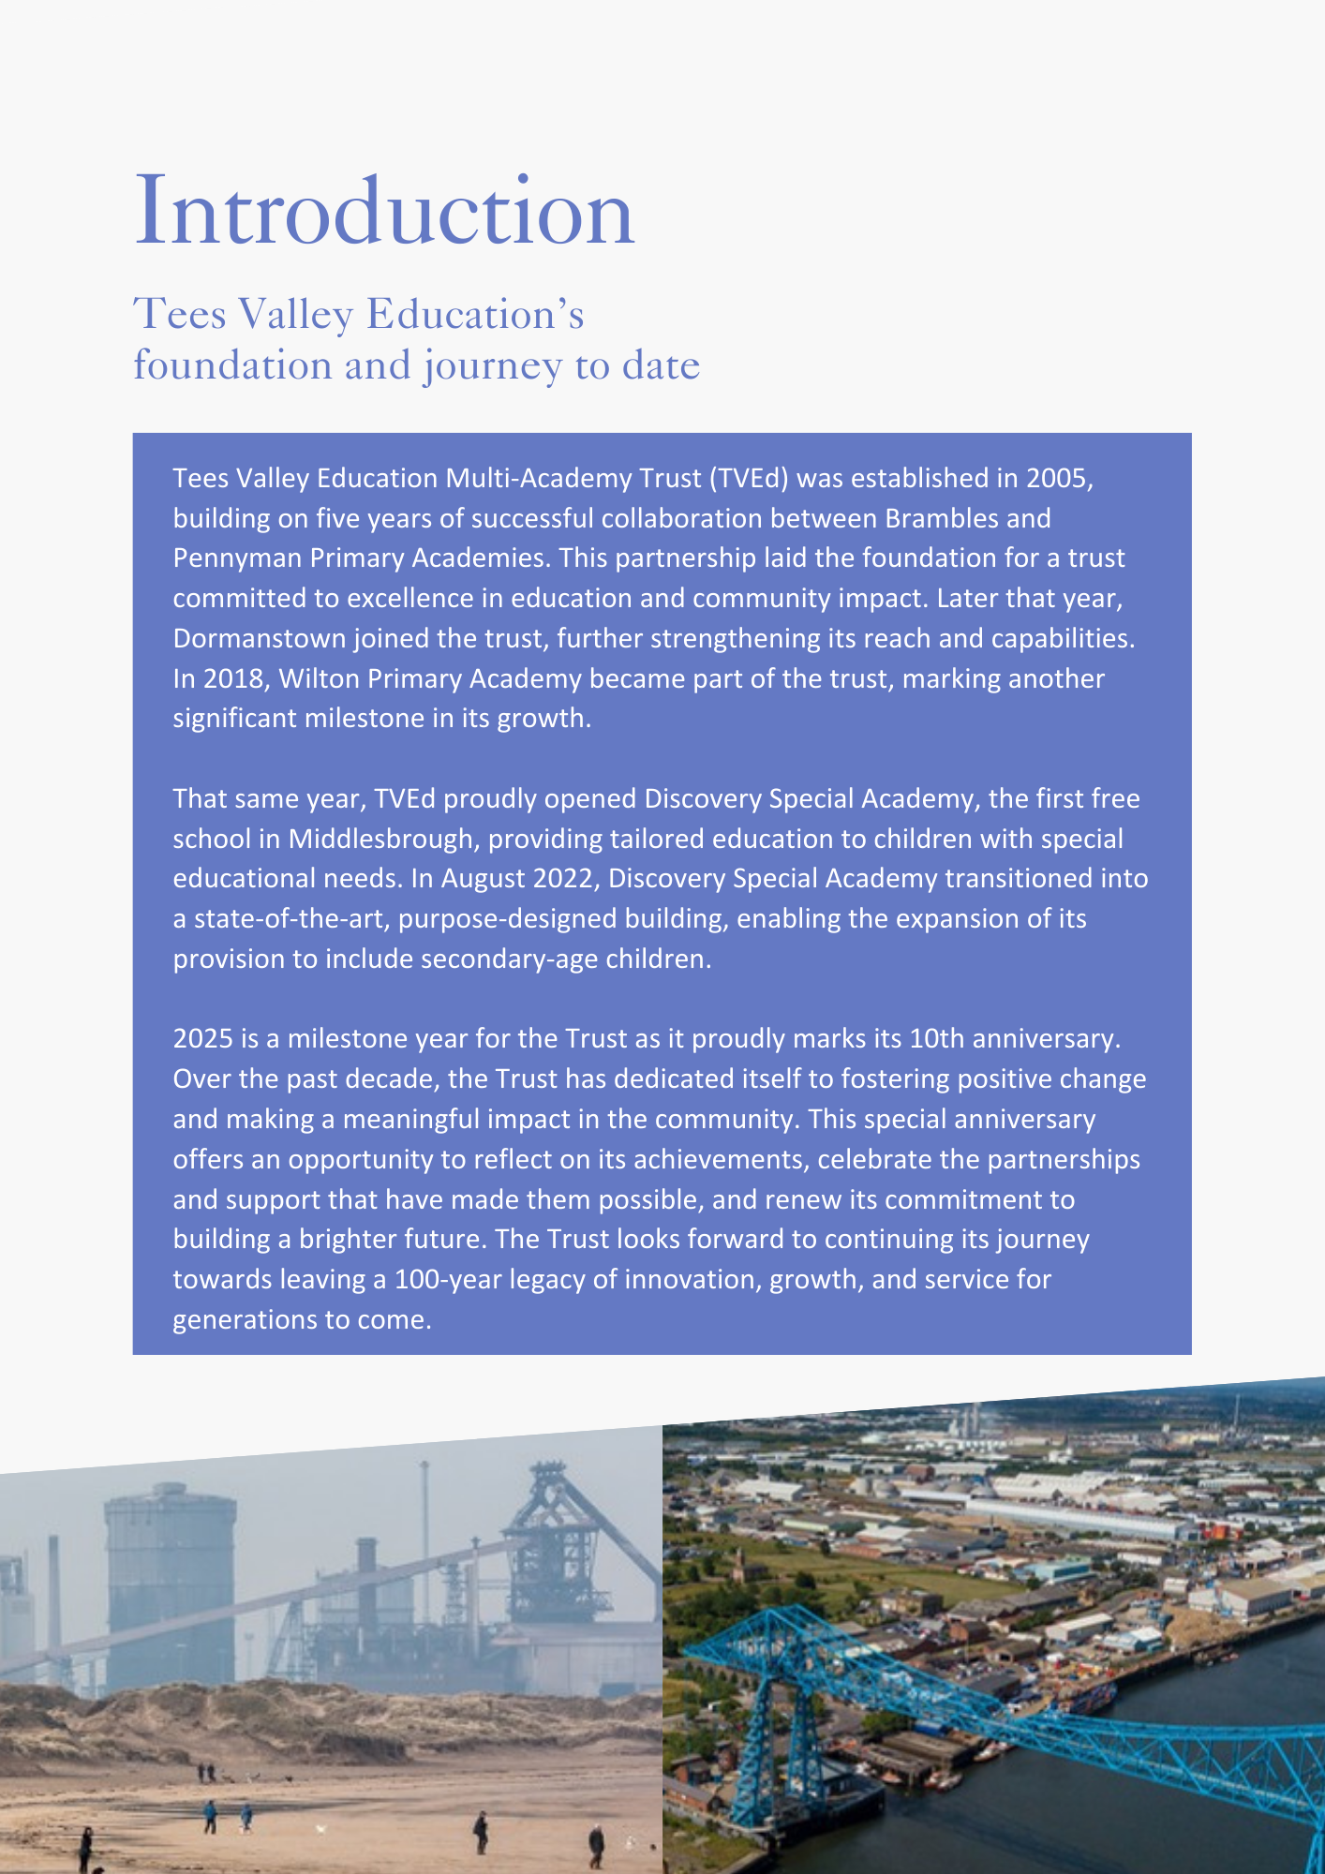

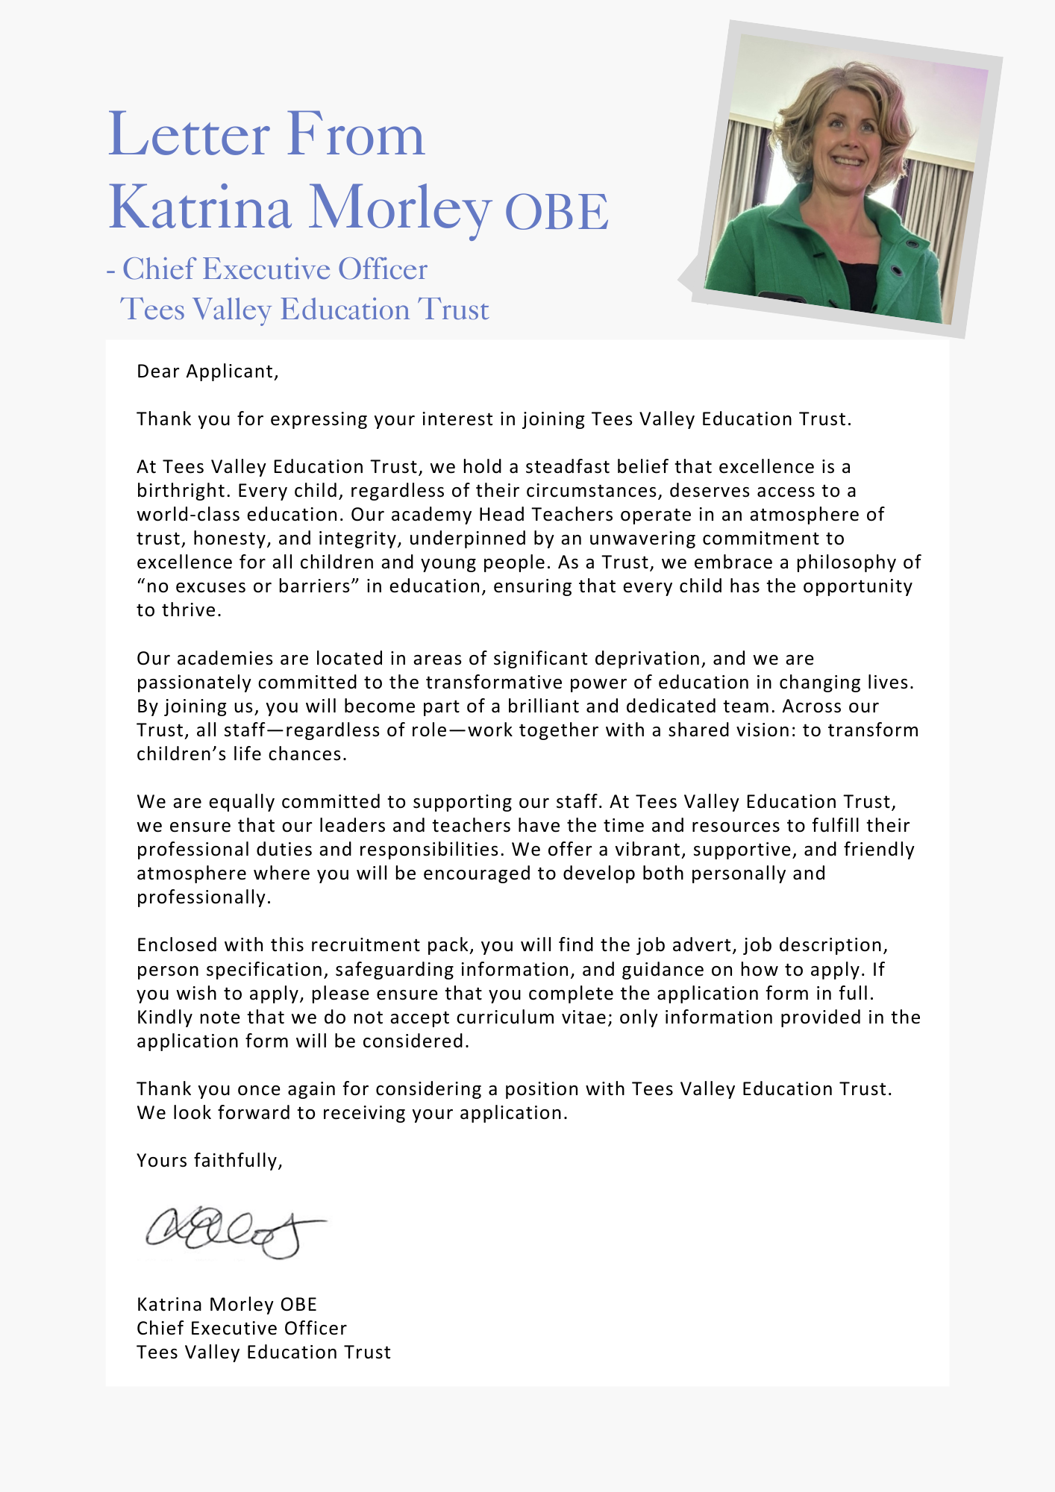





|  |
| --- |
| **ADVERTISEMENT** |

**Senior Academy Business Manager (Dormanstown and Wilton Primary Academies)**

**\*Previous applicants need not apply**

**Status:** Permanent **Required:** As soon as possible **Salary:** From SCP 32 to SCP 34 £41,511 to £43,693 **Hours:** 37 hours (full time), whole time role (annual leave allocation of 29 days) **Reporting to:** Academy Executive Headteacher (Dormanstown) and Head of Academy (Wilton) **Academy:** Dormanstown and Wilton Primary Academies (Redcar Academies)

### **About the Trust**

The Trust was established in 2015 and provides education and enrichment activities to more than 1200 children across five Academies, located in Middlesbrough and Redcar and Cleveland local authority areas. Academies within the Trust are:

* Brambles Primary Academy (2 to 11 years),
* Discovery Special Academy (2 to 16 years),
* Dormanstown Primary Academy (3 to 11 years),
* Pennyman Primary Academy (2 to 11 years), and
* Wilton Primary Academy (3 to 11 years).

**About the role we are looking to appoint:**

Redcar academies are seeking to appoint a suitably qualified Senior Academy Business Manager with experience of working across a Trust and with senior leaders.

In order to continue our drive for excellence, the successful candidate will have significant and proven impact in business management, ability to lead a team as well as being enthusiastic, with a strong commitment to teamwork. The role will be required to support the executive headteacher and head of academy at both Dormanstown and Wilton Primary academies to lead the business aspects of running the two academies, as well as being part of the Trust central team one day a week on Trust wide projects e.g. financial management, procurement, safeguarding, Health and Safety, GDPR, HR and policy and procedure development work.

At an academy level this includes providing day to day oversight and support to the executive headteacher and head of academy on financial management including budget management, human resources, payroll, administration and management, contract management, health and safety, facility and premises management.

The role is required to oversee and coordinate the workload of the academy business and premises teams.

### **What we are looking for:**

We are looking for someone who is positive, solution focussed and has strong communication, interpersonal skills and can provide an excellent customer service experience to all. The role will require the post holder to liaise directly with a range of stakeholders internally and externally including CEO, Directors, Trust Improvement Team, Headteachers, Deputy Headteachers, Trustees, Department for Education (DfE), Ofsted and Education Skills Funding Agency (ESFA) as required.

In return, we can offer you the opportunity to be part of a successful trust, that delivers on good outcomes for children with a strong inclusive ethos and an inherent drive for quality. Our children are proud academy citizens, who care for each other, are focused on learning and enjoy coming to school.

We have a strong team ethos, working collaboratively to improve outcomes for our children. We are offering a varied and rewarding role in a busy working environment with access to excellent continuous professional development, as part of a highly functioning team. With the Director of Finance, Resources and Operations, the Academy Business Managers across the Trust academies work closely together, offering support and the development of effective practice through regular communication and network meetings.

### What the Trust will provide the successful candidate with:

* A workplace where all staff are valued and treated with respect as outlined within the Trust’s Diamond Standards
* A passionate, enthusiastic and supportive Leadership Team
* A listening and learning organisation where all staff are encouraged to be curious and share ideas for the Trust/academies/team to improve
* Hard working, committed and dedicated staff who strive to gain the best outcomes for all children across the Trust’s academies
* Dedicated approach to children’s learning to encourage them all to be the best they can be
* Career enhancement opportunities within areas of interest as well as supporting ongoing professional development and training specific to job role
* Dedicated line manager to discuss work streams and capacity
* Free access to the Trust’s Wellbeing offer, which includes counselling, access to GP, Mindfulness and so much more.
* Free parking
* Enrolment into the local government pension scheme
* All support contracts are employed on National Joint Council (NJC) for local government services (also known as Green book)
* Benefits of the Trust’s Staff Charter which can be found at [TVED Staff Charter](https://www.teesvalleyeducation.co.uk/wp-content/uploads/2022/01/STAFF-CHARTER_FINALISED.pdf).

**Safeguarding requirements for the role:**

Tees Valley Education Multi Academy Trust is committed to safeguarding and promoting the welfare of children. All appointments will be subject to a satisfactory enhanced DBS check.

This post is exempt from the Rehabilitation of Offenders Act 1974 and, therefore, all convictions, cautions and bind-overs, including those regarded as “spent” must be declared. The Trust’s Recruitment of Ex-Offender policy can be requested or visit the Trust’s website.

Applications are invited from prospective candidates who demonstrate that they are able to meet the essential criteria set out in the person specification and who have the vision, values and tenacity to join an outstanding team and help continue the journey towards excellence.

|  |  |
| --- | --- |
| **JOB DESCRIPTION** | |
| The role is required to work across more than one academy and undertake central Trust functions by providing strategic leadership for the business requirements across the Trust, through supporting the Senior Leadership Team. | |
| **MAIN RESPONSIBILITIES** | |
| * Be a part of the Trust Business Leadership Team * To deputise for the Director of Finance, Resources and Operations in their absence * Trust wide centralised duties to support the academies in the Trust * Work flexibly to meet the needs of the academies and the Trust * Know and comply with national directions from DfE and ESFA as well as academy protocols * Be responsible for developing Office Managers, level 3 administrators, premises staff and administrative apprentices where needed in processes and procedures * To act as the Trust Finance approver as required and ensure the Trust’s Financial Handbook is followed including the Trusts Financial Scheme of Delegation * Support Head Teachers, Director of Finance, Resources and Operations in setting and managing budgets, linked to the academy and Trust Improvement Plans * Support and maintain financial procedures and processes and maintain timely management of accounts for the Trust * Uphold good governance and to support the Director of Finance, Resources and Operations to undertake Trust compliance audits and quality assurance of operational practice and procedures * Maintain transparent recording suitable for audit inspections * Public sector procurement including tenders and contracts * Prepare and present reports to SLT, the Director of Finance, Resources and Operations and/or the relevant Trust Committee meetings * Research and source various funding streams in liaison with the Head Teacher and Director of Finance, Resources and Operations * To collaborate in the development of the Trust strategic handbooks * To project manage and coordinate the business improvement plan to ensure actions and deadlines are met | |
| **GENERIC RESPONSIBILITIES** | |
| * Represent and promote the Trusts values, internally and externally * Deliver day to day duties consistently with the agreed service level and within the Trusts ethos * Act as champion for improvement, constantly seeking to enhance quality as well as optimise systems and processes * Actively promote and act in line with Trust policies and behaviours * Have a practical and professional commitment to actively contributing to improving standard, provision and outcomes for pupils * Comply with policies and procedures relating to child protection, health, safety and security, confidentiality and GDPR data protection, reporting all concerns to the appropriate person * Be aware of and support difference and ensure equal opportunities for all * Contribute to the overall ethos/work/aims of the Trust * Establish constructive relationships and communicate with other agencies/professionals * Attend and participate in relevant meetings * Participate in training and other learning activities and performance development as required * Recognise own strengths and areas of expertise and use these to advise and support others   Any other duties consistent with the grading of the post that is deemed necessary and as directed by the CEO, Head Teacher or Director of Finance, Resources and Operations | |
| **SAFEGUARDING** | |
| * All staff must adhere to the Trust’s safeguarding training (appropriate for job role) including policies, procedures, latest Keeping Children Safe in Education guidance and Working Together to Safeguard Children DfE 2018. | |
| **ADDITIONAL RESPONSIBILITIES** | |
| * The job holder may be required to undertake additional duties as could be reasonably required in exceptional or emergency situations.  These may include: * to work flexibly between the hours of 8am and 6pm including weekends. * to work across the Trust if required. * to undertake additional training e.g. first aid, Positive Handling. | |
| This job description will be reviewed annually and may be subject to amendment or modification at any time after consultation with the post holder. It is not a comprehensive statement of procedures and tasks, but sets out the main expectations of the Trust in relation to the post holder’s professional responsibilities and duties.  Elements of this job description and changes to it may be negotiated at the request of either the line manager.  The job holder may be required to undertake additional duties as could be reasonably required.  The job holder may be required to work across the academy group, including for Trust wide initiatives.  The job holder may be required to undertake additional training. | |
| |  |  |  | | --- | --- | --- | | Signed (Employee) |  | | | Date: |  | | | Signed (on behalf of employer): | | Name and Role: | | Date: |  | | | |
| **Important:** In the first instance, applications are assessed against the following criteria:  *overall presentation *use of standard English *grammatical accuracy  Where applications do not meet the expected standard, they will be discarded before being matched to the person specification. | |
| **PERSON SPECIFICATION** | |
| **QUALIFICATIONS** | **Office use only** |
| Relevant formal qualification e.g. in accountancy or management | E (1) |
| Good standard of education grade C/4 or above in English and Maths | E (2) |
| Graduate or equivalent | D (1) |
| School Business Management qualification | D (2) |
| **EXPERIENCE** | Office use only |
| Successful experience in managing change | E (3) |
| Experience of working in an education setting | E (4) |
| Successful track record in working with school governors or other boards of directors | E (5) |
| Experience of building capacity and managing change across a range of professional functions and support teams. Experience of developing shared services would be beneficial | E (6) |
| An understanding of financial management across multi-disciplinary functions and of budget formulation, setting and monitoring across a number of disparate bodies | E (7) |
| Experience of building trust and confidence with various stakeholders and providers | E (8) |
| Experience of building effective, productive and relevant working relationships, both internally and externally, with a diverse range of stakeholders | E (9) |
| Experience of working with senior leaders within a local authority, government department, agency or similar high profile organisation with comparable scope, responsibilities, budget and resources | D (3) |
| Experience of Human Resource Management | D (4) |
| Experience of SIMS personnel, IRIS Financials or similar MIS and finance systems | D (5) |
| Experience in premises’ management, risk assessments and emergency planning | D (6) |
| Experience of public sector procurement including tenders and contracts | D (7) |
| **KNOWLEDGE AND SKILLS** | Office use only |
| Operational management skills | E (10) |
| Responsible for leading teams across the Trust in a fast paced environment. Demonstrating added value in all activities | E (11) |
| Skills in management and participation in the formulation of policies and strategies within a large multi-discipline organisation | E (12) |
| Proven track record of education/training in relevant areas of finance/management | E (13) |
| Skills in Microsoft Excel and experience of finance systems | E (14) |
| Understanding of school frameworks and funding | E (15) |
| Effective use of IT | E (16) |
| Skill in supporting strategic leaders to prepare a budget plan taking into account Value for Money, organisational priorities and factors affecting funding/income | E (17) |
| Proven skill in maintaining accurate financial information to facilitate effective monitoring to achieve organisational aims | E (18) |
| Proven skill in presenting complex financial data to support the Head Teacher and Trust Business and Resource Manager | E (19) |
| Proven skill in delegating tasks and managing own workload to meet deadlines | E (20) |
| Identify own professional development needs and ensure they are met | E (21) |
| Identify and report potential risks to senior leaders | E (22) |
| Involvement in leading and supporting a project | E (23) |
| Successful in communicating effectively to a variety of audiences | E (24) |
| Understanding of Health & Safety issues relevant to the post | E (25) |
| Understanding the importance of confidentiality and an appreciation of the implications of the GDPR and Data Protection Act | E (26) |
| Knowledge and responsibility for the effective operation of payroll structures and administration (in particular School Teachers’ Pay and Conditions) | D (8) |
| **QUALITIES** | Office use only |
| An inspirational leader, visionary and visible; able to lead by example. Empowering, enabling, motivating and developing others | E (27) |
| A highly effective communicator with strong influencing skills, able to inspire confidence and trust at all levels. The gravitas to make an impact at the highest levels. | E (28) |
| A corporate player acting with integrity, professionalism, energy and drive in the best interests of the organisation and in accordance with the agreed strategic direction | E (29) |
| Humour, resilience and determination | E (30) |
| Friendly with a ‘can do’ attitude | E (31) |
| Resourceful and creative | E (32) |
| Commitment to working flexibly and co-operatively within a team | E (33) |
| Clear achievement in promoting quality of opportunity | E (34) |
| A strategic operator with the tenacity and personal drive to deliver continuous performance improvements and lead transformational change. | E (35) |
| Successful in applying sound judgement in responding quickly to fast moving priorities whilst also identifying and working towards longer term goals | E (36) |

AM (Assessment Method) - A - Application Form, I - Interview, R – Reference

E – Essential D – Desirable

|  |
| --- |
| **HOW TO APPLY AND EXPLANATORY NOTES OF THE PROCESS** |

An application form is attached below. Application packs can be downloaded or printed directly from the Trust website [www.teesvalleyeducation.co.uk](http://www.teesvalleyeducation.co.uk) or requested from the academy. Only applications via the Trust’s official application form will be accepted. Please do not submit a CV as substitute for part or full application form, the information will not be accepted or considered.

If you are submitting your completed application form by e-mail to **recruitment@tved.org.uk** - please be aware the academy cannot be responsible for any formatting anomalies when printing. If you are unable to submit an electronic application form, hand written or electronic printed copies should be posted or hand delivered to the following address for the attention of Emma Chawner, Director of Finance, Resources and Operations.

Tees Valley Education

C/O Pennyman Primary Academy

Bungalow

Fulbeck Road

MIDDLESBROUGH

TS3 0QS

**Shortlisting Process**

After the closing date, short listing will be conducted by a panel, who will match your skills/experience against the criteria in the Person Specification. You will be selected for interview entirely on the contents of your application form, so please read the Job Description and Person Specification carefully before you complete your form.

**Shortlisted candidates will receive:**

* Letter confirming interview details.
* Details of original ID documentation is required to confirm candidates. Photocopies or certified copies are not accepted.
* Criminal Record Self-Declaration Form, which must be brought on the day of the interview in the sealed envelope provided.

**References for successful Candidate/s**

We may seek references for shortlisted candidate/s, we may also approach previous employers for information to verify particular experience or qualifications before the interview. Finally, we may also undertake a social media search in accordance with Keeping Children Safe in Education guidance. Any relevant issues arising from references will be taken up post interview.

**Interview process**

In addition to candidates’ ability to perform the duties of the post, the interview will also explore issues relating to safeguarding and promoting the welfare of children, including:

* Motivation to work with children and young people
* Ability to form and maintain appropriate relationships and personal boundaries with children and young people
* Emotional resilience in working with challenging behaviours
* Attitudes to use of authority and maintaining discipline

**Conditional Offer: Pre-Employment Checks**

Any offer to a successful candidate will be conditional upon:

* Verification of right to work in the UK
* Receipt of at least two satisfactory references (if these have not already been received)
* Verification of identity checks and qualifications
* Satisfactory enhanced DBS check
* Verification of professional status such e.g. QTS Status, NPQH (where required)
* Satisfactory completion of a Health Assessment
* Satisfactory completion of the probationary period (where relevant)
* Where the successful candidate has worked or been resident overseas in the previous five years, such checks and confirmations as may be required in accordance with statutory guidance.

Please contact the academy office on 01642 221156 to arrange a visit at both Dormanstown and Wilton Primary Academies. The following dates and times are available to visit Dormanstown Primary Academy:

* Wednesday 9th April after 3pm
* Thursday 10th April all day

For your information, the recruitment timetable is detailed below:

**Closing date:** Friday 25 April 2025 at 12pm

**Shortlisting date:** Monday 28 April 2025 at 9am

**Interview date:** Friday 16 May 2025 at Dormanstown Primary Academy, South Avenue, Redcar, TS10 5LY

**Contract Start Date:** As soon as possible

**General Data Protection Regulation**

Refer to our privacy policy on how we will process your personal data including how you can request to access your personal data via Tees Valley Education website: <http://www.teesvalleyeducation.co.uk>.

|  |
| --- |
| **EQUALITIES INFORMATION AND OBJECTIVES STATEMENT** |

As an academy we ensure that our vision, values and ethos meet the expectations of the equality and diversity guidelines and legislation set out by the Equality and Human Rights Commission. This includes the following 9 protected characteristics:

1. Age
2. Disability
3. Gender Reassignment
4. Marriage and Civil Partnerships
5. Pregnancy and Maternity
6. Race
7. Religion or belief
8. Sex
9. Sexual Orientation

**Objectives Statement**

1. To support children’s sensory, academic and communication skills to enable them to develop holistically.
2. To ensure high expectations across all aspects of the academy (as outlined in objective 1) to ensure children make the best progress according to their individual starting points.
3. To continue to monitor attendance of all groups of children in the academy.
4. To review levels of parental and pupil engagement in learning and academy life, across all activities and ensure equality and fairness in access and engagement.
5. To ensure the academy environment is as accessible as possible to pupils, staff and visitors.

