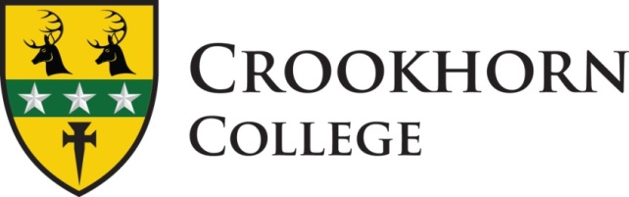

Headteacher: Sarah Bennett, B.A. (Hons), N.P.Q.H.

Stakes Hill Road, Purbrook, Waterlooville PO7 5UD Telephone 023 92 251120

JOB DESCRIPTION

SENIOR ADMINISTRATION ASSISTANT

The Senior Administration Assistant reports to the Business and Operations Manager

Contractual Hours: 35 hours (Mon – Fri 08.30 – 16.00). Term time only plus 5 days.

Overall Function

Manage information systems and databases that relate to students, to support the administration work of the College. This will involve working closely with the Deputy Headteacher, Business and Operations Manager, Assistant Headteacher Behaviour and Heads of House.

Responsibilities

- Undertake/assist with the daily attendance and reports as required
- Ensure all letters are processed and approved by Headteacher in a timely manner
- Initiate Medical Consent Forms for upcoming school trips and collate all relevant and associated data
- Produce Reward Certificates throughout the year and certificates for the Headteachers Reward Evening.
- To assist in the arrangements of the Primary Events liaising with Primary Schools and organising invites and certificates and transport where necessary.
- Organise and produce the weekly newsletter
- Produce and print termly reports for parents as directed by the Examinations Officer
- Assist with the transition process when required
- Assist with filing of new student files.
- Archiving of registers and student records.
- Responsible for a warm, friendly welcome for all visitors and callers.
- Deal with routine enquiries effectively, pleasantly and quickly.
- Input and maintain student records on SIMS
- Ensure the Reception area is covered at all times in the absence of the College Receptionist and report any potential problems to the Business and Operations Manager.

You may be asked to undertake other duties as determined by the Headteacher from time to time. This job description may be reviewed at the end of the academic year, or earlier if necessary. In addition, it may be amended at any time after consultation with you.

